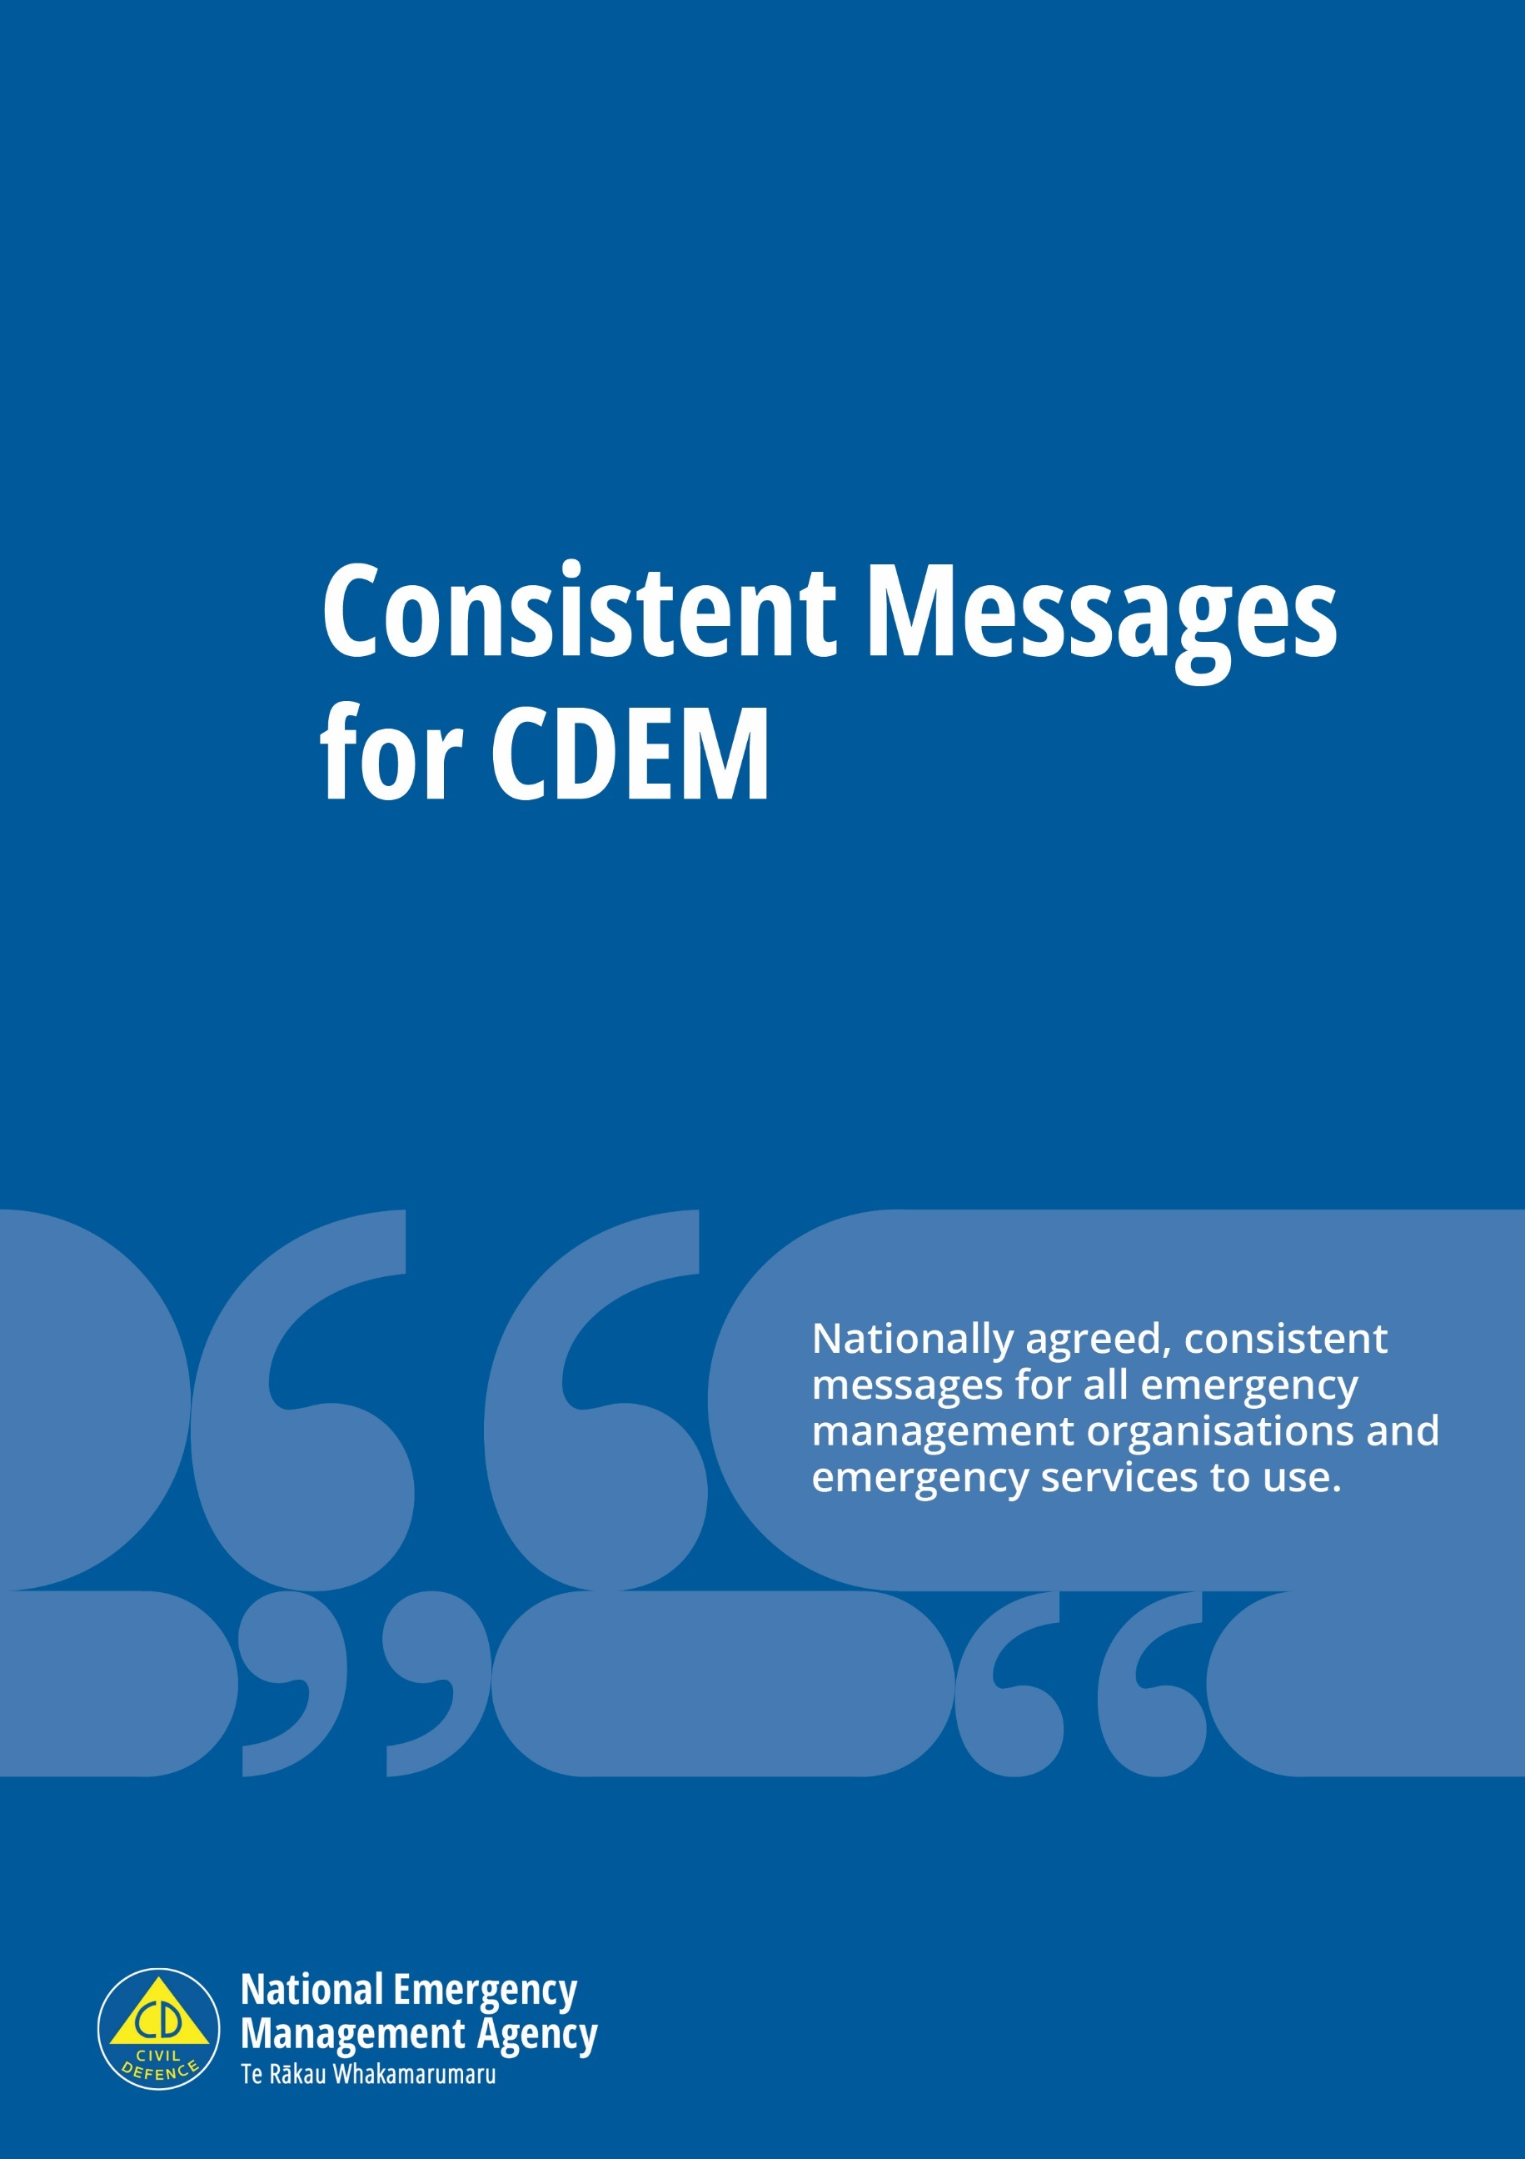
Consistent Messages for CDEM
Nationally agreed, consistent messages for all civil defence emergency management organisations and emergency services to use.

June 2024
Published by the National Emergency Management Agency

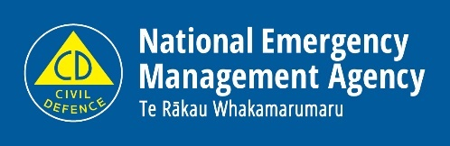
National Emergency Management Agency
PO Box 5010
Wellington 6145
New Zealand
Tel: +64 4 830 5100
Email: emergency.management@nema.govt.nz
Website: www.civildefence.govt.nz

Contents
Foreword 10
About Consistent Messages for CDEM 11
Who is Consistent Messages for CDEM for? 11
When to use Consistent Messages for CDEM 11
How Consistent Messages for CDEM is structured 11
Using Consistent Messages for CDEM 12
Consider the audience 12
Include reference to real events 12
Avoid repeating misinformation 12
Empathy and understanding 12
Accessibility and alternate formats 13
Communicating with culturally and linguistically diverse communities 13
Health advice in an emergency 14
Revisions and updates 14
Contributing agencies 14
Disclaimer 15
Reduction: Reduce the impacts of emergencies 16
Take measures to reduce damage to your whare/home 16
Insurance 16
Homeowners 16
Renters 17
Pets and other animals 17
Readiness: Get prepared to respond to an emergency 19
Know your hazards 19
Know how to stay informed 19
Radio 19
Online 20
Know your neighbours 20
Emergency Mobile Alert 20
Make emergency plans 21
Make a whare/home emergency plan 21
Make a wāhi mahi/workplace emergency plan 23
Make an early learning service or kura/school emergency plan 24
Make a marae emergency plan 25
Make a street/community emergency plan 25
Have emergency supplies 26
How much do you need? 26
Emergency supplies for your whare/home 27
First aid kit 31
Emergency toilet 32
Have a grab bag 32
Emergency supplies for your wāhi mahi/workplace 33
Emergency supplies for your vehicle 33
Babies 34
Young children 34
Disabled people and people with special requirements 35
Pets and other animals 37
Response: What to do in an emergency 38
Responding to specific hazards 38
Evacuation 38
If you have to evacuate 38
Preparing to evacuate 39
Sheltering in place 40
Sheltering at home 40
Do not use outdoor gas appliances indoors 40
Food safety during an emergency 41
Feeding your baby safely during an emergency 41
Telephones and communication 41
Recovery: What to do after an emergency 43
Recovering from specific hazards 43
Ensure food is safe 43
If your property is damaged 43
Urgent repairs and recovery 43
For renters 44
Making a claim 44
Temporary accommodation for unsafe residential property / buildings 44
Pets and other animals 45
Managing stress after an emergency 45
Earthquake 46
Key messages about earthquakes 46
Earthquakes 46
New Zealand earthquakes 46
Earthquake hazards 47
Reduction: Reduce the impacts of earthquakes 49
Structural fixes 49
Inside your whare/home 49
Renters 50
Readiness: Get prepared to respond to earthquakes 51
Develop a wāhi mahi/workplace earthquake response plan 51
Response: What to do in an earthquake 52
Drop, Cover and Hold 52
Keep yourself safe 52
Long or Strong: Get Gone 56
What not to do: bad earthquake advice 56
As soon as the shaking stops 57
Recovery: What to do after an earthquake 58
After a large earthquake 58
Pets and other animals 58
Flood 59
Key messages about floods 59
Floods 59
Types of flooding 59
Flood hazards 60
Reduction: Reduce the impacts of floods 62
Reduce potential flood damage 62
Readiness: Get prepared to respond to floods 63
Response: What to do during a flood 64
If flooding is possible in your area 64
During a flood 66
Recovery: What to do after a flood 67
Cleaning up after a flood 67
Food safety 69
Landslide 70
Key messages about landslides 70
Types of landslides and their processes 71
Landslide hazards 73
Reduction: Reduce the impacts of landslides 75
Readiness: Get prepared to respond to landslides 76
Response: What to do if you think a landslide is about to happen 77
Recognise the warning signs and act quickly 77
What to do if a landslide occurs 77
What to do during severe storms 77
Recovery: What to do after a landslide 79
Storms and severe weather 80
Key messages about storms and severe weather 80
Types of storm 80
Reduction: Reduce the impacts of storms 83
Readiness: Get prepared to respond to storms 84
Severe Weather Outlooks, Watches and Warnings 84
Response: What to do during a storm 86
When severe weather is forecast 86
During a storm 86
If you are caught outside during a lightning storm 87
If you see a tornado 87
If you are near the coast 88
If there is surface flooding in your area 88
Recovery: What to do after a storm 90
What to do if your property is damaged 90
Snowstorms 91
Key messages about snowstorms 91
Snowstorm hazards 91
Reduction: Reduce the impacts of snowstorms 92
Readiness: Get prepared to respond to snowstorms 93
Protecting livestock 93
Prepare your vehicle for the winter 93
Response: What to do during a snowstorm 94
In your home 94
Protecting your health 94
If you need to drive 95
Protecting livestock 95
Recovery: What to do after a snowstorm 96
Tsunami 97
Key messages about tsunami 97
Tsunami 97
Where do tsunami come from? 98
Reduction: Reduce the impacts of tsunami 99
Readiness: Get prepared to respond to a tsunami 100
Find out what can happen to you 100
Know your tsunami evacuation zones 100
Plan your evacuation routes 100
Practise your tsunami hīkoi 101
Kura/School evacuation plan 101
Response: What to do during a tsunami 102
Warnings 102
Evacuation 104
If you have a boat 105
What to do immediately after a tsunami 107
Recovery: What to do after a tsunami 108
Returning home after a tsunami 108
Food safety after a tsunami 108
Volcanic activity 109
Key messages about volcanic activity 109
Volcanoes, volcanic unrest, and volcanic eruptions 109
New Zealand’s volcanoes 109
Types of volcanoes in New Zealand 110
Volcanic hazards 111
Reduction: Reduce the impacts of volcanic activity 116
Readiness: Get prepared to respond to volcanic activity 117
Response: What to do during volcanic activity 119
If ash fall is forecast 119
During ash fall 120
Recovery: What to do after volcanic activity 122
Travelling 122
Cleaning up ash 122
Ash collection, disposal and storage in urban areas 124
Ash collection, disposal and storage in rural areas 125
Households that use roof-collected rainwater tanks 125
Further information 125
Wildfire 126
Key messages about wildfire 126
Reduction: Reduce the risk of wildfire 127
Protect your property from wildfire 127
Readiness: Get prepared to respond to wildfires 128
Response: What to do during a wildfire 129
Smoke 129
Fire in your vicinity – be prepared to leave 129
Evacuation order 130
Shelter in place 131
Recovery: What to do after a wildfire 133
After a wildfire 133
Returning after an evacuation 133
Other hazards 135
Animal and plant pests and diseases 135
What to do if you think you've found a pest or disease that is new to New Zealand 135
Drought 135
Fire 135
Food safety incidents 136
Food safety during emergencies 136
Geothermal Activity 136
What is geothermal activity? 136
Reduction: Reduce the impacts of geothermal hazards 138
Readiness: Get prepared to respond to geothermal hazards 138
Response: What to do during increased geothermal activity 138
Recovery: What to do after geothermal activity 139
Hazardous substance incidents 139
What to do if you are affected by hazardous substances 140
What to do if you spill a hazardous substance 140
Heat 140
What is a heat wave? 140
Reduction 140
Readiness 141
Response 142
Lifeline utilities failure 143
Major transport incident 143
Oil spills 143
What to do if you find an oil spill 144
What to do if you spill oil 144
Pandemic 144
COVID-19 144
Terrorism 145
In crowded places 146

Foreword
Information is one of the best tools we have for keeping people safe during and after emergencies, and for encouraging and enabling them to take action to prepare. To ensure that people are likely to take our messages on board, we need to communicate in ways that build trust, certainty and confidence.
When we consistently give the same messages, we reinforce the right advice, generate better public confidence, and promote faster, better co-ordinated and informed actions by the public.
Since it was first published in 2010, Working from the same Page: Consistent Messages for CDEM has been the key reference for the messages we need to get to our communities before, during and after emergencies.
This revision is the first full update of the document since 2010 and incorporates the latest science and best practice advice. The revision has been developed though a collaborative process and incorporates contributions and feedback from people and organisations across Aotearoa New Zealand’s emergency management system.
This revision centres people in our messaging – acknowledging not just the risks to people and property, but to mental health and wellbeing. It also uses accessible and non-technical language.
The structure has been completely reworked, centring around the 4 Rs of emergency management: risk reduction, readiness, response and recovery. It contains messages applicable to all hazards, as well as hazard-specific sections.
The revised Consistent Messages is an online document, to allow for more regular updates as our understanding of hazards, risk management and risk communication changes and to ensure currency of information. It will also allow us to more easily incorporate new content as it is developed.
I encourage everyone who has a role to play in sharing information before, during and after emergencies to use Consistent Messages.

Gary Knowles
Director Civil Defence Emergency Management

About Consistent Messages for CDEM
Consistent Messages for CDEM is a suite of nationally-agreed messages to help people increase their resilience to hazard impacts.
Consistent Messages for CDEM aims to support the development of tailored communications across the ‘4 Rs’ of emergency management: readiness, reduction, response and recovery.
When we consistently give the same messages, we reinforce the right advice, generate better public confidence, and promote faster, better co-ordinated and informed actions by the public.
This guide incorporates advice on best practice messaging from universities, science agencies, emergency services, government organisations and the insurance industry.

Who is Consistent Messages for CDEM for?
Consistent Messages for CDEM has been developed by and for New Zealand’s Civil Defence Emergency Management whānau/family: emergency managers, public information managers, educators, risk mitigation specialists, media personnel, communicators and hazard scientists.
Civil Defence Emergency Management (CDEM) Groups and other emergency management system agencies are welcome to copy and paste the messages without attribution. Use these messages as your own and add local details to suit your local context.
Media, other organisations and individuals are also welcome to use Consistent Messages for CDEM, attributing messaging to the National Emergency Management Agency.

When to use Consistent Messages for CDEM
You can consult Consistent Messages for CDEM when developing public information related to hazards, emergency management preparedness, events, and recovery. You should also use it when you are developing hazard-related educational material, displays and bulletin boards, print and online media, radio and television broadcasts and any other medium in which emergency safety is communicated to the public.

How Consistent Messages for CDEM is structured
Consistent Messages for CDEM is divided into several sections aligned with the ‘4 Rs’ of emergency management: reduction, readiness, response and recovery.
The first four sections focus on reduction, readiness, response and recovery messages that are common across hazards.
The remaining sections provide hazard-specific messages for natural hazards. Each hazard-specific section is divided into reduction, readiness, response and recovery messages specific to these hazards.

Using Consistent Messages for CDEM

Consider the audience
The better you know your community and its population demographics and profile, the better you can identify which communities need specifically targeted messages, and how to provide information that is accessible to them.
For example, if you are communicating to people who predominantly rent their dwelling, focus on risk reduction actions renters can do themselves, not ones that can only be done by home-owners.
If time or space is limited, evaluate your audience and the chosen topic to determine the most important messages. For emergencies that can occur with little or no warning, such as local source tsunami, the immediate response actions are generally most important. For emergencies with plenty of warning time, such as storms, risk reduction and readiness messages may be most important.

Include reference to real events
Understanding the past helps us plan for the future. At the community level, past hazard events (particularly those that have occurred in the local area) can inform and influence decisions on preparedness. This understanding can come from living memory or oral and written histories.
Annual research into the effectiveness of public education campaigns tells us that people are more likely to be prompted into preparedness by actual events (e.g. floods, earthquakes occurring) than by advertising alone.
If possible, support information and communication about risk reduction and readiness activities by including messages or stories about events that have occurred in the local area.

Avoid repeating misinformation
This content is provided courtesy of The Workshop.
Myth-busting is when we repeat incorrect information, say it is untrue and then give the accurate information.
However, repeating misinformation brings it to people’s attention and can embed it. An example is the phrase “don’t think of an elephant” – what did it make you think of, despite the advice? People may inadvertently end up attributing this incorrect information to a trusted source.
Further information on dealing with COVID-19 misinformation is available on The Workshop website. While specific to COVID-19, this page provides useful tips and alternative strategies that can be applied to other situations.

Empathy and understanding
An emergency response triggers many different emotions for everyone involved. Our audiences trust us, but they are also human beings who may be anxious, scared or uncertain. Showing that you understand their feelings will help to build empathy and ensure your communications have the most impact.
It can be useful to begin by acknowledging the feelings of your audience, and indicating that you understand and share those feelings – after all, you are all part of the same community, you are all in this together, you will help each other out and get through this. Clarity is kindness: be up front about what the situation is, and realistic about what will come next.

Accessibility and alternate formats
All people must be treated without discrimination. This means that everyone, including disabled people, must have access to information and services on the same basis as others.
Accessible information and communications are provided in formats and languages that disabled people can access independently, without relying on other people, and is compatible with assistive technology, such as computer screen readers (known as alternate formats). Essentially, it’s free of barriers.
Information and communications include any printed or online information in pamphlets, brochures, websites, online applications, forms, or ways that people access and engage with information and services.
Further information on what accessibility is, why accessibility is important, and how you can make information and communications accessible for disabled people, is available in the Accessibility Guide on the Ministry of Social Development website.
The Ministry of Social Development is responsible for coordinating all-of-government’s management of alternate formats – Easy Read, New Zealand Sign Language (NZSL), braille, audio and large print. It is also responsible for coordinating advice on creating accessible information.
Further information on the all-of-government process for producing alternate formats is available on the Ministry of Social Development website.

Communicating with culturally and linguistically diverse communities
Members of culturally and linguistically diverse (CALD) communities are people who do not speak English or Te Reo Māori as their primary language, or who are raised in a different culture from the predominant one where they live. They may be New Zealand-born or from refugee and migrant backgrounds. These communities also include international students, tourists, and international visitors.
CDEM personnel and members of CALD communities may face specific challenges, including differences in ability with spoken or written English, access to media in their language and the urgent need to communicate with whānau/family overseas. Emergency situations may trigger anxiety and stress associated with prior experiences.
As you engage and build relationships within your region, get to know the CALD groups in your area. CALD community networks are often well developed with strong connections, and will aid in communicating and engaging with community members.
The Get Ready website provides information on the natural disasters that can happen in New Zealand and advice on how to be better prepared. The website has information in twenty-seven languages.
More information is available in Information Series 12/13, Including CALD Communities: Information for the CDEM sector

Health advice in an emergency
Scientific advice and guidance from the health sector about various hazards and events will change based on best practice and previous events.
The Ministry of Health’s Protecting your Health in an Emergency provides general key messages for a response, but further advice may be tailored to specific circumstances. We recommend you check back with the lead agency and make contact with the local public health service for more area-specific guidance.
Learn more here: Protecting your Health in an Emergency

Revisions and updates
Consistent Messages for CDEM is a “living document”, designed to be updated with evolving best practice. This current online version updates and replaces Working from the Same Page: Consistent Messages for CDEM version 1.0, June 2010.
Messaging was agreed through consensus between the contributing agencies and organisations, which specialise in emergency management, natural and other hazards and risk communication. The messaging has been carefully refined to ensure accuracy, consistency and appropriateness.
Date | Changes
October 2022 | Full update
September 2023 | Revision to storing water messages: advice to not use fruit juice containers removed from storing your own water section.
October 2023 | Update to broken link: Maritime NZ Responding to Oil Spills
February 2024 | Update to broken link: Tsunami boat safe distance map
June 2024 | Added Fire and Emergency New Zealand to list of Contributing Agencies  Updated and expanded Telephones and communication messages  Update to broken link: Protecting your health in an emergency  Inserted Wildfire section

Contributing agencies
Consistent Messages for CDEM is the product of a collaborative effort between agencies and organisations in partnership with Civil Defence Emergency Management. Contributing agencies and organisations include:
- University of Auckland
- Department of Conservation
- GNS Science
- Wellington Region Emergency Management Office
- MetService, Te Ratonga Tirorangi
- Ministry of Health
- Waikato Civil Defence Emergency Management Group
- Massey University
- Fire and Emergency New Zealand

Disclaimer
The information contained in this document is provided for general information purposes only. The National Emergency Management Agency (NEMA) endeavours to ensure that the information is reliable and accurate. However, any person who relies upon any information contained herein does so at their own risk and NEMA disclaims any liability arising from the use of the information.
It is available, along with further information about NEMA, on the NEMA website www.civildefence.govt.nz.

Reduction: Reduce the impacts of emergencies
New Zealand communities are at risk from a broad range of hazards. This guide covers geological hazards like earthquakes, landslides and volcanoes; weather-related hazards such as storms, floods and droughts; and other hazards like pandemics, oil spills and fires.
Reduction can involve eliminating or avoiding the risks of a hazard where practical and desirable to do so. By learning more about the hazards that can impact your community, you can take steps to reduce the extent of their impacts. There is no way we can fully eliminate hazards and their impacts on our households, communities and wāhi mahi/workplaces, which is why it is so important to know what to do in an emergency and take steps to be prepared.

Take measures to reduce damage to your whare/home
The best way to protect your whare/home is to take steps to reduce the potential damaging impacts of the hazards that can occur in your community.
Learn about the hazards that can affect you and what steps you can take to reduce their impact.
- Earthquake
- Flood
- Landslide
- Storms and severe weather
- Snowstorms
- Tsunami
- Volcanic activity
- Wildfire
- Other hazards
Learn how to reduce potential damaging impacts to your house, apartment or rental property at https://www.eqc.govt.nz/be-prepared

Insurance

Homeowners
A house is often a homeowner’s most valuable asset, so it’s important to protect your whare/home and its contents against loss or damage caused by hazards.
Check your insurance:
- Find out what your insurance policy covers, as well as what it doesn’t cover (these are known as exclusions).
- If you’ve engaged an insurance broker, ensure you know which insurer your policy is held with.
- Check that you will have enough insurance cover to rebuild your whare/home and replace your valuables after an emergency.
- Review your insurance cover regularly to make sure it keeps pace with any change in the value of your whare/home or contents, or any change in the costs to repair or rebuild your whare/home.
The Earthquake Commission Act 1993 automatically gives some cover for your home, contents and land if you have private insurance (that includes fire insurance) when a natural hazard damages your whare/home. This is called EQCover.
Toka Tū Ake EQC has partnered with insurers to provide a single point of contact for residential insurance customers. You should contact your insurer to make a claim for damage from natural hazards.
Find out more about EQCover.

Renters
If you rent your whare/home, it is strongly recommended that you have your own contents insurance. This will help to replace your belongings if they are lost or damaged. In addition, some contents insurance policies may include provision of temporary accommodation if the property you rent becomes uninhabitable.
Find out more about temporary accommodation here.
Renters with private contents insurance (that includes fire insurance) will access insurance cover through their insurer, in line with their contents policy.
Changes to the New Zealand’s Residential Tenancies Act in February 2021 made it easier for tenants of rental properties to quake-safe their homes. The updated Act specifies that landlords must not unreasonably withhold consent for a minor fixture, renovation, alteration, or addition to a rental property. This means it’s now easier for tenants to protect themselves and loved ones from well-known household hazards such as unsecured tall and heavy furniture.
Under the Act, tenants must return the premises to substantially the same condition it was in before changes were made. If you’re a tenant and planning any quake safe actions at your place, be sure to talk to your landlord or property manager first.
Find out more on the steps you should take at your place in the Be Prepared section of the Toka Tū Ake EQC website:
- Securing tall and heavy furniture
- Quick and easy safety steps
- Use appropriately sized hooks to hang items such as mirrors and picture frames
- Store heavy items in cupboards and on lower shelves

Pets and other animals
Reduce the risks to your pets and other animals:
- Ensure your pets are all microchipped and their details are registered with the NZ Companion Animal Register (NZCAR). Make sure these details are kept up to date and include details for an out-of-region contact (as close friends and whānau/family may also be affected by the emergency).
- Review your pet insurance policy to see if it covers emergencies (for example, pet accommodation, behavioural trauma, and illnesses such as giardia from floods).
- Ensure outside kennels and caging are located on higher ground to avoid floods, and away from other hazards such as slopes prone to landslides.
- Restrain standing cages for birds and rodents, and tanks for fish and turtles, so they do not fall over or become damaged during earthquakes.
Advice about protecting animals in emergencies is available on the Ministry for Primary Industries website.

Readiness: Get prepared to respond to an emergency
Emergencies can happen anytime, anywhere – and the best thing you can do is make sure you are prepared. Learn as much as you can about what might happen, what you’ll do when it does and what you need on hand to make sure you, your whānau/family and your community get through.

Know your hazards
Learning about the hazards that can occur in your community, and the impacts they can cause, will help you work out what steps you can take to get prepared.
Find out from your local Civil Defence Emergency Management Group which hazards can affect you. Ask:
- Are my most-visited places in a hazard zone? This includes my whare/home, wāhi mahi/workplace, community/cultural meeting place (e.g. kura/school, marae, place of worship, sports and recreation grounds) or anywhere I spend a lot of time.
- What hazards could impact my community?
Learn about the hazards you may be at risk from and how they could impact you and your whānau/family:
- Earthquake
- Flood
- Landslide
- Storms and severe weather
- Snowstorm
- Tsunami
- Volcanic activity
- Wildfire
- Other hazards

Know how to stay informed
It's important to know the different ways you can stay informed during an emergency – which radio stations to listen to, which websites and social media to follow, the importance of getting to know your neighbours, and checking if you can receive Emergency Mobile Alerts.
Plan for how you will stay informed if the power goes out – such as ensuring you have a battery or solar powered radio, USB chargers and/or portable charging devices or a plan to share information with your neighbours.

Radio
If the power goes out, a solar or battery powered radio (or your car radio) can help you keep up to date with the latest news.
The following radio networks work collaboratively with civil defence emergency management authorities to broadcast important information and advice in an emergency:
- Radio New Zealand (AM and FM frequencies)
- MoreFM (FM frequencies)
- NewstalkZB (AM and FM frequencies)
- Today FM (AM and FM frequencies)
- The Hits (FM frequencies)
Check with your local Civil Defence Emergency Management Group to find out what local stations they recommend you should listen to during an emergency.

Online
Most emergencies are managed at the local level. For local emergency updates, check your council’s website, as well as your local Civil Defence Emergency Management Group’s website and social media.
The National Emergency Management Agency is responsible for issuing national emergency updates and tsunami warnings. Tsunami warnings and information will be published on the National Emergency Management Agency’s website and the @nzcivildefence Twitter channel.
Severe Weather Outlooks, Watches and Warnings are issued by MetService, Te Ratonga Tirorangi, New Zealand’s National Weather Service. Stay up to date with the latest weather information through the MetService website and mobile app.
Your local Civil Defence Emergency Management Group may also use apps such as the Red Cross Hazards App to share emergency updates and warnings.

Know your neighbours
In an emergency, you’ll want to look out for your neighbours – and they’ll want to look out for you. Getting to know them before an emergency means you’ll know how to check in with each other, and how you can work together to look after your community.
- Share contact details so you can get in touch if an emergency occurs.
- Tell them about your emergency plan and ask about their plans.
- Find out who can help you and who might need your help.
- Join or form a Neighbourhood Support Group. Neighbourhood Support Groups bring local people together to create safe, supportive, and connected communities. Join today at neighbourhoodsupport.co.nz.

Emergency Mobile Alert
Emergency Mobile Alerts are messages about emergencies sent by authorised emergency agencies to capable mobile phones. They are designed to keep people safe.
The alerts can be targeted to areas affected by serious hazards. They will only be sent when there is a serious threat to life, health, or property, and, in some cases, for test purposes.
To get Emergency Mobile Alerts, you need a phone capable of receiving Emergency Mobile Alerts. The phone also needs to have cell reception and up-to-date software. You don’t have to download an app or subscribe to a service.
Find out more about Emergency Mobile Alerts

Make emergency plans
Emergencies can disrupt our lives, damage property and cause serious harm. Making a plan will help you get ready, and talking about your plan with your whānau/family, workmates, marae and community will make sure everyone’s prepared.
- Make a whare/home emergency plan
- Make a workplace emergency plan
- Make an early learning service or kura/school emergency plan
- Make a marae emergency plan
- Make a community emergency plan
- Make a sports organisation emergency plan
There’s more information on the Get Ready site, along with some templates to get you started.

Make a whare/home emergency plan
A home emergency plan lets each member of a household know what to do in an emergency and how to be prepared in advance.
Having a home emergency plan helps alleviate fears about potential emergencies and makes actual emergency situations less stressful while saving precious time.
Make sure your whare/home emergency plan lines up with emergency plans for your mahi/work, kura/school and other places where you spend a lot of time. You should also make sure it lines up with your community response plans or community resilience plans. Different communities have different response plans.
- Contact your local Civil Defence Emergency Management Group to find out about your community’s response plan.

How to make a whare/home emergency plan
You can make a home emergency plan online at getready.govt.nz/household-plan, or by following the instructions below.
- Write down the names of everyone in your household and their contact details.
- Decide where you will go in case you have to evacuate or can’t get home.
  - Plan and mark evacuation routes on a map. Plan several evacuation routes in case certain roads are blocked, closed, and/or put you in further danger.
  - Discuss and write down your places to go:
    - Right outside your whare/home, in case of a sudden emergency (e.g. fire).
    - A safe location away from your immediate area which you can reach from home by walking. If you live near the coast, make sure it is not in a tsunami evacuation zone. Go here in case of a sudden emergency (e.g. flash flood or tsunami) or if you can’t get home.
    - Out of town, to stay during or after an emergency. Go here when you have time to evacuate from your neighbourhood (e.g. for a flood) or if you can’t get back to your neighbourhood. This place can be a relative or friend’s home, or a hotel, motel or campground you are familiar with.
    - A meeting place if you can’t get home. It might be a kura/school, a friend’s home or with whānau/family.
- Think about people who might need your help in an emergency (e.g. elderly and disabled people, single parents with young children, people who are new to the area, people who live on their own, and others who might need help in the neighbourhood).
  - Introduce yourself and save their contact phone numbers.
  - Discuss what they may need and how you and others can help them.
  - See Disabled people and people with special requirements for more information.
- Pick two contacts outside your neighbourhood to leave a message with if you can’t contact each other:
  - A friend or relative who will be your household’s primary contact.
  - A friend or relative who will be your household’s alternative contact.
  - Tell these contacts that you will call or text them in an emergency. Make sure they have all of your contact numbers. In an emergency, they will need to know:
    - Where you are.
    - What happened.
    - How to reach you.
  - All adults and children in your household should know the primary and alternative contacts’ names, addresses, phone numbers, and how to leave this emergency information in a text message or voicemail. For small children, write the names and numbers on a card and keep it in their school/daycare bag.
- Decide on emergency contacts for each family member and ensure these are saved in their phones. Think about who you might need to contact for information or help in an emergency. Write down important contact details. Try filling out this table:
Contact | Details
Local council call centre
Insurance company 24-hour
Insurance number and policy number
Local radio station (Frequency: )
Kura/School
Whānau/Family and neighbours
Bank phone number and details
Work phone numbers
Medical Centre/GP
Pharmacy
Local police station
Vet/kennel/cattery
Local hotel or B&B
Gas supplier, meter number and account number
Electricity supplier, meter number and account number
Water supplier, meter number and account number
Electrician
Plumber
Builder
Landlord
Local contact for emergency accommodation
Out of town contact
Insurance company

- Write down where your emergency supplies are at home. Make sure everyone knows where these are. They don’t all need to be in one place, but you might have to find them in the dark. This includes any medication, and where it is stored, in case you need to evacuate.
- Write down how and when to turn off the water, electricity and gas at the main switches or valves at home.
  - Make sure everyone in the household can turn these off – even in the dark.
  - If you need them, make sure that you have necessary tools in an obvious, weather-tight place close to the gas and water shut-off valves.
  - Only turn these off if you suspect a leak or damaged lines or if you are instructed to do so by your utility provider, local Civil Defence Emergency Management Group or other local authority. If you turn the mains gas off, you will need a professional to turn it back on.
  - Place a tag on shut-off valves to make them easier to identify.

Make a wāhi mahi/workplace emergency plan

Make a personal wāhi mahi/workplace emergency plan
In an emergency, you can be stuck at mahi/work, without transport home. Make a personal wāhi mahi/workplace emergency plan so you know who to contact at mahi/work in an emergency and have a plan to get home safely.
You can find a personal workplace emergency plan template on getready.govt.nz.
It is also a good idea to have some emergency supplies at mahi/work in case you have to wait to travel home.
If you run a business, you should make sure all your staff members have a Personal Workplace Emergency Plan.

Emergency planning for businesses
An emergency plan is a health and safety requirement for all wāhi mahi/workplaces. Not having one is a big risk for your business and the people in it. An emergency plan details what you and your colleagues will do when a disaster strikes to keep yourselves and your customers safe.
Being prepared for an emergency can:
- save lives and prevent harm,
- help businesses to continue trading through hardship,
- give staff and owners confidence,
- protect equipment and premises,
- quickly get businesses running again.
Information about emergency planning for businesses is available on business.govt.nz.
It is also important that businesses have a business continuity plan in place. A business continuity plan identifies how your business can keep its essential functions up and running following an emergency.

Make an early learning service or kura/school emergency plan

Emergency planning for early learning services and kura/schools
Early learning services and kura should have an emergency management plan for all hazards they may face, especially for sudden impact hazards where children, students and staff have to act quickly, e.g., earthquake, tsunami, fire, violent threat.
The Ministry of Education provides guidance for kura/schools to plan and prepare for emergencies and traumatic incidents.
There is also a Best Practice Guide specifically targeted at early learning services.
Early learning services and kura/schools should have plans for excursions and education outside of the classroom (EOTC) activities. An emergency may happen when children, students and staff are outside of the early learning service or kura/school grounds, and it is important that there are plans in place for these scenarios.
Emergency plans should detail arrangements for caring for children and students including information to help reunite them with their parents, legal guardians, or approved alternate caregiver in a safe and timely manner.

Make an early learning service or kura/school emergency plan as a parent or guardian
Find out about your children’s kura/school’s emergency plan and talk to your children about it. Do they know what to do if there is an emergency? Have their teachers discussed it?
Parents and guardians need to know all emergency procedures in advance, especially the safe locations and whānau/family reunification procedures.
Find out if the kura/school’s emergency plan requires you to pick up your children from a safe location after the “all-clear” is given.
- Plan to collect your children by foot or bicycle, if possible. Routes to and from schools may be jammed. Telephone lines during an emergency may be overloaded.
- Ensure emergency contact details held by the early learning service or kura/school are up to date.
- Parents and guardians should provide multiple pre-approved emergency contacts. Decide who will pick up your children if you can’t get to them and provide their name to the school. Be sure that parent and emergency contact information is updated at the beginning of each year as a minimum, and that parents notify the early learning service and/or kura/school of any changes during the year. Children can only be released to a person identified by the parent or usual caregiver as approved to uplift that child.

Make a marae emergency plan
Marae preparedness planning enhances resilience and safety of marae, taonga and iwi, assisting te hau kāinga (the people of the marae) and te haupori (the wider community) to understand and manage their risks.
A marae emergency preparedness plan will identify the potential hazards, people from the marae who have specialist skills (such as first aid), and a list of items that will be required to ensure the marae is adequately prepared.
Work through the marae emergency preparedness plan to work out what your marae will do.

Make a street/community emergency plan
One of the best ways to prepare for emergencies is by getting together with other people in your community and discussing how you all plan to respond to events.
Street-level plans encourage neighbours to build their own networks and identify people who may need extra support in an emergency. Talk to people close to where you live and find out what’s already in place.
Your community may already have groups of people or networks that have their own plans and will have a role in bringing different people together. Most communities have a Civil Defence Centre or a community hub, where locals can come together during and after an emergency. In times of need, these will be opened and run by communities. Contact your local Civil Defence Emergency Management Group to find out how you can volunteer.
There may also be local voluntary, church and sports groups, kura/schools, marae, and service organisations. Make contact with them and find out what they are doing.
Volunteering New Zealand and Neighbourhood Support Groups provide other opportunities to volunteer and have contacts to groups that may have existing community plans.
Getting to know your neighbours has other benefits, too. You can share contact details and find out what resources and skills you can share with each other. Try to keep it low-stress and low-expectation: tell people it’s about doing what you can to support each other.

How to make a street emergency plan
- Get in touch with the people who live on each side of you, and on opposite sides of the street. This will create a circle of support.
- Swap phone numbers, so you can check-in with each other without having to visit.
- Encourage neighbours to prepare emergency plans and keep them up to date.
- Encourage neighbours to keep emergency supplies and grab bags and keep them up to date.
- Plan with neighbours how you can work together during an emergency. Consider ways you can help each other during recovery.
- What resources could you share? Find out your neighbours’ special skills (for example, medical or technical training), and consider how you can help in an emergency situation.
- Make plans with neighbours for childcare, in case you cannot get home in an emergency.
- Try holding a street barbeque or gathering once a year to get to know your neighbours. This can help everyone to meet others on the street and share and update contact details.
- Identify elderly and disabled people, single parents with young children, people who are new to the area, people who live on their own, and others who might need help in the neighbourhood. Work out how neighbours can help them before or during an emergency (e.g. transport, securing the home, getting medications).
- Check whether emergency management training is offered by your local Civil Defence Emergency Management Group or local fire station.
- Find out where your nearest Community centre is (or equivalent in your community). Community centres are a great way for community members to come together to share skills and resources.

Have emergency supplies
In an emergency, Civil Defence Emergency Management and other emergency services will be on the scene, but they cannot reach everyone immediately. You could be stuck at home without basic services, such as electricity, gas, drinking water, flushing toilets, and phones, for days or even weeks.
Think about what you will need in an emergency:
- Do you have enough food and water for your household?
- How will you cook and store food without electricity?
- Do you have enough water for everyone in your household? Does this include water to cook and wash with?
- What about family members who need medication? Do you have enough?
- Do you have a baby who may need extra supplies (e.g. nappies, formula)?
- Do you have enough food and water for your pets?

How much do you need?
Official advice suggests we should have a week’s worth of water and food for everyone in our households. However, this may be out of reach for many people – due to the financial outlay in assembling an emergency food supply, or space considerations in small houses, apartments or shared accommodation.
Important points to note:
- Something is always better than nothing.
- Aim for a minimum of three days’ food and water – you can build this over time by adding an extra tin of food here and there, and gradually increasing the amount of basic food you keep at home. Check expiry dates frequently and follow the practice of first-in, first-out.
- Ask your GP if you can get prescription supplies of common medicines like Panadol, allergy medicine or cold/flu relief – they are often much cheaper. You can also ask for an extra week’s supply of any prescription medicines to keep in your emergency kit.
- Water doesn’t need to be commercially bottled. You can store water in clean plastic containers.
- You will already have a lot of useful supplies in your whare/home: blankets on your bed, clothes in your wardrobe, items in your bathroom. Don’t forget items in your fridge and freezer, too.
- Neighbours can help each other out by sharing resources like barbecues and portable gas stoves.

Emergency supplies for your whare/home
Your house is already full of emergency items disguised as everyday things – as long as you know where they are and can find them in a hurry and/or in the dark! Make sure everyone in your household knows where the torches and batteries are.
Some parts of New Zealand could be cut off without basic services for longer than three days during an emergency. Check with your local Civil Defence Emergency Management Group for specific guidance about your region.
Your household emergency supplies should include:
- Water for a minimum of three days, or a week or more if you can – make sure you have at least nine litres of water for every person. Find out more about storing water.
- A minimum of three days, or a week or more if you can, of food and consider how you will cook it (do you have a camping stove or BBQ?). Include food for babies and pets if they are in your household. Find out more about how to store food.
- Medicines and copies of prescriptions (names/dosage).
- USB chargers and/or portable charging devices (such as power banks) to charge your mobile phone. Some solar- and battery-powered radios can also be used to charge phones.
- Torch and batteries. Battery powered lighting is the safest and easiest.
  - Do not use candles as they can tip over in a gust of wind or in earthquake aftershocks and start a fire.
  - Do not use kerosene lamps, they need a lot of ventilation and are not designed for indoor use.
- A solar- or battery-powered radio (or your car radio), so you can keep up with the latest news and alerts.
- A large plastic bucket with a tight lid (or large rubbish bags), toilet paper, and disinfectant, for an emergency toilet.
- Dust masks (rated P2 or N95) and work gloves, to protect yourself. Masks can be useful in emergencies caused by a number of different hazards, such as during pandemics and volcanic eruptions or when cleaning up after a flood or tsunami.
- A small fire extinguisher. For advice on fire extinguishers and how to use them, visit fireandemergency.nz/at-home/fire-extinguishers/
- Camping stove and enough fuel to use it for a minimum of three days.
By looking after yourself and your whānau, you’ll help emergency services focus their attention on people who need the most help.

Storing water
Household water supplies, including drinking water, can be affected in an emergency. It is important to have a supply of stored water – either commercially-bottled water, or your own containers filled from the tap.
Some parts of New Zealand could be without water for longer than three days during an emergency. Check with your local Civil Defence Emergency Management Group to see how much water they recommend people in your region should store.

How much water to store
You should have a minimum of three litres of drinking water per person per day for three days – that is, 9 litres per person – for drinking and basic sanitation. Ideally, you would have a week’s worth: 21 litres per person.
Children, nursing mothers, and ill people will need more. Hot environments and intense physical activity can double the amount of water you need.
You will need additional water for washing and cooking.
You will also need more water for your pets and livestock to drink and be cleaned with. The amount needed will depend on their sizes and the conditions. Remember that animals often drink more water than usual when under stress. The Ministry for Primary Industries provides guidance on water requirements for different animals in emergencies.

Commercially bottled water
If you choose to purchase commercially bottled water, store in the original sealed container and do not open it until you need to use it. Observe and replace according to the expiration or “use by” date.

Storing your own water
There are many different options for storing your own water. Some suggested options include:
- Water or soft drink bottles
  - If you are reusing containers, two-litre plastic water or soft-drink bottles are best. You can also purchase food-grade water-storage containers from hardware or camping supplies stores.
    - Do not use cardboard containers. These containers are not designed for long-term storage of liquids and can leak easily.
    - Do not use containers that have had milk in them. Milk proteins cannot be adequately removed from these containers and provide an environment for bacterial growth when water is stored in them.
    - Do not use glass containers, because they can break and are heavy.
- 10-20 litre containers
  - These larger containers are available from hardware stores.
- 200-litre water tanks
  - 200-litre tanks can be attached to downpipes or used to store tap water. Cover all holes in the tank if you are using it to store tap water. These tanks are available from water tank manufacturers. Some councils have larger tanks for sale at reduced prices. Details for the Wellington region councils are here, or contact your local council to see if they can assist you with purchasing a tank.
- Larger tanks
  - Larger tanks are available directly from manufacturers and hardware stores. Before purchasing a larger tank, check with your local council to see if there are any planning requirements you need to consider when installing a larger water tank. More information on how to keep tank water safe.

Prepare containers of water
If you are preparing your own containers of water, follow the directions below for selecting, cleaning, and filling the containers with water:
- Thoroughly clean the containers and lids with hot water (not boiling, as this will damage the bottle).
- Fill the containers to top with regular tap water until it overflows. Remove a very small amount to allow for the addition of five drops of non-scented liquid household chlorine bleach per litre of water. A list of how much bleach to add to different volumes of water can be found here.
  - Do not use bleaches that contain added scent or perfume, surfactants or other additives – they can make people sick.
  - Do not drink the water for at least 30 minutes after adding bleach.
- Tightly close the containers using the original caps, making sure there are no air gaps.
  - Be careful not to contaminate the caps by touching the inside of them with your fingers.
- Place a date on the outside of the containers so that you know when you filled them.
- Store them in a cool, dark place. If possible, store in two different places in case one is not accessible in an emergency.
- Check the bottles every six months, for example at the beginning and end of daylight saving. If the water is not clear, throw the water out and repeat steps 2 to 5 above.
You can fill clean plastic ice cream containers with water, cover, label and keep in the freezer. These can help keep food cool if the power is off and can also be used for drinking when thawed.
Your hot water cylinder and toilet cistern are valuable sources of water. Check that your hot water cylinder and header tank are well secured. The toilet cistern is only safe to use if no chemical toilet cleaner is present. Boil water for one minute before drinking. It is OK to use jugs with an automatic cut-off switch as long as they are full. Under no circumstances should the switch be held down to increase boiling time.
Collect rainwater by either placing a clean container outside to catch rain or by disconnecting the downpipe from the roof and filling a container. Boil water for one minute before drinking. It is OK to use jugs with an automatic cut-off switch as long as they are full. Under no circumstances should the switch be held down to increase boiling time. Alternatively, disinfect with plain, unperfumed household bleach (five drops per litre of water). Do not drink the water for at least 30 minutes after adding bleach. Reserve one clean utensil to use as a dipper.
DO NOT collect drinking water from the roof if it is contaminated with ash, smoke or any other debris.

Storing food
Familiar foods can lift morale and help people feel secure in time of stress. Try to include foods that everyone will enjoy. Look for foods high in calories, protein, carbohydrates, vitamins, and minerals. Look for canned foods with high liquid content in case water is scarce.
Store long lasting food that doesn’t need cooking (unless you have a camping stove (and fuel) or BBQ), as power and gas may not be available. Remember to ensure you have a can opener if you are storing canned food.
Suggested food to store:
- Ready-to-eat canned meats, fruits, and vegetables.
- Canned juice, long-life or powdered milk, and soup.
- High-energy foods such as peanut butter, jam, salt-free crackers and energy bars.
- Scroggin or trail mix (pre-packaged or homemade).
- Comfort foods such as hard sweets, sweetened cereals, snack bars, and biscuits.
- Instant coffee, tea bags.
- Compressed food bars. They store well, are lightweight, taste good, and are nutritious.
- Dried or bulk foods like dried fruit, nuts or crackers – also pasta, rice and dried beans. Avoid very salty foods, as they may increase thirst.
- Freeze-dried foods. They are tasty and lightweight but will need water for reconstitution.
- Whole-grain cereals (oatmeal, whole-wheat, multi-grain).
- Instant meals. Cups of noodles or cups of soup are a good addition, although they need water for reconstitution and may contain a lot of salt.
- Snack-sized canned goods, which generally have pull-top lids or twist-open keys.
- Pre-packaged beverages. Those in foil packets and foil-lined boxes are sealed and will keep for a long time if the seal is not broken.
- Foods for infants, elderly persons, or persons on special diets.
- Non-perishable foods for pets and other animals.
When selecting foods, keep in mind that:
- Salty foods are usually not a good choice, because they will make you thirsty and drinking water may be in short supply.
- Commercially dehydrated foods often require a lot of water for reconstitution and effort to prepare.
- Glass bottles and jars can easily break in an earthquake.
- Whole grains, beans, and dried pasta require water for preparation and cooking. Water can be in short supply in an emergency.

Special dietary requirements
If you or someone in your household has special dietary needs, make sure you have sufficient stock of these food items for a minimum of three days, or a week or more if you can. Include a supply of your special food items in your grab bag too. Emergency shelters are unlikely to have the special food items you may need.

First aid kit
Keep a first aid kit in your whare/home, in your car and in your grab bag.
Find the location of first aid kits where you work.
Remember to include prescription drugs with your emergency survival items. Because the storage requirements of prescription drugs vary, some may have to be added to your first aid kit at the last minute, such as those stored in the fridge. You may want to pin or tape a note to the outside of your first aid kit container reminding you to take along prescription drugs if you have to evacuate.

Suggested contents for a basic first aid kit
First aid kits come in many shapes and sizes. Your local chemist or supermarket may sell them. You can purchase one from St John or the Red Cross.
- St John first aid kits
- Red Cross first aid kits
You can also make your own first aid kit. A basic first aid kit may contain:
- Plasters (in a variety of sizes and shapes).
- Sterile gauze dressings (small, medium and large).
- Sterile eye dressings (at least 2).
- Triangular bandages.
- Crêpe rolled bandages.
- Safety pins.
- Disposable sterile gloves.
- Tweezers.
- Scissors.
- Alcohol-free cleansing wipes.
- Sticky tape.
- Thermometer (preferably digital).
- Skin rash cream (such as hydrocortisone).
- Cream or spray to relieve insect bites and stings.
- Antiseptic cream.
- Painkillers, such as paracetamol (and infant paracetamol for children), aspirin (not to be given to children under 16), and ibuprofen.
- Cough medicine.
- Antihistamine cream or tablets.
- Distilled water for cleaning wounds.
- Eye wash and eye bath.
- CPR breathing barrier with one-way valve (for protection during rescue breathing or CPR).
- Alcohol gel
It may also be useful to keep a basic first aid manual with your first aid kit.
Red Cross have a First Aid App that provides a free and comprehensive guide to first aid and emergency response.

First aid training
If someone you care for is injured in an emergency, your knowledge of first aid may be the difference between life and death.
Many organisations provide first aid training courses. It is recommended that you take a First Aid course, followed by regular refresher sessions.

Emergency toilet
In some emergency situations, the water supply may be cut off, or water and sewage lines may be damaged, and you may need to use improvised emergency toilets.

How to make a basic emergency toilet
Use sturdy, watertight containers that can hold approximately 15 – 20 litres, such as a rubbish bin or an empty paint bucket, with a snug-fitting cover.
If the container is small, keep a large container with a snug-fitting cover for waste disposal.
- Line buckets with plastic bags (if possible).
- Pour or sprinkle a small amount of regular household disinfectant (such as chlorine bleach) into the container each time the toilet is used, to reduce odour and germs. If you don’t have disinfectant, you can use dirt and dry materials (such as sawdust, dry leaves, soil or shredded newspaper).
- Replace the lid after each use.
- After using the toilet, wash your hands thoroughly using soap and water, or use hand sanitiser.
- When you reach capacity, empty the waste into a large storage bin, such as a wheelie bin and follow instructions from local authorities or public health about how to dispose of it. If you have a garden, you can bury the waste outside. Make sure the hole is away from any water source, above the groundwater table and far away from any vegetable gardens.
Instructions for making an emergency two-bucket toilet that separates solid waste (poos) and liquid waste (wees) and a long-drop toilet are available on the Wellington Region Emergency Management Office website.

Have a grab bag
If you have to evacuate, you will need essential items that you can carry with you. It’s ideal to store these items in a grab bag, ready for you to take if you have to leave in a hurry – but if that’s out of reach right now, figure out what you’ve already got in your whare/home, and make sure you know where these items are kept so you can grab them quickly.
If you can, ensure that everyone has easy access to a grab bag at mahi/work and at home. You can store a grab bag in your car so that you are never far from it.
Basic supplies to have in a grab bag in case you have to evacuate:
- Torches and batteries.
- Radio (solar, wind up or battery powered).
- Hand sanitiser.
- Cash.
- Copies of important documents (online or paper). You can do this by taking a photo or a scan of an important document on your smartphone.
- Walking shoes, warm clothes, raincoat and hat.
- First aid kit and prescription medicine.
- Water and snack food (remember babies and pets too).
- Chargers for your phone and any other devices you may need. If your car has a 12v power outlet or a cigarette lighter, consider including a USB phone charger which will plug in to it.

Emergency supplies for your wāhi mahi/workplace
If an emergency happens while you are at mahi/work, it’s important to be ready. Employers must have a workplace emergency plan, but it’s also a good idea to keep a basic emergency kit at your mahi/work, under your desk or in your locker.
Basic supplies could include:
- Water and snack food.
- Walking shoes, warm clothes, raincoat and hat.
- Cash (as electronic banking services may not be available).
- Hand sanitiser, small first aid kit, prescription medicine.
- Chargers for your phone and any other devices you need.

Emergency supplies for your vehicle
Plan ahead for what you will do if you are in your car in an emergency. You may be stranded in your vehicle for some time. A major traffic accident, flood or snowstorm can make it impossible to proceed.
In addition to the basic vehicle safety items – a properly inflated spare tyre, wheel wrench and jack – keep a grab bag and a first aid kit in your vehicle.
Additional items could include:
- A fire extinguisher, jumper cables, bottled water, non-perishable food, medications, a USB phone charger, toilet tissue and pre-moistened towelettes in case you break down or get stuck.
- When driving in extreme winter conditions or cold climates, you should add a windshield scraper, brush, shovel, tire chains and warm clothing. Blankets or sleeping bags will keep you warm and can also be used to cover the ground when making repairs or changing tyres. Extra socks and shoes are helpful if your feet get wet or you are wearing non-waterproof shoes.
Check your vehicle supplies regularly for expired or unusable items.
It is a good idea to keep some fuel in your tank at all times in case of an emergency. Petrol stations may not be able to operate pumps if there are power cuts, and roads may be blocked or damaged preventing you from getting to a petrol station.

Babies
Babies are more at risk of becoming dehydrated or getting an infection, so they need special care and attention in an emergency.
In an emergency, roads and shops may be closed for three days or more, so you need to have supplies to get your baby through. This list of emergency supplies will be enough for a minimum of three days. It will help you look after your baby when you do not have water or power. If you can, you should prepare supplies for a week or more.
- Disposable nappies.
- Baby wipes.
- Alcohol-based hand sanitiser.
- Rubbish bags for dirty nappies.
- Any medicines or creams your baby needs.
- Disposable gloves.
- Spare clothes
- A blanket or special toy.
Make sure you also have these supplies for your baby in your grab bag, in case you need to leave home in a hurry.
If your baby often stays with whānau/family or carers, think about having some emergency supplies for your baby at their place as well as at home.
Advice about feeding your baby safely during an emergency is available on the Ministry of Health website.

Young children
You can involve young children in planning for an emergency by giving them small tasks to do. For example, check the date on your stored water or test the torch is working.
Talk to them in an honest, but not scary, way about what might happen in an emergency, what you can do to keep safe, and what your plan is if you can’t get home. Ask at their day care, kindergarten, kura or school to find out what they teach children to do, and how to reinforce these messages at home.
Practice emergency activities like “drop, cover, hold”, or “get down, get low, get out”. The more involved they are, the less scared they will be when an emergency does happen.
Make sure you have supplies for young children in a grab bag in case you have to leave home in a hurry. The grab bag should have warm clothing, water and snack food, and a favourite toy or game to keep them occupied.

Disabled people and people with special requirements
If you or someone in your whānau/family has special requirements or is disabled, you will need to include their needs in your plan for emergencies. People with mobility, hearing and visual impairments, and intellectual disabilities will need additional support, and it’s important to take time to plan and prepare.
- A comprehensive guide on emergency preparedness for people with disabilities is available on the Bay of Plenty Civil Defence Emergency Management Group website (link to pdf)

Think about how an emergency can affect you
The most important thing you can do is prepare – and the first step is thinking about how an emergency could impact your life.
- How will an emergency affect you?
- What if the roads are closed?
- What if the shops are closed?
- What if there is no power?
- What if there is no water?
- What if there is no phone or internet?
- What if you have to leave home in a hurry?
Once you know what the impact could be, the next step is preparing. In an emergency, disruptions can last for days – you’ll need to think about what you will need, who can support you and where you will go if you can’t stay at home.

Build a personal support network
Your support network will be the first people you can turn to in an emergency. They might be your neighbours, friends, caregivers and co-workers – people who are regularly in the same area as you. It’s important that your network includes more than one person.
Build a support team at each place where you spend a large part of your day (mahi/work, whare/home, kura/school) and work with them to create a needs assessment. This can help your support network learn the best ways to assist you and offer additional ideas for you to think about. You need to agree on how you will contact each other during an emergency, including if internet and phone lines are down.
Make contact with disability support groups in your area. The Ministry of Health has a comprehensive list here.
At home, get to know your neighbours. Share contact details so you can get in touch if an emergency occurs. Tell them about your emergency plan and ask about their plans.
Practice your plan with your support network, including how you will Drop, Cover and Hold in an earthquake, and how you will evacuate if you are in a tsunami or flood zone.
Arrange with your network to check on you immediately if Civil Defence Emergency Management or emergency services have advised people in your area to evacuate.

Make sure you have any special supplies you may need
In an emergency, roads and shops can be closed for days. Make sure you have supplies, including any medicine and special items you need, for a minimum of three days, or a week or more if you can.
- Note the name and dosage of any medications you need.
- If your medical supplies need to be refrigerated, talk to your medical provider and find out how long medication can be stored at higher temperatures and get specific guidance for any medications you need.
- Wear a medical alert tag or bracelet to identify your disability or health condition.
- Work out what supplies you need. Have essential supplies in a grab bag, in case you need to leave in a hurry.
- If you are travelling, let a hotel or motel manager know of your requirements in case of an emergency.
- Know where to go for assistance if you are dependent on a dialysis machine or other life-sustaining equipment or treatment, which may not operate in an emergency. If you or a member of your whare/household is dependent on critical electrical equipment (such as a ventilator) you should ensure your electricity retailer is aware and you have plans in place to deal with any power outages. Information for medically dependent electricity consumers is available at https://www.ea.govt.nz/what-are-my-rights-as-a-medically-dependent-consumer/
- If you have special dietary requirements, or severe food allergies, make sure you have enough food for a minimum of three days, or a week or more if you can. You should also include suitable snack food in your grab bag.
- If you have asthma or a respiratory disorder, make sure your grab bag has dust masks (rated P2 or N95) that fit you well. You may find that hazards such as volcanic eruptions and earthquakes make it harder to breathe.

Hearing impairment
Make sure you have a way to find warnings, information and advice in an emergency.
- Radio and television stations will broadcast civil defence information and advice. Arrange for your personal support network to alert you to any warnings and to keep you informed. Contact your local Civil Defence Emergency Management Group or council to find out what local warning systems are in place in your community.
- Give a neighbour or someone in your support network a key to your house so they can alert you.
- Install a warning system that is appropriate to your needs, such as an alarm with flashing strobe lights to get your attention. Replace the batteries every 12 months, for example at the beginning of daylight saving.
- Put a writing pad, pencils and a torch with batteries in your grab bag so you can communicate with others.
- If you wear hearing aids, make sure you have spare batteries.
Comprehensive advice about emergency preparedness is available in New Zealand Sign Language at https://getready.govt.nz/nzsl/

Sight impairment
Be prepared if you have to evacuate. You may have to depend on others if you have to evacuate or go to an unfamiliar Civil Defence Centre.
If you have a guide dog, make sure you have a grab bag for them with food, medications, vaccination records, identification and harnesses.
Keep extra canes at home and in the wāhi mahi/workplace, even if you use a guide dog. Animals may become confused or disoriented in an emergency.
Trained service animals will be allowed to stay in emergency shelters with their owners. See more details about disability assist dogs.

Physical disability or mobility impairment
If you or someone you are caring for has a physical disability or mobility impairment, include mobility aids in your emergency supplies and grab bag. This will help you cope if you are evacuated to a different area.

Disability assist dogs
If you have an assistance dog, such as a guide dog, ensure it is certified with an authorised organisation, such as Blind Low Vision NZ, Hearing Dogs for Deaf People NZ or the Assistance Dogs New Zealand Trust.
Get a Disability Assist Dog identification tag and ensure your dog is wearing it at all times. This is a unique tag worn by a certified dog to provide easy identification of Disability Assist Dog status, and it will allow your dog to access Civil Defence Centres in an emergency. It will also help reunite you if you become separated.
Plan for your dog. Have a grab bag for your disability assist dog, with food, medications, vaccination records, identification, and harnesses.

Pets and other animals
Your animals are your responsibility. You need to include them in your emergency planning and preparation. Failing to plan for them in case of hazards (such as an earthquake or flood) puts their lives at risk.
Include essential supplies for your pets in your grab bag and emergency supplies.
Make arrangements with friends or relatives. Ask people outside your immediate area if they would be able to shelter you and your pets (or just your pets) if necessary. If you have more than one pet, you may need to arrange to house them at separate locations.
Make sure you have a pet crate or cage for your animal(s) to be transported or held in while accommodation is being sought.
If you have livestock in your care you will have to take different precautions to ensure their safety. MPI provides a checklist to help you prepare an emergency plan specifically for livestock and horses. Advice about preparing a plan for your pets and other animals is available on the Ministry for Primary Industries website.

Response: What to do in an emergency
Emergencies like earthquakes, floods, storms, tsunami and volcanic eruptions can strike at any time, sometimes without warning. They can be immensely disrupting, threatening property and lives. Knowing what to do during an emergency will help keep you and your loved ones safe.

Responding to specific hazards
Depending on the situation, you may need to take extra measures. Find out about specific hazards here:
- Earthquake
- Flood
- Landslide
- Storms and severe weather
- Snowstorm
- Tsunami
- Volcanic activity
- Wildfire
- Other hazards

Evacuation
During an emergency, some houses, streets, and neighbourhoods may not be safe to stay in and you may have to leave home in a hurry.
If you are asked to evacuate, the easiest place to go is to friends or whānau/family who live outside the area affected by the emergency. If that isn’t an option, you may be given specific instructions about where to go – for example, to an emergency evacuation centre or to higher ground.
Evacuation is scary, and it’s not a decision that will be taken lightly. You will not be asked to evacuate unless authorities believe your life may be in danger.

If you have to evacuate
Evacuate immediately if told to do so by authorities. They will not ask you to leave unless they think your life may be in danger. Self-evacuate if you feel unsafe.
Take your grab bag with you if possible, but do not travel into any evacuation zone to collect it if you do not have it with you.
If you don’t have a grab bag, evacuate with the following if possible:
- Cash and personal identification.
- Torch, radio, and water.
- A change of clothes and a sleeping bag or blankets for each household member.
- First aid kit, prescription medications and anything else you might need like dentures, extra eyeglasses, and hearing aid batteries.
- Car keys and house keys.
- USB phone charger.
Take your pets and other animals with you only if it will not delay you. Do not spend time looking for them and do not return to get them if you are not at home.
You should prepare to evacuate on foot or by bicycle if you are able to, especially in a local source tsunami event (Long OR Strong, Get Gone!) where there may only be a few minutes available to get to safety. Evacuating by vehicle can cause congestion and can delay emergency services and people with mobility issues from reaching safety.
If you need to drive, use travel routes specified by local authorities. Some areas may be impassable or dangerous, so avoid “shortcuts”. Do not drive through flood water. If you come upon a barrier, follow posted detour signs.

Preparing to evacuate
There may be times when authorities tell you to prepare to evacuate but you do not need to leave immediately. For example, you may be told to prepare to evacuate when an earthquake on the other side of the Pacific Ocean has generated a large tsunami but it is not expected to arrive in New Zealand for several hours.
Prepare to evacuate by following these steps:
- Put on protective, weather appropriate clothing that covers your arms and legs and sturdy footwear in case you have to move through debris (e.g. if there has been an earthquake).
- Put your grab bag by the door or in your vehicle if you are evacuating by vehicle.
- If you don’t have a grab bag, at least try to take the following:
  - Cash and personal identification.
  - Torch, radio, and water.
  - A change of clothes and a sleeping bag or blankets for each household member.
  - First aid kit, prescription medications and anything else you might need like dentures, extra eyeglasses, and hearing aid batteries.
  - Car keys and house keys.
  - USB phone charger.
- Leave mobile phones on and charged so you can receive Emergency Mobile Alerts.
- Check your local Civil Defence Emergency Management Group’s website or social media channels and listen to the radio or TV for updates.
- Listen to local Civil Defence Emergency Management authorities and follow any instructions regarding evacuation of your area. Self-evacuate if you feel unsafe.
Do not turn off mains gas unless you are advised to do so by local authorities. You will need gas for heating and cooking if you return home. If you turn mains gas off, a licensed professional is required to turn it back on, and it may take weeks for a professional to respond. Turn off the mains gas if you can smell it in your whare/home and cannot determine where it is originating.

If you have pets or other animals
Bring your pets indoors and maintain direct control of them as soon as possible.
Confine pets to one room. Pets may try to run if they feel threatened. Keeping them inside and in one room will allow you to find them quickly when you need to leave.
Get pet carrier boxes and leashes ready.
Take your pets with you when you evacuate – if it is not safe for you, it is not safe for them. Leaving them behind may endanger you, your pets, and emergency responders.
Consider an early evacuation of pets and other animals, especially if you have lots of animals, or large animals. Waiting to evacuate animals until the last minute can be fatal for them and dangerous for you.

Sheltering in place
If it is too dangerous for you to leave your current location, you may need to take shelter wherever you are. How and where to shelter in place depends on the emergency, so short-term in-place shelter is described in the sections dealing with specific hazards.
You may be asked to shelter in place at your wāhi mahi/workplace, at kura/school or another location. You should stay there either until you are asked to evacuate, or until you are told it is safe to leave.

Sheltering at home
Sometimes, emergencies make it unsafe for people to leave their homes. If you have been asked to shelter at home, you should stay there until you are asked to evacuate, or until local authorities say it is safe to leave.
- Turn off utilities if told to do so by authorities. Authorities may ask you to turn off water or electricity supply to prevent damage to your whare/home or within the community.
- Do not turn off mains gas unless you are explicitly advised to do so by local authorities. You will need it for heating and cooking. If you turn mains gas off, a licensed professional is required to turn it back on, and it may take weeks for a professional to respond.
- Turn off the mains gas if you can smell it in your whare/home and cannot determine where it is originating.
- Do not use candles for lighting if the power goes out. Candles cause fires and are quiet and easily forgotten. They can tip over with a gust of wind and during earthquake shaking.
- Unplug small appliances. Small appliances may be affected by electrical power surges. Unplugging them reduces potential damage.

Do not use outdoor gas appliances indoors
Do not use outdoor gas appliances such as patio heaters, camping cookers and barbecues indoors. These appliances do not have the safety systems as indoor heating appliances which will shut off the gas supply when oxygen levels are depleted and high levels of carbon monoxide are present.
Carbon monoxide is a highly poisonous gas. Prolonged or high-level exposure can cause collapse, unconsciousness and even death. Breathing small amounts of carbon monoxide can cause headaches, nausea, dizziness, tiredness and vomiting.
If you suspect you have been exposed to carbon monoxide, immediately move into fresh air and seek medical attention. If it can be done safely, turn off the appliance and ventilate the room or area.
- Learn more about how to keep yourself safe from carbon monoxide

Food safety during an emergency
Normal household services such as water supplies, waste disposal (including sewerage) and refrigeration may break down during emergencies, such as floods. This can pose a health risk.
Because food and water are easily contaminated during emergencies, you need to take extra care to avoid getting sick.
- Advice about food safety during emergencies is available on the Ministry for Primary Industries’ website.

Feeding your baby safely during an emergency
Babies are at more risk of becoming dehydrated or getting an infection, so they need special care and attention in an emergency.
- Advice about feeding your baby safely during an emergency is available on the Ministry of Health website.

Telephones and communication
Emergencies may affect your ability to communicate by telephone, especially if electricity is cut off. Telephone networks require electricity to operate, both at the customer’s end and at the telephone exchange or cell tower.
Use text messages to contact whānau/family and friends during emergencies. Mobile networks can become overloaded during emergencies, making it hard to make and receive phone calls. Text messages take up very little room on the network so thousands of texts can be sent in the same space as a few voice calls. Try to only make voice calls if it’s urgent, like calling 111 if lives are in danger.

Fixed telephones or landlines
If you have a fibre connection, your phone will not work if the power is off.
If you have a copper connection, a wired phone may work but only if the exchange or local cabinet is backed up by a generator.
A cordless phone won’t work if your home power is off.
If your landline phone is not working, you will not be able to use it to dial 111.
- The Commerce Commission 111 Contact Code details measures being taken to protect vulnerable customers who may not have access to 111 services in event of a power failure.

Mobile phones
Mobile phones will work so long as the device and the connecting cell tower have electricity.
Even if your mobile phone says you have no network connection you may still be able to ring 111.
If you have a mobile phone, consider buying a portable power bank and keeping it in an easy-to-find place.
Conserve your battery power by avoiding voice calls unless it is essential. Use TXT messages instead where possible and avoid using data for non-essential communications (e.g. watching videos).

Satellite services
Satellite services require electricity to operate. If you rely on satellite services for connectivity you may wish to consider a generator for power needs at home.
Satellite services may not function if line of sight with the sky is compromised.

Recovery: What to do after an emergency

Recovering from specific hazards
Recovering after an emergency can be a long and stressful process, but there are some steps you can take to get back on your feet as quickly and safely as possible.
Some emergencies require specific recovery measures – learn what to do here:
- Earthquake
- Flood
- Landslide
- Storms and severe weather
- Snowstorm
- Tsunami
- Volcanic activity
- Wildfire
- Other hazards

Ensure food is safe
Floods, earthquakes and other emergencies may cause breakdowns in normal household services such as water supplies, waste disposal (including sewerage) and refrigeration. This can pose a health risk.
Because food and water are easily contaminated during emergencies, you need to take extra care to avoid getting sick.
- Advice about food safety during emergencies is available on the Ministry for Primary Industries’ website.

If your property is damaged
Please note that this advice may differ depending on the type of event and the impact it has had on you and your community. For example, specific advice for a flood event may differ to advice for severe weather or earthquakes.
- If you have been affected by a disaster, get in touch with your insurer or insurance broker as soon as you can to lodge a claim and understand how they can help. More information about talking to your insurer is here.
- Talk to your insurer to check if you can make a claim if you can no longer live safely in your whare/home, have suffered loss, sustained damage, or suffered a business interruption loss as a result of the event
- Your insurance company will talk you through the claim process and let you know what you need to do next.
Find out more about how your insurer can help you here.

Urgent repairs and recovery
- Do not do anything that puts your safety at risk or causes more damage to your property.
- Always wear protective gear, including gloves and masks, in case you’re exposed to hazardous material.
- Do what you need to do to make your whare/home safe, sanitary and weather-tight but if possible don’t do non-essential repairs. Record the work you have done.
- Get essential services repaired and keep copies of invoices.
- Damaged sewage and effluent systems are health hazards. Contact a certified drainlayer or plumber to fix damaged septic tanks, leaking pipes, cesspools, pits, effluent and leaching systems as soon as possible.
- Contact your local council about any sewage or effluent system damage past the footpath.
- Take photos and videos of any damage and note down the details of valuable items.
- If it’s safe, don’t dispose of anything until you’ve spoken to your insurer as it will help speed up assessments of your claims.
- Be sure to take photos of perishable or unsanitary items before you dispose of them.
Toka Tū Ake EQC has partnered with insurers to provide a single point of contact for residential insurance customers. You should contact your insurer to make a claim for damage from natural hazards.
To be eligible for EQCover due to natural disaster damage, you must have a home insurance policy that includes fire cover, with a private insurance company when the natural disaster damage occurred (most do).

For renters
If you rent your property, contact your landlord and your contents insurance company as soon as possible. More details about insurance for renters is here. Only undertake essential repairs and record the mahi/work done. Be sure to take photos and keep a copy of the bills paid.
Take photos of any damage. It will help speed up assessments of your claims.

Making a claim
If you have been affected by an event, you should contact your insurer as soon as possible to ensure the claims process is as easy and efficient as possible.
There is plenty of time to make a claim with Toka Tū Ake EQC or your private insurer. The sooner you get in touch, the sooner they can help you get the claim process underway to help you get things back to normal.

Temporary accommodation for unsafe residential property / buildings
Your City or District Council in New Zealand may issue a “Section 124” Building Act notice if a residential building is deemed to be dangerous and poses a risk to people’s health and safety. Find out how Toka Tū Ake EQC is involved and what it means for you.
If your whare/home or building is not safe or is uninhabitable because of damage, contact your insurer to discuss whether your insurance will cover the cost of alternative accommodation.
If you need to leave your property, friends and whānau/family may be able to help. You can also contact your local CDEM group for advice about emergency accommodation, or contact MBIE’s Temporary Accommodation Service.
Find out more about temporary accommodation here.

Pets and other animals
Try to keep pets calm and under control so that they don’t try to run away. Keep leashes and pet-carrier boxes handy. Make sure your pets have plenty of water.
The behaviour of pets may change dramatically after any disruption, becoming aggressive or defensive. They may become disoriented, particularly if the emergency has affected scent markers that normally allow them to find their way home. Be aware of their wellbeing and take measures to protect them from hazards and to ensure the safety of other people and animals.
Livestock may also experience distress and their behaviour may change after an emergency. Be aware of their wellbeing and ensure they are secure, have food and water, and are safe. Prevent livestock or other animals from accessing pooled water where there is a risk of contamination from effluent or chemicals.
- Advice about caring for your pets and other animals after an emergency is available on the Ministry for Primary Industries website.

Managing stress after an emergency
Emergencies are scary and it’s perfectly normal to feel stressed or anxious afterwards. It’s okay not to be okay: don’t be afraid to talk to others about how you feel and to seek help if you need it.
- The Ministry of Health has advice on their website about understanding emotional reactions to an emergency and positive ways of coping.

Earthquake

Key messages about earthquakes
- Everywhere in New Zealand is exposed to earthquake hazard. Large earthquakes can injure and sometimes kill people, and damage or destroy property.
- Earthquakes can also trigger other hazards such as tsunami, landslides, floods and fires.
- You can reduce the impacts of earthquakes by making sure objects that can fall, damage and hurt are either placed somewhere else, or fixed and fastened.
- Make and practise your emergency plan, have a grab bag and emergency supplies.
- Drop, Cover and Hold is the right action to take during an earthquake. It stops you being knocked over, makes you a smaller target for falling and flying objects, and protects your head, neck and vital organs.
- Practise Drop, Cover and Hold at least twice a year. You can do this when the clocks change for daylight savings and take part in New Zealand’s annual ShakeOut drill.
- In a major earthquake, masonry and glass falls off buildings and into the streets. If you are inside, Drop, Cover and Hold – do not run outside or you risk getting hit by falling bricks or concrete and glass.
- If you are outside, move away from buildings, trees, streetlights, and power lines, then Drop, Cover and Hold. Stay there until the shaking stops.
- It is important to recognise the natural warning signs of a tsunami and remember, if an earthquake is Long or Strong, Get Gone.
- Expect aftershocks. Each time you feel one, drop, cover and hold. Aftershocks can occur minutes, days, weeks, months and years following an earthquake.

Earthquakes
An earthquake is the shaking of the surface of the Earth, caused by a sudden movement and energy within the Earth’s crust.
Earthquakes are the fracturing and release of energy usually on faults. Faults are fractures that go deep within the Earth’s crust. Tension builds along faults as the tectonic plates move.
Some large earthquakes may be preceded by a foreshock. All large earthquakes will be followed by aftershocks.
- Learn more about earthquakes: https://www.gns.cri.nz/our-science/natural-hazards-and-risks/earthquakes/.

New Zealand earthquakes
New Zealand lies on the boundary of the Pacific and Australian tectonic plates, so earthquakes happen here every day. Most are too small, too deep, or too far offshore to be noticed. However, a strong, damaging earthquake can happen at any time, and can be followed by aftershocks over months or even years.
Every year, GNS Science locates over 15,000 earthquakes in New Zealand. About 100 to 150 earthquakes per year are large enough to be felt.
Earthquakes tend to cluster in space and time. Some decades have few larger earthquakes and other decades have many more. From historic trends and records dating from the 1840s, we know that New Zealand can expect roughly one magnitude 6 earthquake every year, and one magnitude 7 every ten years. Since 1840, we have recorded one earthquake larger than magnitude 8, the M8.2 1855 Wairarapa Earthquake which caused the surface of the earth to be offset by up to 18 metres. The largest New Zealand earthquake in the past decade was the M7.8 Kaikoura earthquake in November 2016.
Clusters of earthquakes around a particular location are known as swarms and can include many quakes of varying size. If there is increased earthquake activity, the probability of a large earthquake occurring increases.
Magnitude measures the energy released by an earthquake at its source, while intensity describes the severity of earthquake shaking experienced at the surface.
While we know the locations of more than 600 large fault lines in New Zealand, there are many other faults that we don’t know about. Everywhere in New Zealand is exposed to earthquake hazard.
- Learn more about New Zealand earthquakes: https://www.gns.cri.nz/our-science/natural-hazards-and-risks/earthquakes/

Earthquake hazards
Large earthquakes can injure and sometimes kill people, and damage or destroy property and lifelines utilities. For example, the magnitude 6.3 Christchurch earthquake on 22 February 2011 caused major damage and disruption to the Canterbury region. 181 people died as a direct result of the earthquake.
Earthquake hazards include ground shaking, land deformation, and liquefaction.
- Ground shaking is the shaking of the ground during an earthquake and is one of the main causes of earthquake damage to buildings and lifeline utilities.
- Land deformation is changes to the ground surface, such as swelling, sinking, or cracking. Land deformation can damage buildings, structures and lifelines utilities, cause landslides and change the risk of flooding as the ground moves.
- Surface fault rupture is the ripping and warping of the ground surface along a fault as the ground on one side moves sideways and/or up relative to ground on the other side. This only happens in moderate to large earthquakes (larger than about magnitude 6.5) where the fault movement is large enough to come all the way up to the ground surface.
- Liquefaction is a process where loose soils below the groundwater level substantially lose strength and stiffness, in response to earthquake shaking. This causes the soil to behave like a pressurised liquid. In some cases, this soil/water mixture is ejected up to the ground surface. Liquefaction caused much damage in the Canterbury Earthquake Sequence, primarily to houses and buildings.
Earthquakes can also trigger other hazards such as tsunami, landslides, floods, fires and gas leaks.
All of these hazards can cause damage to people, the environment, buildings and lifeline utilities including transportation, water, electricity and communications networks.
Earthquakes can also have profound psychological and emotional impacts. Homes and possessions can be damaged or lost, and family life disrupted. However, there are simple fixes you can do to ensure your whare/home is as earthquake-safe as possible, and preparing your whānau/family will help keep you safe in an emergency.

Reduction: Reduce the impacts of earthquakes
Most earthquake-related injuries and deaths result from people moving during earthquake shaking, due to collapsing walls and roofs, and falling glass and objects caused by the earthquake shaking. You can reduce the impacts of earthquakes by making sure objects that can fall, damage, and hurt are either placed somewhere else, or fixed and fastened.
Think about your whare/home, wāhi mahi/workplace, kura/schools, and in other places where you and your whānau/family spend a lot of time and see what you can do to make them safer.
Find out more about Toka Tū Ake EQC’s suggested steps to make your whare/home safer.

Structural fixes
- If you have a tall chimney made from brick or concrete masonry, consider removing or replacing it. Chimneys built before the 1970s that extend above the roofline are at greater risk of collapse.
- Hot water cylinders should be secured to wall framing with seismic restraints. If the water heater tips over, the gas line can break, causing a fire hazard, and the water line can rupture. Consider having a certifying plumber and gasfitter install flexible fittings for gas and water pipes.
- If your whare/home has a header tank, make sure it is well secured. If the tank is no longer in use, remove it.
- Consider replacing heavy roofing materials, such as clay or slate tiles, with lighter weight options. Ensure any heavy tiles are properly secured to roof framing beneath.
- Make sure your whare/home is securely anchored to its foundations and that adequate bracing is in place. If you are not sure, contact a professional engineer or Licensed Building Practitioner. Buildings that are securely attached to their foundations and correctly braced are less likely to be severely damaged during earthquakes, and less likely to become uninhabitable.
- Consider having your whare/home evaluated by a Chartered Professional Engineer or Licensed Building Practitioner. This is particularly important if there are signs of structural defects, such as cracks in foundations or chimneys.

Inside your whare/home
- Use brackets or specific seismic restraints to securely fix bookcases, cabinets, and other tall furniture and appliances to wall framing.
- Hang heavy items, such as pictures and mirrors, away from beds, couches, and anywhere people sleep or sit. Use appropriately sized hooks and push them closed to prevent the string or wire jumping out during shaking.
- Install strong latches on cabinet doors. The contents of cabinets can shift during the shaking of an earthquake. Latches will prevent cabinets from opening and spilling their contents.
- Place heavy objects on shelves near the floor. Secure large ornamental items that might fall and break.
- Store weed killers, pesticides, and flammable products securely in closed, latched metal cabinets.
Keep your pets safe too: think about where they sleep or hide, or where crates, cages or tanks are kept. Ensure they are as safe as possible by securing objects that might fall on them, or hazardous substances that might harm them.
Have insurance and review your level of cover regularly.
- Find out how to reduce the impact of earthquakes in your whare/home: eqc.govt.nz/be-prepared.

Renters
Make sure you have private contents insurance and review your level of cover regularly.
Tenants can ask to make changes to the rental property and landlords must not decline if the change is minor. This includes earthquake-proofing steps such as securing tall and heavy furniture and hot water cylinders.
You should apply in writing to your landlord or property manager about any earthquake-proofing steps you’d like to take in your rental. They may not be aware of the risk posed by certain household features and fixing them will reduce the chance of damage to the property and injury to you.
Secure valuables with Blu-Tack, museum wax and non-slip mats.
Know what factors make some properties more at risk of damage and discuss any major concerns with your landlord or property manager.
- Find out how to make your rental home safer: eqc.govt.nz/be-prepared/tenants.

Readiness: Get prepared to respond to earthquakes
Make and practise your emergency plan, have a grab bag and emergency supplies.
In a severe earthquake, every second counts. Make sure you know what actions to take in the places where you spend most of your time.
Practise Drop, Cover and Hold at least twice a year. You can do this when the clocks change for daylight savings and take part in New Zealand’s annual ShakeOut drill. It’s important to practise so that when a real earthquake happens, you know what to do. If you live, work or socialise in a tsunami evacuation zone, practise a tsunami evacuation drill. You can read more about tsunami here.
Identify safe locations within your whare/home, kura/school, wāhi mahi/workplace and other places you frequently visit:
- Somewhere close to you, no more than a few steps (less than three metres away), to avoid injury from flying debris.
- Under a strong table. Hold on to the table legs to keep it from moving away from you.
- Away from windows that can shatter and cause injury and tall furniture that can fall on you. Protect your head and neck with your arms.
- Keep in mind that in modern homes, doorways are no stronger than any other part of the structure, and usually have doors that can swing and injure you.

Develop a wāhi mahi/workplace earthquake response plan
All New Zealand wāhi mahi/workplaces should develop a plan for what to do immediately after a major earthquake, assuming serious damage. Smaller, more common, earthquakes can use a scaled-back version.
The plan needs to focus on what staff and visitors need to do to protect each other.
- Discuss arrangements with staff from other organisations in the building. Arrange to check on and support each other during and after an earthquake.
- Work out whether your building is in a tsunami evacuation zone and if so, work out an evacuation plan in the event of a Long or Strong earthquake.
- Talk to employees with disabilities. Find out what assistance, if any, they require if there’s an emergency. Consider how to assist any visitors who have a disability.
- Make sure important emergency response messaging like Drop, Cover and Hold and Long or Strong, Get Gone are displayed prominently. Printable posters can be downloaded here.
- Practise – people need to know what the plan is and practise it.
- Provide staff with a grab bag to store under their desks.
- All staff members should develop their own personal workplace emergency plan.
Business continuity planning, which protects the business’ ability to keep trading or to recover, is also important but should be kept separate from the immediate wāhi mahi/workplace earthquake response plan to avoid confusion.
- business.govt.nz/emergency-planning-for-businesses/

Response: What to do in an earthquake

Drop, Cover and Hold
Drop, Cover and Hold is the right action to take during an earthquake. It stops you being knocked over, makes you a smaller target for falling and flying objects, and protects your head, neck and vital organs.
If you feel an earthquake:
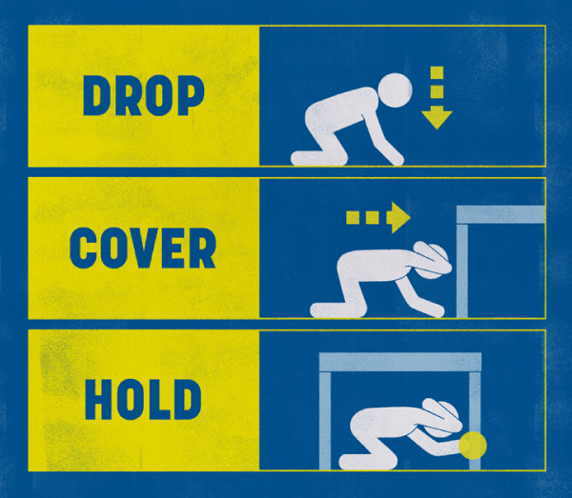
- DROP down on your hands and knees. This protects you from falling over but lets you move if you need to.
- COVER your head and your neck (or your entire body if possible) under a sturdy table or desk (if it is within a few steps of you). If there is no shelter nearby, cover your head and neck with your arms and hands.
- HOLD on to your shelter (or your position to protect your head and neck) until the shaking stops. If the shaking shifts your shelter around, move with it.

Keep yourself safe
During an earthquake, the biggest hazard is earthquake shaking, as it can lead to collapsing walls and roofs, and falling glass and objects. Many injuries are caused by people moving during or immediately after the shaking.
In a major earthquake, masonry and glass falls off buildings and into the streets. If you are inside, Drop, Cover and Hold – do not run outside or you risk getting hit by falling bricks or concrete and glass. You should only leave if the building is showing obvious signs of distress, or if you are in a tsunami evacuation zone. Read more about what to do during a tsunami here.
Do not try to stand in a doorway – in modern homes, doorways are no stronger than any other part of the structure and usually have doors that can swing and injure you.
Even after earthquake shaking stops, move with care as debris can cause further injuries.
If you are outside, move away from buildings, trees, streetlights, and power lines, then Drop, Cover and Hold. Stay there until the shaking stops.

If you are in bed
If you are in bed when the shaking starts, Stay, Cover, Hold: Stay in bed. Cover yourself by pulling the sheets and blankets over you. Hold your pillow over you to protect your head and neck.
You are less likely to be injured if you stay in bed.
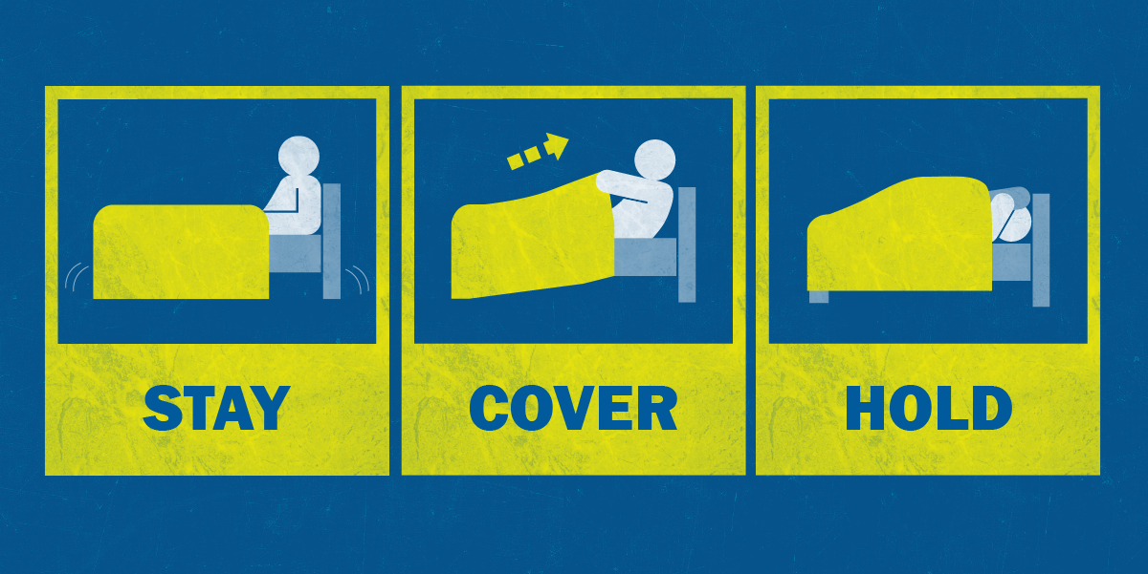

If you are inside a building
If you are inside a building, Drop, Cover and Hold. Stay indoors until the shaking stops and you are sure it is safe to exit. In most buildings in New Zealand, you are safer if you stay where you are until the shaking stops. Do not run outside after an earthquake.

If you are at mahi/work
If your wāhi mahi/workplace is in a tsunami evacuation zone and the earthquake is Long or Strong, move immediately after the shaking stops to the nearest high ground or as far inland as possible out of tsunami evacuation zones.
After the shaking stops, do a head count and work out if anyone’s unaccounted for. Check stairs and bathrooms. If you can, gather in one place.

If you are outside
If you are outside, find a clear area away from buildings, trees, streetlights, power lines, unstable slopes and cliffs: these may fall and cause injuries during an earthquake.
Drop and Cover: Drop down on your hands and knees and cover your head and neck with your arms. Stay where you are until the shaking stops.

People with a physical disability or mobility impairment
In a major earthquake, the ground shaking will make it difficult or impossible for you to move any distance.
If possible Drop, Cover and Hold.
If you cannot safely get under a table, move near an inside wall of the building away from windows and tall items that can fall on you.
If you have difficulty getting onto the ground, or cannot get back up again without the help of a caregiver, then follow these recommendations:
- If you are in a recliner or bed, Stay, Cover, Hold: Stay in bed. Cover yourself by pulling the sheets and blankets over you. Hold your pillow over you to protect your head and neck.
- If you are using a cane, Drop, Cover and Hold or sit on a chair or bed and cover your head and neck with both hands. Keep your cane near you so it can be used when the shaking stops.
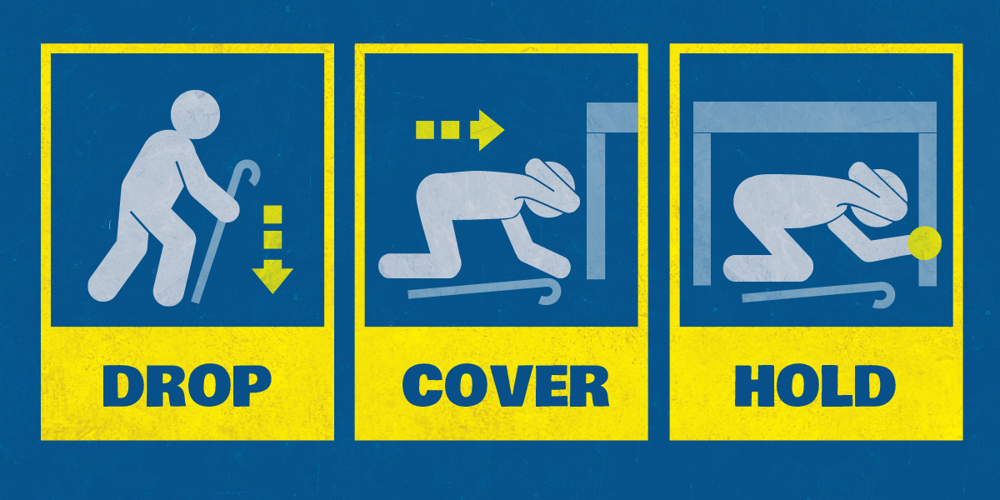
- If you are using a walker, Lock, Cover and Hold. Lock your wheels (if applicable). Carefully get as low as possible, bend over, and Cover your head and neck as best you can. Hold on until shaking stops.
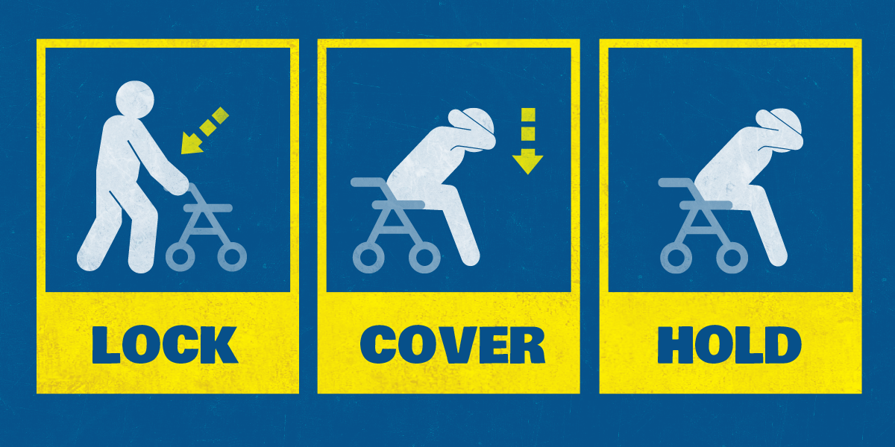
- If you are using a wheelchair, Lock, Cover, Hold. Lock your wheels. Bend over and Cover your head and neck as best you can. Hold on until shaking stops.
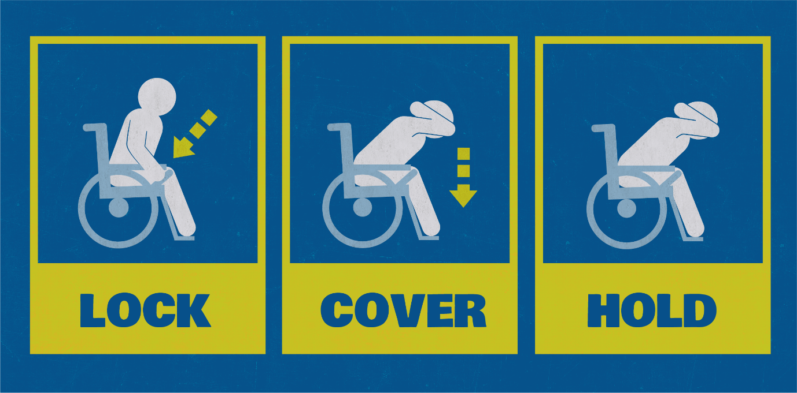
- If you are sitting in a chair, Stay, Cover, Hold. Bend over and Cover your head and neck as best you can. Hold on until shaking stops.

If you are driving
If you are driving, Pull Over and Wait.
- Pull over: to a clear location, away from trees, power lines, poles, street signs, overpasses, cliffs, and other overhead items, that may fall during earthquakes.
- Wait: stop and keep your seatbelt fastened until the shaking stops.
Once the shaking has stopped, proceed with caution. Avoid bridges, tunnels, cliff roads, ramps – any features that might have been damaged by the earthquake.
There may be more emergency vehicles on the road than normal. Make sure you allow them past as soon as it is safe to do so.
Listen to your car radio for advice from emergency services and your local Civil Defence Emergency Management Group.
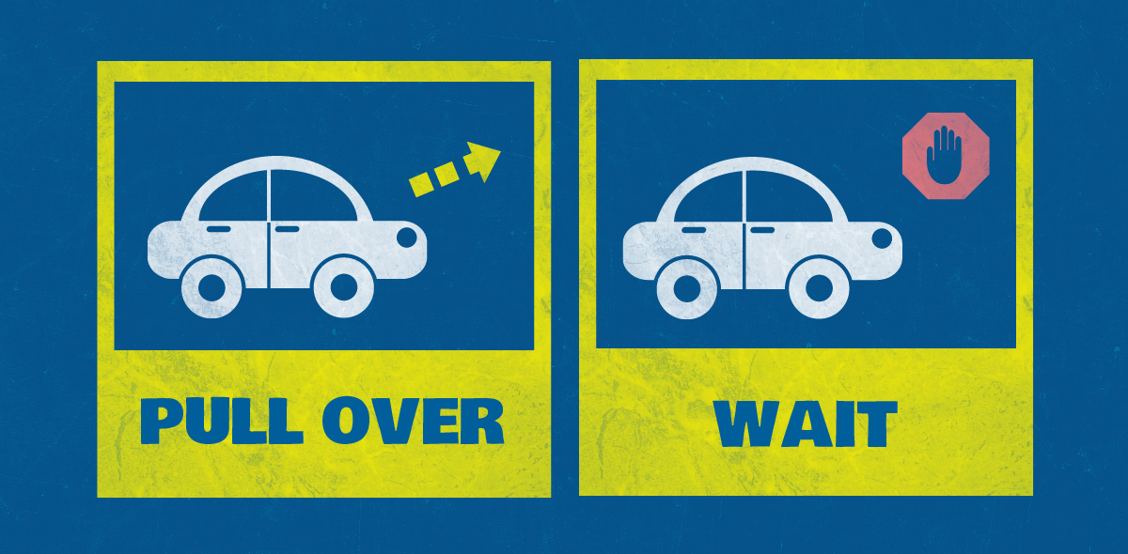

If you’re near a baby or a young child
Pick them up and hold them against your chest as you Drop, Cover and Hold.
If you can’t get under a table or piece of furniture, drop to the ground and protect the child with your body while doing your best to cover your own head and neck.
If you’re breastfeeding, stay seated or in bed, shielding your bodies with blankets or pillows.

If you’re in a separate room from a baby or young child
Your instinct will be to run to them – don’t. If you run or move during earthquake shaking you could be seriously injured. If you’re injured, you won’t be able to help.
Immediately Drop, Cover and Hold or Stay, Cover and Hold if you are in bed. If possible, call out to the child and tell them to Drop, Cover and Hold or Stay, Cover and Hold if they are in bed. Talk to them in a reassuring voice to alleviate panic and anxiety.
Stay where you are until the shaking stops. Move with care when you go to check on the child as debris can cause injuries

Long or Strong: Get Gone
Earthquakes can generate tsunami.
It is important to recognise the natural warning signs of a tsunami and remember, if an earthquake is Long or Strong: Get Gone.
- Learn more about what to do if you feel a long or strong earthquake.
- Learn more about tsunami.

What not to do: bad earthquake advice
You may find other information (not Drop, Cover and Hold) on the Internet about what to do in an earthquake. Much of it has been discredited and should not be followed.
Research from the United States, Taiwan, Japan and Christchurch (all places with modern, earthquake resistant building design codes), supports and recommends the core message for New Zealand: Drop, Cover and Hold is the right action to take in an earthquake.

As soon as the shaking stops
- Check yourself for injuries and get first aid if necessary. Help others if you can.
- If you are in a tsunami evacuation zone you need to move to higher ground immediately, or as far inland as you can, out of tsunami evacuation zones. You can read more about what to do during a tsunami here.
- Look quickly for damage around you, particularly in buildings where furniture and fittings may have become hazardous.
- Look for small fires and, if safe to do so, extinguish them.
- If you can, put on protective, weather appropriate clothing that covers your arms and legs and sturdy footwear in case you have to move through debris.
- If you are in a store, unfamiliar commercial building, or on public transport, follow the instructions of those in charge.
- If you are at mahi/work, gather information about your building (e.g. are the stairs to the ground level useable) and what is happening around your area and elsewhere in town. If practical, keep a register of who’s present, log when people leave and note what they plan to do next (e.g. fetch children from day-care, walk home etc.). Arrange to travel in groups.
- Do not run outside unless the building is showing obvious signs of distress, or you are in a tsunami evacuation zone. It is frightening to stay in a building, but it is much safer than immediately going outside, where masonry and glass could fall on you.
- Your usual fire evacuation assembly area might not be a safe location after an earthquake if it is exposed to falling glass and masonry.
- When you eventually leave, take your wallet, keys, and phone. You are more vulnerable if you leave those things behind. If you have a grab bag, take it with you.
- Avoid travelling through tsunami evacuation zones to return home.

Recovery: What to do after an earthquake

After a large earthquake
Expect aftershocks. Each time you feel one, drop, cover and hold. Aftershocks can occur minutes, days, weeks, months and years following an earthquake.
As soon as possible, seek advice on how to prevent further damage during aftershocks. A major aftershock can lead to further falling glass and masonry, which can cause harm to those standing in the street or moving through exposed areas.
Clean up hazardous debris as soon as it is safe to do so.
Find out what to do if your property is damaged.
Check out the Insurance section for more information on how your property might be covered following a hazard event.

Pets and other animals
Try to keep pets calm and under control so that they don’t try to run away. Keep leashes and pet-carrier boxes handy. Pets may become disoriented, particularly if the earthquake has affected scent markers that normally allow them to find their way home. Make sure they have plenty of water.
If farming, check livestock have access to fresh water as well as their general welfare. Check fences to ensure livestock are secure.
Be aware that the behaviour of pets and livestock may change dramatically after an earthquake and they may become more aggressive or defensive.
- Advice about caring for your pets and other animals after an emergency is available on the Ministry for Primary Industries website.

Flood

Key messages about floods
- Floods are New Zealand’s number one hazard in terms of frequency, losses, and declared Civil Defence Emergency Management emergencies.
- The best thing you can do to protect yourself and your whānau is get ready. Make and practise your emergency plan, make a grab bag and have emergency supplies in case you need to evacuate.
- Your regional council will be able to tell you about the flood risk is in your area, and may be able to provide information and resources to reduce potential damage.
- Stay up to date with the latest weather information from MetService, Te Ratonga Tirorangi, New Zealand’s National Weather Service. Pay attention to Watches and Warnings which are also available on the MetService mobile app.
- Put safety first. Don’t take any chances. Act quickly if you see rising water.
- Never try to walk, swim, drive through or play in flood water.
- Listen to the radio for updates and check the websites of your Regional Council and your local Civil Defence Emergency Management Group. Follow any instructions from local Civil Defence authorities or emergency services regarding evacuation of your area.
- If you have been evacuated, it may not be safe to return home even when the floodwaters have receded. Listen to emergency services and local Civil Defence authorities and don’t return home until they tell you it is safe to do so.
- Stay away from damaged areas. Your presence might hamper rescue, obstruct other emergency operations and put you at further risk.
- If your whare/home has been affected, it is important to clean and dry your house and everything in it and protect yourself while you do it. Floodwater may contain sewage and other hazardous materials which can contaminate your whare/home.
- Ensure you contact your utility suppliers if your utilities have been affected by water or debris (e.g. contact your gas supplier if your gas meter has been affected).

Floods
A flood is when water covers land that is normally dry. Floods are usually caused by heavy or prolonged rainfall, but can also occur due to landslides triggered by heavy rainfall or earthquakes, failure of dams, high sea levels at river mouths, coastal storm inundation, and tsunami.
Floods happen frequently in New Zealand and can cause a lot of damage to buildings and lifeline utilities, as well as injuries and loss of life.
Flooding may be caused by rainfall some distance away. Many of New Zealand’s rivers are quite long, and heavy rain in the upper part of their catchments can result in flooding a long way downstream.

Types of flooding
There are different types of flooding:
- River flooding generally happens during heavy rain, when rivers overflow their banks into the floodplain. A floodplain is the flat section next to a river, and these can flood quite regularly. Normal rainfall soaks into the soil, is taken up by trees and plants, and runs off the land to form our streams and rivers. Floods happen when there is too much water and the run-off is too much to be carried by the rivers.
- Surface flooding can happen when heavy rain falls either in a small area or in an urban area with lots of hard surfaces that stop rainwater from soaking into the ground. Usually, surface flooding starts quickly but doesn’t last very long. It is often associated with thunderstorms and short, intense rainfall.
- Groundwater flooding can happen during periods of unusually high rainfall, when the rising water table causes water to rise out of the ground. Groundwater flooding can bubble up and start flowing along the surface, and can also rise up directly in homes.
- Flash floods occur rapidly. They are usually the result of intense rainfall which overwhelms natural or urban drainage systems, and they usually affect small areas. Flash floods often appear as a torrent, can carry rocks, mud and other debris, and can sweep away most things in their path.
- Storm surges are produced when high winds push water onshore. They can cause beach erosion and threaten life and property. Storm surges are most common at the coast, where severe weather can cause extreme tides. Storm surges can also happen at large lakes.

Flood hazards
Floods are New Zealand’s number one hazard in terms of frequency, losses, and declared Civil Defence Emergency Management emergencies. They can cause property and land damage, injury and loss of life.
- Floodwaters can damage buildings, land, and lifeline utilities, including roads, bridges, power lines and phone lines. Crops can be destroyed and livestock drowned.
- Fast-flowing water is often filled with debris, and it is strong enough to sweep people away. Floodwater can even be strong enough to pick up vehicles.
- Dangerous chemicals and biohazards can enter floodwater from the ground surface, septic tanks and sewage systems. This can contaminate drinking water, land and any surfaces it touches.
- Flooding can cause major damage to houses, and families can face months away from home while their homes are being repaired.
- The majority of flood deaths are vehicle-related – caused by driving through flood water or attempting to move a stranded vehicle. As little as 30 centimetres of water can cause you to lose control of a vehicle, including SUVs. The depth of the water is not always obvious, stopping you from seeing hazards like potholes or washouts. Rapidly-rising water may stall the engine, engulf the vehicle and you and the vehicle can be quickly swept away by rapidly-rising water.
If you live in a flood-prone area, the best thing you can do is prepare yourself, your whare/home and your whānau/family. Floods can cause major disruption to whānau/family life – you might have to leave your whare/home and you could lose some or all of your possessions - and the emotional impact can be profound. But there are things you can do to reduce the risk and ensure you are prepared.

Reduction: Reduce the impacts of floods
First, find out what the flood risk is in your area. Your regional council can provide you with maps and may have additional resources and information.

Reduce potential flood damage
If you own a house or another building in a flood-prone area, take steps to reduce potential flood damage:
- Install non-return valves in drainage pipes, to prevent sewage backing up into the house.
- Reduce water ingress:
  - Fit water-resistant door and window frames
  - Install ready-made flood defences, such as flood barriers
  - Use waterproof sealant on external walls
- On your property’s ground floor, avoid fitted carpets, wooden skirting boards and normal (non water-resistant) plaster. These will be damaged by floodwater and will need replacing. Choose instead ceramic tiles for floor covering and skirtings, and water-resistant lime plaster or cement render and water-resistant paint on internal walls.
- In kitchens and bathrooms, raise cupboards up on stilts, so that water can flow beneath them. Avoid chipboard or MDF units, which will be damaged by floodwater – install stainless steel, plastic or marine plywood kitchen and bathroom units, which can be wiped down after flooding.
- Raise the height of electrical sockets to at least 1.5 metres above ground floor level, to prevent floodwater damage.
- Position any main parts of heating or ventilation systems upstairs or raised well above ground level.
- Purchase a portable pump, or install an automatic pump, to remove flood water. Pumps can keep the floodwater level low inside.

Readiness: Get prepared to respond to floods
Make and practise your emergency plan, make a grab bag and have emergency supplies in case you need to evacuate.
Find out from your regional council what the flood risk is in your area and know how to stay informed.
Stay up to date with the latest weather information from MetService, Te Ratonga Tirorangi, New Zealand’s National Weather Service. Pay attention to Watches and Warnings.
Beef + Lamb New Zealand have a flood preparedness fact sheet for farmers with immediate and long-term strategies to increase their farm flood readiness.

Response: What to do during a flood
Put safety first. Don’t take any chances. Act quickly if you see rising water.
Floods and flash floods can happen quickly. If you see rising water, do not wait for official warnings. Head for higher ground and stay away from floodwater.
Do not try to walk, play, swim, or drive in floodwater: even water just 15 centimetres deep can sweep you off your feet, and half a metre of water will carry away most vehicles. Flood water is often contaminated and can make you sick.
Help others if it is safe to do so, especially people who may require special assistance.

If flooding is possible in your area
Be ready to act quickly. Floods and flash floods can happen quickly and without warning.
Be prepared to evacuate and keep your grab bag close.
Leave mobile phones on and charged so you can receive Emergency Mobile Alerts.
Listen to the radio for updates, and check the websites of your Regional Council and your local Civil Defence Emergency Management Group.
Many Regional Councils have systems for contacting rural landowners whose properties are close to monitored waterways.
Listen to emergency services and local Civil Defence authorities and follow any instructions regarding evacuation of your area.
Get your whare/home or business ready:
- Move valuable and dangerous items, including electrical equipment and chemicals, as high above the floor as possible. Use watertight containers to store important items.
- Lift curtains, rugs and bedding off the floor.
- Secure outdoor possessions including outdoor furniture and trampolines that can be swept away in floodwaters.
- Clear debris and leaves from external drains and gutters.
- Take photos of your ground floor rooms and outdoor areas, for insurance purposes.
- If you can, attach sheets of waterproof plastic around exterior doors using duct tape.
- Consider using sandbags to keep water away from your house or other buildings.
- Move vehicles to higher ground, or park vehicles in garages, if you can.
Help neighbours who may need assistance.
If you have been evacuated, it may not be safe to return home even when the floodwaters have receded. Listen to emergency services and local Civil Defence authorities and don’t return home until they tell you it is safe to do so.

Protecting pets and other animals
Bring your pets indoors as soon as possible. Ensure you keep control of your pets.
Confine pets to one room. Pets may try to run if they feel threatened. Keeping them inside and in one room will allow you to find them quickly if you need to leave.
Get pet carrier boxes and leashes ready.
Where possible, move livestock to higher ground.
Take your pets with you when you evacuate – if it is not safe for you, it is not safe for them. Leaving them behind may endanger you, your pets, and emergency responders.
Consider an early evacuation of pets and other animals. Waiting to evacuate animals until the last minute can be fatal for them and dangerous for you.

Using sandbags
Sandbags can be used to divert water away from your house or other buildings. They can be used to block doorways, drains, and other openings into properties, as well as to weigh-down manhole covers, garden furniture, and to block sink, toilet, and bath drains, to prevent water backing up.
Sandbags require time and effort to fill and place, so they need to be filled and placed in advance of flooding, rather than in the middle of a flood or a storm. They also won’t stop water coming from under a house, through floorboards or other access points.
If you don’t have sand, any fine material including soil can be used. You can also use pillowcases as makeshift sandbags.
Filling the bags:
- Fill bags with sand or any other fine material. Don’t use gravel or rocky soils as they will let the water through.
- It’s easiest if two people are involved - one to hold the bag and the other to shovel the sand in.
- Only fill bags to half or two-thirds full. This gives the sand room to expand as it absorbs the water.
- Don’t tie or seal the bag when you put it in place, fold the flap into a triangle and tuck it under the bag.
Placing the bags:
- Clear any debris from the area where the bags will be placed.
- If you can, put a large sheet of heavy-duty waterproof plastic between the sandbags and the building or surface.
- Place your first row of sandbags lengthwise and flat to the ground, butting each end to the next, folding the open end of the sandbag underneath.
- Place bags in layers like a brick wall, overlapping each row. Place the second row of sandbags on top staggering the joints.
- Stamp bags firmly into place to eliminate gaps and create a tight seal.
- Bags can be placed like this to a height of three layers, if further height is required, place sandbags behind to add strength to your wall.

During a flood

Stay out of flood water
Never try to walk, swim, drive through or play in flood water.
Many flood deaths are caused by people attempting to drive through water, or people playing in high water.
Slow-flowing, deep water or fast-flowing, shallow water, can unbalance people and sweep them away. Even water just 15 centimetres deep can sweep you off your feet.
Keep children away from flood waters. It is not safe for them.
Do not put yourself at risk to take photos or videos of the flood.
Always assume that all flood water is contaminated with farm run-off, animal and human sewage and chemicals. Flood water may also be electrically charged from underground or downed power lines.
If you come in contact with floodwater, thoroughly clean hands, clothes and any property touched.

If you are driving
Never try to drive through flood waters. Most deaths from floods are vehicle related.
If you come to a flooded area, turn around and go another way. Avoid already flooded areas, and areas subject to sudden flooding. Do not attempt to cross fords, flowing streams or water-covered roads.
If your vehicle stalls during a flood, abandon it immediately and climb to higher ground. Many deaths have resulted from attempts to move stalled vehicles.
Driving through water also puts other people’s lives and properties at risk. Driving through floodwater causes waves which can wash into other vehicles, other people’s property and over pedestrians.

Recovery: What to do after a flood
Remember that if you have been evacuated, it may not be safe to return home even when the floodwaters have receded. Listen to emergency services and local Civil Defence authorities and don’t return home until they tell you it is safe to do so.
Stay up to date with the latest weather information from MetService, Te Ratonga Tirorangi New Zealand’s National Weather Service,. Check to see if further severe weather or flooding is possible.
Stay away from damaged areas so that rescue and emergency operations can continue. You will also avoid further risk from the residual effects of floods, such as contaminated water, damaged roads, landslides, mudflows, and other hazards.
Look before you step. After a flood, the ground and floors are covered with debris, including broken bottles and nails. Floors and stairs that have been covered with mud can be very slippery.
- Find out what to do if your property is damaged.
Check out the Insurance section for more information on how your property might be covered following a hazard event.

Cleaning up after a flood
It is important to clean and dry your house and everything in it. Floodwater may contain sewage and other hazardous materials which can contaminate your whare/home.
If your gas meter has been affected by water or debris, contact your gas supplier. Always work safely when cleaning up after a flood:
- Protect yourself by wearing a properly fitted P2- or N95-rated mask, goggles, gloves, long pants, long-sleeved shirt, and gumboots or work shoes.
- Cover any open cuts, scratches, grazes and wounds with waterproof plasters or dressings.
- Always wash your hands thoroughly after each clean-up session and before handling food.
Wet furniture and surfaces get mouldy after a couple of days, making the air in your whare/home unhealthy. Mould may make some people with asthma, allergies, or other breathing problems sick.
- Talk to your doctor or another medical professional if you have questions about cleaning or working in a whare/home that has been flooded.
- If there is a large amount of mould, you may want to hire professional help to clean up the mould.
Make your whare/home safe and sanitary, but don’t do non-essential repairs. Learn about making temporary repairs that are needed quickly here.
Keep children and animals away from previously flooded areas until they have been cleaned and made safe.
Follow advice and instructions from your local council and your local Civil Defence Emergency Management Group.
Take photos and videos of the damage and anything that needs to be thrown away before starting the clean-up, for insurance purposes.

Cleaning up inside
- Clean up, drain, and dry inside as quickly as possible. Take out everything that is wet and that can be moved – floor coverings, furniture, bedding, clothing, etc., and put them outside to dry when the weather is fine.
- Check for trapped water and mud in wall cavities, as well as under shower trays, baths, benches and bottom shelves. You may have to chisel out some bricks at the bottom of brick veneer walls.
- Open all doors and windows, and use heaters (e.g., hot air blowers for under-floor space). Do not use outdoor gas appliances, such as patio heaters, indoors.
- Do not light fires in brick fireplaces for at least 2 weeks, and then use only small fires until the firebricks have dried out.
- Consult an engineer if there are signs that the house has moved on its foundations. Signs can include buckled floors, new cracks in walls, or out-of-shape door frames.
- Remove skirting, if necessary, and cut out softened plaster board in damaged areas. Consult an expert such as an insurance assessor or builder.
- Replace wall linings and floor coverings only after the building is completely dry.
- Leave redecorating for at least 3 months after finishing the repairs, to prevent risk of mould, blistering, and peeling.
If you have insurance, contact your insurer to lodge a claim and understand how they can help. They may undertake some of these steps for you as part of your claim.

In the kitchen
Discard wooden items such as chopping boards and spoons, plastic utensils, and baby bottle teats and dummies, if they have come into contact with floodwater. There is no way to safely clean them.
Clean any other cooking, eating and kitchen utensils that have come into contact with floodwater:
- Wash in hot soapy water.
- Rinse thoroughly in safe water, then disinfect by immersing for 1 minute in a solution of 500 ml (about 2 cups) of plain, unperfumed, household bleach in 10 litres of water.
- Rinse again in safe water.
- Alternatively, boil all utensils for 1 minute and let cool.

In bedrooms and living rooms
You will need to throw away mattresses and other large items that have been soaked with floodwater. Foam rubber mattress or pillows may be able to be washed, disinfected and dried in the open air.
Get rid of contaminated clothing, carpets, upholstered furniture, toys and bedding, unless they can be cleaned and disinfected.

Cleaning up outside
First clear the access to the building – the rest of the section can come later. It’s easier to clean up outside once the outside has dried naturally, too.
Use a shovel to remove surface contamination. Place it at the edge of your section, ensuring it doesn’t block drainage channels. If you need assistance with disposing of flood debris, check with your local council to see if they have arrangements for flood debris disposal.
The best way to make your outside areas safer is to rely on natural processes such as sunlight, drying and wind. Leave garden surfaces and lawns exposed to the air and sunshine to dry out naturally. Make drainage holes with a fork to aerate.
- If the outside area is heavily contaminated with sewage, use garden lime to disinfect the area. Garden lime can be bought from a garden shop. Follow the instructions on the label.
- Hard surfaces, such as driveways, can be cleaned and disinfected with 1 litre of household chlorine bleach in 10 litres of cold water (a household bucket). Leave the disinfectant on for 30 minutes, then rinse with clean water.

Food safety
Floodwater can carry bacteria that can contaminate food.
Throw away all food and drinking water that has come in contact with floodwater, including things stored in containers. It is impossible to know if containers have been damaged and the seals compromised.
Do not eat garden produce if the soil has been flooded. Clean up and remove debris and sprinkle gardens with lime.
Avoid drinking or preparing food with tap water until you are certain it is not contaminated. Follow any boil water notice instructions from your local authorities.
- Advice about food safety after a flood is available on the Ministry of Health website.

Landslide

Key messages about landslides
- Landslides occur when sloping ground becomes unstable and rock, soil or vegetation fall down a slope.
- Landslides are commonly classified by the material involved (e.g., rock, debris, soil or mud) and the way they move (e.g., fall, topple, slide, spread, or flow)
- Landslides cause more deaths than any other geological hazard in Aotearoa New Zealand. They can cause significant damage to buildings, roads and other infrastructure. They can also dam rivers and if the dam fails, this can result in flooding downstream.
- The impacts of landslides can be reduced by land use planning, avoiding building on or near unstable land, strengthening the site through engineering solutions and carefully monitoring land for signs of movement.
- Although landslides may be triggered by a number of factors, they are most often triggered by earthquakes and heavy rain.
- If a landslide occurs – or you see any signs that the ground is unstable – evacuate immediately. If lives are in danger dial 111. Otherwise, seek advice from your local council once you are in a safe location.
- Reduce your personal risks – after heavy rainfall, don’t drive unless absolutely necessary and stay away from areas where landslides have occurred previously.
- Seek expert advice from a chartered professional geotechnical engineer if you are planning on excavating or building on steep slopes or believe the site may be affected by landslides.
- Make and practise your emergency plan, have a grab bag and emergency supplies.
- If you learn or suspect that a landslide is occurring or is about to occur in your area: Evacuate immediately, away from the potential slide area if it is safe to do so. Getting out of the path of a landslide or debris flow path is your best protection.
  - If you are in a property that could be or is being impacted by landslide debris move to the side of the house furthest from the landslide. This is likely to be the safest location within the property.
  - Take your pets with you, and move livestock to safe paddocks, if you can do so without endangering yourself.
  - Alert your neighbours. They may not be aware of the potential hazard. Advising them of a threat may save their lives. Help neighbours who need assistance to evacuate if you can do so without putting yourself in danger.
- During a severe storm:
  - Stay up-to-date with the latest weather information from MetService, Te Ratonga Tirorangi, New Zealand’s National Weather Service. Pay attention to heavy rain warnings. Short bursts of heavy rain may be particularly dangerous, especially after longer periods of wet weather.
  - Be especially alert when driving. Embankments along roadsides are particularly susceptible to landslides. Watch the road for collapsed areas, mud, fallen rocks, and other indications of a possible debris flow.
- Following a landslide, stay away from the landslide area. Further landslides may occur.

Types of landslides and their processes
A landslide is the movement of rock, soil and/or vegetation, down a slope. There are many different types, and they can range in size from a single boulder in a rock fall, to a very large avalanche of debris with huge quantities of rock and soil that spreads across many kilometres. They are common in both rural and urban settings.
Landslides are commonly classified by the material involved (e.g., rock, debris, soil or mud) and the way they move (e.g., fall, topple, slide, spread, or flow). All these types of landslides may occur in New Zealand. Listed below are some classical examples of different landslide types.
- Rockfall - individual rocks that detach and rapidly fall from steep slopes and cliffs.
- Debris Avalanche - a shallow flow of rock and debris that detach from steep slopes and cliffs fall from steep slopes and cliffs to form an avalanche. The landslides that blocked SH1 after the Kaikoura Earthquake are a classic example of debris avalanches
- Debris Flows - rapid surging flows of saturated debris that occur in channels. They are often triggered by heavy rainfall or rapid snowmelt. A debris flow devastated Matatā on the 18th May 2005.
- Slides - landslides that occur when a zone of weakness separates the slide material from more stable underlying material. They can be rotational or translational. The slow moving Tāhunanui Slump in Nelson is an example of a rotational slide.
Landslides can occur without any trigger but are most commonly associated with heavy rainfall (like the landslides generated during Cyclone Gita in 2018) and earthquakes (like the landslides that impacted SH1 triggered by the 2016 Kaikōura earthquake). Human activities including mining, construction, removal of trees and vegetation, steep roadside cuttings or leaking water pipes can also cause or increase the likelihood of landslides.
Some landslides move rapidly, while others are slow and gradual, causing damage to property and infrastructure, but rarely injuring people. The Taihape Landslide is an example of a slow-moving landslide.
More information on landslide types and processes is available in this USGS fact sheet.

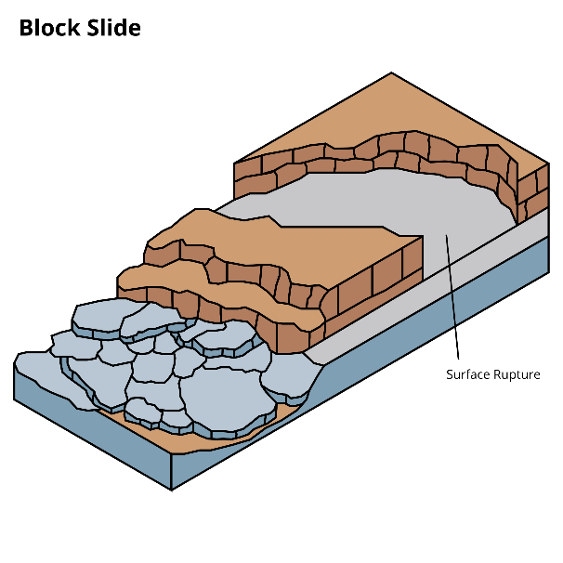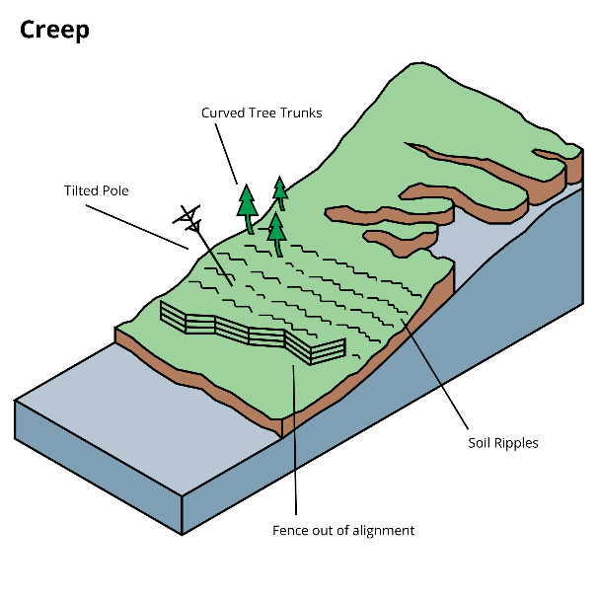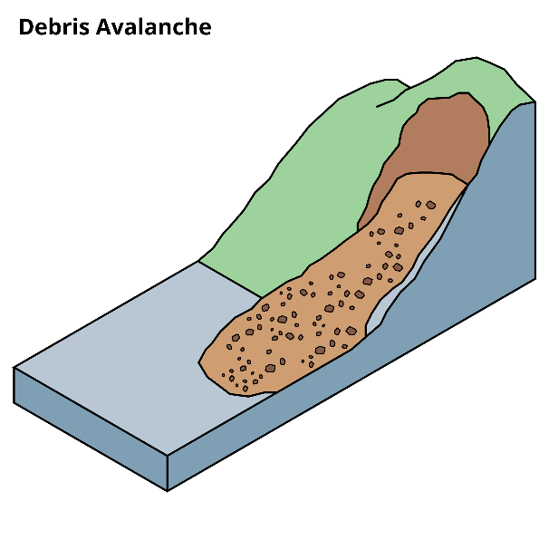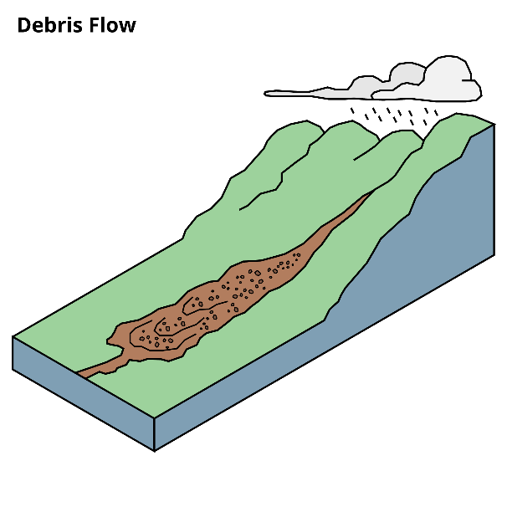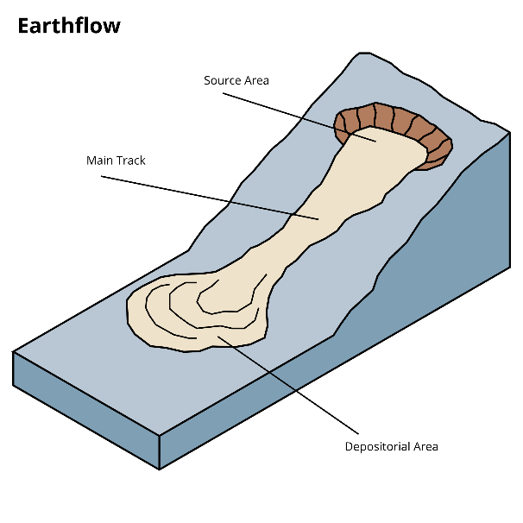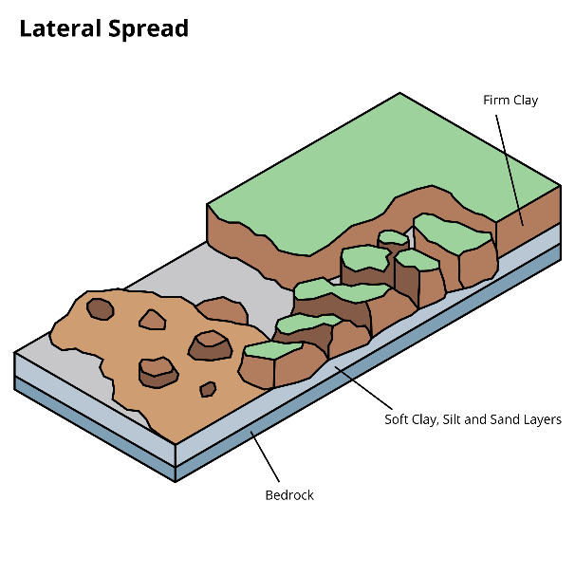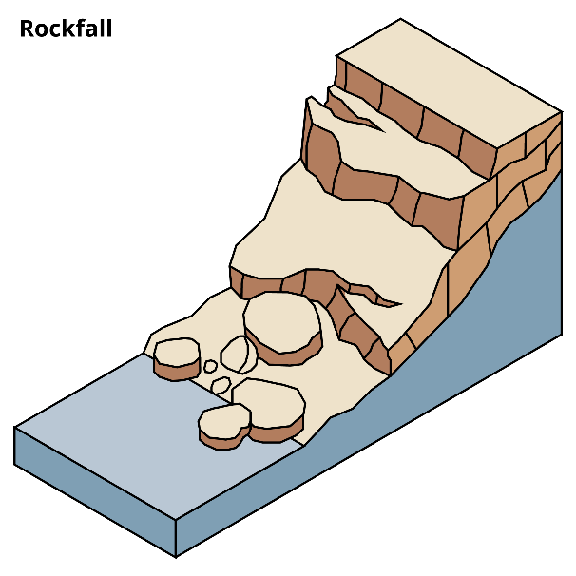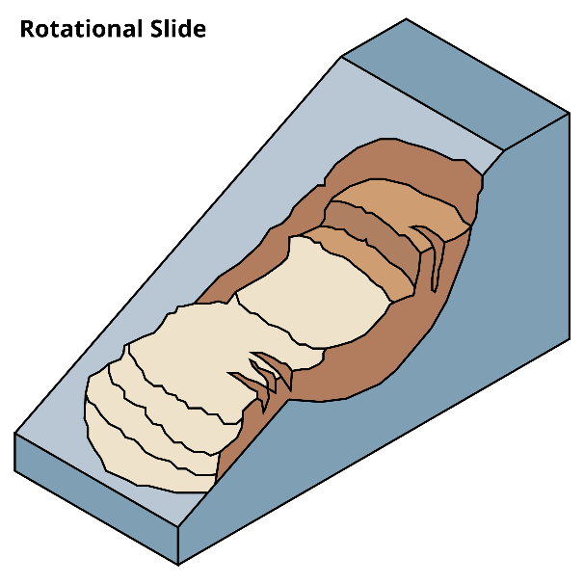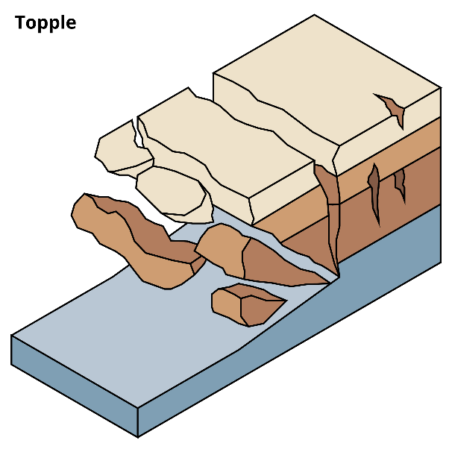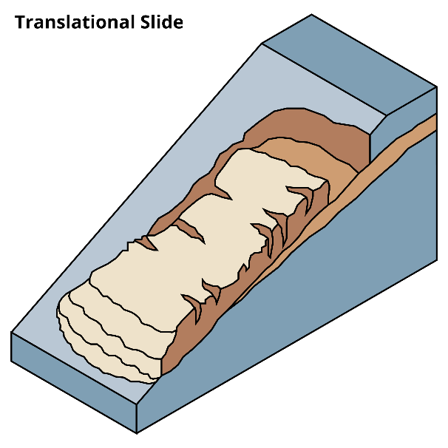

Landslide hazards
Landslides cause more deaths than any other geological hazard in New Zealand. There have been around 1800 deaths from slips over the past 160 years, more than from earthquakes or tsunami. On average, three people die each year from landslides in New Zealand.
Landslides are also an incredibly destructive force. They damage houses, land and infrastructure – and the clean-up and recovery can be very expensive.
In addition, landslides can create secondary hazards:
- If landslides block streams and rivers, they can dam the water ways. This may lead to the development of lakes upstream of the dam, and these dams can fail rapidly, releasing flood waters down catchments.
- Landslides that fall into water bodies, such as lakes, fiords and the sea can also generate local tsunami waves.
Landslide hazards can be divided into two broad categories: slippage and landslide runout:
- Slippage is the movement or loss of land from a slope when a landslide occurs beneath it (the landslide source area)
- Landslide runout is the inundation of an area by rock, debris, soil and other material that is travelling downslope from the landslide source area. This debris inundation can crush cars, building, people and move heavy objects.
The hazard associated with landslides is determined by the type of landslide that occurs together with its size, travel distance (runout) and speed of movement. Rapid landslides can result in a loss of life and property damage as there is not enough time to evacuate and get out the way. Slow moving landslides may not present a threat to life but can affect many properties and cause significant damage to property and assets. Slow moving landslides can transition into more rapid landslides under certain conditions.
As with any emergency, landslides cause an emotional toll. It can take a long time to restore homes and infrastructure, and in some cases property has had to be abandoned. If you live in an area that’s prone to slips, getting together with your friends, whānau and community and making a plan will help you understand the warning signs, and learn what to do if a landslide event happens.

Reduction: Reduce the impacts of landslides
Some areas are at a higher risk of landslides – including areas with existing old landslides, steep slopes, drainage channels on steep slopes, stream and riverbanks, or coastal cliffs.
- The best option is not to build or develop on unstable or hazardous/higher risk sites. Seek expert advice from a chartered professional geotechnical engineer if you are planning on excavating or building on steep slopes or believe the site may be affected by landslides. Council Land Use Planning plays an important part in this.
- Be aware that landslides on another property could affect you – for example, if you are in the path of a landslide runout.
- Find out from your council if they have information on landslide hazard and risk, if there have been landslides in your area before, and where they might occur again.
- Areas that are prone to landslide often include existing (old) landslides, steep slopes, streams or riverbanks or coastal cliffs.
- If you have a slope on your property, check drains are clear and adequate, and that retaining walls are in good condition.
- Learn the warning signs for unstable ground:
  - Small slips, and rockfalls.
  - Subsidence at the bottom of slopes.
  - Doors and window frames that start to stick, or gaps developing around them.
  - Outside fixtures like steps, decks and verandahs moving or tilting away from your house.
  - New cracks or bulges on the ground, road or footpath.
  - Trees, retaining walls or fences that start to tilt.
- Be alert when driving, especially where there are embankments along roadsides. Watch the road for collapses, mud and fallen rocks.
- Review your insurance regularly.

Readiness: Get prepared to respond to landslides
Make and practise your emergency plan, have a grab bag and emergency supplies.
Regularly inspect your property, especially after long dry spells, earthquakes or heavy rainfall.
- Look for signs of instability: doors and windows that start to stick, gaps appearing, decks moving or tilting away from the house, new cracks or bulges on the ground, leaning trees or fences, slope movement, etc.
- Watch the land around where you live for signs of increased threat. Look at the hillsides around your home for any signs of land movement (like rockfall, small landslides or debris flows) and any trees that start to “tilt” over time.
- Watch the patterns of storm water drainage on slopes near your home, and especially the places where runoff water converges, increasing flow over soil-covered slopes. Noticing small changes can alert you to an increased threat of a landslide.
If you notice any of these changes, seek professional advice as soon as possible. There may be some problems you can fix yourself, but many will require expert help.
Other things you can do:
- Keep gutters, downpipes and drains free of dirt, leaves and other blockages. Trim back or remove vegetation blocking drains and gutters.
- Inspect swimming pools regularly for leaks.
- Regularly empty septic tanks.
- Check retaining wall drainage for blockages and water build-up behind the wall.
- Regularly check and clear drains.

Response: What to do if you think a landslide is about to happen

Recognise the warning signs and act quickly
Landslides can occur without any warning signs. Be aware of the potential for landslides, particularly in the weeks after potential triggering events, such as heavy rainfall, earthquakes, and previous landslides.
Some warning signs before landslides occur:
- Small slips, rock falls, and sinking land, at the bottom of slopes.
- Sticking doors and window frames, which may mean the land is slowly moving under the house.
- Gaps where window frames are not fitting properly.
- Steps, decks, and verandas, moving or tilting away from the rest of the house.
- New cracks or bulges on the ground, road, footpath, retaining walls and other hard surfaces.
- Tilting trees, retaining walls, or fences.
If you see a landslide, move quickly out of its path and stay away from it. It is important to recognise the warning signs and act quickly.
If you learn or suspect that a landslide is occurring, or is about to occur in your area:
- Evacuate immediately if it is safe to do so. Seek higher ground outside the path of the landslide. Getting out of the path of a landslide or debris flow path is your best protection.
- If you cannot leave safely, move out of the path of the debris. The side of your house furthest from the landslide is likely to be the safest location within the property.
  - Take your pets with you, and move livestock to safe paddocks, if you can do so without endangering yourself.
- Alert your neighbours. They may not be aware of the potential hazard. Advising them of a threat may save their lives. Help neighbours who need assistance to evacuate if you can do so without putting yourself in danger.
- Contact your local council or technical expert. Local council engineers or other geotechnical engineers are the people best able to assess the potential danger.

What to do if a landslide occurs
If you see a landslide, move quickly out of its path and stay away from it.
If lives are in danger, evacuate immediately and dial 111. Alert your neighbours if you can do so safely. If you can’t get outside, move away from the slide area and dial 111. Stay away from the landslide area. Further landslides may occur.
Check for injured and trapped persons and animals near the landslide, without entering the landslide area. Direct rescuers to their locations.

What to do during severe storms
During a severe storm, if you are in an area susceptible to landslides, you should:
- Evacuate if you can - move to higher ground and out of the path of potential landslides. Staying out of the path of a landslide can save your life.
- If you cannot evacuate, move to an upper floor in your whare/home, or the side furthest from the potential slide area. This is likely to be the safest location within the whare/home.
- Stay up-to-date with the latest weather information from MetService, Te Ratonga Tirorangi, New Zealand’s National Weather Service. Pay attention to heavy rain warnings. Short bursts of heavy rain may be particularly dangerous, especially after longer periods of wet weather.
- Watch for signs of slope movement, such as:
  - small slips, rock falls, subsidence or bulges at the bottom of slopes
  - cracks in the ground, plaster, brick work, tiles, foundations, retaining walls, driveways and other hard surfaces
  - tilting trees, walls or fences
  - building movement, such as doors or windows that stick or jam
  - outside fixtures, such as steps, that are pulling away from buildings.
- If you are near a stream or waterway, be alert to any sudden increase or decrease in water flow, and to a change from clear to muddy water. Such changes may indicate landslide activity upstream, so be prepared to move quickly. Save yourself, not your belongings.
- Be especially alert when driving. Embankments along roadsides are particularly susceptible to landslides. Watch the road for collapsed areas, mud, fallen rocks, and other indications of a possible debris flow.
- Ensure livestock are in safe paddocks if there is heavy rain. Consider precautionary evacuation of livestock if you believe there is a risk of landslide.

Recovery: What to do after a landslide
Further landslides may occur, so stay away from the affected area.
Look for broken utility lines (power, telephone) and report them to appropriate authorities. Reporting potential hazards will get the utilities turned off as quickly as possible, preventing further hazard and injury.
- What to do if your property is damaged
The Earthquake Commission Act 1993 may provide residential property owners EQCover for damage caused by landslides to residential properties, outbuildings, land within eight metres of buildings and outbuildings, access-way land, and a range of other structures and utilities. Toka Tū Ake EQC has partnered with insurers to provide a single point of contact for residential insurance customers. You should contact your insurer to make a claim for damage from natural hazards. Full details are available at eqc.govt.nz.

Storms and severe weather

Key messages about storms and severe weather
- Make and practise your emergency plan, make a grab bag and have emergency supplies.
- Stay up to date with the latest weather information from MetService, Te Ratonga Tirorangi, New Zealand’s National Weather Service. Pay attention to Watches and Warnings.
- If severe weather is coming, Severe Weather Outlooks, Watches and Warnings are issued by MetService . They are available through radio, television, the MetService website and mobile app, by registering for email, via radio and television, also on social media from @MetService on Facebook and Twitter.
- Listen to advice provided by your local Civil Defence Emergency Management Group and emergency services and follow any instructions.
- Postpone outdoor activities if a storm is imminent.
- If you hear distant thunder or see a flash of light, get indoors immediately.
- If you live in a coastal area, follow the instructions and advice of Civil Defence Emergency Management authorities to find out if you are required to evacuate. Local authorities are the most informed about areas most likely to experience coastal inundation and will inform you if an evacuation is required.
- If you see a tornado funnel nearby, take shelter immediately.
- If there is surface flooding in your area and you see rising water, do not wait for official warnings. Head for higher ground and stay away from floodwater.
- Never try to walk, play, swim or drive in floodwater.
- Following an event, listen to advice provided by your local Civil Defence Emergency Management Group and emergency services and follow any instructions.
- Continue to stay up to date with the latest weather information from MetService in case of extended severe weather.

Types of storm
A storm is a weather system with strong winds and is likely to cause heavy rain. It can also bring hail, lightning, tornadoes, heavy swells, coastal inundation and storm surges.
Storms can make driving dangerous. They can also cause road damage, power supply disruption and damage to buildings. As a result, storms can isolate communities and cut off communications and power supply.
Storms can last for days or can be short-lived. Thunderstorms typically exist for no more than one or two hours but can cause significant damage.
A tornado is a narrow, violently rotating wind column, extending downwards to the ground, from the base of a thunderstorm. Every year, a few tornadoes are observed in New Zealand.
Compared with the tornadoes that occur over the Earth’s major continents, tornadoes in New Zealand are generally small, but they can still cause severe localised damage, injuries and death. They are usually around a few tens of metres wide, have tracks a few kilometres long, and exist for just a few minutes.
A tropical cyclone is a large storm that develops in the Tropics. They are also called hurricanes or typhoons in the northern hemisphere. A tropical cyclone has a sustained wind-speed of at least 63 kilometres per hour, but a severe tropical cyclone has winds of 120 kilometres per hour or more. Wind gusts can be much stronger, causing extensive damage.
Tropical cyclones usually change as they meet the cooler sea temperatures around New Zealand, so they are not classified as tropical cyclones by the time they reach our shores. These “ex-tropical cyclones” remain dangerous storms and can cause major damage affecting large parts of New Zealand.
Learn more about tropical cyclones and warnings issued by MetService on the MetService website.

Storm hazards

Heavy rain
Heavy rain can cause stream and river levels to rise, leading to dangerous, fast-flowing currents. Rain can lead to landslides and flooding. High river levels with strong currents can cause flooding and destroy bridges.

Storm surges, heavy swells and large waves
During storms, New Zealand’s low-lying coastal areas are particularly vulnerable, especially when high tides, storm surges and/or heavy swells/large waves occur at the same time.
Potential consequences of large waves include:
- Inundation/flooding.
- Overtopping, where waves spill over a seawall or breakwater.
- Hazardous driving conditions.
- Structural damage.
- Beach erosion.
- Rip currents.
- Stormwater and drainage networks overwhelmed.
- Higher salinity water up rivers and streams that can affect potable water supplies.
- Pasture damage for up to a year from salt burn.
Sea-level rise is likely to cause more frequent coastal inundation and wave damage.

Hail
Large hail can cause injuries to people, damage cars and roofs, and can break glass. Crops can be ruined and livestock killed. In large quantities, small hail can build up to centimetres deep on the ground, making driving dangerous.

Lightning
Lightning can be fatal. There are more than 50,000 lightning strikes per year in New Zealand, with one death reported every five to ten years.

Strong winds and tornadoes
Strong winds and tornadoes can fell trees and poles, tear off roofs, and cause flying objects.
More often than not, the damage resulting from tornadoes in New Zealand is minor, because they only exist for a very short time. Once in a while, there is significant damage and threat to public safety, when one or more tornadoes passes through a built-up area.

Reduction: Reduce the impacts of storms
If you live in a storm-prone area, regularly inspect and trim trees and shrubbery. Strong winds frequently break weak tree limbs and hurl them at great speed, causing damage to buildings or injury when they hit.
- Make trees more wind-resistant by removing diseased or damaged limbs, and strategically remove branches so that wind can blow through.
- Green waste and tree removal services may be unavailable just before a storm arrives, so it is best to do this regularly rather than leave it until severe weather is forecast.
Get your roof checked regularly to make sure it is secure. Make sure all materials are securely fixed down, and all nails and other fastenings are in place. Clear away leaves and other debris from spouting and drains to prevent blockage and flooding or water damage.
Additional measures to consider:
- Strengthen garage doors. Garage doors are often damaged or destroyed by flying debris, allowing strong winds to enter.
- Install permanent shutters to cover windows. Shutters can be closed quickly and provide the safest protection for windows.
- Install lightning rods on your whare/home and on sizeable sheds or any other buildings that house animals. Lightning rods will carry the electrical charge of lightning strikes safely to the ground, greatly reducing the chance of a lightning-induced fire.

Readiness: Get prepared to respond to storms
Make and practise your emergency plan, make a grab bag_Make_a_Grab and have emergency supplies.
Stay up to date with the latest weather information from MetService, Te Ratonga Tirorangi, New Zealand’s National Weather Service. Pay attention to Watches and Warnings, which are also available on the MetService mobile app.
Make a list of items to bring inside or tie down when strong winds are forecast. A list will help you remember anything that can be broken or picked up by strong winds.
Identify a safe location in your whare/home for household members to gather during a thunderstorm. This should be a place away from windows, skylights, or glass doors, which can be broken by strong winds or hail and cause damage or injury.
Keep materials at hand for repairing windows, such as tarpaulins, boards and duct tape.
If you have livestock, know which paddocks are safe to move livestock away from floodwaters, landslides and power lines.

Severe Weather Outlooks, Watches and Warnings
Severe Weather Outlooks, Watches and Warnings are issued by MetService, Te Ratonga Tirorangi, New Zealand’s National Weather Service. They are available through radio, television, the MetService website and mobile app, by registering for email, via radio and television, also on social media from @MetService on Facebook and Twitter.
Typically, MetService will issue advice six days out from potential severe weather through a ‘Severe Weather Outlook’. This applies to large areas of rain, wind and snow. The Outlook is a “heads up” that although severe weather is coming, there is some uncertainty about what might happen and where.
As an event gets closer, MetService can be more specific about severe weather timing, location and intensity. MetService will issue a ‘Severe Weather Watch’ (with colour-code Yellow) or a ‘Severe Weather Warning’ (with colour-code Orange or Red depending on the severity of the event).
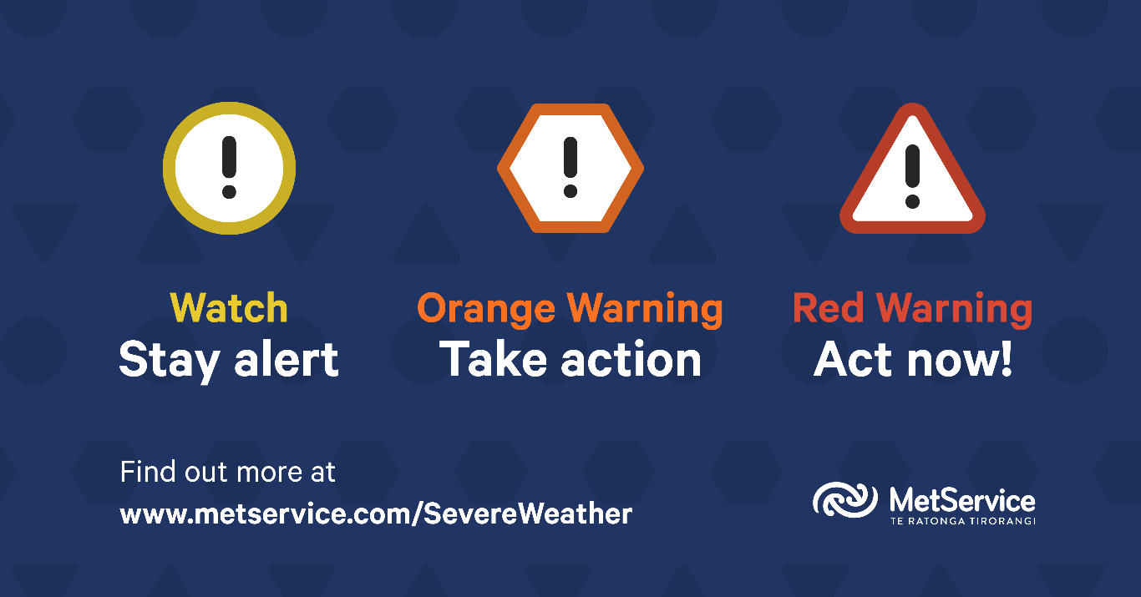
- Severe Weather Watch – Yellow: Bad weather is coming or getting closer. Either the weather will be substantial, but not serious enough to reach ‘warning’ criteria, or MetService are more confident about what might happen but there is still some uncertainty. Watches are issued as required for events expected in the next 48-72 hours, or issued for events expected in the next 24 hours where uncertainty is high.
- Severe Weather Warning – Orange: MetService are confident about what is going to happen. They warn about when and where warning criteria will be reached and the impacts of this weather will be significant.
- Severe Weather Warning – Red: This event is extreme and is among the worst that we get – it will have substantial impacts and it is possible that a lot of people will be affected. This may be similar to Cyclone Gita in February 2018, the Fiordland/Southland floods of February 2020, the Canterbury flood of May 2021, or the Buller flood of July 2021.
Thunderstorms are different. They form incredibly quickly and are less predictable. At most, a “heads up” Thunderstorm Outlook is issued up to 36 hours before the event (covering ‘today’ and ‘tomorrow’), and a Severe Thunderstorm Watch is typically issued within 6-12 hours of the event. Severe Thunderstorm Warnings are issued once a severe thunderstorm is observed on weather radar and provide information on where the storm will move in the next 60 minutes. Because a severe thunderstorm has the potential to cause substantial impacts, damage and disruption, a Thunderstorm Warning will always be depicted with a Red colour-code.
Learn more about MetService Severe Weather Outlooks, Watches and Warnings on the MetService website.

Response: What to do during a storm

When severe weather is forecast
If severe weather is coming, Severe Weather Outlooks, Watches and Warnings are issued by MetService, Te Ratonga Tirorangi, New Zealand’s National Weather Service. They are available through radio, television, the MetService website and mobile app, by registering for email, via radio and television, also on social media from @MetService on Facebook and Twitter.
If there are warnings of severe weather for your region:
- Bring inside or tie down anything that can be broken or picked up by strong winds, such as outdoor furniture.
  - If you have a trampoline, turn it upside down to minimise the surface area exposed to wind.
- Remove any debris or loose items from around your property. Branches and firewood may become missiles in strong winds.
- Clear debris and leaves from external drains and gutters to prevent overflow or water damage in heavy rain.
- Bring pets indoors. They can be unsettled by storms and it is more comforting and safer for them to be with you.
- Ensure livestock are not gathered under an isolated tree or anything that presents a risk from a lightning strike.
- Moor boats securely or move to a designated safe location.
  - Use rope or chain to secure boat trailers. Use tie-downs to anchor a trailer to the ground or to a building.

During a storm
Listen to advice provided by your local Civil Defence Emergency Management Group and emergency services and follow any instructions.
Secure your whare/home and critical buildings by closing windows and shutters, if you have them. Pull curtains and blinds over windows. This can prevent injury from flying glass if the window breaks.
Close all interior and external doors. Closed doors will help prevent damaging winds from entering rooms.
Take extreme care with items that may conduct electricity if your whare/home is struck by lightning:
- Using electric lights is safe, but unplug appliances and avoid using the telephone or any other electrical appliance, especially television sets.
- Turn off air conditioners and heat pumps, which can be overloaded by power surges from lightning.
- If you live in an old house with metal plumbing, avoid using bathtubs, water taps and sinks as these may conduct electricity.
- Use battery-powered radios and water from your emergency supplies.
Stay up to date with the latest information and updates from MetService. Heavy rain and thunderstorms can be tracked on the MetService radar.

If you are caught outside during a lightning storm
If you hear distant thunder or see a flash of light, get indoors immediately.
- A sturdy building is the safest location during a severe thunderstorm.
- Avoid gazebos, rain or picnic shelters and other isolated structures. These offer little protection from large hail, can be struck by lightning, and are often poorly anchored and subject to being uprooted and blown around in strong winds.
If you are boating, fishing or swimming, get to land, get off the beach, and find shelter immediately.
If you are in a car:
- Pull safely onto the shoulder of the road and stop, making sure you are away from any trees or other tall objects that can fall on the vehicle. Turn your hazard lights to alert other drivers that you have stopped.
- Stay in the vehicle with your windows closed. You are safer from lightning in a vehicle than out in the open.
- Avoid contact with metal or other conducting surfaces inside and outside the vehicle to reduce your chance of being shocked.
If you are in the bush, find an area protected by a low clump of trees.
- Never stand beneath a single large tree in the open.
- Be aware of the potential for flooding in low-lying areas.
If you cannot find any suitable shelter, as a last resort, find a low-lying, open place away from trees, poles, or metal objects. Make sure the place you pick is not subject to flooding. If you are physically able to, crouch low to the ground on the balls of your feet. Place your hands on your knees and your head between your knees. Minimize your body’s surface area and minimize your contact with the ground. Lightning currents often enter a victim through the ground rather than by a direct overhead strike.
Places and objects to avoid:
- Tall structures or elevated areas such as towers, tall trees or hilltops, as lightning normally strikes the tallest objects in the area.
- Open spaces or exposed spaces such as exposed sheds or construction sites. Move to a location beneath a solid roof and avoid openings such as windows or doors.
- Any electrically conductive objects such as metal fences, clothes lines and power and telephone lines.
- Objects in metallic contact with the ground. Machinery such as tractors are often struck by lightning, so do not seek shelter under equipment such as this.
Call 111 immediately if someone is struck by lightning.

If you see a tornado
If you see a tornado nearby, take shelter immediately.
If you are inside:
- Move to an interior room or hallway without windows, on the lowest floor. This can be a centre hallway, bathroom or closet. Putting as many walls as you can between you and the outside will provide additional protection.
- Stay away from windows and exterior doors.
- For added protection, get under something sturdy such as a heavy table or workbench. If possible, cover your body with a blanket, mattress or sleeping bag, and protect your head with your hands.
If you are outdoors:
- Lie down flat in a nearby gully, ditch or low spot on the ground. Protect your head with an object or with your arms.
- Tornadoes cause a lot of debris to be blown at very high speeds. Dangerous flying debris can be blown under overpasses and bridges, and the structures themselves can be destroyed. You will be safer lying flat in a low-lying area where the wind and debris will blow over you.
If you are in a car:
- Pull safely onto the shoulder of the road, stop, and get out. Do not try to outrun a tornado in your car.
- Lie down flat in a nearby gully, ditch, or low spot on the ground. Do not get under your vehicle.
- Protect your head with an object or with your arms.

If you are near the coast
Storms can cause inundation (flooding) in coastal areas, depending on the timing of high tides and their relative height, storm surges and accompanying wave/swell conditions.
- Be ready to act quickly. Coastal inundation can happen quickly and the warning time may be short.
- Follow the instructions and advice of Civil Defence Emergency Management authorities. Local authorities are the most informed about areas most likely to experience coastal inundation and will inform you if an evacuation is required.
- If you feel unsafe, evacuate to higher ground or away from coastal areas. You do not need to wait for an evacuation order to move to safety.
- If you have evacuated, it may not be safe to return home even when the water has returned to normal. Listen to emergency services and local Civil Defence authorities and don’t return home until they tell you it is safe to do so.

If there is surface flooding in your area
Rain associated with a storm can lead to overloading of the stormwater system and surface flooding, particularly in urban areas. Even though thunderstorms are relatively short, the suddenness and sheer intensity of the rainfall over a localised area can be hazardous.
- Be prepared to evacuate and keep your grab bag_Make_a_Grab close.
- Listen to the radio for updates and check the websites of your Regional Council and your local Civil Defence Emergency Management Group.
- Listen to emergency services and local Civil Defence authorities and follow any instructions regarding evacuation of your area.
- If you see rising water, do not wait for official warnings. Head for higher ground and stay away from floodwater.
- Do not try to walk, play, swim, or drive in floodwater: even water just 15 centimetres deep can sweep you off your feet, and half a metre of water will carry away most vehicles. Flood water is often contaminated and can make you sick.
- Help others if it is safe to do so, especially people who may require special assistance.
- If you have been evacuated, it may not be safe to return home even when the floodwaters have receded. Listen to emergency services and local Civil Defence authorities and don’t return home until they tell you it is safe to do so.
Learn more about what to do during a flood.

Recovery: What to do after a storm
Listen to advice provided by your local Civil Defence Emergency Management Group and emergency services and follow any instructions.
If it is safe to do so, check in on neighbours, friends or whānau/family who may have been affected and offer support.
Stay away from damaged areas. Your presence might hamper rescue and other emergency operations and put you at further risk from the residual effects of floods, such as contaminated water, crumbled roads, landslides, mudflows, and other hazards.
Continue to stay up to date with the latest weather information from MetService.
Stay alert for extended rainfall and subsequent flooding.
Find out what to do if your property is damaged.
Check out the Insurance section for more information on how your property might be covered following a hazard event.

What to do if your property is damaged
Contact your insurance company or insurance broker as soon as possible. If you rent your property, contact your landlord and your contents insurance company as soon as possible.
Find out what to do if your property is damaged.
Check out the Insurance section for more information on how your property might be covered following a hazard event.

Snowstorms

Key messages about snowstorms
- Take steps to reduce the impact of snowstorms if you live in an area at risk of heavy snowfall, such as making sure buildings are properly insulated to keep the heat in during winter.
- Make and practise your emergency plan, make a grab bag_Have_a_Grab and have emergency supplies.
- Stay up to date with the latest weather information from MetService, Te Ratonga Tirorangi, New Zealand’s National Weather Service. Pay attention to Watches, Warnings and Road Snowfall Warnings, which are also available on the MetService mobile app.
- Keep emergency supplies in your vehicle, including warm clothes, sleeping bags and blankets.
- Postpone outdoor activities if a snowstorm is imminent.
- If you are outside when a snowstorm occurs, seek shelter. Bring pets indoors or into shelter.
- Drive only if it is absolutely necessary. It only takes a few centimetres of snow on a road to make driving dangerous. Avoid travel until conditions have improved.
- If you need to drive during snow conditions, stay up-to-date with the latest weather information from MetService including Road Snowfall Warnings, and check traffic and travel updates from Waka Kotahi (New Zealand Transport Agency) before you go.
- After a snowstorm, keep listening to a radio for updated information and instructions. Local Civil Defence information will be issued by your local Civil Defence Emergency Management Group.

Snowstorm hazards
A snowstorm is a very heavy snowfall, sometimes accompanied by strong winds that can create blizzard-like conditions and severe wind chill.
Snowstorms can make driving dangerous. On mountains, snowstorms can increase the risk of avalanches, which can fall onto roads and ski fields.
In very large quantities, snow can isolate communities, cut communications, disrupt power supply, and cause buildings to collapse under its weight.
Prolonged low temperatures present a risk to people and livestock, especially if deep snow stays on the ground for extended periods, preventing livestock from grazing.

Reduction: Reduce the impacts of snowstorms
Take steps to reduce the impact of snowstorms if you live in an area at risk of heavy snowfall:
- Make sure buildings are properly insulated to keep the heat in during winter.
  - Learn more about whare/home insulation on the genless.govt.nz website.
- Seal gaps around doors and windows to keep out cold air.
- Consider installing double-glazed windows. Double glazing can halve heat loss through windows.
  - Learn more about double glazing on the genless.govt.nz website.
- If double glazing is not an option, you can install window insulation film.
  - Learn more about window insulation film on the genless.govt.nz website.
- If you are in an area prone to freezing, consider insulating and installing a heat trace cable on all exterior water pipes and interior pipes located on outside walls (and anywhere else that temperatures can go below freezing).
- Install snow straps, to reduce the chance of gutters sagging or breaking under the weight of snow.
- Consider buying heating equipment that can be used if the power goes out, such as a gas heater.
  - Do not use outdoor gas appliances indoors. If you have an unflued portable gas heater, only use it in well ventilated areas. Never use an unflued gas heater in a bedroom, bathroom, caravan or tent.
  - You can learn more about unflued gas heaters on the health.govt.nz website.

Readiness: Get prepared to respond to snowstorms
Make and practise your emergency plan, make a grab bag_Have_a_Grab and have emergency supplies.
Stay up to date with the latest weather information from MetService, Te Ratonga Tirorangi, New Zealand’s National Weather Service. Pay attention to Watches, Warnings and Road Snowfall Warnings, which are also available on the MetService mobile app.
If you have a fireplace, consider keeping a supply of firewood or coal.
Have chimneys and wood stoves inspected annually and cleaned if necessary. Chimneys and wood stoves build up creosote, which is the residue left behind by burning wood. Creosote is flammable and needs to be professionally removed periodically. Store ashes in a metal container with a tight-fitting lid.
Protect exposed pipes from freezing by wrapping pipes in insulation or layers of newspaper and then covering them with plastic to keep out moisture.

Protecting livestock
- Ensure you can meet your animals’ needs in the event of prolonged snow coverage. Alternative electricity arrangements (like a generator) will mean cows can still be milked.
- Make sure you can feed your animals if they cannot eat grass. It’s important to have supplementary feed and access to a tractor or farm vehicle so that you can travel through the snow to feed livestock.
Further information on protecting livestock during a snowstorm is available on the Ministry for Primary Industries’ website.

Prepare your vehicle for the winter
Keep emergency supplies in your vehicle, including warm clothes, sleeping bags and blankets.
If you are likely to need to drive in snow conditions prepare for the winter season:
- Carry tyre chains – and make sure you know how to fit and use them.
- Keep your fuel tank near full, to avoid ice in the tank and fuel lines.
- Ensure your car’s battery and ignition system are in top condition, with clean battery terminals.
- Ensure antifreeze levels are sufficient, to avoid freezing.
- Ensure the car heater works properly.

Response: What to do during a snowstorm
Stay up to date with the latest weather information from MetService, Te Ratonga Tirorangi, New Zealand’s National Weather Service. Pay attention to Watches, Warnings and Road Snowfall Warnings, which are also available on the MetService mobile app.
Postpone outdoor activities if a snowstorm is imminent.
If you are outside, seek shelter.
Bring pets indoors or into shelter:
- Make sure there is good ventilation and that your animal can freely move away from any external heat sources. Keep animals away from coming in contact with heat sources, such as fires, to reduce the risk of burns.
- Do not keep your animal in a garage or room with running vehicles or unflued gas heaters. Even small amounts of carbon monoxide will kill them.

In your home
Secure your whare/home and critical buildings by closing the windows and doors.
Close off rooms you are not using to conserve heat.
Stuff towels or rags in cracks under doors.
Close curtains and blinds at night. Open them in the day to let the sun warm the rooms up.
If necessary, conserve fuel by keeping your whare/home slightly cooler than normal and wearing extra layers.
When heating using a fireplace, wood stove, or space heater, use fire safeguards and ventilate properly.
Keep one or two taps running slowly during periods of extreme cold. Water moving through the system should prevent lines from freezing.
If your pipes freeze:
- Turn off water at the mains tap immediately.
- Completely open all taps. As you treat the frozen pipe and the frozen area begins to melt, water will begin to flow through the frozen area. Running water through the pipe will help melt ice in the pipe.
- Apply heat to the frozen pipe using a hair dryer or by wrapping the pipe with towels soaked in hot water. Do not use a blowtorch or other open flame device.
- Apply heat until full water pressure is restored. If you are unable to locate the frozen area, if the frozen area is not accessible, or if you cannot thaw the pipe, call your plumber.

Protecting your health
- If you have to go outside, dress for the conditions
  - Wear several layers of loose fitting lightweight warm clothing, rather than one layer of heavy clothing. The outer garments should be tightly woven and water repellent.
  - Cover your hands and fingers. Mittens are warmer than gloves.
  - Ensure your head is well covered.
  - Cover your mouth with a scarf to protect your lungs.
- Watch for signs of frostbite. These include loss of feeling, and white or pale appearance in extremities, such as fingers, toes, ear lobes, and the tip of the nose. If symptoms are detected, get medical help immediately.
- Watch for signs of hypothermia. These include uncontrollable shivering, memory loss, disorientation, incoherence, slurred speech, drowsiness, and exhaustion. If symptoms of hypothermia are detected, move to a warm location, remove wet clothing, warm the centre of the body first, and give warm, non-alcoholic beverages, if conscious. Get medical help as soon as possible.
- Regardless of your age or physical condition, avoid overexertion in the winter.
  - Be aware that cold weather puts a strain on your heart, even without exercise.
  - Be careful when shovelling snow, pushing a car, or performing other tasks.

If you need to drive
Drive only if it is absolutely necessary. It only takes a few centimetres of snow on a road to make driving dangerous. Avoid travel until conditions have improved.
If you need to drive during snow conditions:
- Stay up-to-date with the latest weather information from MetService including Road Snowfall Warnings, and check traffic and travel updates from Waka Kotahi New Zealand Transport Agency before you go.
- Think about where you’re going and which route you should take. Choose safety over convenience. Stay on main roads and avoid back road “shortcuts”.
- Ensure you take your mobile phone and car chargers with you.
- Keep others informed of your schedule and primary and alternate routes.
- If possible, do not travel alone.
- Travel in daylight. Avoid driving at night, when hazards rapidly multiply.
- Take or fit tyre chains if the roads are not cleared and the snow is deep, or the roads are icy.
Further information about winter driving is available on the Waka Kotahi New Zealand Transport Agency website.

Protecting livestock
- If you are aware of a snowstorm coming, try to move your livestock off the high country and any south-facing areas so that they are not as exposed to the elements and can seek shelter.
- Move animals to sheltered areas. Shelter belts, properly laid out and oriented, are better protection for cattle than confined shelters, such as sheds.
- Have a water supply available. Most animal deaths in winter storms are from dehydration.
- Further information on protecting livestock during a snowstorm is available on the Ministry for Primary Industries’ website.

Recovery: What to do after a snowstorm
Keep listening to a radio for updated information and instructions. Local Civil Defence information will be issued by your local Civil Defence Emergency Management Group.
Avoid driving and other travel until conditions have improved.
- Roads may be blocked by snow or emergency vehicles.
- Stay up to date with the latest weather information from MetService including Road Snowfall Warnings and check traffic and travel updates from Waka Kotahi New Zealand Transport Agency before you go.
If you have no electricity, take precautions to keep food safe.
- Avoid unnecessary opening of fridge or freezer doors.
- Foods that have been defrosted should not be re-frozen. If you think or suspect that food is not safe, throw it out.
Find out what to do if your property is damaged.
Check out the Insurance section for more information on how your property might be covered following a hazard event.

Tsunami

Key messages about tsunami
- New Zealand’s entire coastline is exposed to tsunami hazard. Tsunami can also happen in larger lakes. Tsunami can violently flood our shores, causing devastating property damage, injuries and loss of life.
- In New Zealand, some of the biggest tsunami are caused by events close to our shore, and can arrive within minutes.
- For a local-source tsunami which can arrive in minutes, there is not enough time for an official warning. It is important to recognise the natural warning signs and act quickly.
- Remember, LONG or STRONG, GET GONE: If you are near the coast and experience any of the following:
- Feel a strong earthquake that makes it hard to stand up, or a weak rolling earthquake that lasts a minute or more.
- See a sudden rise or fall in water level.
- Hear loud and unusual noises from the water.
- Move immediately to the nearest high ground or as far inland as you can, out of tsunami evacuation zones. Do not wait for official warnings.
- Walk, run or cycle, if you can. This reduces the chances of getting stuck due to damaged roads or traffic congestion.
- Your local Civil Defence Emergency Management Group has tsunami evacuation zone maps and local advice. Make sure you know where to go, whether you are at home, at mahi/work or out and about.
- Plan evacuation routes from your whare/home, farm, kura/school, wāhi mahi/workplace, or any other place you frequently go, that is in a tsunami evacuation zone.
- Once you have evacuated, follow official advice from your local Civil Defence Emergency Management Group about when it is safe to return to tsunami evacuation zones. Do not return until an official all-clear message is given by Civil Defence Emergency Management. Tsunami activity will continue for several hours and the first wave may not be the largest.

Tsunami
A tsunami is a series of powerful waves with strong currents. They are mostly caused by underwater or coastal earthquakes, and sometimes by underwater landslides or volcanic eruptions.
Tsunami waves have a lot of power and travel much further and faster inland or up hills than regular waves. Once they travel over land, tsunami waves can keep going at the speed of a car on land (30km per hour), so you can’t out-run them. They can damage or destroy buildings and lifeline utilities and carry vehicles and boats. Tsunami waves pick up things in their path like trees, vehicles or bits of buildings which can cause further damage as they are moved by the wave. The largest wave may happen several hours after the first wave and there can be more than one set of waves.
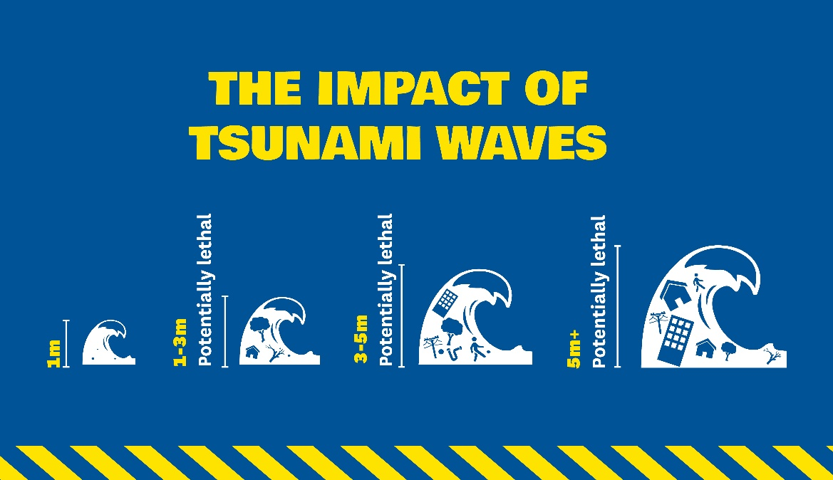

New Zealand’s entire coastline and some of our larger lakes are exposed to tsunami hazard. Tsunami can violently flood our shores, causing devastating property and lifeline utility damage, injuries and loss of life.
In New Zealand, some of the biggest tsunami are caused by events close to our shore, and can arrive within minutes.
- Learn more about tsunami.

Where do tsunami come from?
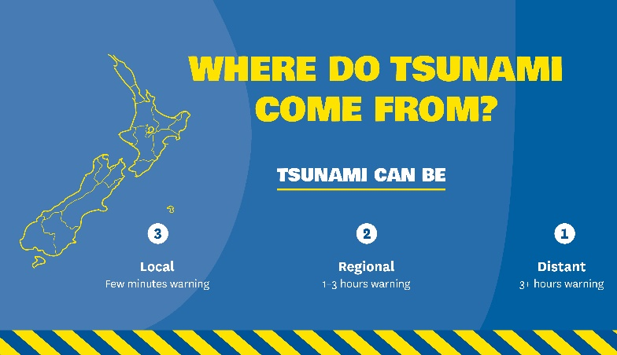
Tsunami can come from different sources.
Local-source tsunami can arrive at New Zealand coastal areas within minutes. They are generated very close to New Zealand, usually by earthquakes. This type of tsunami is very dangerous because of their short arrival times.
Regional-source tsunami are between one and three hours travel time away from New Zealand. A large earthquake in the Southwest Pacific, and an eruption from an underwater volcano in the Kermadec Trench to the north of New Zealand, are two possible triggers for regional tsunami.
Distant-source tsunami take at least 3 hours and in some cases 14 hours or more to arrive. A distant-source tsunami is most likely to be generated by a very large earthquake in the Pacific Ocean, particularly off the South American coast.
For a local-source tsunami, which can arrive in minutes, there is not enough time for an official warning. It is important to recognise the natural warning signs and act quickly.
For regional or distant-source tsunami, there is time to issue official tsunami warnings.

Reduction: Reduce the impacts of tsunami
Check with your Council to learn about your tsunami risk. You can find out if your property is at risk by checking on the nationwide tsunami evacuation map.
Ensure that you have appropriate insurance cover for your whare/home and contents.
If you have pets or livestock, consider installing or changing fence lines so your animals are able to move to higher ground in the event of a tsunami.

Readiness: Get prepared to respond to a tsunami

Find out what can happen to you
Find out if the places where you live, work or frequently visit are in tsunami hazard areas. Be aware of tsunami evacuation zones, tsunami evacuation routes, and warning methods and signage.
If you are visiting an area at risk from tsunami, check with the hotel, motel or campground operators for tsunami evacuation information, and find out what the local warning system is for tsunami. It is important to know the evacuation routes before any natural or official warnings.

Know your tsunami evacuation zones
A tsunami evacuation zone is an area that you may need to leave if you feel a long or strong earthquake, or if there is an official tsunami warning.
Make sure you know where to go, whether you are at home, at mahi/work or out and about Search for your home, work or school address on the nationwide tsunami evacuation zones map to find out if they are in a tsunami evacuation zone.
Your local Civil Defence Emergency Management Group has tsunami evacuation zone maps and local/regional advice.
Most regions have three tsunami evacuation zones – red, orange and yellow – based on the areas that can be affected in different sized tsunami.
- The Red Zone is the marine and beach exclusion zone (includes beaches, harbours, rivers and estuaries). This is the zone that will be evacuated in the event of any expected tsunami and therefore the one we most often ask people to stay out of when a tsunami warning is issued.
- The Orange Zone is the area which may be inundated in a distant or regional-source tsunami.
- The Yellow Zone is designed to keep people safe from the largest tsunami we could experience and includes the highest impact tsunami events.
If you feel a long or strong earthquake, you must move immediately to the nearest high ground or as far inland as you can, out of tsunami evacuation zones. Do not wait for an official warning. The earthquake itself is your only warning.
In a regional or distant source tsunami where there is time for an official warning to be issued, you may be advised which zones you need to leave by your local Civil Defence Emergency Management Group.
If you live near the coast but are not located in a tsunami evacuation zone, you do not need to evacuate. Your whare/home could be a safe location for friends and family who live inside an evacuation zone and need to evacuate.

Plan your evacuation routes
If your whare/home, farm, kura/school, wāhi mahi/workplace, or any other place you frequently go is in a tsunami evacuation zone, you should plan an evacuation route.
Your evacuation route needs to take you out of tsunami evacuation zones. Even if you can’t get out of your evacuation zone, go as far or as high inland as you can. Every metre makes a difference.
You should be able to reach your safe location as soon as possible. Your safe location could be a friend or relative’s house in short distance outside of the tsunami evacuation zones. Follow posted tsunami evacuation routes where present - these will lead to safety.
Plan to evacuate on foot or bicycle if you can. After an earthquake, roads and bridges may be damaged or blocked. Plan different evacuation routes to account for this.

Practise your tsunami hīkoi
Practise your evacuation route or ‘tsunami hīkoi’. A tsunami hīkoi is a walk that takes you along your tsunami evacuation route either inland or towards high ground. Being familiar with your route may save your life.
Practise your evacuation walk to high ground or inland by foot or bicycle.
- Make sure you can follow your route at night and during bad weather.
- Practising your tsunami evacuation route helps your muscle memory kick in when an event occurs, even in a very stressful situation.

Kura/School evacuation plan
If your children’s kura/school is in a tsunami evacuation zone, find out what the kura/school evacuation plan is. Do not travel through tsunami evacuation zones to your children’s kura/school during an event.
Parents and guardians need to know, in advance, all emergency procedures especially the safe locations and family reunification procedures.
Find out where the kura/school’s safe location is so you know where your children can be picked up from, after the “all-clear” is given.

Response: What to do during a tsunami

Warnings

Natural warning signs: Long or Strong, Get Gone
For a local-source tsunami which can arrive in minutes, there is not enough time for an official warning. It is important to recognise the natural warning signs and act quickly.
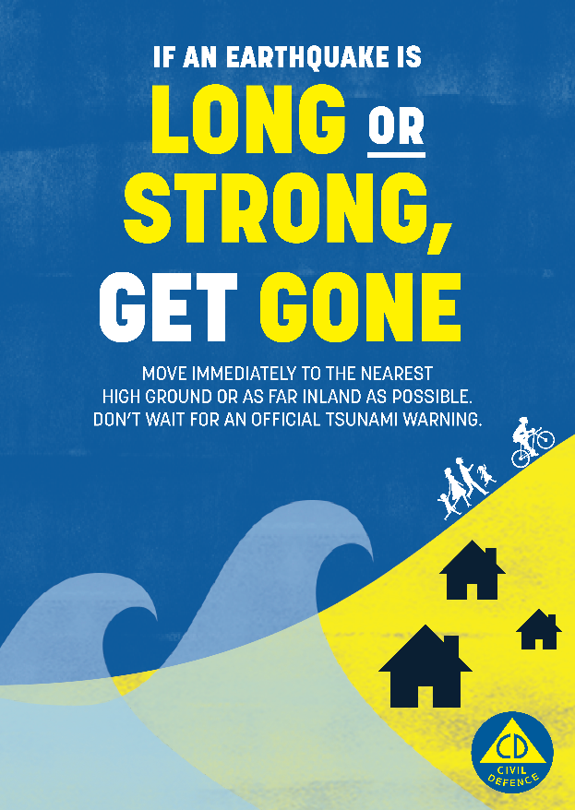
Remember, LONG or STRONG, GET GONE.
If there is earthquake shaking, drop, cover and hold. Protect yourself from the earthquake first, then act as soon as the shaking stops.
If you are near the coast, you need to act immediately if you experience any of the following:
- Feel a strong earthquake that makes it hard to stand up, or a weak rolling earthquake that lasts a minute or more.
- See a sudden rise or fall in water level.
- Hear loud and unusual noises from the water.
Move immediately to the nearest high ground or as far inland as you can, out of tsunami evacuation zones. Do not wait for official warnings.
Walk, run or cycle, if you can. This reduces the chances of getting stuck due to damaged roads or traffic congestion.
While evacuating, be aware of other hazards. For example, a large local earthquake may damage powerlines and bridges and create liquefaction and landslides.
Do not return until an official all-clear message is given by Civil Defence Emergency Management. Tsunami activity can continue for several hours, and the first wave may not be the largest. If there was an earthquake, expect aftershocks. Each time you feel one, drop, cover, and hold. Aftershocks may generate another tsunami.
Listen to the radio and/or TV for updates, local CDEM groups’ websites and social media and @NZCivilDefence Twitter.

Official warnings
When tsunami travel across the ocean from far away, there is time to issue official warnings.
The National Emergency Management Agency is responsible for issuing tsunami warnings in New Zealand.
Tsunami warnings are published on www.civildefence.govt.nz and Twitter @NZCivilDefence. Tsunami warnings will also be broadcast on radio and television.
If there is a land threat, Emergency Mobile Alerts (EMA) will be issued by the National Emergency Management Agency and Civil Defence Emergency Management Groups to areas under threat.
If strong and unusual currents and unpredictable surges are expected near the shore, a local EMA may be issued by your local Civil Defence Emergency Management Group.
Your local area may have its own methods for broadcasting warnings. These might include sirens, phone calls, local EMAs, or warnings through loud hailers. Contact your local Civil Defence Emergency Management Group or your local council to find out about the warnings you can expect to receive in your area.
Immediately follow the advice of any emergency warning. Do not wait for more messages before you act.
Depending on the location of the earthquake, you may have a number of hours in which to take appropriate action.

Tsunami threat to land and marine areas warning
A tsunami threat to land and marine areas warning will be issued when coastal inundation (flooding of land areas) is expected, and unusually strong and hazardous currents and unpredictable surges are expected near the shore.
- The land warning may apply to all of New Zealand’s coastline, or only to certain areas.
- A land warning means that evacuations may be required in some areas.
- An Emergency Mobile Alert will be issued to the areas under land threat. This will advise people to evacuate immediately or prepare to evacuate.
- Listen to local Civil Defence Emergency Management authorities and follow any instructions regarding evacuation of your area.

Tsunami activity advisory
A tsunami activity advisory will be issued when inundation of land areas near the shore is not expected (although this assessment may change), but strong and unusual currents and unpredictable surges are expected near the shore.
- The tsunami activity advisory may apply to all of New Zealand’s coastline or only certain areas.
- Strong currents and surges can injure and drown people. There is a danger to swimmers, surfers, people fishing, small boats and anyone in or near the water close to shore.
- People on boats, liveaboards and at marinas should leave their boats/vessels and move onto shore. Do not return to boats unless instructed by Civil Defence.
- Evacuation of land areas is not required but people should stay out of the water (sea, rivers, and estuaries, including boats) and stay off beaches and shore areas when a tsunami activity advisory is issued.
- Do not go swimming, surfing, fishing or engage in small boat activities when a tsunami activity advisory is issued.

Informal warnings
A tsunami warning could also come from friends, neighbours, your community or international media. If you trust them and you feel unsafe, consider evacuating.
If you feel a tsunami threat is imminent, move immediately to the nearest high ground or as far inland as you can, out of tsunami evacuation zones.
Check the accuracy of the warning once you have arrived at your safe location or en route only if it won’t slow you down. You can check the warnings at civildefence.govt.nz or via TV/radio broadcasts, news websites, or through your local Civil Defence Emergency Management Group and emergency services.
If official warnings are available, trust their message over informal warnings.

Evacuation
Anyone near the coast who feels a long or strong earthquake should self-evacuate as soon as the shaking stops. Do not wait for an official warning.
If you are inside a tsunami evacuation zone when a tsunami is expected, you may need to evacuate.
If you are outside of tsunami evacuation zones, you do not need to evacuate. If you stay where you are, it will help to reduce congestion for those who must evacuate.

Advised to evacuate immediately
Land and marine tsunami warnings for local and regional tsunami will advise people near the coast in affected areas to evacuate immediately.
The National Emergency Management Agency will issue an Emergency Mobile Alert to areas under land threat advising people near the coast in affected areas to evacuate immediately. Civil Defence Emergency Management Groups will also issue supporting Emergency Mobile Alerts providing local information.
- Do not wait for an Emergency Mobile Alert if you felt a long or strong earthquake. Self-evacuate as soon as the shaking stops. Remember, LONG or STRONG, GET GONE.
If you are advised to evacuate immediately, you should:
- Move immediately to the nearest high ground or as far inland as you can, out of tsunami evacuation zones,.
- Walk, run or cycle, if you can. This reduces the chances of getting stuck due to damaged roads or traffic congestion, especially in a local source tsunami event where there may only be a few minutes available to get to safety. Use of vehicles on roads should be limited to emergency services and those with mobility impairments, including wheelchair users.
- If you have to drive, keep going once you are well outside of all evacuation zones, to allow room for others behind you.
- Evacuate via the routes shown on tsunami evacuation route signs or drawn on tsunami evacuation maps if these are available.
- Take your grab bag_Make_a_Grab with you if possible, but do not travel into the evacuation zone to collect your grab bag or other belongings.
- Take your animals with you only if it will not delay you. Do not spend time looking for them and if you are not at home, do not return to get them.

Advised to prepare to evacuate
Land and marine tsunami warnings for distant tsunami will advise people near the coast to prepare to evacuate. If you are advised to prepare to evacuate you should:
- Listen to local Civil Defence Emergency Management authorities and follow any instructions regarding evacuation of your area.
- Leave cell phones on and charged so you can receive alerts.
- Listen to the radio or TV for updates, and check your local Civil Defence Emergency Management Group’s website
- Find any pets and bring them with you when you evacuate, only if it will not delay you.
- Put essential items such as food, clothing, and medication in your grab bag_Make_a_Grab to take when you evacuate.
- Secure your whare/home as you normally would when leaving for an extended period.
- Share information with your neighbours. They may not be aware of the tsunami warning. Help neighbours who need assistance to evacuate.
- If you are farming along the coast or river estuary, evacuate your whānau/family and staff first. If you have time, move livestock to higher ground.
When it is time to evacuate:
- Evacuate via the routes shown on tsunami evacuation route signs or drawn on evacuation maps if these are available. If these routes appear slow or congested, use a different route.
- Walk, run or cycle, if you can. This reduces the chances of getting stuck due to damaged roads or traffic congestion.
- If you have to drive, keep going once you are well outside of all evacuation zones, to allow room for others behind you.

Cancellations
Once you have evacuated, follow official advice from your local Civil Defence Emergency Management Group about when it is safe to return to tsunami evacuation zones. Do not return until an official all-clear message is given by Civil Defence Emergency Management. Tsunami activity will continue for several hours and the first wave may not be the largest. Aftershocks may cause additional tsunami events.

If you have a boat
Tsunami are often most destructive in bays and harbours, not just because of the waves, but because of the strong currents they generate in local waterways. Tsunami dangers for boats include:
- Strong and unpredictable currents and surges that can affect ports and marinas even during small tsunami.
- Grounding of vessels, as water levels can suddenly drop.
- Capsizing from incoming surges (bores), complex coastal waves, and surges hitting grounded boats.
- Collision with other boats, docks, debris and changes to the seafloor (e.g. movement of sand bars, wrecks, reefs and boulders).
Depending on the nature of the tsunami and your location, you may need different action plans:
- What would you do if you were getting ready to head out? Out on the water? Coming back in?
- What would you do if you had minutes until a tsunami hit – or an hour, or a few hours?
Always have at least three days, or a week or more if you can, of food, fuel, and water.
In the event of a potential tsunami threat, Coastal Navigational Warnings will be issued by the Rescue Coordination Centre New Zealand (RCCNZ), via Maritime Radio. Along with the RCCNZ, the National Emergency Management Agency will advise each regional Civil Defence Emergency Management Group (CDEM Group). Each regional CDEM Group will inform the mariner as quickly as possible via their regional council and harbourmasters/port authorities. Port authorities would likely take their own precautions as per their Emergency Operating Procedures.
For further information check out these helpful resources:
- https://www.hbemergency.govt.nz/assets/Uploads/Tsunami-Boat-Safe-Distance1.png
- https://www.linz.govt.nz/sea/nautical-information/new-zealand-nautical-almanac-nz-204/download-new-zealand-nautical-almanac-nz-204

Local source tsunami
In a local source tsunami, which can arrive in minutes, you need to take action quickly. Be aware of the natural warning signs:
- Onshore:
  - Feel a strong earthquake that makes it hard to stand up, or a weak rolling earthquake that lasts a minute or more.
  - See a sudden rise or fall in water level.
  - Hear loud and unusual noises from the water.
- Offshore:
  - You may feel the earthquake through the hull of your boat.
  - You could see a rapid and extreme shift in currents and simultaneous changes in wind wave heights.
If you are on land or tied up at dock, and you see or hear natural warning signs of a tsunami, leave your boat, move immediately to the nearest high ground or as far inland as you can, out of tsunami evacuation zones.
If you are on the water shallower than 50 metres or 27.3 fathoms depth:
- Stop commercial fishing operations immediately.
- Free the vessel from any bottom attachment and gear that might drag in currents (cut lines if necessary).
- If you can beach or dock your small boat and evacuate on foot within ten minutes of a natural warning, then this is your best chance.
- If evacuation on foot is not possible, head for the deepest water possible, greater than 50 metres deep.
  - Proceed directly away from the shore.
  - Sail directly into waves. Be aware that tsunami can interact with wind waves and produce unusual effects.
Maintain as much separation as possible from other vessels. If you are on the water at greater than 50 metres outside of harbours/channels, continue to head to deeper water which is safer from tsunami currents and waves.
- Do not return to port if you are at sea and a tsunami warning is issued. Port and harbour facilities may become damaged and hazardous with debris.
- Listen to maritime radio reports to find out when it is safe to return and be careful navigating when you return as the seafloor may have changed and there may be debris.

Regional or distant source tsunami
Check with your local harbourmaster to find out what your local tsunami response procedures are.

What to do immediately after a tsunami
Follow official advice from your local Civil Defence Emergency Management Group about when it is safe to return to tsunami evacuation zones. Do not return until an official all-clear message is given by Civil Defence Emergency Management. Tsunami activity will continue for several hours and the first wave may not be the largest.
- If there was an earthquake, expect aftershocks. Each time you feel one, drop, cover, and hold. Aftershocks may generate another tsunami. Be prepared to evacuate.
- Be cautious in and around coastal water, tidal estuaries, rivers and streams after any tsunami or tsunami warning, as even small waves create dangerous currents that can injure or drown people.

Recovery: What to do after a tsunami
Expect aftershocks. Each time you feel one, drop, cover and hold. Aftershocks can occur minutes, days, weeks, months and years following an earthquake and may trigger another tsunami. Be prepared to evacuate.
Avoid areas impacted by the tsunami. Your presence might hamper rescue and other emergency operations and put you at further risk from the residual effects of tsunami flooding, such as contaminated water, crumbled roads, and other hazards.

Returning home after a tsunami
If you have evacuated, it may not be safe to return home even when the water has returned to normal. Listen to emergency services and local Civil Defence authorities and don’t return home until they tell you it is safe to do so.
Stay out of buildings if water remains around them. Tsunami water, like floodwater, can undermine foundations, causing buildings to sink, floors to crack, or walls to collapse.
When re-entering homes or buildings, use extreme caution as floodwaters may have damaged buildings. Look before you step. After a tsunami, the ground and floors are covered with debris, including broken bottles and nails. Floors and stairs that have been covered with mud can be very slippery. Look for broken utility lines and report them to appropriate authorities.
Find out how to clean up if your property has been flooded by tsunami water.
Find out what to do if your property is damaged.
Check out the Insurance section for more information on how your property might be covered following a hazard event.

Food safety after a tsunami
When ocean water comes ashore, it can carry microorganisms (bacteria, viruses, parasites) and chemicals that can contaminate food and negatively affect human health.
Throw away all food and drinking water that has come in contact with tsunami floodwater, including things stored in containers. It is impossible to know if containers have been damaged and the seals compromised.
Avoid drinking or preparing food with tap water until you are certain it is not contaminated. Follow any boil water notice instructions from your local authorities.
- General advice about food safety in disaster and emergencies is available on the Ministry of Health website.

Volcanic activity

Key messages about volcanic activity
- Volcanic unrest is increased activity that may or may not lead to a volcanic eruption. Volcanic unrest can produce hazards on or near a volcano, such as volcanic earthquakes, gas emissions and land deformation.
- Volcanic eruptions produce several near and far-reaching hazards. Volcanic eruptions can last for days, weeks, months, or years. The most widespread and disruptive hazard is usually volcanic ash.
- Make and practise your emergency plan, make a grab bag_Make_a_Grab and have emergency supplies.
- Find out from your local Civil Defence Emergency Management Group what the volcanic risk in your area is and know how to stay informed.
- Follow official advice provided by your local Civil Defence Emergency Management Group, the Department of Conservation (for visitors to the Tongariro and Taranaki National Parks), local authorities and emergency services both during and following volcanic activity.
- If a volcano is active, minimise your time near the volcano especially the summit region and valleys. During volcanic activity, near-volcano hazards may be present. If you are in an exposed area and become aware of near-volcano hazards, the best way to protect yourself is to quickly move (run or drive if you can) as far away as possible from the volcano.
- If ash fall has been forecast for your region, before ash fall starts, if possible, go home to avoid exposure to, and driving during, ash fall.

Volcanoes, volcanic unrest, and volcanic eruptions
A volcano is an opening in Earth’s crust through which molten rock, volcanic ash and gases can reach the surface.
Volcanic unrest is increased activity that may or may not lead to a volcanic eruption. Volcanic unrest can produce hazards on or near a volcano, such as volcanic earthquakes, gas emissions and land deformation. Some volcanic unrest can only be detected by monitoring instrumentation. Most volcanic eruptions follow unrest, but not all unrest episodes lead to volcanic eruptions. This makes managing unrest challenging for scientists and Civil Defence Emergency Management, and means that you might find unrest unsettling. Unrest can last for days, weeks, months, or years.
Volcanic eruptions produce several near- and far-reaching hazards. Volcanic eruptions can last for days, weeks, months, or years. The most widespread and disruptive hazard is usually volcanic ash.

New Zealand’s volcanoes
New Zealand is situated between the Australian and Pacific Plates on the “Ring of Fire” around the Pacific Ocean. The Ring of Fire contains most of the Earth’s active volcanoes.
New Zealand has 11 active volcanic areas (above the water):
- Eight are in the North Island:
  - Auckland Volcanic Field
  - Northland (Bay of Islands and Whangarei Volcanic Fields)
  - Okataina Volcanic Centre (including Tarawera)
  - Rotorua Volcanic Centre
  - Ruapehu
  - Taranaki
  - Taupō Volcanic Centre
  - Tongariro Volcanic Centre (including Ngauruhoe, Te Maari and Red Crater)
- Three are offshore:
  - Kermadec Islands (Raoul and Macauley islands)
  - Tuhua | Mayor Island
  - Whakaari | White Island
There are also many more underwater volcanoes in the Kermadec Volcanic Arc between the North Island and Tonga.
More information on New Zealand’s volcanoes is available on the GNS Science website.

Types of volcanoes in New Zealand
Volcanoes come in different shapes and sizes. There are three main types in New Zealand:
- Cone volcanoes (also called stratovolcanoes), such as Whakaari/White Island, Ruapehu, Taranaki and Tongariro/Ngauruhoe. Cone volcanoes are characterised by a series of frequent (every 10 to fifty years) small to moderate eruptions from roughly the same point on the Earth’s surface. Erupted rocks build up to form a volcanic cone. Cone volcanoes produce many hazards, including lava flows, ashfall, lahars, pyroclastic flows and landslides.
- Volcanic fields, such as the Auckland Volcanic Field, where eruptions have happened at (at least) 53 different places so far. Volcanic fields form when small eruptions (compared to cones and calderas) occur over a wide area. Despite the eruptions being relatively small, the impacts in New Zealand’s largest city can be catastrophic. These eruptions are spaced over long time intervals, with each eruption building a single small volcano that usually does not erupt again. Some eruptions form hills, such as Mount Eden, and some form explosion craters, such as Orakei Basin. Because each eruption occurs in a different place, the location of the next eruption cannot be predicted until it is imminent. We may only get hours to days’ notice of a new eruption of the Auckland Volcanic Field.
- Caldera volcanoes, are large volcanic centres such as across the central Taupō Volcanic Zone (the area from Taupō to Tarawera) and Tuhua/Mayor Island. The most frequent activity is unrest. Unrest is very likely in a lifetime. Moderate eruptions are unlikely, but possible, in your lifetime. Calderas form by the collapse of a volcano into itself, making a large volcanic basin, such as the one now filled by Lake Taupō. Large, caldera-forming eruptions are extremely rare (tens of thousands of years apart) and extremely unlikely in your lifetime. In the last 30,000 years, there have been 12 moderate to large eruptions in the Okataina area (including Tarawera) and 26 in the Taupō area. The most likely location for the next unrest or eruption activity is in these two areas.
More information on the types of volcanoes in New Zealand is available on the GNS Science website.

Volcanic hazards
Volcanic eruptions in New Zealand have injured and killed people and destroyed property. For example, the eruption of Mount Tarawera in 1886 killed at least 106 people, and a lahar on Mount Ruapehu in 1953 caused the deaths of 151 people in the Tangiwai railway disaster. In 2019, 22 lives were lost and 25 people were injured following an explosive eruption on Whakaari/White Island.
New Zealand volcanoes produce a range of hazards and have different levels of volcanic unrest or eruptive activity. Whakaari/White Island and Tongariro (especially Ngauruhoe) have been the most frequently active volcanoes in our recorded history, closely followed by Ruapehu. Some of our other volcanoes can have hundreds or even thousands of years between eruptions.

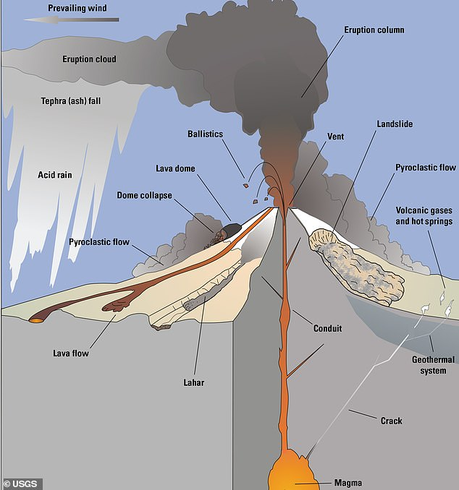
Image credit: U.S. Geological Survey.
Volcanic hazards can be divided into four groups: geothermal activity, volcanic unrest, near-volcano eruption hazards and far-reaching eruption hazards.
Geothermal activity is often associated with volcanic activity. Geothermal activity occurs when groundwater is heated by hot rock or magma. In some parts of New Zealand, geothermal activity forms long-lived features such as hot pools, boiling mud pools, geysers and fumaroles. Volcanic activity can increase geothermal activity. Geothermal activity can cause burns from the hot water and steam. See the Geothermal Activity section for more information on geothermal hazards.
Volcanic unrest hazards occur on and near the volcano, and can include:
- Earthquakes: Earthquakes are usually unrelated to volcanic activity, but they can also be caused by magma moving, and pressure building, inside or beneath a volcano. See the Earthquake section for more information on earthquake hazards.
- Gases: Volcanic unrest may be accompanied by increased volcanic gas emissions. Magma contains dissolved gases, which are released via the volcanic conduit into the atmosphere as magma approaches the Earth’s surface. Carbon dioxide (CO₂) and sulfur gases such as hydrogen sulphide (H₂S) and sulphur dioxide (SO₂) are the hazardous gases which are most likely to be emitted during unrest. Some volcanic gases are heavier than air and can build up in confined spaces such as hollows, caves, and sometimes rooms in buildings, displacing oxygen. In high concentrations, these gases can be lethal to people and animals.
- Land deformation: Changes to the ground surface, such as swelling, sinking, or cracking are often associated with volcanic unrest or as a result of volcanic eruption. Land deformation can directly damage homes, cause landslides and change the risk of flooding as the ground moves. See the Landslide section for more information on landslide hazards. See the Flood section for more information on flood hazards.
- Landslides (debris avalanches): The sudden collapse of unstable rock, mud, sand, and soil, from the side of a volcano. Landslides can happen at any mountain where the slope of the mountain has become less stable, but they are commonly associated with volcanic activity because the volcanic mountain is weakened by magma moving and pressure building inside. At the largest scale, collapses of whole sections of a volcano can occur. See the Landslide section for more information on landslide hazards.
Near-volcano eruption hazards can be highly destructive and dangerous near an active volcano, impacting 3-5 km from the vent. Some near-volcano hazards can extend up to 10-20 km away from the eruption site. In rare cases, near-volcano hazards may reach beyond 20 km. They can include:
- Ash falls: Small (less than 2 mm) jagged pieces of rock and glass produced by explosive eruptions and transported downwind. Close to volcanoes, ash can be thick enough to collapse roofs and cause structural damage to buildings. Even thin layers can cause serious disruption to lifeline utilities, such as water and electricity networks. Small amounts of ash can make driving dangerous.
- Ballistics: Lava and rock fragments, from centimetres to tens of metres in size, which are ejected from the volcano vents along fast, cannonball-like trajectories. Ballistics are lethal and highly damaging. They can travel hundreds of metres to a few kilometres from the eruption site. Along with pyroclastic flows, ballistic hazards are the main reason for evacuations near an active volcano.
- Earthquakes: Earthquakes are usually unrelated to volcanic activity, but they can also be caused by eruptions, magma moving, and pressure building inside or beneath a volcano. See the Earthquake section for more information on earthquake hazards.
- Floods: Rainfall events, days to weeks after a volcanic eruption can lead to remobilisation of volcanic ash. When fine ash covers soil and reduces infiltration, it can cause increased runoff and flooding when it rains. Some of these vents can behave as lahars. See the Flood section for more information on flood hazards.
- Gases and aerosols: Emissions of gases including carbon dioxide (CO₂), hydrogen chloride (HCl), and sulphur gases (H₂S and SO₂) increase during eruptions:
  - Near vents and volcanoes, volcanic gases are irritating to eyes, skin, and breathing, and can be lethal at high concentrations.
  - Some volcanic gases are heavier than air and can build up in confined spaces such as hollows, caves, and sometimes rooms in buildings, displacing oxygen. In high concentrations, gases can be lethal to people and animals.
  - Acid rain can occur when rain falls through a plume of gases and aerosols, particularly if there are high concentrations of volcanic gases. Close to the vent, rainfall can be as acidic as freshly squeezed lemon juice. Acid rain can irritate the skin and eyes or cause a stinging sensation. If acid rain occurs for a sustained period, it can also damage plants, and accelerate the rusting of metal surfaces on buildings, vehicles, farm equipment, and infrastructure components, including plumbing fittings which can result in the contamination of drinking water. It may also affect the quality of surface waters, and may kill fish in open ponds.
- “Vog” (volcanic smog) is caused by volcanic gases reacting in the atmosphere. Vog is visible as a haze and is blown downwind. Vog can be irritating to breathing and may cause persistent health problems. More information on vog is available on the International Volcanic Health Hazards Network website.
- Lahars (volcanic mudflows): A hot or cold, dense mixture of water, rock, mud, sand, and soil, that flows rapidly downstream. Lahars form in a variety of ways, usually by the rapid melting of snow and ice by hot volcanic debris, intense rainfall on loose volcanic deposits, breakout from a lake dammed by volcanic deposits or an eruption through a crater lake. Lahars can occur long after an eruption has ceased, usually when there is heavy rain. Lahars are lethal and highly destructive to anything in their path.
- Land deformation: Changes to the ground surface, such as swelling, sinking, or cracking. Land deformation can directly damage homes, cause landslides and change the risk of flooding as the ground moves. See the Landslide section for more information on landslide hazards. See the Flood section for more information on flood hazards.
- Landslides (debris avalanches): The sudden collapse of unstable rock, mud, sand, and soil, from the side of a volcano. Landslides can happen at any mountain where the slope of the mountain has become less stable, but they are commonly associated with volcanic activity because the volcanic mountain is weakened by magma moving and pressure building inside. At the largest scale, collapses of whole sections of a volcano can occur. See the Landslide section for more information on landslide hazards.
- Lava flows: Streams of molten rock that pour from an eruption site and flow down valleys. You can generally avoid lava flows, as they usually cover new ground slowly, but they will destroy everything in their path. Lava flows set fire to buildings, infrastructure, and vegetation, can cause dangerous explosions, and toxic smoke from lava flows can travel hundreds of metres.
- Pyroclastic flows: Extremely fast-flowing mixtures of hot gases and volcanic rock that form when eruption columns or lava domes collapse. They flow down, and sometimes beyond, the slopes of the volcano, and are lethal and highly destructive. Along with ballistics, pyroclastic flows are the main reason for evacuations.
- Pyroclastic surge: a fluid mass of turbulent gas, water, steam and rock fragments that is ejected during a volcanic eruption. They are similar to pyroclastic flows, but they have a lower density because they include more gas, steam and/or water. This allows them to rise over ridges and hills. These are common if the eruption occurs through hydrothermal systems, wet ground or a crater lake.
- Tsunami: A volcanic eruption or landslide into water can generate extremely destructive tsunami waves. See the Tsunami section for more information on tsunami hazards.
- Wildfire: Volcanic eruptions (especially lava flows) can set fire to buildings, infrastructure, and vegetation, which can spread quickly, particularly in dry conditions and in urban areas. \\hamlet\groupshares\DPMC\Share\MCDEM\Analysis and Planning\Hazard Risk Management\Risk Communication\Consistent messages update\Working drafts\Sections\8. Volcanic activity\Wildfire section
Far-reaching eruption hazards, beyond 10-20 km from the eruption site, are usually disruptive rather than destructive. They can include:
- Ash falls: Small (less than 2 mm) jagged pieces of rock and glass produced by explosive eruptions and transported downwind. Ash fall is the most likely volcanic hazard for most people in New Zealand. Eruptions from volcanoes such as Taranaki, Ruapehu, and Tongariro (including Ngauruhoe), will likely produce light to heavy ash falls in downwind areas. Ash can be thick enough to collapse roofs at a distance from volcanoes especially if ash is not removed and becomes wet and heavy on weaker structures. Breathing airborne volcanic ash can cause short-term symptoms such as a cough and sore throat, and may have more serious health effects for some people and animals. Volcanic ash can also disrupt air traffic and road transport and cause power and water outages.
- Earthquakes: Earthquakes are usually unrelated to volcanic activity, but they can also be caused by magma moving, and pressure building inside or beneath a volcano. See the Earthquake section for more information on earthquake hazards.
- Floods: When fine ash covers soil and reduces infiltration, it can cause increased runoff and flooding when it rains. See the Flood section for more information on flood hazards.
- Gases and aerosols: During eruptions, plumes of volcanic gases and sulphate aerosol are blown downwind. Gases and aerosols can be harmful to health, vegetation and infrastructure. The most common volcanic air pollutant that may cause problems in downwind communities during a volcanic eruption is vog (volcanic smog), caused by volcanic gases reacting in the atmosphere to form sulphate aerosol. Vog is visible as a haze and is blown downwind. Vog can be irritating to breathing and may cause persistent health problems. More information on vog is available on the International Volcanic Health Hazards Network website. More information on volcanic and geothermal gases is available on the International Volcanic Health Hazards Network website.
- Lahars (volcanic mudflows): A hot or cold mixture of water and volcanic debris that flows rapidly downstream. Lahars form in a variety of ways, usually by the rapid melting of snow and ice by hot volcanic debris, intense rainfall on loose volcanic deposits, breakout from a lake dammed by volcanic deposits or an eruption through a crater lake. Lahars can occur long after an eruption has stopped, usually when there is heavy rain. Lahars are lethal and highly destructive to anything in their path and can travel tens of kilometres or more from volcanoes.
- Tsunami: A volcanic eruption or landslide into water can generate extremely destructive tsunami waves. See the Tsunami section for more information on tsunami hazards.
- Wildfires: Volcanic eruptions can set fire to buildings, infrastructure, and vegetation, which can spread quickly, particularly in dry conditions and in urban areas.
More information on volcanic hazards is available on the GNS Science website.

Reduction: Reduce the impacts of volcanic activity
Find out from your local Civil Defence Emergency Management Group what the volcanic risk is in your area. Auckland, Bay of Plenty, Gisborne, Hawkes Bay, northern Manawatū, Northland, Taranaki and Waikato are especially at risk from volcanic ash falls.
For areas that are at risk from near-volcano hazards, consider mitigation through education to increase awareness of areas to avoid during volcanic activity. These may include hazard zones (some regions, such as Taranaki, have these) and all areas within at least 20 kilometres of a volcano, particularly valleys and other low-lying areas.
If you live in an area at risk from volcanic ash falls, take the following steps to reduce volcanic impacts:
- Make buildings as airtight as possible, to exclude ash.
- Ensure rain gutters are well-maintained, kept clear of debris, and securely attached. Gutters are prone to collapse from ash loading.
- If your household uses roof-collected rainwater tanks, consider installing first-flush diverters to reduce ash entering water tanks.
- Ensure galvanised steel roof cladding is well-maintained and painted/coated to be more resistant to corrosion from volcanic ash, gases and aerosols.
- Design buildings with steeply pitched roofs to help shed ash to reduce risk of roof collapse. This is primarily an issue for buildings in Tongariro and Taranaki National Parks.
- Seal any openings in water tanks (e.g. poorly-fitted covers) to prevent the entry of ash.
Specialist advice to reduce the impacts of volcanic activity is also available for:
- Lifeline and city managers (on the GNS Science website).
- Agriculture and forestry (on the Ministry for Primary Industries’ website).
- Siting new projects and facilities in areas prone to volcanic hazards (on the ThinkHazard! website).

Readiness: Get prepared to respond to volcanic activity
Make and practise your emergency plan, make a grab bag_Make_a_Grab and have emergency supplies. Be aware that in the event of ash fall, you may need to remain indoors for several days.
Find out from your local Civil Defence Emergency Management Group what the volcanic risk in your area is and know how to stay informed.
If you are at risk from volcanic ash fall (especially in Auckland, Bay of Plenty, Gisborne, Hawkes Bay, northern Manawatū, Northland, Taranaki and Waikato), you should add the following to your emergency supplies:
- Properly-fitted effective dust masks (rated P2 or N95) and goggles without side vents.
  - Be aware that masks can make breathing more difficult for some people. Speak to your doctor if you are unsure if you should wear a mask.
  - Adult masks do not fit smaller children well, so may offer little protection
  - You can learn how to fit a dust mask correctly on the International Volcanic Health Hazard Network (IVHHN) website.
- Plastic wrap or plastic sheeting (to keep ash out of electronics).
- Cleaning supplies, including an air duster (available at hardware stores), a broom, a shovel, and spare bags and filters for your vacuum cleaner.
You could be stuck in your vehicle, so remember to store emergency supplies there.

Protecting your health
If you or your dependents have any respiratory conditions, such as asthma, chronic obstructive pulmonary disease (COPD) or chronic bronchitis, be aware that you are at higher risk of experiencing ill effects from airborne volcanic ash, gas and aerosols.
- If you have asthma, ensure you have a current asthma action plan. This written set of instructions, prepared by your doctor, is essential to help you recognise if your asthma is worsening and what to do about it.
- If you have respiratory or heart conditions, keep your relief and preventer medications handy and use as prescribed. If you have any concerns, call your doctor.
- Further information on respiratory protection in ash fall, including how to fit a dust mask correctly, is available on the International Volcanic Health Hazard Network (IVHHN) website.

Power cuts
Expect power outages as ashfall can lead to power cuts. These may have implications for health due to lack of heating or other infrastructural requirements that depend on electricity.
If you or a member of your whare/household is dependent on critical electrical equipment (such as a ventilator) you should ensure your electricity retailer is aware and you have plans in place to deal with any power outages. Information for medically dependent electricity consumers is available at https://www.ea.govt.nz/what-are-my-rights-as-a-medically-dependent-consumer/

Response: What to do during volcanic activity
If there is volcanic activity, follow official advice provided by your local Civil Defence Emergency Management Group, the Department of Conservation (for visitors to the Tongariro and Taranaki National Parks), local authorities and emergency services.
If a volcano is active, minimise your time in the summit region and valleys. During volcanic activity, near-volcano hazards may be present. These can be highly destructive and dangerous up to 20 kilometres (km) from the volcano. In rare cases, near-volcano hazards may reach beyond 20 km. If you are in an exposed area and become aware of near-volcano hazards, the best way to protect yourself is to quickly move (run or drive if you can) as far away as possible from the volcano.
If you cannot leave the area, try and do the following:
- Seek shelter and cover your nose, mouth, and exposed skin to protect yourself from ashfall and pyroclastic flows.
- Seek shelter and cover your head with your pack to protect yourself from ballistics.
- Avoid valleys and low-lying areas – getting to higher ground may reduce your exposure to lava flows and lahars.

If ash fall is forecast
If there has been a volcanic eruption in New Zealand, GeoNet will provide ash fall forecasts at geonet.org.nz/volcano. These will also be communicated in the media.
If ash fall has been forecast for your region:
- Before ash fall starts, if possible, go home to avoid exposure to, and driving during, ash fall.
- Move pets and pet water bowls indoors.
- If you have respiratory or heart conditions, keep your relief and preventer medication handy, and use as prescribed. If you have any concerns, call your doctor.
- Take steps to keep ash out of your house:
- Set up a single entry/exit point for your house. Place damp towels by the door to prevent ash being tracked indoors on your shoes.
- Close all remaining doors and windows.
- Close other entry points, such as cat doors and air vents.
- Shut down heat pumps and air conditioning units, to prevent ash from being blown indoors, and to prevent ash from damaging the units by clogging filters and corroding metal.
- Cover electronics and leave covered until the indoor environment is free of ash.
- Move vehicles and machinery under cover (if possible), or cover them, to avoid ash-causing corrosion damage.
- Cover spa pools and swimming pools, as ash can clog filters.
- Disconnect downpipes from gutters, to allow ash and water to empty from gutters onto the ground.
- Disconnect roof catchment rainwater storage tanks from downpipes, to prevent contamination.
- Seal any openings in water storage tanks (e.g. poorly-fitted covers), to prevent the entry of ash.
- Cover any open gully traps or drains with a sheet of plywood or similar, to prevent ash from entering the wastewater or stormwater systems.
- Cover vegetable gardens with tarpaulins, to prevent ash contamination.
Further information on how to prepare for ash fall is available on the International Volcanic Ash Impacts website.

Protecting livestock
- Move livestock to shelter, where possible. Airborne ash can cause eye and skin irritation and accumulate in sheep fleece.
- Ensure that animals have supplementary feed. Ash ingestion can be hazardous to livestock. It can cause physical problems such as tooth abrasion and gut blockages and toxicity problems such as fluorosis.
- Ensure livestock have access to clean drinking water. Cover open water troughs with a sheet of plywood or similar, to avoid contamination by ash fall.
- Further information on protecting livestock from ash fall is available on the Ministry for Primary Industries and International Volcanic Ash Impacts websites.

During ash fall
- Stay indoors.
- Keep pets indoors.
- Do not attempt to clear ash from your roof while ash is falling.
- Avoid non-essential driving. If you have to drive, drive slowly, maintain a safe following distance behind other traffic, use headlights on low beam, and avoid using wipers as ash can scratch windscreens.
- Put your emergency plan into action.
- Listen to the radio for updates and check your local Civil Defence Emergency Management’s Group’s website. Follow any instructions from emergency services, the Department of Conservation (for visitors to the Tongariro and Taranaki National Parks), local authorities and Civil Defence Emergency Management.
- Do not use unflued gas heaters indoors while your house is sealed to keep out ash, as there is a risk of carbon monoxide poisoning. Never use outdoor gas appliances indoors.

Protecting your health
- Reduce your exposure to ash, gases and aerosols by staying indoors. This is particularly important for high-risk groups (children, older adults and those with pre-existing respiratory conditions, such as asthma, COPD, or chronic bronchitis).
  - If you have been prescribed preventer medication, ensure you take it as advised by your doctor. Keep your reliever medication with you at all times.
- If you have to go outside, wear protective clothing: a properly-fitted P2 or N95 mask, goggles without side vents, strong footwear, gloves and clothing that covers your skin.
  - Be aware that masks can make breathing more difficult for some people. Speak to your doctor if you are unsure if you should wear a mask.
  - Masks do not fit smaller children well, so may offer little protection. Keep children indoors.
  - Do not wet masks as evidence shows this makes no difference to filtration efficiency.
  - Further information on respiratory protection in ash fall, including how to fit a dust mask correctly, is available on the International Volcanic Health Hazard Network (IVHHN) website.
- Do not wear contact lenses, because trapped ash can scratch your eyes. Wear glasses instead.
- Contact your doctor or Healthline (0800 611 116) if you have any concerns about your, or someone else’s, health.
  - People experiencing asthma symptoms even for the first time should not ignore them. Seek medical advice as soon as possible.
  - A severe asthma flare-up can vary in severity and can be life threatening. If there are signs that someone’s condition is deteriorating, call 111.

Protecting vehicles
Ash may damage vehicles by clogging filters, corroding metal surfaces, and causing abrasion damage to windscreens, paintwork, and moving engine parts.
- Keep vehicles under cover or covered as much as possible to avoid ash causing corrosion damage.
- Remove ash from car paintwork and windscreens by gently brushing with a soft brush and, if necessary, washing with water sparingly. Avoid rubbing as this can cause abrasion damage.
- Clean or replace air and oil filters regularly (every 80-160 kilometres in heavy ash or every 800-1600 kilometres in light ash).
- Apply lubricant/grease more frequently and check for wear regularly.
Further information on protecting vehicles and other machinery from ash fall is available on the International Volcanic Ash Impacts website.

Recovery: What to do after volcanic activity
Continue to follow official advice provided by your local Civil Defence Emergency Management Group, the Department of Conservation (for visitors to the Tongariro and Taranaki National Parks), local authorities, and emergency services.
- Stay out of designated restricted zones.
- If you have been evacuated, do not return home until told it is safe to do so.
- Keep children indoors and discourage playing in ash.
- Keep animals indoors until ash is cleaned up or washed away. If pets go outside, brush ash from their paws and fur before letting them back indoors.
Be prepared for further ash falls and accumulation.

Travelling
Be careful driving as the reduction in visibility from airborne ash may cause accidents. This danger is compounded by ash covering roads. Not only are road markings covered up, but thin layers of ash are very slippery, reducing traction. Thick deposits of ash may make roads impassable, cutting off communities from basic supplies.

Cleaning up ash
It is important to clean up ash promptly from homes and neighbourhoods, as it is a potential health hazard and can cause damage to buildings and machinery. Be aware that:
- Ash clean-up is physically demanding and time-consuming. You may require assistance with ash clean-up and disposal.
- Repeated cleaning or multiple clean-ups may be necessary.
Water restrictions will likely be in force after ash fall. Use water very sparingly to avoid depleting treated water supplies.
Follow advice and instructions from your local council and your local Civil Defence Emergency Management Group.
Further information on how to clean up ash is available on the International Volcanic Ash Impacts website.

Cleaning up ash indoors
Always work safely when cleaning up ash indoors:
- Wear a properly-fitted P2 or N95 mask. All cleaning activities lift fine ash into the air, which is a breathing hazard.
  - Be aware that masks can make breathing more difficult for some people. Speak to your doctor if you are unsure if you should wear a mask.
  - Masks do not fit smaller children well, so may offer little protection. Keep children away from ash clean-up.
  - Further information on how to fit a dust mask correctly is available on the International Volcanic Health Hazard Network (IVHHN) website.
- Wear goggles without side vents.
- Do not wear contact lenses, because trapped ash can scratch your eyes. Wear glasses instead.
Any ash indoors should be cleaned up promptly to protect indoor air quality:
- The best cleaning methods to prevent scratching damage are vacuuming and rinsing (using water sparingly). Do not wash ash down drains.
  - Clean carpets and soft furniture by vacuuming.
  - Clean hard surfaces, including floors, by rinsing with water or by blotting with a damp cloth. To avoid scratching, do not wipe surfaces.
  - Clean electronic equipment such as televisions, phones and tablets by vacuuming or with an air duster. To avoid scratching, do not wipe surfaces.
  - Clean clothing, bedding, tablecloths and rugs by shaking ash outside. Then, when there are no water restrictions, wash in small batches using plenty of water and detergent.
- Wash ash off fruit and vegetables before eating.

Cleaning up ash outdoors
Always work safely when cleaning up ash outdoors:
- Wear a properly fitted P2 or N95 mask. All cleaning activities lift fine ash into the air, which is a breathing hazard.
  - Be aware that masks can make breathing more difficult for some people. Speak to your doctor if you are unsure if you should wear a mask.
  - Masks do not fit smaller children well, so may offer little protection. Keep children away from ash clean-up.
  - Further information on how to fit a dust mask correctly is available on the International Volcanic Health Hazard Network (IVHHN) website.
- Wear goggles without side vents.
- Do not wear contact lenses because trapped ash can scratch your eyes. Wear glasses instead.
- Wear protective footwear, gloves and long clothing, and a hard hat if working on a roof.
Wait until ash has stopped falling, and you have cleaned up indoors, before starting any outdoor clean-up.
- Cover open drains so ash does not enter drains.
- If your roof catchment water supply system has first-flush diverters, clean these out.
- Small amounts of ash will be removed naturally from your roof by wind or rain, but any ash remaining on your roof after approximately a week should be removed, to prevent corrosion damage to roofing materials.
- Roof clean-up must be carefully planned and only done if you can do so safely as it is highly hazardous. Many injuries and some fatalities have occurred while clearing ash from roofs, either due to falling or roof collapse. You should do your own risk assessment to see if it is safe to clear ash from your roof. Suggestions to make working conditions safer:
  - Make sure there is a safe access point to the roof.
  - Avoid electrical hazards such as power lines.
  - Be aware that roofs may have reduced capacity due to ash loading.
  - Be aware that ash-covered surfaces are slippery.
  - Do not work on steep roof sections.
  - Avoid any weak sections of the roof such as skylights or Perspex panels.
  - Isolate the area below the roof cleaning work to protect people on the ground from falling debris.
  - A broom is usually the best method for cleaning your roof. Sweep the ash off the roof onto the ground.
  - When piling ash on the ground, don’t block building entry and exit points.
  - Further information on working on roofs is available on the WorkSafe website.
- Clean the outside of your house (e.g. windowsills) by sweeping ash off with a brush.
- If it can be done safely, clear ash gently from solar panels using soapy water and a soft brush. Using a long-handled window-cleaning brush may be a good option.
- For air intakes on heating, ventilation and air-conditioning (HVAC) systems (including heat pumps), vacuum or gently blow away excess ash from air intakes. Then wipe down with a cloth.
  - Remove filters before cleaning.
  - Avoid cleaning with water as this may increase clogging of radiator fins. Wet ash is also conductive, so this increases the risk of short-circuiting.
  - Wait until all outdoor areas are clear of ash before turning on HVAC systems.
- Clean outdoor areas. For driveways and other hard surfaces, lightly wet the surface of the ash then use a broom to sweep up. Avoid dry sweeping, as this can create high levels of airborne ash, but be careful not to soak the ash, as this will make it very heavy and difficult to remove and can cause serious damage to your roof and gutters.
  - Shovels, buckets and wheelbarrows are useful for moving ash. Ash is very heavy, so don’t overload these.
  - Be very careful cleaning near to electricity insulators – supply outages can be caused from insulator flashover by ash contamination and water.
- Try to coordinate clean-up with your neighbours and community, where practical.

Ash collection, disposal and storage in urban areas
Follow instructions about ash disposal, storage and collection from your local council and local Civil Defence Emergency Management Group.
- Do not dispose of ash into drains. It will cause blockages and will be very difficult to remove.
- Do not dispose of ash in your regular rubbish collection. Ash will make rubbish bags and bins too heavy to collect and does not need to be disposed of in landfills.
- Dispose of small amounts of ash (a few millimetres) on your own property by spreading (e.g. raking) thinly over your lawn and garden, where possible. Rainfall, or a light sprinkling of water, will help mix the ash into the soil.
- Wash all fruit and vegetables carefully. Keep all food clean and protected. Ash should not be ingested. You can dig ash into vegetable gardens, in most cases. However, as the chemical composition of ash varies between events, wait until event-specific official advice is available, based on the results of ash analysis.
- For large amounts of ash, contact your local council or your local Civil Defence Emergency Management Group for ash collection instructions.

Ash collection, disposal and storage in rural areas
- If you are not connected to mains water and your supplies allow, you may prefer to use wet clean-up methods.
- It may be possible to remove small amounts of ash (a few mm) from roofs using a hose while standing on the ground.
  - Disconnect downpipes from gutters to prevent soak pits becoming blocked with ash.
- For large ash falls, rural households will need to dispose of ash on their own property. When identifying suitable sites and methods for ash disposal, consider:
  - Is there shelter from wind? Windblown ash may cause ongoing problems.
  - Can the ash dump create a new hazard? When fine ash covers soil and reduces infiltration, it can cause increased runoff and flooding when it rains. Consider location in relation to waterways and water sources used for drinking water.
  - Deposits can be stabilised by covering the ash with a layer of soil, gravel, lawn clippings, old hay, and/or crop stubble, then fertilising and seeding to encourage vegetation cover.

Households that use roof-collected rainwater tanks
- If you have ash on your roof and you did disconnect your downpipe from your rainwater tank, wait until rain washes ash from roof, or you clear the ash from your roof, before reconnecting downpipe to your tank.
- If you have ash on your roof and you did not disconnect your downpipe from your rainwater tank, disconnect the downpipe now to protect your tank water. Wait until rain washes ash from roof, or you clear the ash from your roof, before reconnecting the downpipe to your tank.
- If there is ash in your rainwater tank, use your emergency water for drinking and preparing food until official advice is provided, based on the results of volcanic ash analysis and/or water testing.
  - You can continue to use your tank water as usual for all uses other than drinking and preparing food.
  - In most cases, small amounts of ash (a few mm) are unlikely to make water unsafe to drink but may give the water an unpleasant metallic or sour taste. Over time, fresh rainfall will dilute the chemicals from the ash and improve water quality.
If your water system uses pumping, check that the tank outlet is well above the ash settled in the bottom of the tank so that ash does not get drawn into pumping equipment where it may cause damage.

Further information
Further information on health impacts of volcanic activity can be found here:
Ministry of Health website – keeping safe from volcanic ash.
IVHHN gas pamphlet English pdf.

Wildfire

Key messages about wildfire
- In New Zealand, people cause 98% of wildfires. They can happen any time of year, so your actions make all the difference.
- You don’t need to live in a rural area to be at risk from wildfire. If there’s vegetation close by and potential for someone to generate a spark, then there’s a wildfire risk.
- Always check whether it’s safe to light a fire and if you’ll need a fire permit at checkitsalright.nz.
- Practice good fire safety when doing anything that could cause a spark.
- If in doubt, get out! Wildfires move quickly. If you can see smoke or flames from a wildfire and you feel unsafe, don’t wait for an official warning to leave. Evacuate immediately.
- Call 111 if your life or property is threatened, or you can’t evacuate on your own.

Reduction: Reduce the risk of wildfire
You don’t need to live in a rural area to be at risk from wildfire. If there’s vegetation close by and potential for someone to generate a spark, then there’s a wildfire risk.
Don’t wait until there’s smoke in the air to prepare. Help protect your property from wildfire.
Visit checkitsalright.nz to find practical steps you can take to reduce the risk of wildfire.
Learn how to protect your home from outdoor fires on Fire and Emergency New Zealand’s website.

Protect your property from wildfire
- Keep your grass short and green, if possible, around buildings on your property.
- Keep gutters and areas around decks clear of dead leaves, debris and pine needles.
- Remove highly flammable plants close to buildings on your property. This includes avoiding bark mulch or similar ground coverings.
- Plant low flammability plants. Find out more about the flammability of plant species.
- If you have a RAPID number, make sure it is visible at your property entrance. Your accessway must be wide enough for a fire engine (4m wide by 4m high).

Readiness: Get prepared to respond to wildfires
Make and practise your emergency plan, have a grab bag and emergency supplies.
Always check whether it’s safe to light a fire and if you’ll need a fire permit at checkitsalright.nz.
Practice good fire safety when doing anything that could cause a spark.
Plan your escape route. When planning your route, you won’t always know what direction the fire is coming from. It’s important to have more than one way out.
Identify a safe zone that is clear of vegetation in case you can’t evacuate and have to shelter in place. You may need to shelter in place on your property or in your community. A safe zone might be somewhere that has:
- large areas of concrete,
- well-maintained short grass, or
- large volumes of water.
Know how you will stay informed. Emergency services will always try to alert you to an approaching wildfire. But there may not be time to issue an official warning.
Be aware of what is happening in your area. Particularly if you see or smell smoke on a hot or windy day, because fire can move very quickly.

Response: What to do during a wildfire

Smoke
Smoke contains substances that are harmful to health.
Smoke can make it hard for some people to breathe. Inhaling smoke may cause coughing, shortness of breath and throat irritation.
Smoke can irritate the eyes, causing a stinging sensation.
People with medical conditions, pregnant women, young children and the elderly may be particularly at risk from inhaling smoke.
Smoke can make it hard to see when you are driving. Some roads may be closed.
Smoke can interfere with powerlines, making them dangerous to be near.

If Smoke is present
- Watch for signs of a wildfire, especially smoke, flames and loud noises including explosions.
- Stay inside and close windows and doors as smoke could be harmful.
- Turn off air conditioning units.
- Keep respiratory medication within easy reach.
- Reduce outdoor exercise.
- Avoid driving through smoke if you can. If the smoke is too thick to see through, it is unsafe to go through. Otherwise, turn your headlights and hazard lights on and drive slowly.
- Watch out for firefighters working in the area.

Fire in your vicinity – be prepared to leave
Be prepared to leave if there is a wildfire near you. Conditions can get worse quickly.
Burning embers can be blown by the wind and start new fires up to several kilometres away from the main fire.
If your life or property is in danger, call 111 immediately.
Some roads may be closed or impacted.
Power, mobile phone services and internet may be impacted.
Stay informed – listen to your local radio station and follow your local Fire and Emergency District Facebook page – there is one for every region of New Zealand.
Watch out for firefighters working in the area.
Do not fly drones around the fire. Drones affect aerial firefighting operations.

Preparing to leave
Leaving early is the safest and best option. The later you try to leave a threatened area, the more likely you are to be in danger – both there and while you are evacuating. Don’t wait for an official order to leave if you are concerned for your safety.
If you find it hard to move quickly, or you and others in your household are elderly or dependent on others, you should always plan to leave early.
Prepare to leave so you can go quickly if the wildfire gets close:
- Decide where you and your household will go. Plan how you will get there. Check for local road closures on your council’s website and for state highways at www.nzta.govt.nz. Have a back-up plan in case your preferred route is blocked. Never try to bypass roadblocks or go off-road to “get around a fire”.
- If you do not drive, call your support service, a family member or a friend to organise transport.
- Check your grab bag has a mobile phone charger, enough clothes for five days, important documents (like ID, passports and photos), medicine, cash and keys.
- Bring your pets inside so they are ready to leave. Have pet carriers / leads ready.
If you have time, prepare your property before you leave:
- Close all windows, doors and vents.
- Turn on lawn sprinklers around your house to wet the ground.
- Bring doormats and outdoor furniture inside or move them away from the house.
- Block downpipes at the top and fill the gutters with water if you can.
- Move flammable items away from your house if you can.
Your water tank could be contaminated by debris, ash, fire retardants or dead animals.
- If you collect water from your roof, disconnect the downpipes to your water tank.
Check on neighbours and help others if you have time and it is safe to do so.

Evacuation order
Firefighters may not be able to control or stop the fire. Do not expect emergency personnel at your door telling you to leave.
An evacuation order may be issued with immediate effect or with a very short notice period.
Power, water and mobile phone services may stop working.
Smoke will make it hard to see and breathe. The smoke will sting your eyes.
It will be hot and loud. You may hear explosions nearby.
The sky will be dark.
You could be isolated.

What to do if you are ordered to evacuate
Leave immediately if you are ordered to evacuate. Your life could be at risk. It will soon be too dangerous to drive.
You will put the lives of emergency services personnel at risk if you choose to remain and later call for help.
Take pets and important belongings with you if they are close at hand but don’t spend time looking for them.
Go to a place away from the emergency warning area. Plan how you will get there. Tell others where you are going.
- Check for local road closures on your council’s website and on state highways at www.nzta.govt.nz.
- Have a back-up plan in case your preferred route is blocked.
- Never try to bypass roadblocks or go off-road to “get around a fire”.
Wear protective clothing and stay hydrated.
Keep medications with you.
Stay informed – listen to your local radio station and follow your local Fire and Emergency District Facebook page – there is one for every region of New Zealand
Do not fly drones around the fire. Drones affect aerial firefighting operations.

Shelter in place
Sheltering in place is the last resort in the worst-case scenario. You will need to shelter in place when:
- it is no longer safe to leave.
- firefighters cannot stop the fire. Do not expect emergency personnel at your door.
Power, water and mobile phone services may stop working.
Thick smoke and flying embers will make it hard to see and breathe, and will sting your eyes.
It will be very hot and loud. You may hear explosions nearby.
The sky will be dark.

What to do if you have to shelter in place
Your life is in danger. You need to seek shelter immediately to survive.
Do not try to leave. Driving now could be deadly.
The place where you shelter should be:
- Inside a building.
- On the opposite side from the approaching fire.
- In a room with multiple escape points. Make sure you always have two ways out of the room you are in.
Put on protective clothing like closed in shoes, long pants and a long-sleeved shirt made of cotton or wool. Avoid synthetic clothes that can melt if exposed to high heat.
Close windows and doors. Seal any gaps with wet towels.
Check for embers inside. Put them out quickly with water.
Have plenty of water with you and drink lots to stay hydrated.
Keep vital medications with you.
Do not try to leave before the main fire front has passed, it is too dangerous.
As the fire approaches and passes, the safest place will change so be ready to move quickly.
Keep pets safe inside. Move them when you move. Give them water.
Stay informed if you can:
- Listen to your local radio station.
- Keep checking the Fire and Emergency District Facebook page for your area.

Recovery: What to do after a wildfire

After a wildfire
After fire conditions have eased the situation could change quickly and get worse again.
Firefighters may still be working in the area.
- Do not fly drones around the fire. Drones affect aerial firefighting operations.
Some roads may still be closed because of fallen trees, branches, or powerlines or other damage.
Access may be restricted to residents only.
Some places may have no power.
Mobile phone and internet services might not work.
The ground in burnt areas could still be very hot.
Trees may be damaged by the fire and could fall or drop branches with no warning.
Fence posts and tree stumps may have burnt, leaving holes in the ground.
Your water tank could be contaminated by debris, ash, fire retardants or dead animals.
Smoke and the smell of burnt material may stay in the area for days or even weeks.
- Smoke can make it hard for some people to breathe.
- The smell of smoke can linger indoors and on furnishings and clothes.

Returning after an evacuation
Only return after emergency services have said it is safe to go back. Returning before the “all clear” has been given will put you in danger.
Stay informed because the situation can change quickly and get worse again. Listen to your local radio station and follow your local Fire and Emergency District Facebook page for updates on the situation.
Follow all instructions from emergency services.
Watch out for burnt trees, hot embers on the ground, fallen powerlines and holes created by burnt out tree stumps and fence posts.
- Treat all power lines as live.
- Treat all damaged trees as dangerous and avoid walking underneath them until they have been assessed by an arborist.
Wear strong boots and protective clothing.
If your water looks or tastes unusual then it is likely to be contaminated. Do not use the water for drinking or food preparation and do not give it to animals.
- Boiling water does not remove fire retardants or other chemicals from your water.
- Contact your local council’s environmental health officer for advice prior to using it for drinking or food preparation.
- If you collect water from your roof, only reconnect the downpipe after the roof has been cleaned and the downpipe thoroughly flushed.
Get professional advice about ventilating and cleaning if your home or belongings smell of smoke. It’s not uncommon after a wildfire for the smell of smoke or a smoky haze to remain for several days.
Find out what to do if your property is damaged.
When driving, respect all road signage and watch for hazards at all times. Watch out for firefighters still working in the area.
Some people may feel upset or unsafe returning after an evacuation. Seek support if you or your family are anxious, upset or feel uneasy about returning home.

Other hazards

Animal and plant pests and diseases
The Ministry for Primary Industries leads New Zealand's biosecurity system, including responses to the outbreak of animal and plant pests and diseases.
Learn more about New Zealand’s biosecurity system.

What to do if you think you've found a pest or disease that is new to New Zealand
Early detection of harmful new pests and diseases is a vital part of our biosecurity system. Every New Zealander has a responsibility to be vigilant for and report suspected new organisms.
If you think you’ve found a pest or disease that is new to New Zealand:
- Call the Ministry for Primary Industries’ Pest and Disease Hotline, as soon as you find something, on 0800 80 99 66.
- Photograph it and catch it if it's safe to do so. Photos will help the MPI specialist interpret your finding.
Be extra vigilant when coming home from overseas, or opening international mail, because these are common pathways for unwanted pests to enter New Zealand.
Learn more about reporting a pest or disease that’s new to New Zealand.

Drought
Every year, there are periods of dry weather that can have a disruptive impact on farms and local farming communities.
The Ministry for Primary Industries works with local stakeholders to determine how a drought should be classified, based on its impact on the rural sector.
Help is available to farmers, growers, and their families during drought and in the recovery period. Learn more about dealing with drought conditions.
Councils monitor and manage water supplies. When there is high demand on water or supplies are under pressure councils may place restrictions on some uses, such as watering gardens.

Fire
If you see smoke or fire and believe there is a risk to people or property, call 111 and ask for 'Fire' immediately.
If you are not sure whether the smoke or fire is a real emergency or not, call 111 and ask.
Learn more about fire safety and what to do in the event of a fire.
See the wildfire section for more information on wildfire.

Food safety incidents
The Ministry for Primary Industries leads New Zealand's food safety system, protecting the health and wellbeing of consumers here and overseas.
Learn more about New Zealand’s food safety system.

Food safety during emergencies
Events that cause power cuts or disrupt your access to clean water could make your food unsafe to eat. It's crucial to follow food safety advice during these events to avoid getting sick.
Learn more about food safety during emergencies.

Geothermal Activity

What is geothermal activity?
Geothermal activity occurs when heat is transferred from within the Earth to its surface. New Zealand is known worldwide for its geothermal features. Almost all of New Zealand’s geothermal systems are hydrothermal systems, which means groundwater is heated by hot rocks or magma and rises to the surface.
Geothermal activity includes:
- Hot pools.
- Boiling mud pools.
- Geysers: Hot springs with intermittent water eruptions, accompanied by steam.
- Fumaroles: Holes which emit superheated gas and steam under pressure.

Geothermal hazards
Geothermal activity forms permanent features in some parts of New Zealand. The primary geothermal hazard is burns from the hot water or steam. Changes in hot spring activity can occur with volcanic activity. See the Volcanic Activity section for more information on volcanic hazards.
Geothermal hazards include:
- Boiling hot water: In many cases, geothermally-heated water can be hot enough to scald the skin, resulting in serious burns and even death.
- Boiling mud: Mud pools are unpredictable, and larger-than-normal eruptions can suddenly occur, sending boiling mud further than expected. Boiling hot mud can burn skin and clothing.
- Geothermal chemicals in water: Some geothermal water may be very acidic or very alkaline, and may irritate the skin, corrode clothing or oxidise jewellery.
- Geothermal gases and aerosols: Geothermal gases include carbon dioxide (CO₂), hydrogen chloride (HCl), hydrogen sulphide (H₂S) and sulphur dioxide (SO₂). More information on volcanic and geothermal gases is available on the International Volcanic Health Hazards Network website.
  - Near vents and volcanoes, geothermal gases can be irritating to eyes, skin and breathing and can be lethal at high concentrations. See the Volcanic Activity section for more information on volcanic hazards.
  - Some geothermal gases are heavier than air and can build up in confined spaces such as hollows, caves, and sometimes rooms, displacing oxygen. In high concentrations, geothermal gases can be lethal to people and animals.
  - Acid rain can occur when rainfall falls through a plume of volcanic gases and aerosols. Close to the vent, rainfall can be as acidic as freshly squeezed lemon juice. Acid rain can irritate the skin and eyes or cause a stinging sensation. Acid rain can also damage plants and accelerate the rusting of metal surfaces on buildings, vehicles, farm equipment, and infrastructure components. It may also impact the quality of surface waters and may kill fish in open ponds.
- Geothermally-altered ground: Geothermal activity can also form underground caves (tomo) beneath a thin, hard crust. The crust can suddenly give way under the weight of a person, sometimes into a scalding geothermal stream.
- Geyser eruptions: Geysers can erupt boiling-hot water infrequently and unexpectedly, and can scald the skin, resulting in serious burns and even death. Geothermal water also contains silica, which sticks to glass surfaces such as spectacles (glasses), camera lenses, watch faces, and car windscreens, causing permanent damage.
- Hydrothermal eruptions: When superheated ground water is trapped below the surface, it can rapidly convert from liquid to steam, expand, and erupt through the confining rock. Hydrothermal eruptions are caused by increasing the amount of steam present at shallow depth Hydrothermal eruptions almost always occur without warning and can be violent enough to be life-threatening. They can cause damage up to a few hundred metres away and can deposit boiling mud and ballistics (rock fragments ejected along fast, cannonball-like trajectories).
- Land deformation: Changes to the ground surface, such as swelling, sinking, or cracking. Land deformation can directly damage homes, cause landslides and change the risk of flooding as the ground moves. See the Landslide section for more information on landslide hazards. See the Flood section for more information on flood hazards.
- Steam: Although no steam can be seen, steam from fumaroles can be hot enough to burn. Steam from fumaroles and hot pools can also drift across roads, reducing visibility.
Health hazards associated with geothermal features include:
- Amoebic meningitis: Hot pools can contain microscopic organisms (amoebas) that cause the disease amoebic meningitis. Remember to keep your head above water in hot pools. Further information on amoebic meningitis is available on the HealthEd website.
- Mercury in water: Geothermal waters contain chemicals including mercury, making geothermal water undrinkable. These chemicals also build up in fish, making fish found in geothermal streams and lakes unsafe to eat.

Reduction: Reduce the impacts of geothermal hazards
Find out from your local or regional council if you are in a geothermally active part of New Zealand, and what the hazards are.
In areas with high geothermal activity, avoid constructing confined spaces, such as basements and hollows. Some geothermal gases are heavier than air and displace oxygen, so can be lethal to people and animals if they build up to high concentrations in confined spaces. Good ventilation is important to reduce potential indoor concentrations of gases.
Indoor pollution can be reduced with an air cleaner/purifier. To reduce particles, these require a particle filter (‘HEPA’ filter). Air conditioners and dehumidifiers can also help improve indoor air quality.
Stay away from surface activity (hot springs, fumaroles, hot ground). Hot water and steam can cause burns.

Readiness: Get prepared to respond to geothermal hazards
Make and practise your emergency plan, make a grab bag_Make_a_Grab and have emergency supplies.
Find out from your local or regional council if you are in a geothermally active part of New Zealand, and what the hazards are.

Protecting your health
Be aware that geothermal air pollution can increase the risk of experiencing breathing difficulties. If you or your dependents have any pre-existing respiratory conditions, such as asthma, COPD or chronic bronchitis, you may wish to speak with your doctor if you anticipate increased personal exposure to geothermal emissions.
- If you have asthma, ensure you have a current asthma action plan. This written set of instructions, prepared by your doctor, is essential to help you recognise if your asthma is worsening and what to do about it.
- If you have respiratory or heart conditions, keep your relief medication handy and use as prescribed. If you have any concerns, call your doctor.

Response: What to do during increased geothermal activity
If there is increased geothermal activity, follow official advice provided by your local Civil Defence Emergency Management Group, the Department of Conservation (for geothermal areas on Public Conservation Land), local authorities, and emergency services.

Protecting your health
Geothermal air pollution can increase the risk of experiencing respiratory difficulties.
- People experiencing asthma symptoms, even for the first time, should not ignore them. Seek medical advice as soon as possible.
- If you have respiratory or heart conditions, continue to keep your relief medication handy and use as prescribed. If you have any concerns, call your doctor.
- Monitor children for changes in their health. Adults should ensure that children’s exposure is reduced by limiting exertion, staying indoors, or leaving the area.
- An asthma flare-up can vary in severity and can be life threatening. If there are signs that someone’s condition is deteriorating, call 111.
Reduce your exposure:
- In an active geothermal environment, move upwind and away from the smell of the gases, if you find yourself in uncomfortable breathing conditions.
- Limit strenuous activities during poor air quality. Outdoor mahi/work, exercise and exertion increase your chances of being affected by the gases and aerosols. Try to breathe through the nose and reduce mouth breathing while outdoors.
- Stay indoors when there is poor air quality. Close all doors and windows, and seal up large gaps to the outdoors (for example, using tape or plastic sheeting). Be aware of becoming overheated as a result of sealing your house. Even if your house is not well sealed, it may still offer some protection. If available, consider visiting indoor areas that are better sealed and/or have air conditioning (for example, commercial buildings or businesses).
- Try to eliminate sources of indoor pollutants (for example, smoking, candles/incense, un-vented cooking and heating stoves, or other appliances which produce smoke or carbon monoxide).
- Reduce indoor pollution with an air cleaner/purifier. If possible, close doors and windows and use an air cleaner/purifier to help reduce the levels of gases and aerosols that have entered. To reduce particles, you need a particle filter (‘HEPA’ filter) and to reduce geothermal gas exposure, you need an acid gas filter for the air cleaner. Air conditioners (outside vent closed and set to recirculate) and dehumidifiers can also help improve indoor air quality.
- Leave the area if appropriate. If indoor areas have poor air quality, consider temporarily relocating to a less impacted area.
- Restrict geothermal emissions from entering your vehicle. Temporarily close your windows and vents and turn your fan and air conditioner off when driving in heavily affected areas (although be aware of the risk of overheating, particularly for pets and young children).

Recovery: What to do after geothermal activity
Continue to follow official advice provided by your local Civil Defence Emergency Management Group, the Department of Conservation, local authorities and emergency services.
When pollution levels drop, refresh the air in your whare/home or building by opening doors and windows.
If you have any health concerns, contact your doctor.
Find out what to do if your property is damaged.
Check out the Insurance section for more information on how your property might be covered following a hazard event.

Hazardous substance incidents
The term hazardous substance refers to any product or chemical that has properties that are explosive, flammable, oxidising, corrosive, or toxic to the environment.
Fire and Emergency New Zealand is the lead agency for hazardous substance emergencies.
Learn more about hazardous substances.
Information and guidance on working with hazardous substances is available on the WorkSafe website and at www.hazardoussubstances.govt.nz.

What to do if you are affected by hazardous substances
If someone is exposed to a hazardous substance seek medical advice immediately by dialling 111.
- More information about what to do if you are affected by hazardous substances is available on the Fire and Emergency New Zealand website.

What to do if you spill a hazardous substance
Call 111 immediately and ask for Fire if there is a hazardous substance spill.
- More information about how to respond to a hazardous substance spill is available in the emergency management flipchart on the hazardoussubstances.govt.nz website.

Heat
Extreme heat and heatwaves have negative impacts on health.
Even small increases above average temperatures can harm those most vulnerable to heat.
Newborn babies, infants, elderly and those with serious long-term medical conditions are at greater risk when exposed to heat events.
It is important that everyone is aware of the health risks of heat and acts to protect their own health and the health of others during all periods of warmer weather.
Stay up to date with the latest temperature observations and forecasts from MetService Te Ratonga Tirorangi, New Zealand’s National Weather Service.

What is a heat wave?
There is no universal definition of a heat wave. The term is relative to the usual weather in the area and at that time of year. Commonly, a heat wave is described as a prolonged period of excessive heat (temperatures several degrees above normal for that place and time of year) that lasts for three to five days or more.

Reduction
To make your whare/home safer during a heat wave, you should:
- Make sure your whare/home is properly insulated, and put weather stripping around doors and windows, to keep cool air inside. This can also help to reducing your home’s power demands for air conditioning.
- Check air-conditioning ducts for proper insulation. Insulation around ducts prevents cool air from leaking and keeps it directed through the vents.
- Protect windows from the sun. Hang shades, draperies, awnings, or louvers on windows receiving morning or afternoon sun. Outdoor awnings or louvers can reduce the heat entering the house by as much as 80 percent.
- Consider installing an attic fan, which can vent warm air out of your attic to help keep your whare/home cool.

Readiness

Protecting your health
The best way to protect yourself from UV radiation from sunlight is to Slip, Slop, Slap and Wrap:
- Slip on clothing that covers as much skin as possible, such as a top with a collar and long sleeves, trousers, or long shorts or skirts. Fabrics with a tighter weave and darker colours will give you better protection from the sun.
- Slip into the shade of a leafy tree, building or shade sail. Plan your outdoor activities for early or later in the day when the sun’s UV levels are lower.
- Slop on sunscreen. Slop on plenty of broad-spectrum, water-resistant sunscreen of at least SPF 30. An average-sized adult needs a teaspoon of sunscreen for their head and neck, each limb and for the front and back of the body. Apply 20 minutes before going outside and reapply every two hours, or after being in water or sweating.
- Slap on a hat. Wear a hat with a wide brim or with flaps covering the ears and neck. More people are sunburnt on the face and neck than any other part of the body.
- Wrap on sunglasses. Choose close fitting, wrap around style sunglasses. Not all sunglasses protect against UV radiation, so always check the label for the sun protection rating.
Although anyone at any time can suffer from heat-related illness, some people are at greater risk than others. Be aware of those at greatest risk of heat-related illness. This includes:
- older people, especially those over 65 years of age, or living on their own and socially isolated
- people who have a serious or long-term illness, – including heart or lung conditions, diabetes, kidney disease, Parkinson’s disease or severe mental illness.
- people who may find it hard to keep cool, including babies, people who are bed bound, people with Alzheimer’s disease and people with drug or alcohol addictions.
- people who spend a lot of time outdoors or in hot places – including people who work outside and the homeless.
Talk to the members of your household about the steps they should take to stay safe in excessive heat. Everyone should know what to do in the places where they spend time. Some places may not be air-conditioned or safe during a heat wave, so plan alternatives.
To learn more about being SunSmart head to the SunSmart website or the Cancer Society website.

Response
In hot weather, you should stay cool and out of the heat. Limit physical activity as much as possible, and stay hydrated.
Watch for signs of excessive heat exposure – particularly in people at a higher risk and young children. These may include:
- Heat rash – Small, red, itchy bumps.
- Heat cramps – Muscular pains and spasms, usually in the abdomen, arms or legs. Medical attention is required for those with heart conditions or on a low-sodium diet.
- Sunburn – Red painful skin that is warm to the touch. Severe sunburn may result in fever, blistering and severe pain and may require medical attention.
- Heat exhaustion – Heavy sweating, paleness, muscle cramps, tiredness, weakness, dizziness, vomiting, headache, fast and weak pulse, fast and shallow breathing. Medical attention is required if symptoms are severe or for those with heart problems or high blood pressure.
- Heatstroke/sunstroke – High body temperature (above 39.4 degrees Celsius), confusion, disorientation, unconsciousness, red hot dry skin (no sweating), throbbing headache, nausea, rapid strong pulse. If you see any of these signs, you may be dealing with a life-threatening emergency and immediate medical attention is required.
New Zealand Red Cross provides detailed guidance for identifying and treating heat exhaustion and heat stroke in their Essential First Aid Manual.
You can also find more information about the effects of high heat on health and how to treat them on the Ministry of Health website.
You can find more information about working safely in extreme temperatures on the WorkSafe website.

Protecting pets and other animals
Pets, horses, and livestock are susceptible to difficulties from excessive heat. Very young and older animals, as well as animals with short snouts, are more susceptible to problems with heat. Animals do not perspire and rely on panting, wetting down, shade, cool earth, and drinking water for cooling. Animals cannot explain their needs, so it is up to you to take extra care during heat waves to ensure your animals’ needs are met.
- Check on your animals frequently to ensure that they are not suffering stress from the heat.
- Make sure animals are indoors or in the shade.
- Provide plenty of water for drinking as well as for cooling the animals. Water intake can double in high temperatures and humidity – you need to clean out farm dams on a regular basis to keep water quality and in good order.
- If the conditions are hot and damp for livestock, make sure you keep an eye on the spore counts for facial eczema as they will rise. Take regular spore counts.
- If you see signs of heat stress, call your veterinarian.
- Advice about caring for your pets and other animals after an emergency is available on the Ministry for Primary Industries website.

Lifeline utilities failure
Failure of lifeline utilities that provide vital services, such as electricity, gas, petrol, water, wastewater, telecommunications, roads, rail, ports, and airports, happens from time to time. Lifeline utility networks are vulnerable to natural hazards, such as earthquakes, floods, tsunami and landslides, but they can also be disrupted by other factors such as terrorism, or system breakdowns.
Small lifeline utility failures, such as short power cuts or a road affected by a small landslide, are relatively common and do not cause much disruption. However, widespread or long-term failure, such as power being cut for many days after a storm or earthquake, or a landslide blocking a main road for days, can cause distress or health issues for people and can affect the economy.
Make and practise your emergency plan, make a grab bag_Make_a_Grab and have emergency supplies.

Major transport incident
Major transport incidents often have high death and injury rates and are generally localised occurrences. Major transport incidents could involve aircraft, helicopters, ferries, ships, trains, trainlines, buses, coaches and/or vehicles.
Damage to property and infrastructure from transport incidents is usually confined to a much smaller area than damage from natural hazards. However, the economic impact of a major transport incident can have short-term consequences for tourism, and the loss of a large aircraft or ship can have substantial financial implications.
Transport incidents are a common cause of hazardous substance releases or spills, which are hazards themselves.
The requirements for preserving evidence at the scene for investigators can mean that roads, airports and rail lines can be out of use for many days, causing disruption. Damage to infrastructure like bridges can also cause prolonged disruption.
New Zealand Police will lead the response to a major transport incident. Emergency services provide the initial response to all major incidents.
Road closure information is provided by Waka Kotahi New Zealand Transport Agency at journeys.nzta.govt.nz.

Oil spills
Most oil spills within New Zealand waters are likely to happen close to the coast or in harbours. This makes it extremely difficult for responders to prevent oil from reaching the shoreline. Depending on local weather, currents, and tides, any spilt oil can reach the coast within hours.
New Zealand’s response capability is maintained (and developed) through partnerships between Maritime New Zealand, Regional Councils, the oil industry, and overseas agencies.
Wildbase Oil Response, based at Massey University, works to minimise the damaging effects of oil pollution on wildlife. They undertake the care, rehabilitation and release of animals after a marine oil spill. The unit operates under contract to Maritime New Zealand and also work on oil responses internationally. Learn more about response to marine oil spills.

What to do if you find an oil spill
Call your regional council to report the spill as soon as possible.
Do not touch the spill and be careful not to breathe any vapours. Oil is toxic.
Do not touch any oiled birds or marine life without gloves.

What to do if you spill oil
Call your regional council to report the spill as soon as possible.
Even the smallest spill needs to be dealt with promptly so that rain cannot wash it into the storm water system and out to a stream or beach or even into a water supply aquifer.
You can help by stopping the spill getting into a storm water grate and cleaning it up without causing water pollution.
- Block off access to storm water grates with covers, sandbags or absorbent material.
- Contain the spill with sand or sawdust. Sweep up solids or powders and put them in a safe container.
- Dispose of the waste appropriately at a landfill.

Pandemic
A pandemic happens when an infection disease spreads quickly and affects many countries around the world. Pandemics can last for many months or years.
The Ministry of Health is the lead agency for planning for and responding to pandemics in New Zealand.
Learn more about preparing for a pandemic.

COVID-19
COVID-19 is a new type of coronavirus that can affect your lungs and airways. Like the flu, COVID-19 is spread from person to person. COVID-19 has affected many people around the world.
- To slow the spread of COVID-19 and continue to protect yourself, your whānau, and your community, it is important to keep up healthy habits. Wear a mask or face covering when out and about.
- Scan in using the NZ COVID Tracer App everywhere you go or keep a manual record.
- Stay home if you are sick
- Wash your hands thoroughly or use hand sanitiser
- Cough or sneeze into your elbow
- Clean or disinfect surfaces regularly
- Improve ventilation in shared spaces
- Keep your distance from people you do not know where possible.
If you have any COVID-19 symptoms call Healthline (for free) on 0800 358 5453 24 hours a day, seven days a week, or talk to your doctor.
Learn more about COVID-19 at covid19.govt.nz.

Terrorism
The New Zealand Police are responsible for leading responses to terrorism incidents. If you are involved in a terrorist incident, New Zealand Police advice is: escape, hide, tell.
Learn more about what to do in the event of a terrorist attack or similar incident here.
Find out how to prepare your crowded place in the event of a terrorist attack or similar incident here.

Escape
- If you see a safe way out, leave the area immediately. Move quickly and quietly away from danger if it is safe to do so.
- Take your mobile phone with you if you can, but do not go back to get it if it puts you in danger. Leave other belongings behind.
- Encourage others to go with you, but don’t let their hesitation slow you down.

Hide
- If you cannot escape, stay out of sight and silence your mobile phone.
- Secure your environment by locking doors and windows and barricading entries where possible.
- Stay away from doors and windows.
- Stay as quiet and still as possible, so you do not give away your hiding place.
- Note any potential exit points.
- Consider looking for something you can use to defend yourself as a last resort if you are found by the attacker.
- If you come across any injured people while hiding, providing first aid may help save their lives. But only help if it does not put yourself and others in any danger.
- Do not leave until you are sure the threat has passed.

Tell
As soon as it is safe, call 111. The more information you can give about your location, surroundings, the attackers and the events that have occurred, the better. You may be asked to stay on the line and provide further information that the operator requests or if the situation changes.
If it is safe to do so, try to obtain the following information:
- Exact location of the incident.
- Description of the offender/s and whether they are moving in any particular direction.
- Details of any weapons being used.
- Number of people in the area and any that have been injured.
- The intent of the offender/s (if known or apparent).

In crowded places
Always try to be aware of your surroundings. If you see a commotion, hear screams, gunfire or loud noises, try to identify where it is coming from. If you think it is dangerous, consider what you can do to keep yourself safe. For example, you may have to hide before you have the opportunity to escape. In some situations, you may still need to hide once you have escaped the immediate area.
Try to stop others from entering the area, but only if it doesn’t put you in any danger.
Do not move closer to see what is happening - this may put you in danger.

