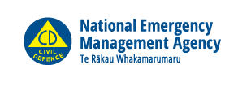
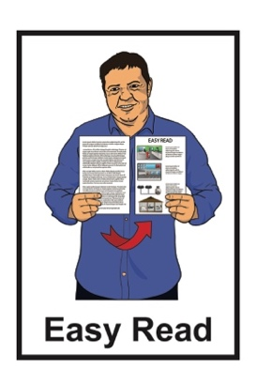

Tell us what you think:
Making the law about
New Zealand emergency management better
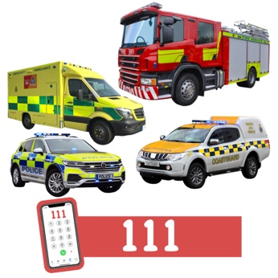
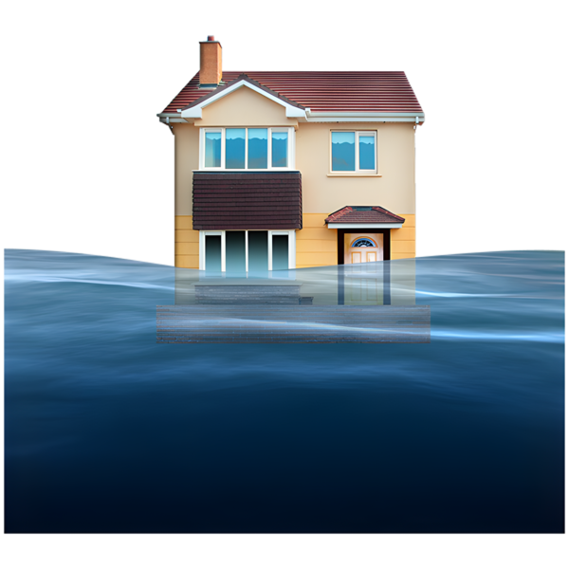

Published: April 2025

Before you start
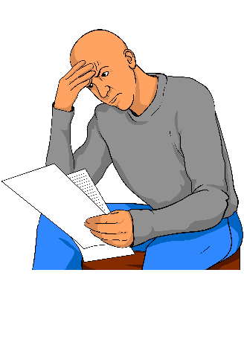

This information may upset some people when they are reading it.

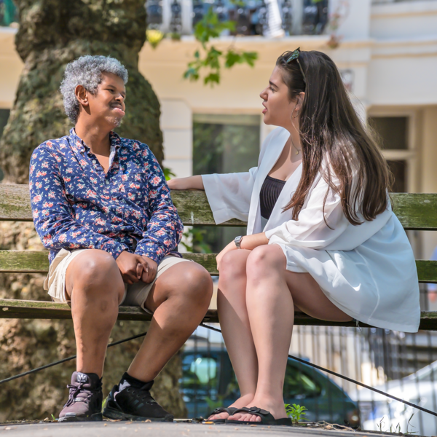
If you are upset after reading this document you can talk to your:
whānau / family
friends.

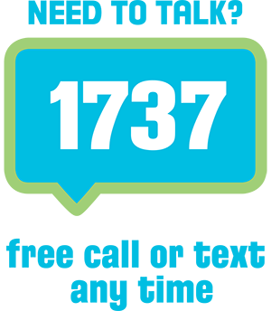
You can also contact Need to Talk by:
calling 1737
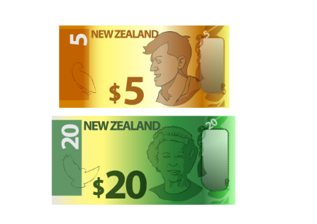

texting 1737

It does not cost any money to call / text 1737.
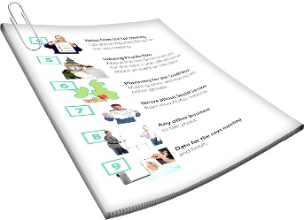
This is a long document.

It can be hard for some people to read a document this long.

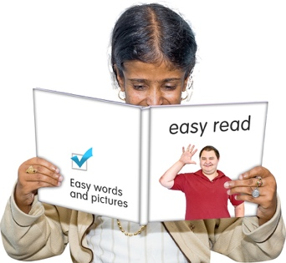
Some things you can do to make it easier are:
read it a few pages at a time
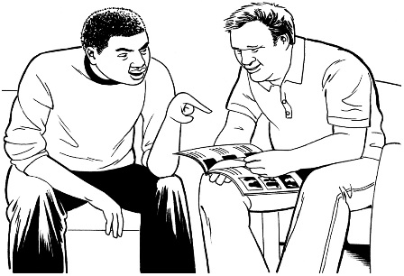
set aside some quiet time to look at it
have someone read it with you to support you to understand it.

What is in this document

Page number:
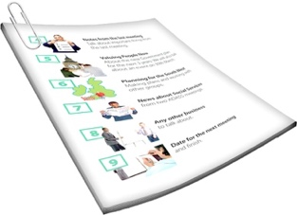

About this document 5

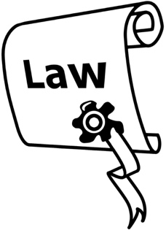
What does the Civil Defence
Management Act do? 10

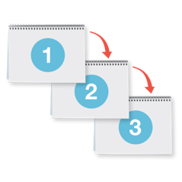
Objectives 15

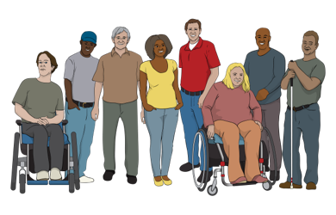
Objective 1 – Make strong
community connections 17

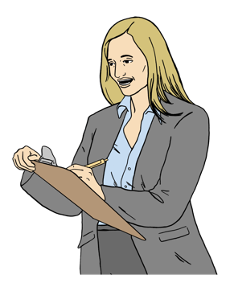
Objective 2 – Have clear
responsibilities 25

Page number:

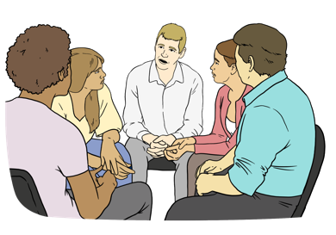
Objective 3 – Make emergency
management work well
in every region 31

Objective 4 – Make sure essential
services are not disrupted 36

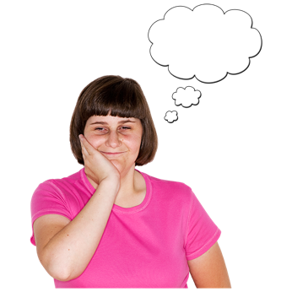
Objective 5 – Have the right
powers ready when an emergency happens 40

Tell us what you think 43

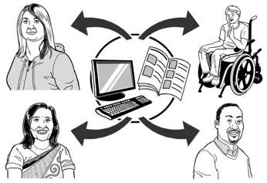
What happens to the information
you give us? 46

About this document

This document has been made by the National Emergency Management Agency.

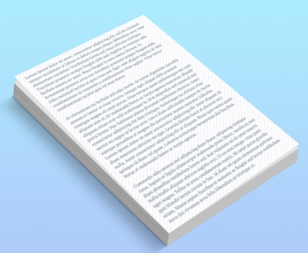

We call the National Emergency Management Agency NEMA for short in this document.

When you see the words
we / us / our in this document it means NEMA.

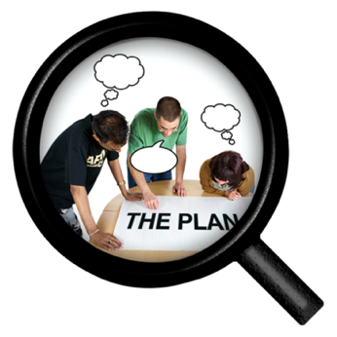
NEMA is the main government agency for managing emergencies in New Zealand.

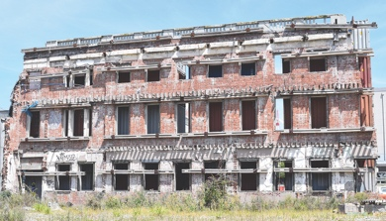
Here an emergency is a very big event that puts a lot of people in danger.

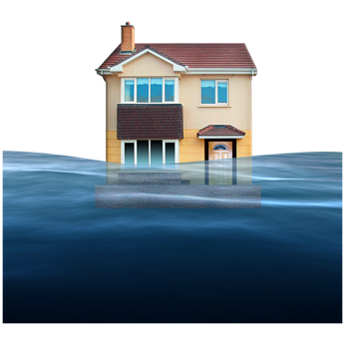
An emergency can be things like:
earthquakes
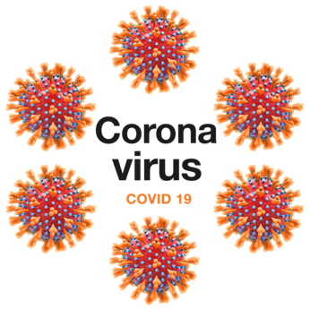
big fires
flooding
pandemics like COVID-19.

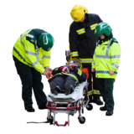
New Zealand has had a lot of emergencies where people have:
been hurt
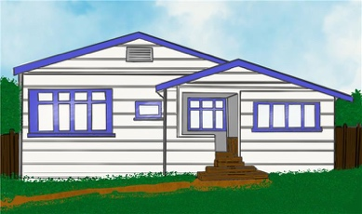

died
lost their home.

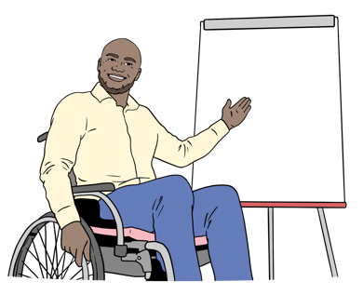
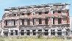
This document is:
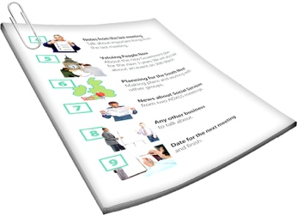
an Easy Read summary of our document about changing the emergency management law
a consultation document.


A summary:
- is shorter than the main document
tells you the main ideas.

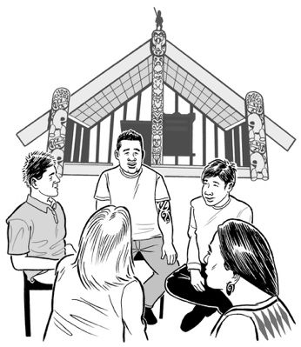
Here consultation is the different ways we find out what people think about our draft document like:
meetings
asking questions.

This year the law about emergency management in New Zealand is being changed.

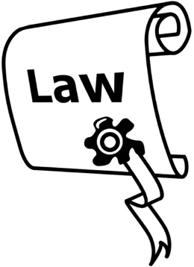
A law is a rule made by the Government that everybody must follow.

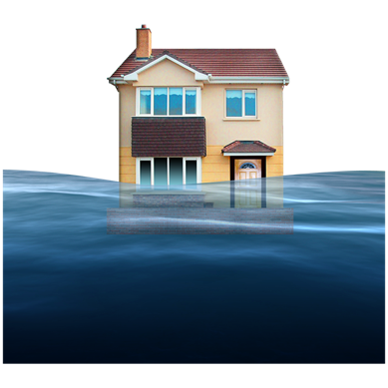
This law is called the Civil Defence National Emergency Management Act 2002.

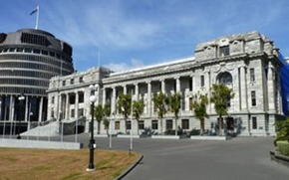
The Government wants to change this law to make managing emergencies in New Zealand better.

This document tells you the things we think should be in the new law.

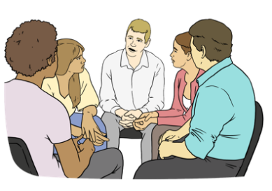
We want to hear what you think about our ideas.
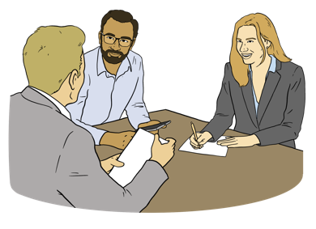
Your feedback will assist us to tell the Government how we think the emergency law can be made better.
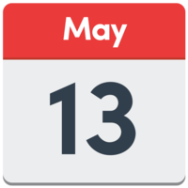
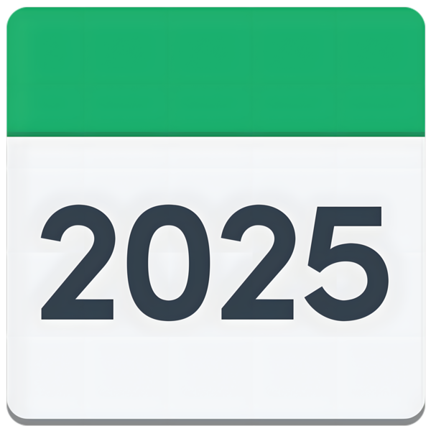
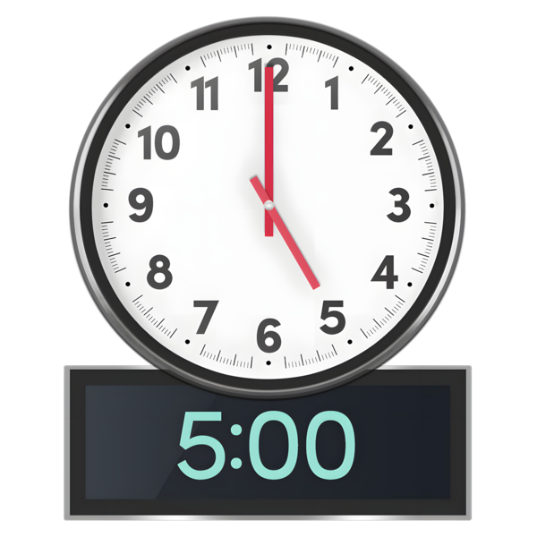

We need to get your feedback by:
13 May 2025
5 pm.

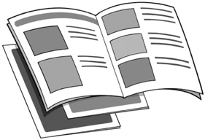
Find out how you can give us your feedback on page 43.

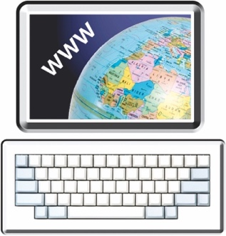
You can read the full consultation document at this website:

https://tinyurl.com/3uarb97n
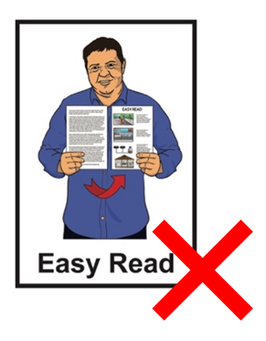

This document is not in Easy Read.

What does the Civil Defence Emergency Management Act do?

The Civil Defence Emergency Management Act is called
CDEM Act for short in this document.

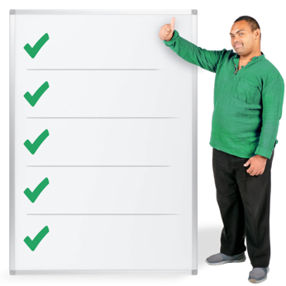
The CDEM Act says what jobs need to be done during an emergency by places like:
government agencies
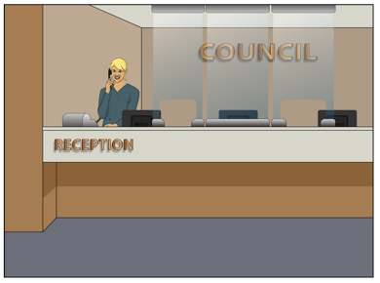
councils
emergency services like:
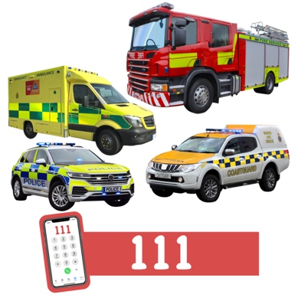
- ambulance
- police
- fire.

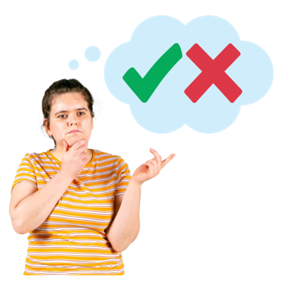
The CDEM Act says what extraordinary powers can be used to keep people safe during an emergency.

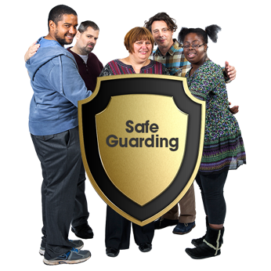
Here extraordinary powers are things the Government can do to keep people safe during an emergency.

For example during very bad storms people were told to leave their homes to keep them safe.

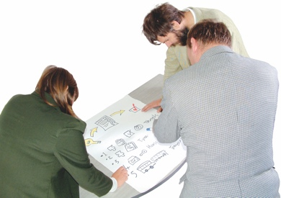
The CDEM Act says what planning should be done before an emergency happens.

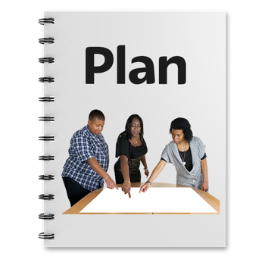
Having a plan in place can support people to be safe when an emergency happens.
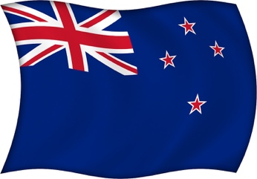
New Zealand has had a lot of emergencies like the:
Christchurch earthquakes
very bad storm called Cyclone Gabrielle.

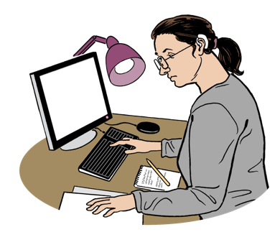
Reports have been made about:
emergencies like
Cyclone Gabrielle
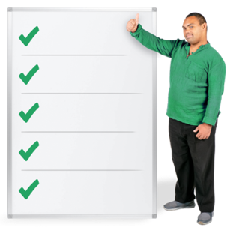
and
what things should be done better.

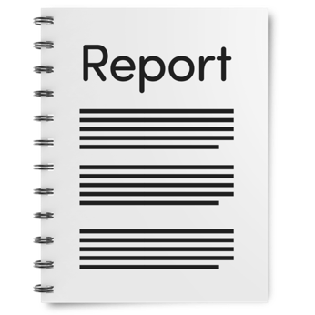
These reports say work needs to be done to manage emergencies better.

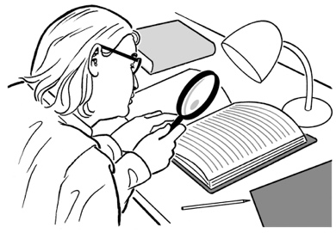
The Government is looking at ways to make emergency management better like:
making a new law
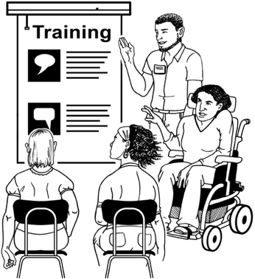
having more ways to train people how to manage emergencies
trying to make sure infrastructure can keep working during an emergency.

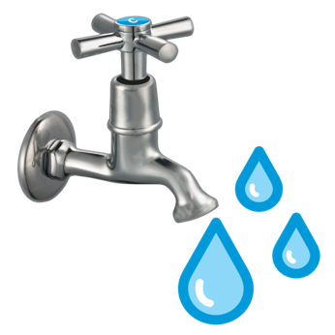
Infrastructure is the important things to keep a city or town working like:
power like electricity
water
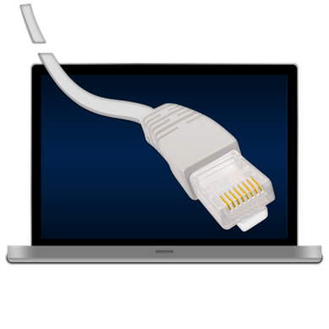
roads / bridges
internet
hospitals.

Having good ways to manage emergencies will protect people:
during an emergency
after an emergency.

Objectives

The Government has 5 proposed objectives to make emergency management better in New Zealand.

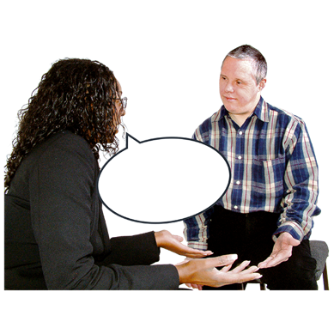
Here proposed means:
the objectives can be changed.
ideas can be shared about changes to the objectives.

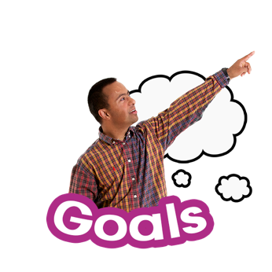
Here objectives mean:
the goals we want to reach to make emergency management better
the work needed to reach the goals.

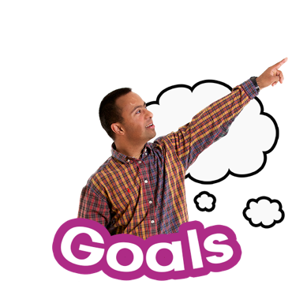
We want to find out what you think about the 5 proposed objectives.

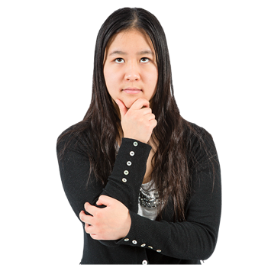
There are ideas in each objective we would like you to think about when you give us your feedback.

1 to 16
These are numbered from 1 to 16.

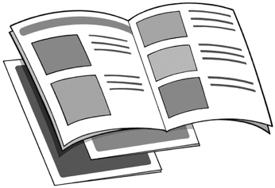
We tell you about each objective on the next pages.

Objective 1 – Make strong community connections

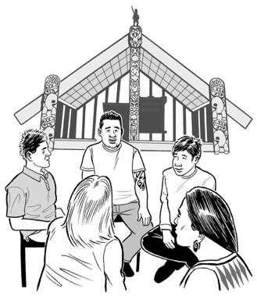
Everyone can take part in emergency management.

This objective is about making sure all communties have a say in emergency management like:
Māori
the disability community.

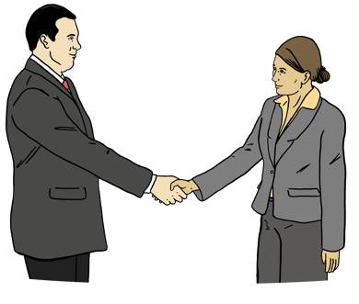
We would like people in our communities to work with the official emergency management response.

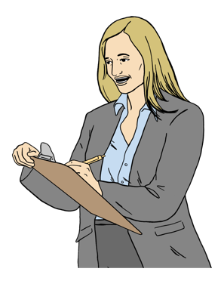
Here official means the people working at places like:
government agencies
emergency services.

This means people in the community can take part in:
the planning before an emergency happens
supporting people:
- during an emergency
- after an emergency happens.

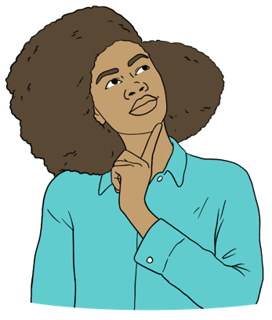
Things to think about for Objective 1

- Meet the needs of all communities

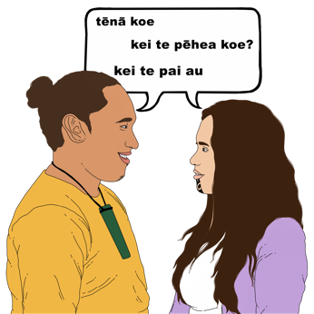
We could meet the needs of different communities by making information in other ways like:
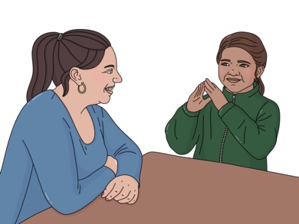
Te Reo Māori
New Zealand Sign Language
different languages.

We could make sure councils think about the different groups in their communities when making emergency plans like:
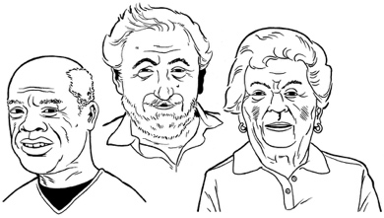
disabled people
older people.
We could make sure NEMA works with different communities when making national emergency management plans.
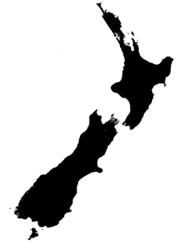

Here national means emergency plans for the whole country.

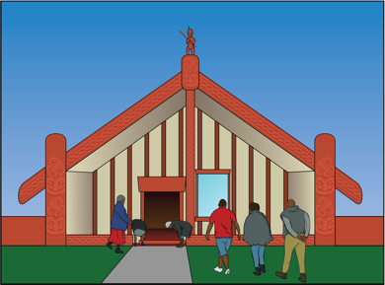
- Make sure Māori can take part more in emergency management

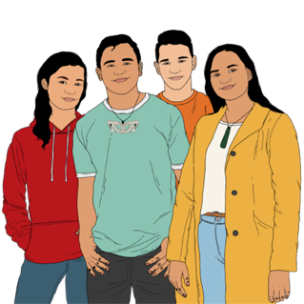
It is important to build strong connections with Māori.

We will need to work with Māori to make sure they are part of emergency management when:
making plans
talking about what will happen:
- during an emergency
- after an emergency.

Māori could also have roles at places making decisions about emergency management, like councils.

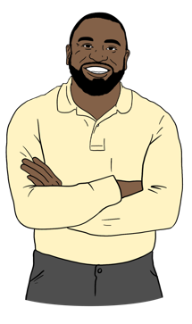
NEMA could also ask Māori for advice when making national emergency management plans.

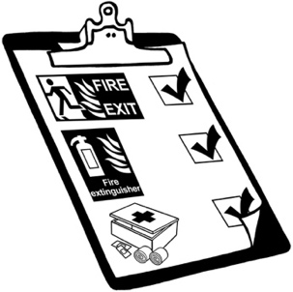
- Make better ways for the community to be part of emergency management

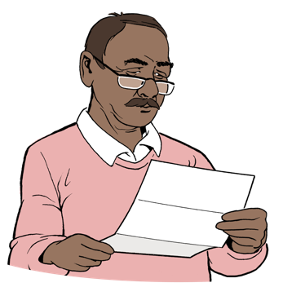
Emergency planning could have been better for community groups about:
how to prepare for an emergency
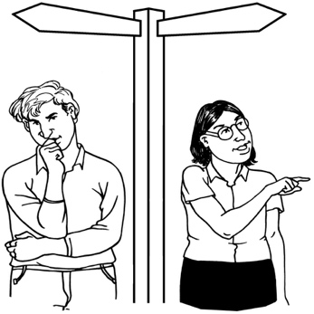
what to do in an emegency
where to go for support during an emergency.
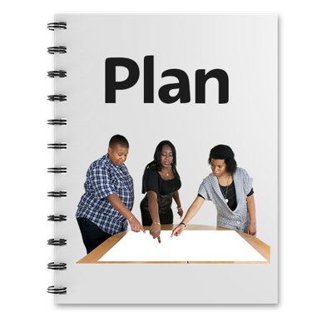

Councils could also make plans for how to manage people who want to assist during an emergency.

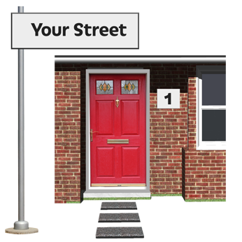
- Understand people in the community are often the first to give support in an emergency

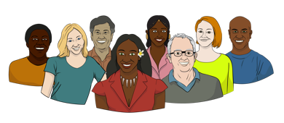
The first people to start supporting in an emergency are often:
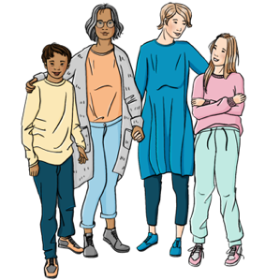
people living where the emergency is happening
local businesses
local community groups.

The law could protect people when they try to help others during an emergency.

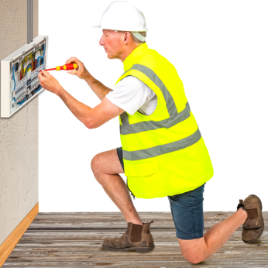
We need to decide if people should be paid when they have been asked to do some jobs during an emergency.

Objective 2 – Have clear responsibilities
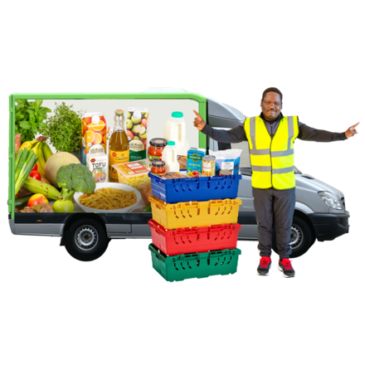

Here responsibilities means
people / organisations are doing the jobs they have been asked to do during an emergency.

There are many people / organisations that have things to do in emergency management.

It is important everybody working in emergency management know their responsibilities in each:
region like Canterbury
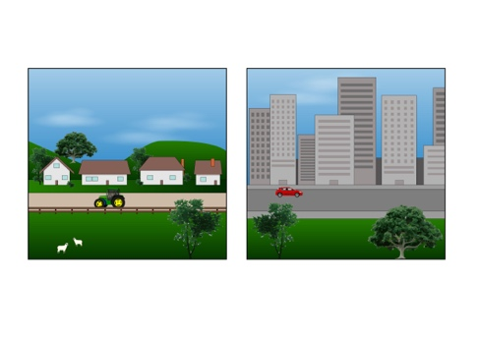
local area like a:
- suburb
- town.
The Government want to make sure:
it is clear who will do each job
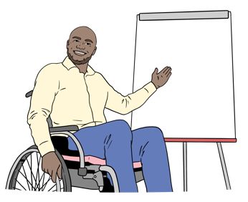

organisations work together
organisations know what they have to do under the CDEM Act.

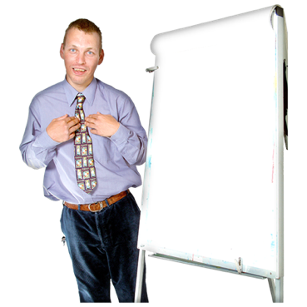

Things to think about for Objective 2
- Clear management of the whole emergency response
It is important people know who is managing the response during an emergency.

Information people are given needs to be clear so people:
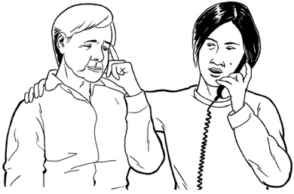
understand it
can be kept safe.

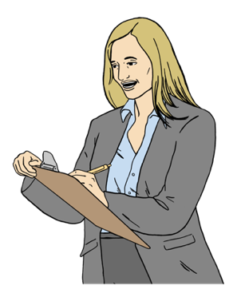
People need to know who is leading the emergency response if no state of emergency has been declared.

A state of emergency is when the Government or a local council:
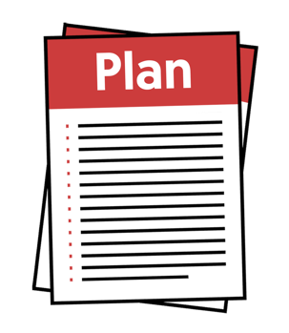
- declares an emergency is happening
- emergency plans can be put into action.
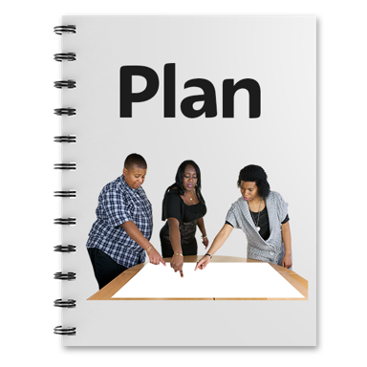

This information should be put in the plan.
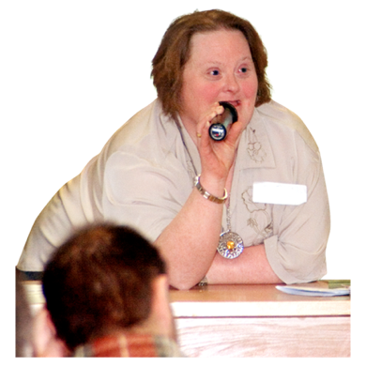
People doing jobs during an emergency need to know:
what they are expected to do
who they get directions from.

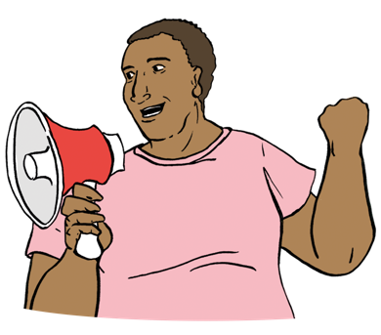
Here declare is to tell people about something very important like an emergency is happening.

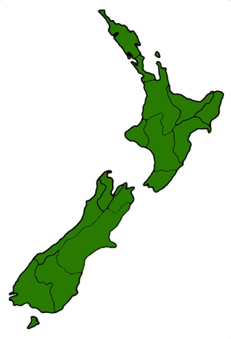
- Emergency management in the regions need strong leaders

There need to be good leaders in the different regions of New Zealand.

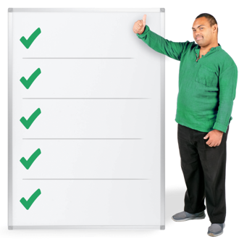
This will support people to:
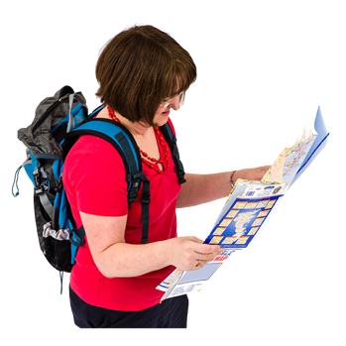
- work out all the jobs that need doing during an emergency
- know where to go to support people during an emergency.

- Make sure emergency management plans are up to date

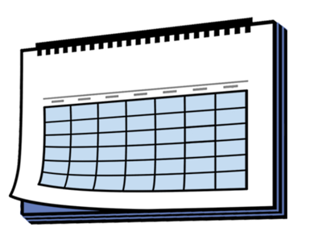
It is important emergency plans are kept up to date.

Not having the right information can put people in danger.

Objective 3 – Make emergency management work well in every region

Each region is different.

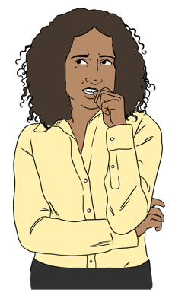
This means each council has different:

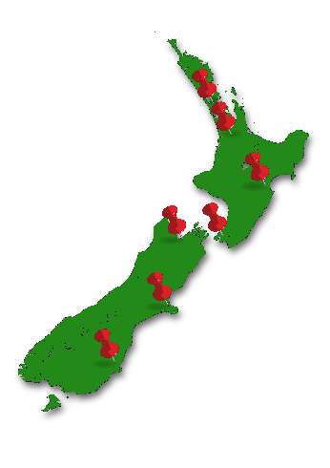
hazards to manage during an emergency
ways to manage an emergency that is right for their region.

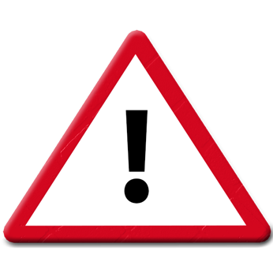
A hazard:
is something that could hurt someone
might not look like it could put someone in danger.
We think it is important good emergency management is in place for:
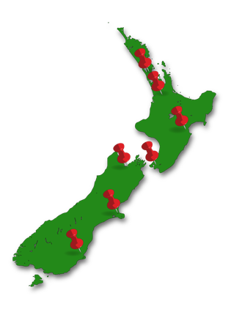
everyone in New Zealand
every part / region of
New Zealand.

Things to think about for Objective 3
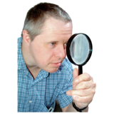
- Make sure people / organisations doing jobs are properly monitored:
before an emergency
during an emergency
after an emergency

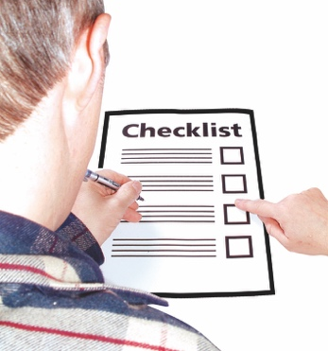
Here monitoring is when something is being looked at closely to find out:
- how well it is working
- if things need to be changed to make it work better

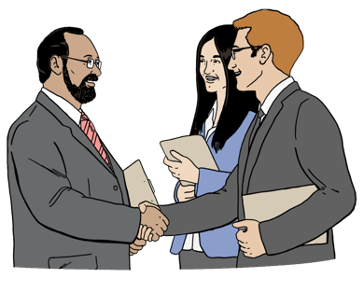
We want to make sure the people responsible for work during an emergency do their jobs in the right way.
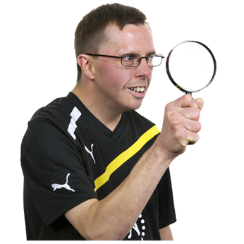

To find this out we will need to monitor how work is being done.

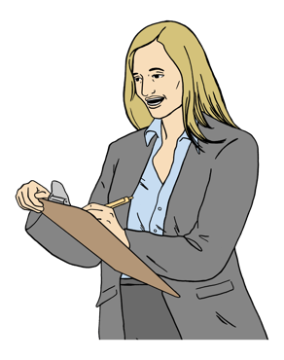
There should be ways to make people / organisations do their jobs in the right way.

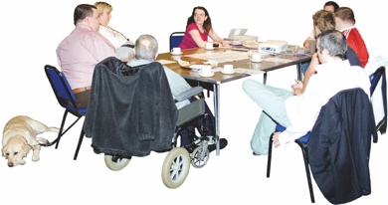
- Manage hazards better in the regions

Hazard management needs to be made better by local councils.

Councils need to know about the hazards in their region that could cause harm during an emergency.


When they find a hazard they can decide how to make it safer during an emergency.

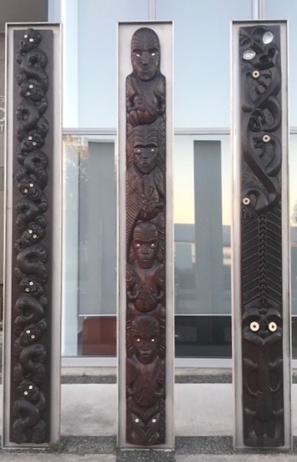
- Think about protecting other important things during an emergency.

Not only people need to be protected during an emergency.

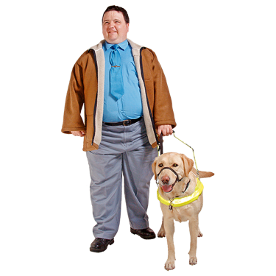
Other things that should be protected can be things like:
taonga Māori /
Māori treasures
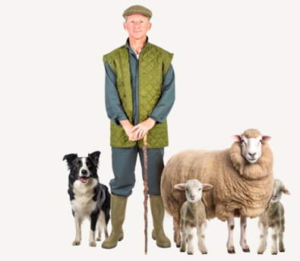
working animals
stock
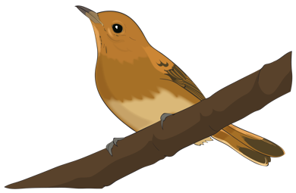
pets
wildlife.

Objective 4 – Make sure essential services are not disrupted

Here disrupted means that essential services are not able to:
work as well as normal
not able to do their job properly.

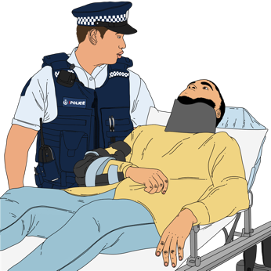
Essential services are things people need like:
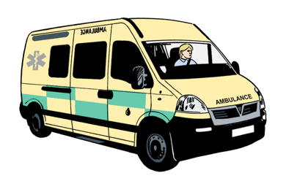
emergency services to keep people safe like the:
- Police
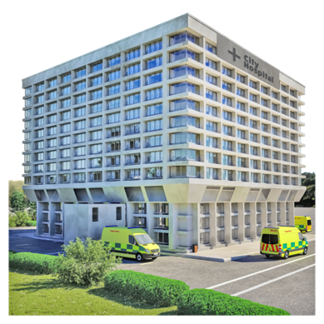
- ambulance servcies
healthcare places like hospital
power.
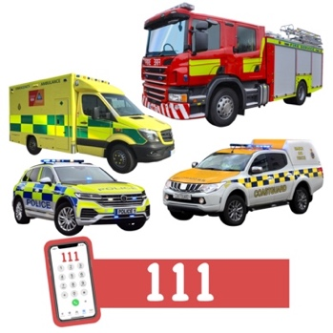
We all need essential services to keep us safe.

The Government want to make sure emergencies do not disrupt essential services too much.

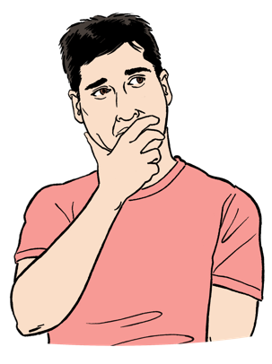
Things to think about for Objective 4
- Work out how to protect essential services during an emergency
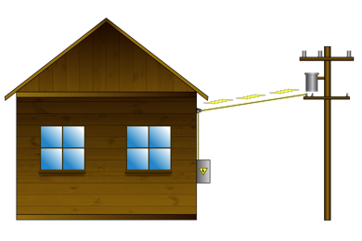
We will need to make sure organisations providing essential services:
share their information
work together
- look at how they can stop essential services being disrupted
- look after their infrastructure.

- Make sure government organisations that provide essential services have emergency plans
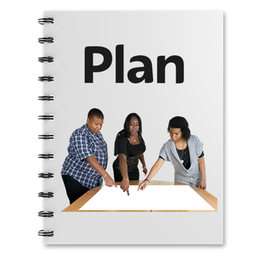
Government organisations need to make good plans so their services are not disrupted during an emergency.

They will sometimes need to work with other government agencies to do this.

For example Health New Zealand should have plans to make sure people can get health care during an emergency.

Objective 5 – Have the right powers ready when an emergency happens

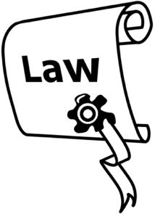
The CDEM Act can give extraordinary powers to support people to be safe:
during a state of emergency
recovering from an emergency.

The Government want to make sure these extraordinary powers are used:
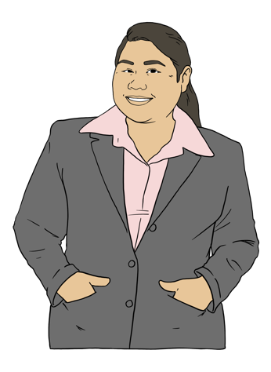
in the right way
by the right people.

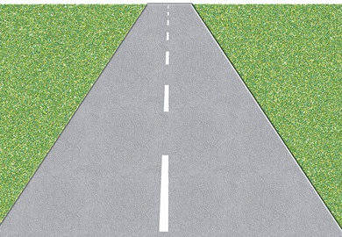
- Closed roads / places need to be managed safely

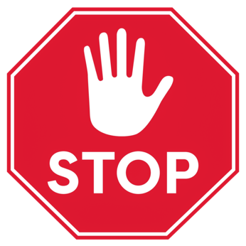
During and after an emergency there are powers to close some
roads
places.

This will keep people out of these areas.

It is important to manage this power in the right way.
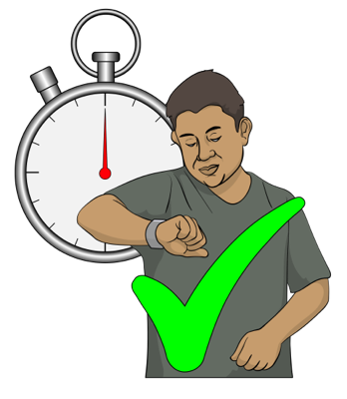

It is also important to make sure emergency workers who need to get to these places can get in.

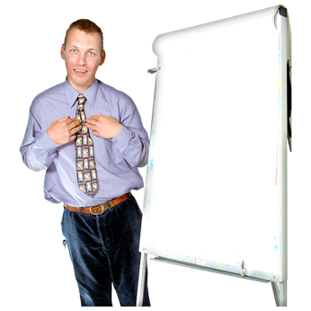
- Make sure the right people have the right powers:
before an emergency
during an emergency
after an emergency
- Make sure a state of emergency can be declared at the right times
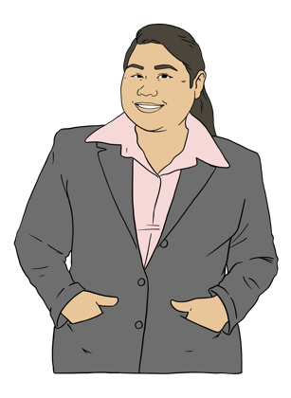
- Make it clear who can declare a local state of emergency

Tell us what you think
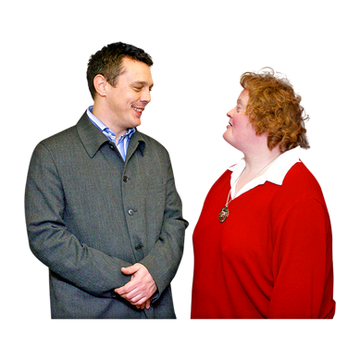

We want to hear what you think about:
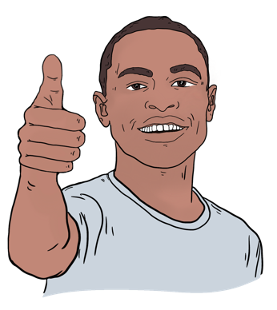
the ideas in this consultation document
ways to make the emergency management law better.

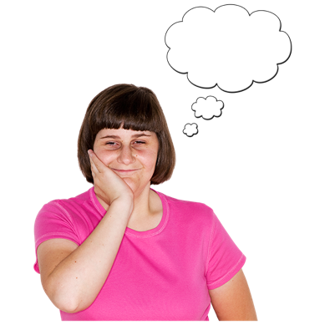
We would like you to tell us if you:
think we have thought about the right things to make the emergency management law better
think the ideas in this document are very good
have other ideas to make this law better.
You need to send us your feedback by:
13 May 2025
5 pm.

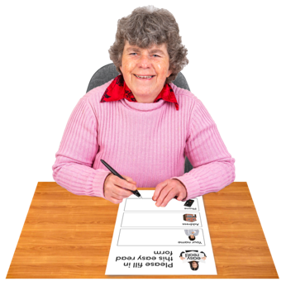
You can give us your feedback by filling out a form on our website at:

www.civildefence.govt.nz

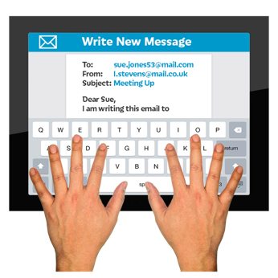
You can also give us your feedback by sending us an email at:

EmergencyManagementBill@nema.govt.nz

You can put your feedback in:
English
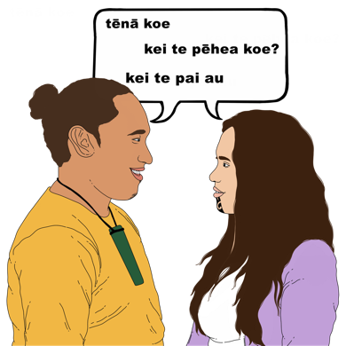
or
Te Reo Māori.

What happens to the information
you give us

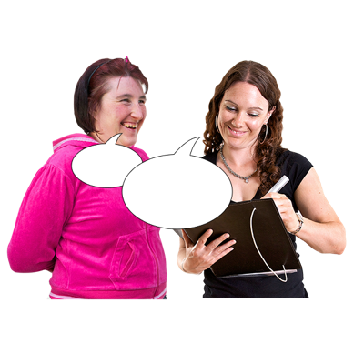
Your feedback may be shared:
with other government agencies
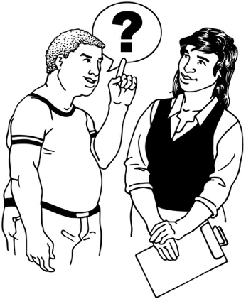
on our website
if somebody asks to see feedback under the Official Information Act.

The Official Information Act is a law that tells government agencies how to look after their information.

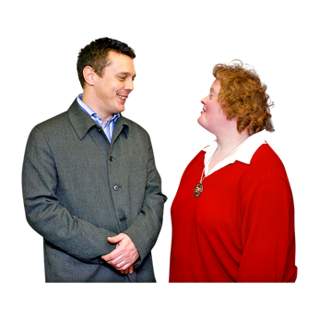
You need to tell us if you:
do not want any of your feedback to be shared
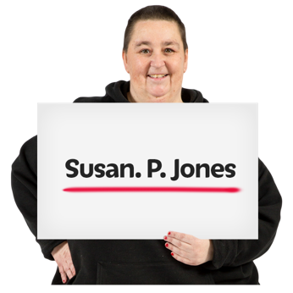
only want some of your feedback shared
do not want your name to be shared.

This information has been written by the National Emergency Management Agency.

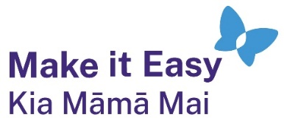
It has been translated into Easy Read by the Make it Easy Kia Māmā Mai service of People First New Zealand Ngā Tāngata Tuatahi.
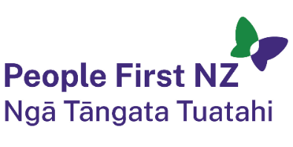
The ideas in this document are not the ideas of People First New Zealand Ngā Tāngata Tuatahi.

All images used in this Easy Read document are subject to copyright rules and cannot be used without permission.

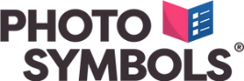
Make it Easy uses images from:

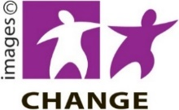
- Photosymbols

- Change Images


- Huriana Kopeke-Te Aho
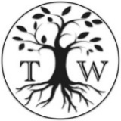
- SGC Image Works

- T Wood

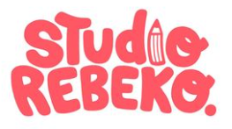
- Studio Rebeko

- Inga Kramer.

