MCDEM Resilience Fund Final Report
Project name: Tsunami Warning System
Reporting authorities: Ōpōtiki and Whakatāne Districts
Report produced by: Jim Tetlow, Eastern Bay of Plenty Emergency Management Co-ordinator
Date of Report: June 2013
Executive Summary:
An application was made to the MCDEM Resilience Fund in 2012 for assistance to develop a coastal alerting system along the Eastern Bay of Plenty Coastline. The project sought to utilise existing New Zealand Fire Service Sirens with some additional units to create a network of sirens along the coast. The sirens would be required to produce a constant rise tone for 10 minutes to signal a requirement for residents to switch on their radio for more information. The installation of the sirens was also to be backed up with an information campaign so that residents knew what the sirens mean and what they should do in the event that they are activated.

Project milestones:
Three project milestones were set to achieve the overall aim of developing a Tsunami warning system along the EBOP coast;

August 2012
Convert 5 existing New Zealand Fire Service sirens on EBOP coast to activate by pager and produce a constant rise tone.

This milestone was achieved, but due to issues relating to the use of the sirens it was not completed until February 2013. 5 existing NZFS sirens were converted to produce a 10 minute constant rise tone (see map). The system was successfully tested in April 2013.

November 2012
Undertake a public education campaign to promote sirens and actions the community should take.

This milestone was achieved in February 2013 to coincide with the conversion of the 5 existing NZFS sirens. The promotion included the development of a tsunami information booklet for the Eastern Bay of Plenty, beach signage and media coverage surrounding the public testing (radio interviews, newspaper adverts etc). Evacuation maps were developed for areas along the coast and this information is made available to the public through both councils and the Bay of Plenty Civil Defence Group website.

June 2013
Install additional sirens along the Eastern Bay of Plenty coastline.

This milestone was achieved in June 2013, with 3 additional sirens installed in Waiotahi and Ōhiwa (Ōpōtiki District) and Coastlands (Whakatāne District).
Example of Information boards placed at 37 locations along the EBOP coast |  | Example of Evacuation maps produced for web, signage and booklet
Example of the information booklet that was produced to accompany the installation of the sirens
Greg West of Rangitāiki Independent School next to the new siren installed to serve the Coastlands community on one of their buildings. | Ian Castles of Ōpōtiki District Council overseeing the installation of the siren at Ōhiwa Holiday Camp.

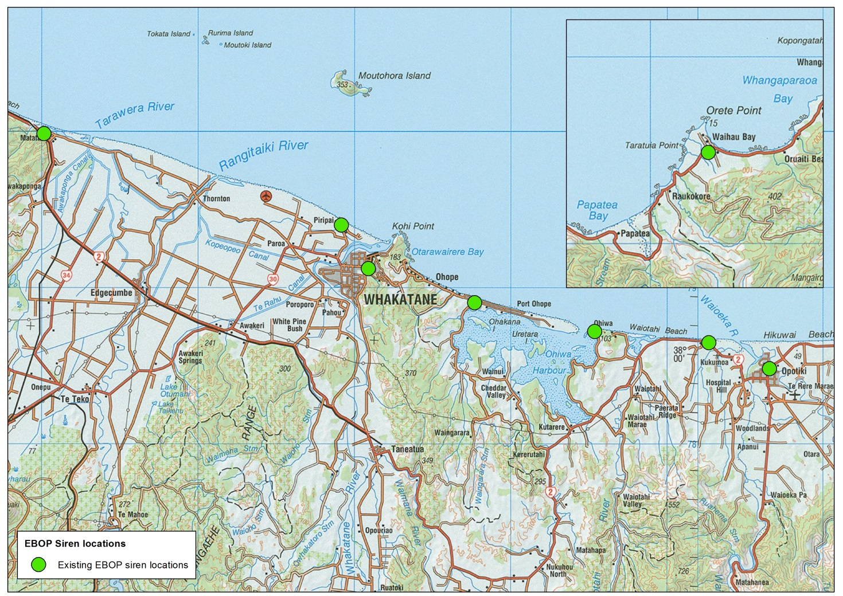
A map showing the locations of the 8 sirens installed as part of the project
Challenges and Issues:

During the project there were a number of challenges that had to be overcome. These included:
- Utilising the existing NZFS sirens to be activated independently of the 111 control room
  - This required independent control boxes developed by Kordia linked to pager numbers and agreement from the NZFS at a national level to activate the sirens independently. Protocols are in place to ensure that the NZFS are aware of activations before they occur.
- Pager signal in remote locations
  - On 3 of the sirens additional aerials were required to ensure constant quality of the pager signal to ensure activation
- Choosing locations for additional sirens and gaining agreement with private landowners for sighting of additional sirens
  - The choice of site for the additional sirens was based upon identified gaps in coverage for permanent residents and requirements for coverage in areas with high summer populations. Gaps in coverage still remain, however, the locations chosen aim to maintain coverage in the most populated areas of the coast until further warning methods are implemented.
- Additional un-identified costs
  - During the installations there were a number of unidentified costs that increased the overall expenditure in the project. These included requirements for additional mounting structures in some locations and strengthening of roof structures to support the weight and vibrations of the siren units when activated. There were also costs associated to increasing pager signals in some areas, which had not been foreseen.
- Ensuring the public understand what the sirens mean
  - The sirens are activated to alert the public to an event and the action to be taken is to listen to the radio for more information. However, regardless of the public education campaign, there are still some within the community who believe it is the signal to evacuate. We will aim to test the sirens regularly and continue the public education campaign to ensure the message regarding what the sirens mean is pushed out through as many different forms of media as possible.

