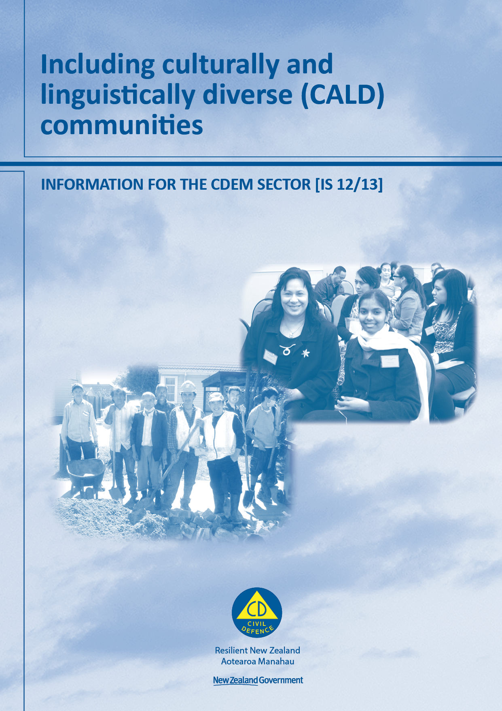
Including culturally and linguistically diverse (CALD) communities
Information for the CDEM sector

Information Series [IS12/13]

June 2013
ISBN: 978-0-478-35573-4
Published by the Ministry of Civil Defence & Emergency Management

This guide is not copyright and may be reproduced with acknowledgement. This guide is available on the website www.civildefence.govt.nz

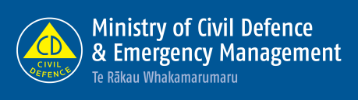

Ministry of Civil Defence & Emergency Management
PO Box 5010
Wellington
New Zealand
Tel: +64 4 473 7363
Fax: 64 4 473 7369

Email: emergency.management@dia.govt.nz
Website: www.civildefence.govt.nz

Foreword
This document has been developed to address an identified gap during the response to the earthquakes in Christchurch. Reviews emphasised the vital importance of partnership between CDEM organisations and communities, and the need for more effort to be made to foster these partnerships, particularly during readiness. Having all members of all communities involved in planning activities will help enhance their resilience to emergencies.
Culturally and linguistically diverse (CALD) communities may be at risk of being overlooked during preparations for and response to civil defence emergencies. The responsibility for addressing this, and generating engagement with CALD communities, lies primarily with local authorities. Their aim should be to partner with CALD communities to include them in readiness preparations, harness their strengths, and develop relationships and arrangements that are critical for an effective response to an emergency.
This document outlines my intention to provide guidance to CDEM practitioners regarding the inclusion of CALD communities in planning for emergencies. The main audience for this document is CDEM practitioners, and it has been developed with the involvement of a number of stakeholders, including the Ministry of Pacific Island Affairs, the Office of Ethnic Affairs, Te Puni Kōkiri, community groups, and CDEM Groups.

John Hamilton
Director of Civil Defence Emergency Management

Contents
Section 1 Introduction 5
1.1 The Aotearoa New Zealand context 5
1.2 About this document 5
Section 2 The partners 7
2.1 Culturally and linguistically diverse communities 7
2.2 Civil defence emergency management (CDEM) 10
Section 3 MCDEM documents 12
3.1 Relevant MCDEM documents 12
3.2 Information that will be included 12
3.3 Examples of relevant text 14
Appendix A Examples from the PIM Guideline 15
Appendix B Information sources 17

Introduction

The Aotearoa New Zealand context
Aotearoa New Zealand is officially a bicultural nation, and is governed by a bicultural legislative foundation. The two predominant cultural groups are Māori and New Zealand Pākehā (people of European origin). New Zealand has three official languages: Te Reo (Māori language), English, and New Zealand Sign Language.
Aotearoa New Zealand is becoming increasingly multicultural so there are increasing numbers of people who identify with other cultures and use languages other than Te Reo or English as their first language.
Business as usual for civil defence emergency management (CDEM) caters for Aotearoa New Zealand’s predominant cultural groups. This document focuses on the needs of people who use languages other than Te Reo or English, or who identify with cultures other than Māori or New Zealand Pākehā.

About this document
The intended audience of this document is anyone with an interest in how the Director of CDEM intends to provide guidance on meeting the requirements of members of culturally and linguistically diverse (CALD) communities when carrying out emergency management, including:
- CDEM personnel, and
- members and representative organisations of CALD communities.
CDEM personnel are required by the Director of CDEM to ensure that all planning, response and recovery arrangements include CALD communities.
The purpose of this document is to outline the ways in which guidance from the Director of CDEM will include provisions for CALD communities.

Background of this document | Following the Canterbury earthquakes, central and local government acknowledged that they needed to improve how they engaged with CALD communities when carrying out emergency management.  The Ministry of Civil Defence & Emergency Management (MCDEM) undertook to provide guidance for CDEM personnel based on the findings of research and reports including Best Practice Guidelines, Engaging with CALD Communities in Times of Disaster, prepared for the Christchurch City Council and Partnership Health Canterbury on behalf of Community Language Information Network Group (CLING).  The Director of CDEM is committed to providing guidance on including CALD communities in all aspects of CDEM.

CALD community topics | MCDEM guidance aims to support CDEM organisations to improve their engagement with CALD communities before, during, and following an emergency, by including the following information in the relevant MCDEM documents:  - the importance of working in partnership with CALD communities to find out what is needed, during all levels of engagement  - specific issues related to CALD communities in CDEM and how to address them, and  - where to get more information.
Mainstreaming information about CALD communities | The information will be incorporated into all relevant MCDEM documents, rather than as a review of the now withdrawn publication Working Together: Guidelines for Emergency Managers working with culturally and linguistically diverse communities, because:  - it provides an inclusive approach to CALD communities  - the information is more easily available for personnel who carry out any relevant CDEM tasks  - a stand-alone document is less likely to be referred to during an emergency, and  - information about CALD communities can be included in the current review of MCDEM documents.
Accessibility | In this document, ‘accessibility’ refers to characteristics of the built environment, and of information and communication systems, that enable their use by all members of the community, regardless of people’s cultural or ethnic identity, or their age, and including people who have physical, sensory, neurological, mental, or intellectual impairment.

The partners

Culturally and linguistically diverse communities
Members of culturally and linguistically diverse (CALD) communities are people who do not speak English or Te Reo (Māori language) as their primary language, or who have been (or are being) raised in a different culture from the predominant one where they live.
Differences in culture may arise from their country of birth, their circumstances, the ethnic group they identify with (including beliefs, customs, values, and traditions), the language they choose to use, or their faith.
CALD communities include people from refugee and migrant backgrounds, international students, tourists, and international visitors. Members of CALD communities may be New Zealand-born, and some CALD communities have been established for a long time. CALD communities in New Zealand consist of Pacific peoples, Asian, Middle Eastern, Latin American, African and Continental European groups.
It is important to note that ethnicity is self-defined/determined, and that there are a lot of differences between and within CALD communities.

CALD communities’ strengths and partnerships | CALD communities have many strengths. Community members may have valuable skills, experience, and language capabilities.  CALD community networks are often well developed with strong connections both within their own community and between communities. Community leadership is often well established. Partnering with CALD community leaders can enable appropriate and effective engagement and communication with community members.
Cultural and linguistic considerations | CDEM personnel and members of CALD communities may face specific challenges. For example, both groups may have difficulty with communicating with each other because of differences in ability with spoken or written English.  Receiving or accessing information may also be difficult for some people if they have limited access to media such as radio, television, newspapers or the internet because of their culture, faith, or social circumstances.  Some CALD community members may be Deaf, which further compromises their understanding of media communications and public information. These people may require additional support.  CALD community members often have specific requirements around social interaction, food, prayer, or gender.  In an emergency CALD community members may have an urgent need to communicate with family overseas (and agents, in the case of international students). They may also base their response to an emergency on past experience in a non-New Zealand context.  The emergency situation may trigger anxiety and stress associated with prior experiences and the psychosocial needs of a person must be considered in addition to their practical requirements.

CALD community organisations | Organisations that represent CALD communities, or provide support or advocacy, are often based on country of origin, religion, or specific tribal groups or geographic regions. Some organisations represent more than one community. There are also organisations that specifically support migrant or refugee settlement, or international students.

Key CALD community resources
The following resources provide information about local, regional, or national organisations relating to CALD communities that may be useful to CDEM personnel.
Information on tools that may assist CDEM personnel in implementing recommendations for CALD communities will be included in MCDEM documents as relevant.
CALD community advisory groups | Some local authorities may work with CALD community advisory panels/groups that provide advice on a range of issues related to CALD communities.
Education New Zealand | Education New Zealand markets New Zealand as an education destination to international students, recruits students and collaborates with international education partners, including education agents who are part of the New Zealand Specialist Agent programme. Their website is www.educationnz.govt.nz.
Family and Community Services | The Family and Community Services (part of the Ministry of Social Development) website www.familyservices.govt.nz lists organisations which engage with some refugee and migrant communities.
International offices – tertiary education providers | Most formal tertiary education providers have an international office which can provide information about their international students. The Ministry of Education website www.minedu.govt.nz includes a directory of tertiary institutions.
Ministry of Business, Innovation & Employment – Tourism and Immigration | The Ministry of Business, Innovation & Employment (MBIE) publishes tourism research and data on international visitor arrivals into New Zealand and also on domestic travel. This information can be accessed either via the MBIE website www.mbie.govt.nz or directly from the Economic Development website www.med.govt.nz.  Immigration New Zealand, which includes settlement services, is part of MBIE. Their website is www.immigration.govt.nz. See Settlement Support New Zealand below.
Ministry of Education | Migrant and Refugee Education Coordinators are based in Ministry of Education regional offices in Auckland, Hamilton, Wellington, and Christchurch to provide support for students from refugee and migrant backgrounds, and to liaise with families and communities. Regional Pasifika Education Coordinators are based in Auckland, Rotorua, and Christchurch regional offices. More information is available on their website www.minedu.govt.nz.
Ministry of Pacific Island Affairs | The Ministry of Pacific Island Affairs promotes the social, economic and cultural development of Pacific peoples in New Zealand. Information about local Pacific communities is available through their regional offices, and on their website www.mpia.govt.nz.

New Zealand Federation of Multicultural Councils | The New Zealand Federation of Multicultural Councils (NZFMC) acts as an umbrella organisation for ethnic and migrant communities of New Zealand, providing advocacy and support. The NZFMC has a Youth Council and an Ethnic Women’s Council. Their website www.nzfmc.org.nz provides information and contacts for regional multicultural/ethnic councils.
New Zealand Human Rights Commission | The New Zealand Human Rights Commission website www.hrc.co.nz provides information on requirements to ensure people are treated fairly and equally.
New Zealand Police Ethnic/Asian Liaison Officers | New Zealand Police Ethnic/Asian Liaison Officers work with CALD communities in Auckland, Wellington and Christchurch. To find out if there is an Ethnic/Asian Liaison Officer working in a particular area, make contact with the local Police Station.
New Zealand Red Cross Refugee Services | New Zealand Red Cross Refugee Services (formerly Refugee Services Aotearoa) runs the New Zealand resettlement programme for quota refugees. The programme supports refugees for one year after their arrival in New Zealand to settle in Auckland, Hamilton, Wellington, Nelson and Palmerston North. More information is available on their website www.redcross.org.nz/refugee-services.
Office of Ethnic Affairs | The Office of Ethnic Affairs website www.ethnicaffairs.govt.nz has many resources. These include the Community Directory, a list of some community associations and organisations from specific ethnicities and nationalities.
Regional Tourism Organisations | Regional tourism organisations operate in around 27 regions in New Zealand and are responsible for promoting their region to international and domestic visitors. Regional tourism organisations act as a bridge between tourism operators, national tourism bodies, and local and central government. More information is available on their website www.rtonz.org.nz.
Settlement Support New Zealand | There are Settlement Support New Zealand offices in 18 locations around the country with some based at local councils. Free information is provided and migrant settlement support advisors help new migrants with local settlement requirements. More information is available on their website www.ssnz.govt.nz/regional-information/index.asp.
Statistics New Zealand | Statistics New Zealand provides population estimates and projections containing statistics about the size and composition of New Zealand’s population. This includes ethnic, regional, and household populations, tourist accommodation surveys by region, as well as past, present, and future populations. Their website is www.stats.govt.nz.
Tourism New Zealand | Tourism New Zealand is the Crown Entity responsible for promoting New Zealand as a tourist destination. More information is available on their website www.tourismnewzealand.com.

Civil defence emergency management (CDEM)
This is a brief overview of CDEM (pronounced sea-dem).
For a comprehensive description of CDEM, please refer to the Guide to the National Civil Defence Emergency Management Plan (the Guide), available at www.civildefence.govt.nz.

Description of CDEM | In general terms, CDEM covers the actions required for improving the safety of people or property in relation to emergencies.  The legal definition is given in the CDEM Act 2002, available at www.civildefence.govt.nz.  CDEM includes reducing the risks that result from an emergency (reduction), preparing for an emergency (readiness), responding to an emergency (response), and recovering from an emergency (recovery). Reduction, readiness, response, and recovery are known as the ‘4Rs’ in CDEM.
Building and maintaining relationships | During readiness, CDEM personnel foster relationships with partners and community groups and need to ensure that CALD communities are engaged and included. Opportunities for maintaining these relationships and keeping contacts up to date should be sought, for example hosting a regular forum.  In readiness for an emergency, representatives of CALD communities are recommended to make contact with their local council’s emergency management officer or community liaison officer. Some local authorities may also have local CALD community advisory panels/groups available to engage with CDEM personnel.  This will help the local council’s emergency management officer to determine the requirements of CALD communities (as well as what they may have to offer), include these in emergency planning, and facilitate preparedness outcomes that are suited to the communities’ needs.

Key terms and documents used in CDEM
MCDEM | The Ministry of Civil Defence & Emergency Management (MCDEM) (pronounced mick-dem) is the central government agency responsible for providing leadership, strategic guidance, national coordination, and the facilitation and promotion of various key CDEM activities.

CDEM Groups | Under the CDEM Act 2002, every regional council must form a CDEM Group that includes the local authorities within the region. CDEM Groups are responsible for carrying out CDEM in their region.  When there is no emergency, CDEM personnel are based in emergency management offices, which may be locally or regionally based.  During and following an emergency, additional CDEM personnel roles are required, and these may be carried out by council personnel or trained volunteers. They may be based regionally, locally, or in communities.
Key CDEM documents | The following documents are available on the MCDEM website www.civildefence.govt.nz by searching the document name.  Director’s Guidelines are documents developed by MCDEM to provide guidance to CDEM and other agencies regarding CDEM. They are issued by the Director of CDEM under the CDEM Act 2002.  The Civil Defence Emergency Management Act 2002 (CDEM Act) describes the legal requirements for CDEM in New Zealand.  The National CDEM Strategy describes the intentions of the Crown regarding CDEM provisions.  The National CDEM Plan (the Plan) mandates the actions required across the 4Rs (reduction, readiness, response, and recovery) and who is required to carry them out.  The Guide to the National CDEM Plan (the Guide) explains the Plan in detail.

MCDEM documents

Relevant MCDEM documents
As stated in the Introduction, the intention is that information regarding CALD communities will be incorporated into all relevant MCDEM documents. All MCDEM documents are available at www.civildefence.govt.nz.
The following MCDEM resources currently include CALD community information:
- Public Information Management Director’s Guideline contains comprehensive material relating to CALD communities.
- Mass Evacuation Planning [DGL 07/08] Director’s Guideline and the best practice guide Community engagement in the CDEM context [BPG 4/10] both mention the need to provide for ethnic communities. These references will be expanded when they are reviewed.
- Get Ready Get Thru website www.getthru.govt.nz provides information on the natural disasters that can happen in New Zealand and advice on how to be better prepared. The website is translated into Simplified Chinese, Traditional Chinese, Hindi, Korean, Te Reo Māori, Gagana Sāmoa, Lea Faka-Tonga, and Arabic.
CALD community requirements will be incorporated into relevant guidance and resources as they are reviewed or developed in future.
Working Together: Guidelines for Emergency Managers working with culturally and linguistically diverse communities has been withdrawn, on the basis that information about CALD communities will be integrated into all relevant MCDEM guidance.

Information that will be included
 | The information that will be provided in relevant MCDEM documents is outlined below.
Statutory basis for CALD community inclusion in CDEM | Any guidance issued by the Director of CDEM will be in line with treaties, agreements and legislation relevant to the statutory requirements for the inclusion of CALD communities in CDEM. These key documents include (but are not limited to):  - The Treaty of Waitangi  - New Zealand legislation:  - New Zealand Sign Language Act 2006  - Human Rights Act 1993  - New Zealand Bill of Rights Act 1990  - International treaties and agreements:  - United Nations Universal Declaration of Human Rights (UNUDHR)  - United Nations International Covenant on Civil and Political Rights (UNICCPR), and  - United Nations International Covenant on Economic, Social and Cultural Rights (UNICESCR).

Sourcing information about CALD communities | MCDEM documents will clearly state that the best source of information about what CALD communities require in a CDEM capacity are:  - members of CALD communities, and  - support and/or advocacy groups for CALD communities such as CALD networks, and community associations and organisations.
Accessibility of information | In relevant MCDEM documents, the requirements regarding accessible information for CALD communities will be described, and references for further information listed, including:  - general information accessibility requirements and tools for:  - written information/printed documents  - spoken/audio information  - visual communication, including New Zealand Sign Language  - electronic information  - meetings and briefings  - using social media and websites  - technology that supports accessibility  - additional specific requirements for CALD communities, including:  - the importance of initiating engagement and maintaining relationships during readiness  - providing education about CDEM  - using translators and interpreters (must be professional whenever practicable)  - how to access and work with interpreters  - less reliance on written information, including providing images as a supplement or as an alternative to text  - supplementing web-based information with other methods  - providing information in hard copy  - providing information in English alongside translated information  - distributing through existing CALD community networks and hubs, and  - making use of existing specialist media such as migrant and CALD publications and community radio.
Facility and service considerations | In relevant MCDEM documents, the facility and service requirements for CALD communities will be described, including:  - space for prayer  - gender-specific areas, and  - cultural and religious dietary requirements.

Other inclusions | MCDEM documents will also include:  - the requirement for relevant CDEM personnel to have training and development in cultural competency, cultural considerations, and accessible information  - a list of key sources for additional information, and  - a glossary of the common terms and abbreviations used by CALD communities.

Examples of relevant text
Information tailored to MCDEM documents | Information related to CALD communities included in MCDEM documents will be tailored to suit each MCDEM document.  For example, in the Public Information Management Director’s Guideline, the focus is on providing information to CALD communities, including:  - the importance of working with local CALD community leaders to determine what the communication requirements are before an emergency occurs  - providing messages in other languages  - use of Plain English to make information more easily understood and accessible to a wide audience, and  - using information channels already accessed by the local CALD communities.  Specific examples of references to the requirements of CALD communities in the Public Information Management Director’s Guideline are given in Appendix A.
Appendices | In addition to the information included in the main body of the document, the appendices will include information to support the understanding of CALD community issues that are relevant to CDEM.  For example, in the Public Information Management Director’s Guideline, there is an appendix on ‘Information accessibility’. It includes a background, obligations and legal requirements, how to make information accessible, key resources, and a glossary of related key terms.

- Examples from the PIM Guideline
The following examples are from the MCDEM publication Public Information Management: Director’s Guideline for Civil Defence Emergency Management Groups, which is a Director’s Guideline, developed under the Civil Defence Emergency Management Act 2002:

In section 2.2 PIM partnerships:

External partners | External partners may include:  - community groups – culturally and linguistically diverse (CALD) community groups (see Glossary of key terms…

In section 2.3.1 Communicating directly with the public, under Existing networks, gatherings, and meeting places:
Existing networks, gatherings, and meeting places are effective ways to reach potentially isolated sectors, including:
- …culturally and linguistically diverse (CALD) community groups…
PIM Manager’s responsibilities | The PIM Manager’s responsibilities include working with other CDEM and community liaison personnel to identify and connect with community/group leaders and key contacts, and determine when gatherings take place.  The PIM Manager also needs to ensure that information is prepared and distributed in formats and languages that will be received and understood by the groups (including printed versions), and that the content is relevant to the specific group or community.  Consider including ethnic student associations and young people’s networks, as they are often the most physically and technologically mobile.

In section 2.3.2 Communicating through the media:
- …community-specific newspapers are an effective way to reach some CALD communities…
- …Access Radio and community-specific stations need to be included as they are often the only radio stations that are regularly accessed by CALD communities, and…

In section 3.3.2 PIM Workspaces, under Setting up information points:
Requirements | An information point needs to:  - be accessible by everyone  - have accessible signage, in languages used by the local communities, so everyone knows information is available there during an emergency  - display current information verified by the PIM team, in accessible formats, and translated into languages used in the local community. Professional interpreters and translators must be used wherever practicable …

In section 3.5 Training and development:
Training and development topics | Training and development may cover CDEM PIM in general, or cover specific topics such as:  - using Plain English (see Glossary of key terms …  - …writing for translation into other languages  - preparing messages for users of other languages  - using interpreters and translation services effectively…  - …improving cultural competency…

In Appendix I Information accessibility, under How to make information accessible:
Cultural considerations | Additional considerations to ensure information is accessible by CALD communities include:  - understanding the importance of initiating engagement and maintaining it during readiness  - providing information in hard copy  - being aware that some CALD communities will have limited or no internet access  - providing information in English alongside translated information  - distributing information through existing CALD community networks and hubs, and  - making use of existing specialist media such as CALD communities’ publications and student and community radio.

- Information sources
In addition to the websites and resources referred to earlier, the preparation of this document has been informed by the following:

Christchurch City Council. (2012). Best practice guidelines: Engaging with culturally and linguistically diverse (CALD) communities in times of disaster. Christchurch, New Zealand: Author.

Human Rights Commission. (n.d.). Human Rights Environment. Retrieved from http://www.hrc.co.nz/human-rights-environment on 25 February 2013.

McKendree, A., Green, J. (2012). Lessons learnt following the Christchurch earthquake 22nd February 2011. A public health perspective. In Sobrun-Maharaj, A., Parackal, S., Rossen, F., Nayar, S., Ho, E., Hand, J., … and Ameratunga, S. (Eds.) Social Environment, Migration and Health: Proceedings of the Fifth International Asian and Ethnic Minority Health and Wellbeing Conference. June 27-28 (pp. 14-27). Auckland, New Zealand: University of Auckland.

Ministry of Civil Defence & Emergency Management. (2010). Community Engagement in the CDEM context. Civil Defence Emergency Management Best Practice Guide [BPG 4/10]. Wellington, New Zealand: Author.

Ministry of Civil Defence & Emergency Management. (2008). Mass Evacuation Planning. Director’s Guideline for Civil Defence Emergency Management Groups [DGL 07/08]. Wellington, New Zealand: Author.

Ministry of Civil Defence & Emergency Management. (2006). Working Together: Guidelines for Emergency Managers working with culturally and linguistically diverse communities. Information for the CDEM Sector [IS8/06]. Wellington, New Zealand: Author. Note – this document has now been withdrawn.

Office of Ethnic Affairs. (n.d.). Ethnicity Matters, a guide to working with ethnic communities. Retrieved from http://ethnicaffairs.govt.nz/story/ethnicity-matters-guide-working-ethnic-communities on18 November 2012.

