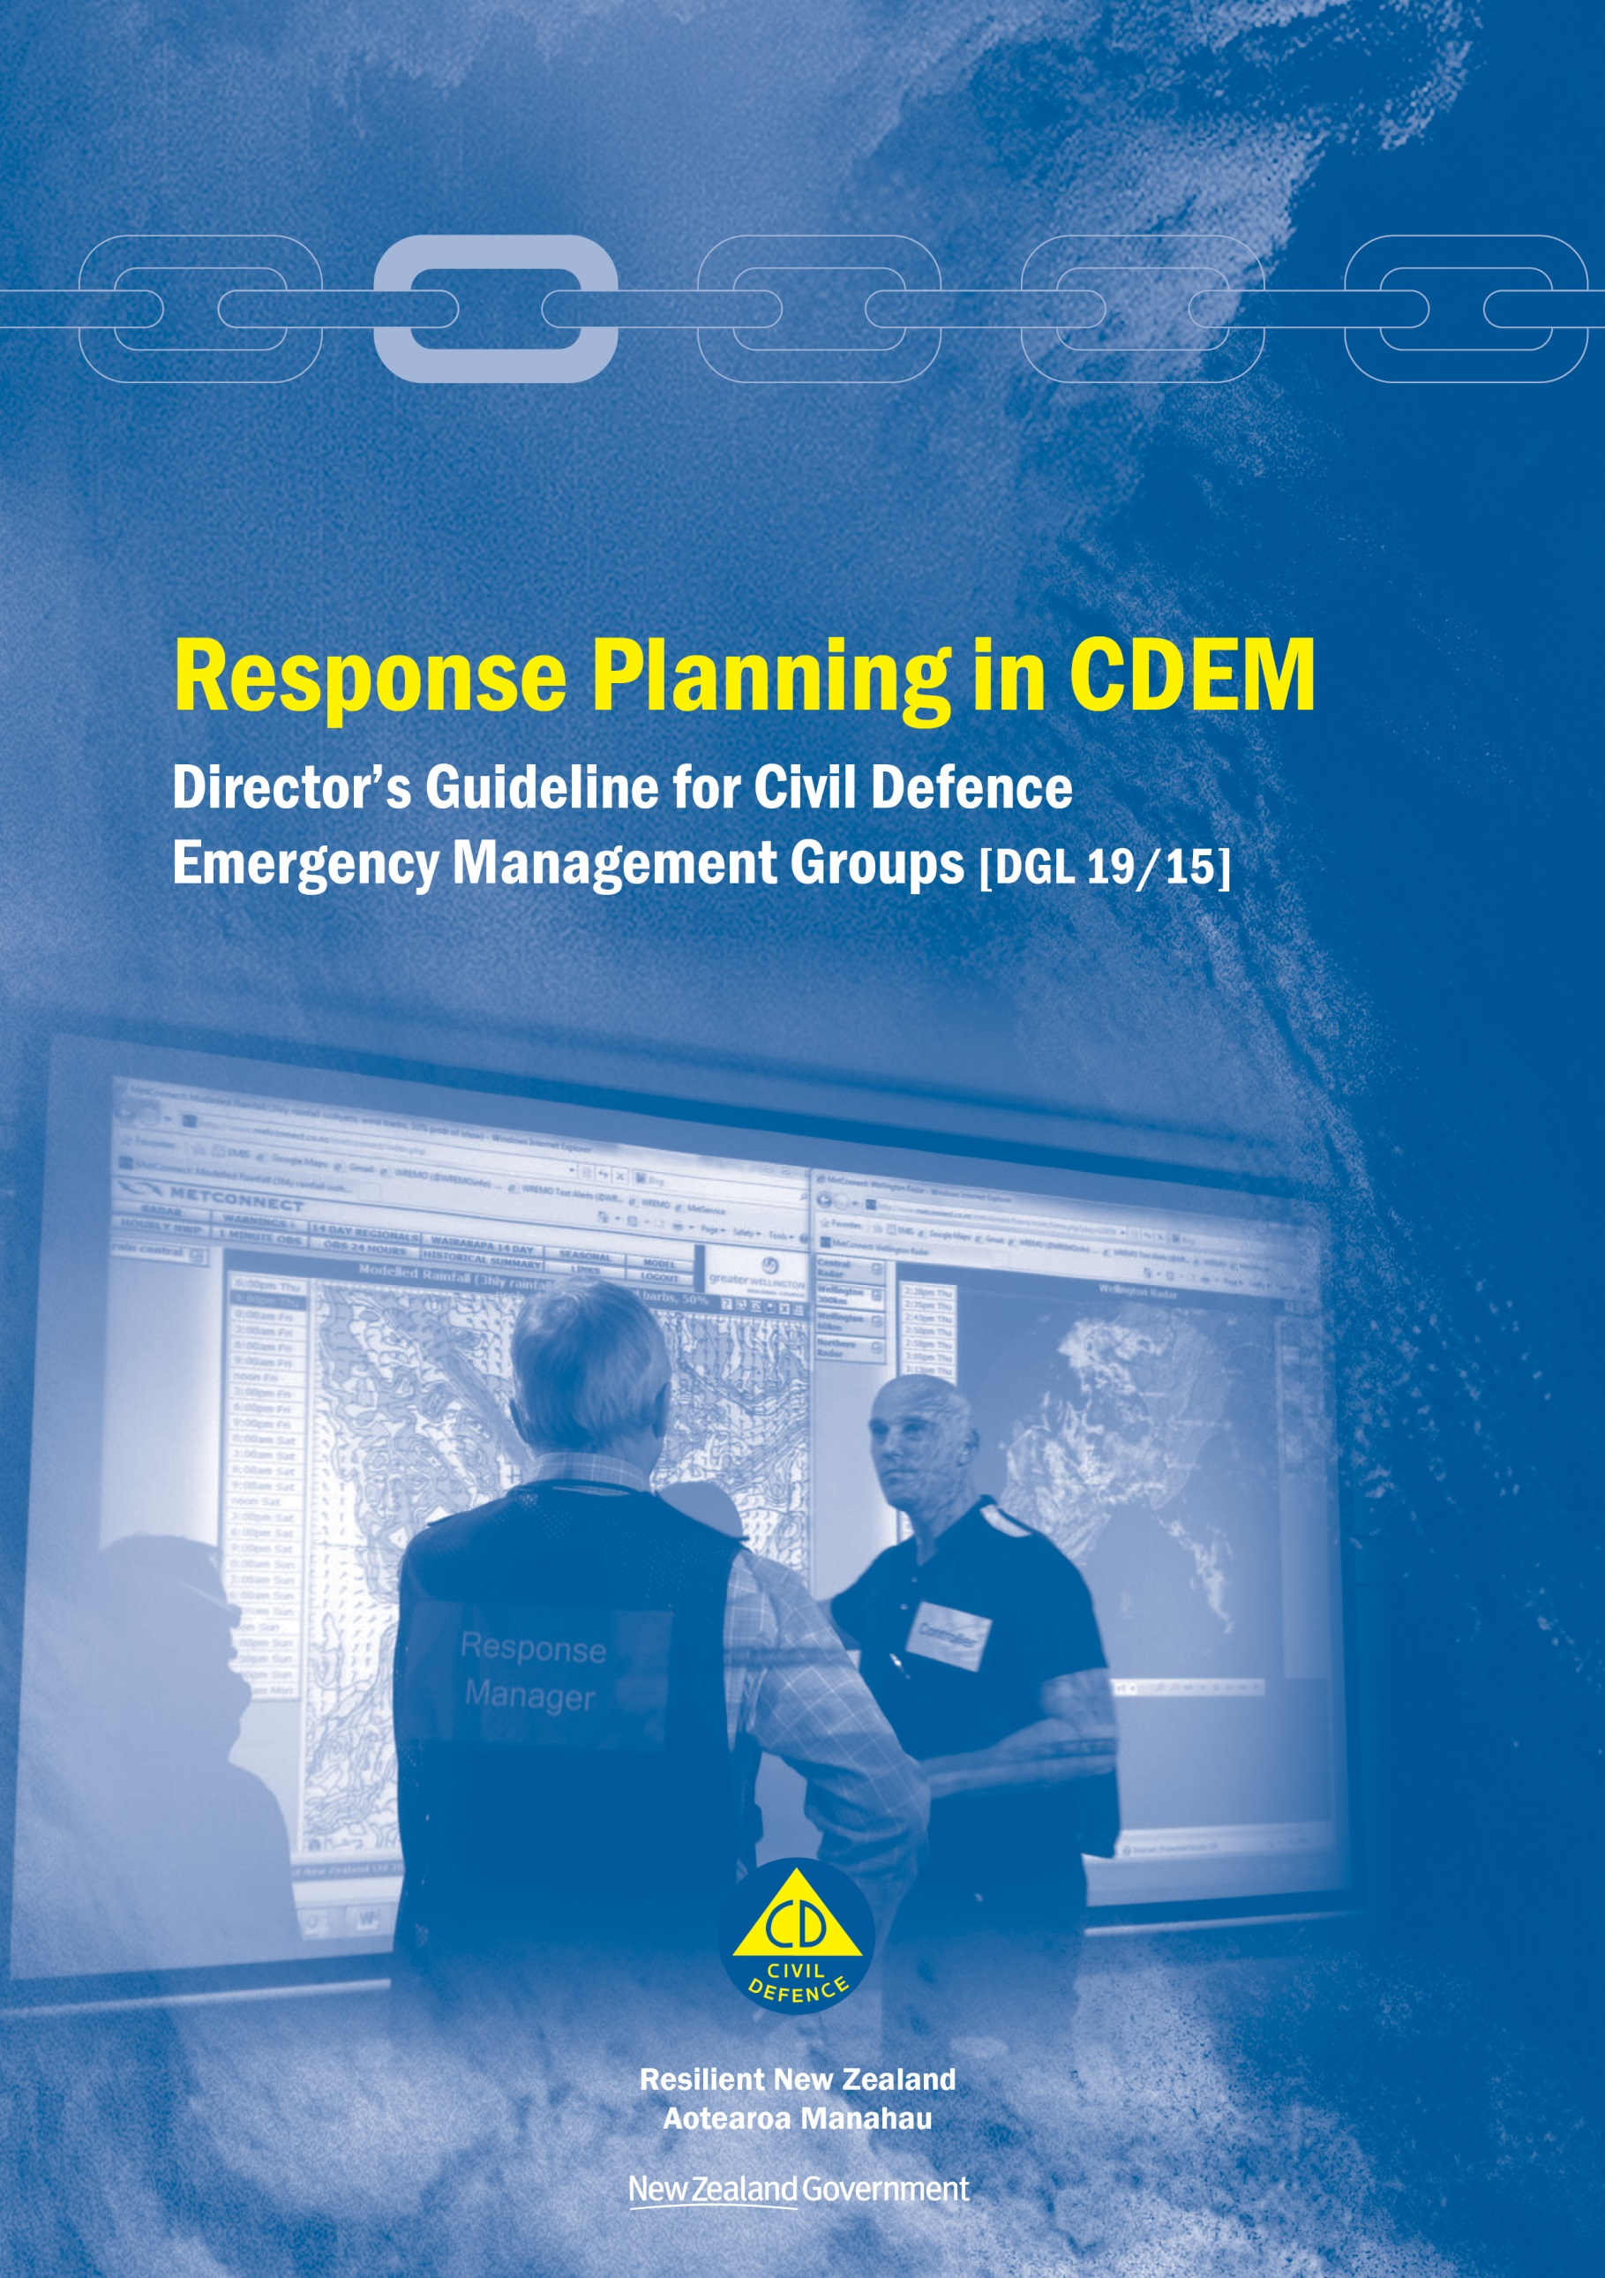

Response Planning in CDEM
Director’s Guideline for Civil Defence Emergency Management Groups [DGL 19/15]

December 2015
ISBN 978-0-478-43512-2
Published by the Ministry of Civil Defence & Emergency Management

Authority
This guideline has been issued by the Director of the Ministry of Civil Defence & Emergency Management pursuant to s9(3) of the Civil Defence Emergency Management (CDEM) Act 2002. It provides assistance to CDEM Groups in the preparation for, and carrying out, of response planning activities during emergencies.

This document is not copyright and may be reproduced with acknowledgement. It is available, along with further information about the Ministry, on the MCDEM website www.civildefence.govt.nz.

Cover images
Kapiti Controller Scott Dray, right, discusses an evolving weather situation with staff during the May 2015 Wellington region flooding event. (Photo courtesy of the Wellington Region Emergency Management Office).

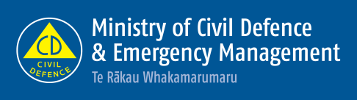

Ministry of Civil Defence & Emergency Management
PO Box 5010
Wellington 6145
New Zealand
Tel: +64 4 817 8555
Fax: +64 4 817 8554

Email: emergency.management@dpmc.govt.nz
Website: www.civildefence.govt.nz

Foreword
Planning is a key part of a successful emergency response. It integrates all functions and agencies into a unified effort to proactively manage the consequences of an emergency. This is no easy task during emergencies, which are dynamic, high-stakes situations, with short timeframes and incomplete information. To successfully respond in such situations, those involved must develop proactive and cohesive plans to coordinate all of the elements in a response. They must manage the flow of communications and actively seek key information. Robust planning processes as well as trained and competent staff are an important part of a successful response.
This guideline aims to provide a consistent approach to carrying out response planning across all agencies involved in the response effort during emergencies. It gives a thorough overview of the Planning function, how it is applied in a CDEM context, and includes suggested processes and a number of templates to make this information more accessible.
The audience for this document includes Planning staff, Controllers and other functions who work closely with Planning, especially Intelligence. In particular it will serve as a key reference for training and capability development for Planning staff.
By detailing the Planning function, its outputs, requirements and internal processes, this guideline will help lay the foundation for the Planning function to be carried out more efficiently and effectively during future emergencies.
Sarah Stuart-Black
Director of Civil Defence Emergency Management

Acknowledgements
The Ministry of Civil Defence & Emergency Management acknowledges its intellectual debt in preparing this guideline to a number of publications, listed below:
- ADFP 5.0.1 Joint Military Appreciation Process, April 2009, Australian Defence Force Headquarters, Canberra, Australia
- Crisis Action Planning For Humanitarian Assistance, Multinational Planning Augmentation Team, Camp Smith, Hawaii, United States
- Incident Action Planning Guide, January 2012, Federal Emergency Management Agency, Washington DC, United States
- New Zealand Coordinated Incident Management System (CIMS), April 2014, Department of the Prime Minister and Cabinet, Wellington, New Zealand
- NZDDP-5.0 Joint Operations Planning, June 2011, New Zealand Defence Force, Wellington, New Zealand
- Operations Planning Process v1.0, May 2012, New Zealand Customs Service, Wellington, New Zealand
- The Planning Process, April 2012, Department of Conservation, Wellington, New Zealand
In addition, this document is the product of a collaborative effort between the Ministry of Civil Defence & Emergency Management, and regional and local civil defence emergency management personnel.

Contents
Section 1 Introduction 1
1.1 About this guideline 1
1.2 Key terms 2
1.3 About CDEM 5
Section 2 Planning in emergency management 10
2.1 The Planning function 10
2.2 Planning sub-functions 12
2.3 Levels of response planning 14
2.4 The Planning team 14
2.5 Types of response plans 16
2.6 Action Plans 19
2.7 Key planning relationships 28
2.8 Factors that influence effective planning 34
Section 3 Planning processes 42
3.1 Key planning inputs 44
3.2 The initial response process 47
3.3 Quick planning process 48
3.4 Detailed planning process 56
Section 4 Readiness 76
4.1 Gathering information 76
4.2 Planning and setting up 77
4.3 Developing processes and supporting documentation 82
4.4 Training and development 84
Section 5 Response 86
5.1 Considerations during response 86
5.2 Starting the planning process 87
5.3 Winding down 88
Section 6 Appendices 89
Appendix A Hazard and Environment Analysis (HEA) 90
Appendix B Information Requirements 100
Appendix C Templates 102
Appendix D Developing response planning procedures 132
Appendix E Planning readiness checklist 133
Appendix F Planning response procedure 135
Appendix G Task log 138
Appendix H Task sheet 140
Appendix I Glossary 141

Introduction
This section provides an introduction to this guideline and includes a list of key terms used.

About this guideline
The purpose of this guideline is to describe the Planning function in the context of Civil Defence Emergency Management (CDEM), and as part of a Coordinated Incident Management System (CIMS) structure.
This guideline is subordinate to the National CDEM Plan 2015 and the Coordinated Incident Management System (CIMS) Manual, 2nd edition. It is intended to expand on the information contained in the response planning sections of those documents.
The objectives of this guideline are to:
- create a common understanding of response planning across all CDEM stakeholders
- describe common planning procedures and practices, and
- provide a basis for response planning training.
The intended audience of this guideline are:
- Controllers
- Response Managers
- CDEM Planning Managers, and members of the Planning team
- CDEM Intelligence Managers, and other function managers in a coordination centre, and
- those developing training for the Planning or Intelligence functions.

Structure | This guideline has the following main sections:  - Section 1 Introduction – an introduction to this guideline, including a clarification of terms, and an overview of Civil Defence Emergency Management (CDEM)  - Section 2 Planning in emergency management – a description of planning structures, products, processes, and key relationships and considerations  - Section 3 Planning processes – a description of the response planning processes  - Section 4 Readiness– Planning tasks before an emergency  - Section 5 Response – Planning tasks during and after an emergency  - Section 6 Appendices – supporting information, templates, and forms that assist planning activities.

Response planning and ‘other’ planning | Response planning is distinct from other types of planning, such as the development of council Long-Term Plans, CDEM Group Plans, and project plans.  Response planning is focused on responses, where the situation is dynamic, time is short, and information is uncertain. Response planning may occur in readiness, but remains focused on responses. There are three types of response plans discussed in this guideline:  - the Action Plan, developed during a response  - Contingency Plans, which may be developed during readiness or a response, and  - Long-term Plans, which may be developed during a response.
Intelligence content in this guideline | This guideline includes content that is directly relevant to the Intelligence function in a coordination centre, particularly the Hazard and Environment Analysis process (HEA).  It is recommended that staff assigned to the Intelligence function in a coordination centre are familiar with the contents of this guideline. This guideline should be a primary reference for training Intelligence staff.
Use of icons | The following icons are used in this guideline:
 | Indicates a template is provided in the appendices | Indicates more information is available in another document or website

Key terms
This section provides clarification for key terms used in this document.
CDEM | In this guideline, Civil Defence Emergency Management (CDEM) has the same meaning as in the CDEM Act 2002:  - Interpretation…  civil defence emergency management—  - means the application of knowledge, measures, and practices that—  - are necessary or desirable for the safety of the public or property; and  - are designed to guard against, prevent, reduce, or overcome any hazard or harm or loss that may be associated with any emergency; and  - includes, without limitation, the planning, organisation, co-ordination, and implementation of those measures, knowledge, and practices.
 | A full description of CDEM (including a full glossary of terms and abbreviations) is provided in the Guide to the National CDEM Plan 2015, at www.civildefence.govt.nz (search for ‘Guide to the National Civil Defence Plan’).
CIMS | The Coordinated Incident Management System (CIMS) is the primary reference for incident management in New Zealand. The purpose of CIMS is to achieve effective coordinated incident management across responding agencies for all incidents regardless of hazard, size, and complexity.  Planning is one of the functions of CIMS. CIMS is described in detail in the 2nd edition CIMS Manual, available at www.civildefence.govt.nz by searching for the document name.
Emergency | In this document, emergency has the same meaning as in the CDEM Act 2002:  - Interpretation…  emergency means a situation that—  - is the result of any happening, whether natural or otherwise, including, without limitation, any explosion, earthquake, eruption, tsunami, land movement, flood, storm, tornado, cyclone, serious fire, leakage or spillage of any dangerous gas or substance, technological failure, infestation, plague, epidemic, failure of or disruption to an emergency service or a lifeline utility, or actual or imminent attack or warlike act; and  - causes or may cause loss of life or injury or illness or distress or in any way endangers the safety of the public or property in New Zealand or any part of New Zealand; and  - cannot be dealt with by emergency services, or otherwise requires a significant and co-ordinated response under this Act.  Note: This definition is different from the one used in CIMS. CIMS is not based on the CDEM Act 2002, and a modified definition is required for other agencies using CIMS, particularly emergency services.
Hazard and Environment Analysis | The Hazard and Environment Analysis (HEA) is an analytical process designed to forecast how the hazard(s) might develop in the affected area. It is future-focused and a key element of the planning process. It is explained in detail in Appendix A Hazard and Environment Analysis (HEA) on page 90.
Planning and the 4Rs | The National CDEM Plan describes the 4Rs of emergency management as being reduction, readiness, response, and recovery. Their definitions are given in Appendix I Glossary on page 141.  Response planning does not have any direct responsibilities relating to reduction. However, planning activities can identify and quantify hazard risks, while the development of contingency plans can reduce hazard risks.
Planning and the 4Rs (continued) | Preparation to ensure effective planning during an emergency response occurs in readiness. Contingency planning may also occur in readiness.  Response planning mainly occurs during response, including the transition to recovery.  Response planning processes may be used to plan activities during recovery.
Planning Manager | The Planning Manager during readiness is the person responsible for preparing information on and arrangements for the use of planning processes that will be used during response and recovery.  The Planning Manager during response and recovery is the person responsible for managing the Planning function at the coordination centre.  This person is likely to have a different job title during business as usual, and these responsibilities may only be a small part of their overall job role.
Planning team | The Planning team includes any personnel who are assigned to the Planning Manager before, during or after an emergency. Many will be members of other functions and agencies, assigned to the Planning team for the duration of a planning process.

Business as usual CDEM facilities
GEMO | GEMO (Group Emergency Management Office) is the regional office where CDEM functions are carried out on behalf of the CDEM Group before an emergency occurs. It is managed by the GEMO Manager.
EMO | EMO (Emergency Management Office) is the office(s) where CDEM functions are carried out at a local level before an emergency occurs. The person who carries out the CDEM functions is the EM Officer.  In some CDEM Groups, EM Officers may be called Advisors or Coordinators.

CDEM response facilities
Coordination centre | A coordination centre is the location from which a Controller and Incident Management Team (IMT) manages a response. There are four types of coordination centre:  - Incident Control Points (ICPs) operate at an incident level  - Emergency Operations Centres (EOCs) operate at a local level  - Emergency Coordination Centres (ECCs) operate at a CDEM Group level, and  - National Coordination Centres (NCCs) operate at the national level.
NCMC | The NCMC (National Crisis Management Centre) is a secure, all-of-government coordination centre used by agencies to monitor, support, or manage a response at the national level.  It is an example of a National Coordination Centre (NCC).  MCDEM is responsible for maintaining the NCMC in a state of readiness, and will act as the lead agency for CDEM-led responses.
ECC | An ECC (Emergency Coordination Centre) is a coordination centre that operates at the CDEM Group level to coordinate and support one or more activated EOCs.
EOC | An EOC (Emergency Operations Centre) is a coordination centre that operates at a local level to manage a response.
CDC | A Civil Defence Centre (CDC) is a facility that is established and managed by CDEM during an emergency to support individuals, families/whānau, and the community. CDCs are open to members of the public, and may be used for any purpose including public information, evacuation, welfare, or recovery, depending on the needs of the community.  CDCs are operated by CDEM-led teams (including CDEM-trained volunteers), or by other agencies as defined in CDEM Group Plans or local level arrangements.
Community-led centres | Community members and/or community-based organisations may establish and operate other centres that offer support to the community.  These centres do not fall under the direction of CDEM, although they may coordinate with and operate alongside CDEM-led facilities.

About CDEM
 | This is a brief overview intended for people who have not been involved in CDEM before. More information is available in the Guide to the National CDEM Plan, available at www.civildefence.govt.nz (search for ‘Guide to the National Civil Defence Plan’).
MCDEM | Ministry of Civil Defence & Emergency Management (MCDEM) is the central government agency responsible for providing leadership, strategic guidance, national coordination, and the facilitation and promotion of various key activities across the 4Rs. It is the lead agency at a national level responsible for coordinating the management of the emergencies listed in Appendix 1 of the National CDEM Plan 2015.  MCDEM may act as a support agency by coordinating the CDEM response to any given emergency managed by another lead agency. MCDEM is responsible for maintaining the NCMC, and the National Warning System.

CDEM Group | In this guideline, CDEM Group refers to the collective of local authorities, emergency services, and other agencies that work together to implement CDEM in their area. CDEM Groups are required under the CDEM Act 2002; every local authority is required to be a member of a CDEM Group.  There are 16 CDEM Groups in New Zealand. Each is responsible for CDEM in its area, including:  - identifying and managing hazards and risks  - providing the organisational structure and resources necessary (including suitably trained personnel) for the effective delivery of CDEM  - undertaking CDEM readiness activities, including raising public awareness about CDEM and preparing a CDEM Group Plan  - coordinating or undertaking CDEM response and recovery activities, and  - providing support and assistance to other CDEM Groups, if required.  More information on CDEM Groups is available at www.civildefence.govt.nz.  Note: Outside the context of this guideline, CDEM Group may also refer to the committee of elected officials that are accountable for CDEM in their area.

Business as usual structure
The general structure of a CDEM Group is shown in Figure 1 below. Variations to this structure are discussed on the next page.
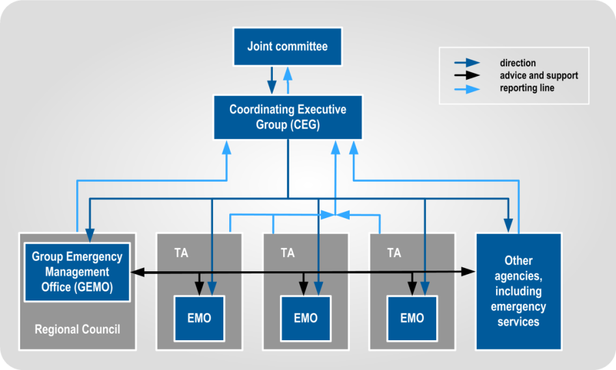
Figure 1 CDEM structure for business as usual
Joint committee | The Joint Committee is part of a CDEM Group’s structure. It is made up of elected representatives of member authorities, such as mayors, chairpersons, or their delegates. In CDEM Groups with a unitary authority structure, the Joint Committee is a committee of council, or a council functioning as a CDEM Group.  Note: In some CDEM Groups, the Joint Committee may be referred to as the CDEM Group.
CEG | The Coordinating Executive Group (CEG) is part of a CDEM Group’s structure. It is made up of chief executives (or their delegates) of the local authorities, representatives of emergency services, and others.
Variations in CDEM Group structure | CDEM structures vary significantly in the different Groups. The CDEM Group Plan will show their particular structure. The main variations in structures are:  - GEMO with no local EMO(s) (includes unitary authorities)  - all or some of the EMOs reporting through the GEMO, rather than through the territorial authorities  - pooling territorial resources to jointly provide all CDEM functions in the CDEM Group’s region  - grouping EMOs under area offices over several local councils, and  - the CDEM Group contracting out provision of CDEM to a third party, who report directly to the CEG.

CDEM response structure
CDEM response structure | The structure of a national emergency response is shown in Figure 2 below:  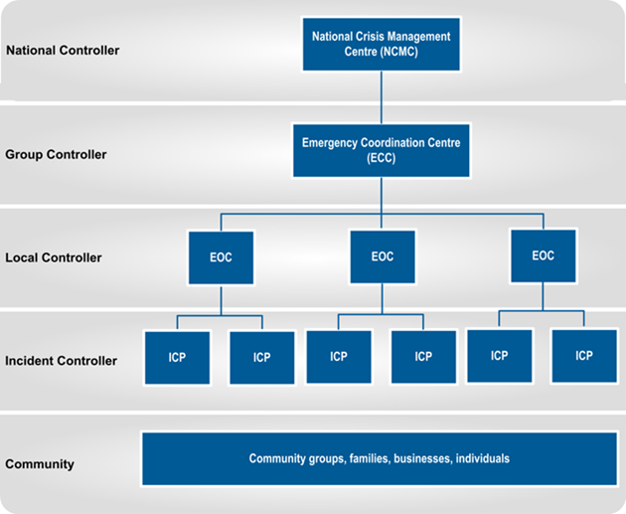  Figure 2 CDEM structure during response  A Controller is the person in charge of the response (or part of the response) at each coordination centre, and at each level of response coordination.

Key CDEM documents
CDEM Act 2002 | The Civil Defence Emergency Management Act 2002 (CDEM Act 2002) provides the legislative framework for CDEM in New Zealand across the 4Rs. It describes the functions and responsibilities of the Director of CDEM, as well as those of government departments, local authorities, emergency services, and lifeline utilities.  The CDEM Act 2002 sets the requirement for CDEM Groups, and defines their statutory functions, duties, and responsibilities. It also provides for local authority elected representatives, mayors, or the Minister of Civil Defence to declare a state of local emergency (the Minister may also declare a state of national emergency), and defines the powers that CDEM Groups and Controllers may exercise during a state of emergency.  The CDEM Act 2002 requires there to be a National CDEM Strategy and a National CDEM Plan, and enables the Director of CDEM to issue Director’s Guidelines.
The National CDEM Strategy | The National CDEM Strategy describes the intentions of the Crown regarding CDEM provisions. It outlines the vision, values, principles, and goals for CDEM, and is reviewed every ten years.
National CDEM Plan 2015 | The National CDEM Plan 2015 is a regulation that sets out the roles and responsibilities of all agencies involved in reducing risks from hazards, and preparing for, responding to, and recovering from emergencies.
The Guide to the National CDEM Plan | The Guide to the National CDEM Plan explains the National CDEM Plan in detail.
CDEM Group Plan | Each CDEM Group is required under the CDEM Act 2002 to have a CDEM Group Plan, which is regularly reviewed.  The CDEM Group Plan sets the strategic direction for the CDEM Group. It describes and prioritises the hazards and risks particular to the CDEM Group’s area, and provides objectives and a framework for activities across the 4Rs.
Director’s Guidelines | Director’s Guidelines are documents developed by MCDEM, to provide guidance to CDEM Groups and other agencies regarding CDEM. They are issued by the Director of CDEM under the CDEM Act 2002.

The CDEM Emergency Management Information System (CDEM EMIS)
The CDEM Emergency Management Information System (CDEM EMIS) is used by CDEM Groups and local authorities to record information and maintain situational awareness during emergency response.
Planning personnel can get information about training, and access to the system from the EM Officer or GEMO Manager.

Planning use of CDEM EMIS | The Planning team can use CDEM EMIS to carry out various information tasks, including:  - accessing information to maintain situational awareness  - storing documents  - creating Action Plans  - tracking tasks, and  - recording and assigning messages  Planning staff should become familiar with the planning pages in CDEM EMIS, in particular the Action Plan template.
Main features of EMIS | The main features of CDEM EMIS are that it:  - provides a common emergency information management tool for CDEM  - is web-based, so users can access the system anywhere the web is available  - provides the ability for MCDEM, CDEM Groups, and local authorities to manage and maintain base data, and assign user rights as required  - provides for the recording and tracking of data, and  - allows for the creation of standardised reports such as Action Plans, Situation Reports, resource status information, Resource Requests, maps, and emergency welfare information.

Planning in emergency management
The purpose of response planning in emergency management is to coordinate response activities in the medium to long term, in order to complete assigned response objectives. Response planning is used in dynamic situations where:
- information is incomplete and uncertain
- there are substantial risks
- timeframes are short
- there are multiple agencies involved, and
- where response organisations and structures are newly formed or ad-hoc.
Effective response planning is achieved by defining response objectives, and integrating the activities of other functions and agencies into a cohesive course of action to achieve those objectives.

The Planning function
Planning is one of the seven functions of the Coordinated Incident Management System (CIMS). The Planning function is responsible for preparing and updating Action Plans, and developing Long-term and Contingency plans.
Planning and the other CIMS functions are shown in Figure 3 below.
Note: The second edition of the CIMS Manual (2014) split Planning and Intelligence into two separate functions; previously they were a single function.
Planning has close relationships with all other CIMS functions, particularly Control, Intelligence, and Operations. See section 2.7 Key planning relationships on page 28 for more information.
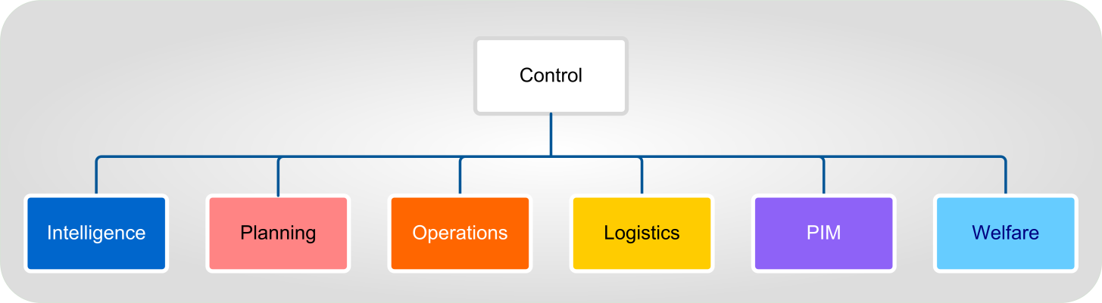
Figure 3 The seven CIMS functions

CIMS is detailed in the CIMS Manual, second edition, available from the CDEM website www.civildefence.govt.nz (search for ‘CIMS’).

Activating the Planning function
The Planning function is activated when the Controller needs support to coordinate a response, especially for larger or more complex emergencies.
Where a response is likely to be simple in nature or of short duration, the Planning function may not be required. Similarly, where a response is nearing completion, the Planning function may be stood down. Planning staff may be used in other coordination centre functions, such as Operations.

Planning in reactive and proactive responses
Responses can be either reactive or proactive.
Short or minor emergencies may only require a reactive response. However, many responses that begin reactively will develop into ongoing or complex operations. The aim of the Planning function is to turn reactive responses into proactive responses, allowing agencies to:
- avoid or reduce hazard consequences before they occur, and
- coordinate their actions with other agencies.

Reactive responses | Reactive responses are when:  - the hazard has already occurred, is just about to occur  - the pace of the response is set by the hazard consequences response agencies have only basic information about the emergency, or information is unverified  - coordination arrangements are not fully developed, and response personnel have to rely on standard operating procedures or on-the-spot analysis to guide their actions, and  - a situation develops and worsens rapidly, allowing little time to contain, reduce, or eliminate the hazard.  In a reactive response, planning is rapid, informal, and unlikely to be very detailed. As a response progresses and more information is gathered, planning will gradually become more proactive.
Proactive responses | Proactive responses are when hazards are forecast, and response actions are designed to eliminate or reduce the consequences of the emergency before they occur. Proactive responses are possible when:  - agencies develop response plans during readiness to respond to likely hazards  - an early warning means response planning can happen before an emergency occurs, or  - time is taken during a reactive response to plan future actions.

Planning sub-functions
Like the other CIMS functions, Planning is made up of a number of sub-functions (shown in Figure 4 below):
- Planning Management
- Action Planning
- Long-term Planning, and
- Contingency Planning.
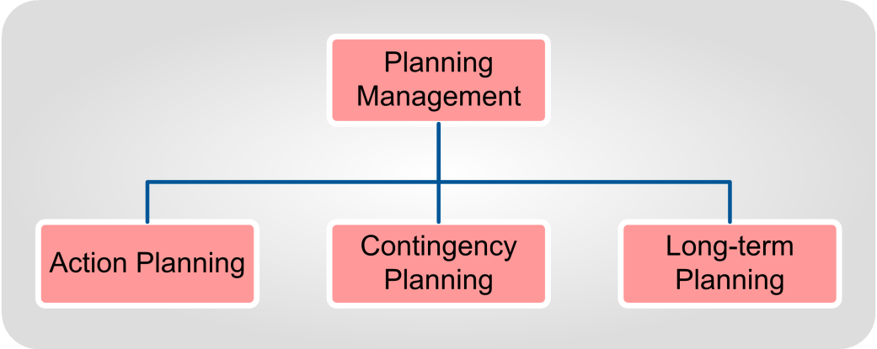
Figure 4 Planning Sub-functions

Planning Management
Planning Management coordinates and manages the rest of the Planning function. It ensures the Planning team follow processes correctly, that everyone contributes, and that agreed conclusions and decisions are documented.
Planning Management’s responsibilities include:
- analysing tasks assigned to Planning
- leading the planning process through to completion
- providing advice on planning to the Controller and other members of the IMT, including the composition of the Planning team
- ensuring other functions and support agencies are involved in planning
- ensuring that plans are developed in a timely manner
- communicating with Planning Managers in other coordination centres, and
- ensuring the welfare and wellbeing of team members, including managing the shift roster for Planning staff.

Action Planning
Action Planning is the primary sub-function for Planning. It addresses the main purpose of the coordination centre: to coordinate the lead and support agency actions into a cohesive, unified response.
Action Planning may take place for an impending emergency, or one that has already occurred. A response may require a series of Action Plans.
See section 2.5 Types of response plans on page 16.

Contingency Planning
Contingency Planning addresses ‘what if’ situations that may but have not yet occurred.
For example, during a flooding emergency, an Action Plan may be developed on the assumption (based on structural assessment) that flood defences will hold. However, a Controller or Planning team may develop a Contingency Plan that will coordinate response actions should flood defences fail.
See section 2.5 Types of response plans on page 16.

Long-Term Planning
Long-term Planning addresses response objectives that cannot be met in the short term (the current Action Plan) or the medium term (the subsequent Action Plan). Depending on the scale of the emergency, Long-term Planning may involve planning for weeks or months in advance.
Long-term Planning often covers the transition from response to recovery.
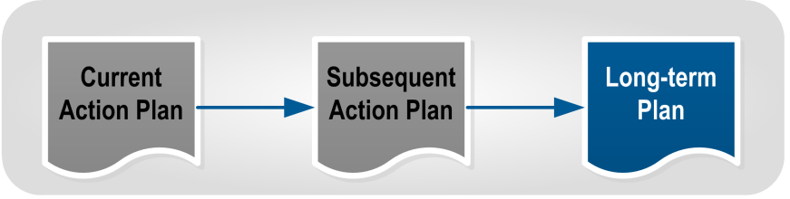
Figure 5 Long-term Plans
See section 2.5 Types of response plans on page 16.

Levels of response planning
The levels of response planning are based on the CIMS response levels:
- national (NCMC or NCC)
- CDEM Group or regional (ECC)
- local (EOC), and
- incident site (ICP).
Each level focuses on planning its own activities, while:
- aligning with higher response level plans, and
- coordinating or supporting planning at a lower response level.
During most emergencies, only incident and local level Planning teams are activated. CDEM Group and national level Planning teams only activate in more complex emergencies, or when they are required to coordinate the response across a region, or the whole of New Zealand.
In some CDEM Groups, the CDEM Group and local levels are combined.

Community level responses | The community level of response is made up of numerous organisations and groups. These organisations may interact with CDEM Planning functions in a variety of ways.  The Planning team must ensure that community needs, resources, and activities are factored into response planning, particularly at the local and incident levels of response.  Liaison, communication, and integration of official responders with communities will lead to a more effective response. Not only will the activities of both official and community responses be aligned, but the community will buy-in to response activities. Where necessary, representatives from community groups may be part of the Planning team.

The Planning team
The Planning team is responsible for carrying out each of the Planning sub-functions.
The Planning team includes:
- a suitably trained and experienced Planning Manager
- a number of Planning Officers (activated as needed by the Planning Manager, depending on the demands of the response), and
- members attached for a planning activity from other functions and agencies (see Additional members of the Planning team on page 15).

Team structure | Teams are structured according to the needs of the Controller, and the demands of the response.  All response plans are developed using the same processes. There is no need to assign team members to a specific Planning sub-function. All team members should be capable of developing Action, Contingency, or Long Term Plans.  Because Planning relies on inputs from other functions, the Planning team should include as many non-planning staff as required.
Experience and seniority | It is important that the representatives from the other functions and support agencies are experienced staff with decision-making authority. In many cases, it is best for the function manager (for example, the Operations Manager, Intelligence Manager, or Welfare Manager) to represent their function.  The advantages for managers participating in the Planning team include:  - shared situational awareness from the planning process  - better input due to their experience and knowledge  - faster development, due to their seniority, and  - familiarity with the Action Plan that they will implement.  While a manager is taking part in the planning process, their deputies can manage their function on their behalf. If necessary, the Manager is on hand within the coordination centre to resolve any issues.
Additional members of the Planning team | A Planning team during a response is likely to have some or all of the following attached during a planning activity:  - the Controller (at selected points in the planning process)  - the Response Manager (possible)  - an Operations representative (preferably the Manager for key Action Plans)  - Intelligence representatives (may be several, including the Intelligence Manager)  - a Logistics representative  - a PIM representative  - a Welfare representative  - lifeline utilities coordination representative, and  - staff from key support agencies including technical experts.  Setting up a Planning team is a key readiness activity. See section 4.2.3 The Planning team on page 78 for more information.

Types of response plans
There may be a number of different plans that are created in the course of a response. The order and circumstances in which these documents are created, and their relationship to each other, is shown in Figure 6 below.
All response plans are owned by the Controller, and developed by the Planning team with participation from all the functions and agencies activated.
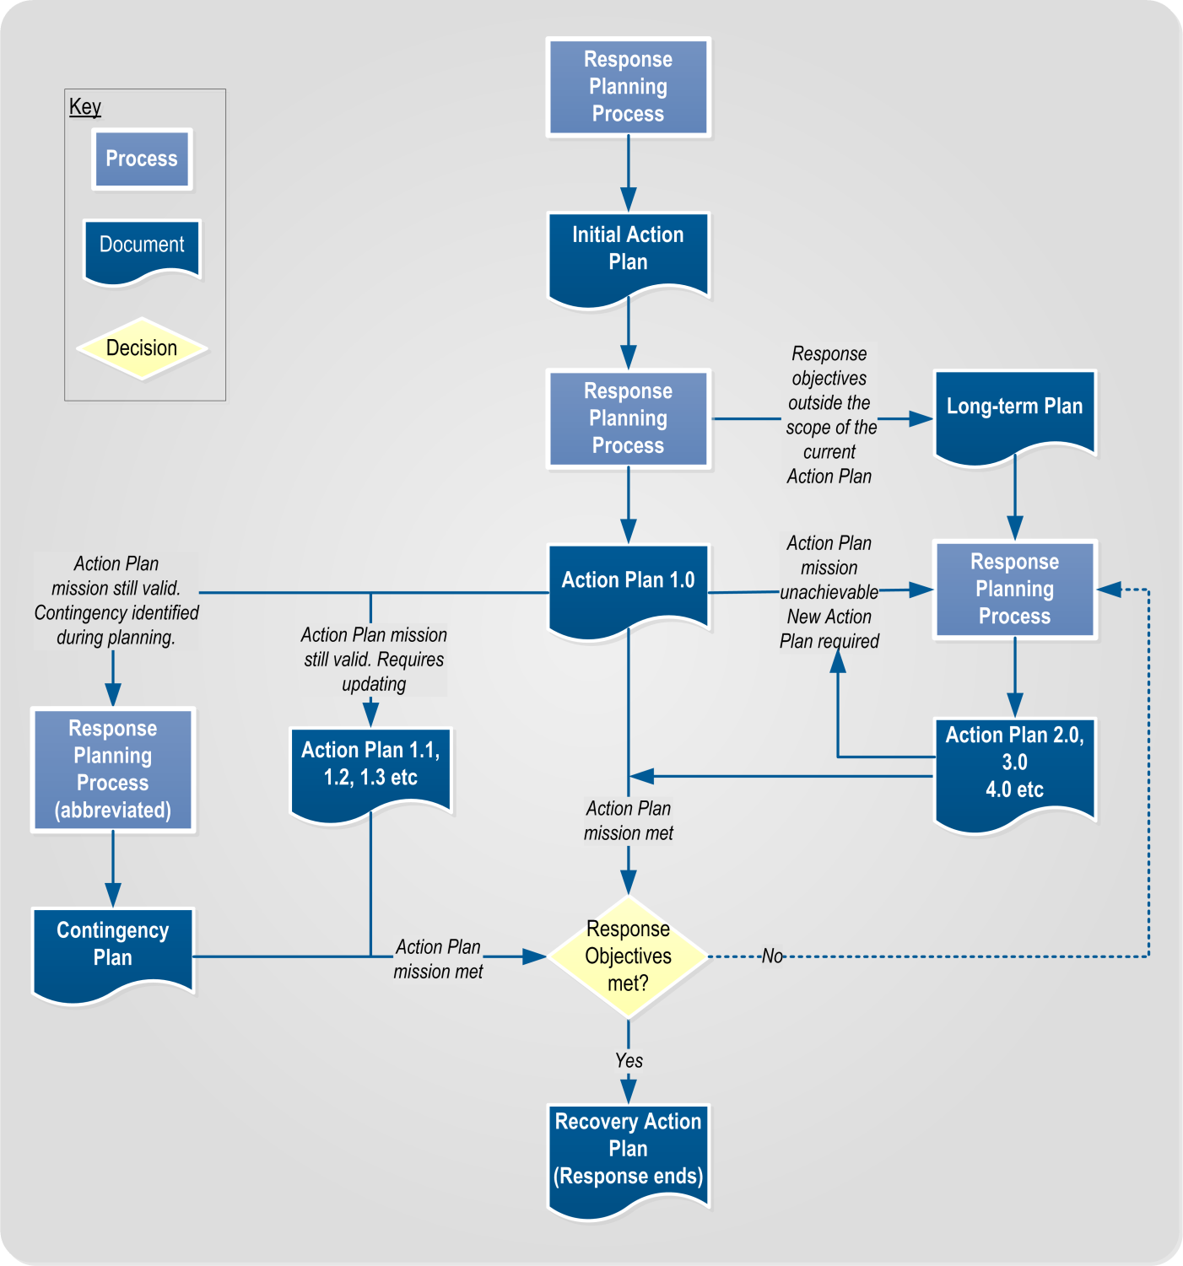
Figure 6 Types of response plans

Initial Action Plans
Initial Action Plans are developed to coordinate the initial response while the response structure is mobilising and information is being gathered. They may be prepared during readiness.
Initial Action Plans aim to collect information, mobilise resources, and perform immediate actions while the planning process is underway. An Initial Action Plan:
- uses the planning process, but with shortened time-frames and less detail
- does not aim to set the conditions for a transition to recovery
- may not address the Controller’s response objectives, and
- may be issued verbally, though a written record must be kept.

Action Plans
Action Plans describe how the response will be managed, and how response agencies will integrate their activities to achieve response objectives.
Action Plans are the primary output of the Planning function, and are described in more detail in section 2.6 Action Plans on page 19.

Differences between Action Plans and other plans | Long-term and Contingency Plans use the same process, inputs, and personnel as the Action Plan. However, they are often completed with less detail because of personnel and time constraints.  Long-term Plans and Contingency Plans will usually be completed after an Action Plan has been developed. They depend on more assumptions than Action Plans, as they cover situations that are yet to happen.

Contingency Plans
During response, the Controller or the Planning team may identify the need for a Contingency Plan. This may be during the planning process, or due to an evolving situation.
Contingency Plans save time and reduce confusion as the response can move quickly to reorient to a changed situation.

Overriding an Action Plan | Contingency Plans do not usually over-ride the current Action Plan. If one does, this should be specifically stated in the Contingency Plan.

Developing a Contingency Plan | Contingency Plans may be developed after an Action Plan has been authorised, or may be developed in parallel. Depending on staff and time restrictions, they may be:  - fully developed plans, or  - developed to the Options Analysis stage (see Section 3 Planning processes on page 42).  Even fully developed Contingency Plans may be less detailed than Action Plans. Contingency Plans may be further developed, and released as an Action Plan update, or as the next Action Plan.

Long-term Plans
If any response objectives cannot be completed in the current or subsequent Action Plans, the Planning team may develop a Long-Term Plan.
For example, if a coordination centre is implementing the first Action Plan (1.0), and the Planning team is working on the next Action Plan (2.0), any response objectives outside the scope of those two plans would be included in a Long-term Plan (which could later be developed into 3.0).

Developing Long-Term Plans | Depending on staff and time restrictions, they may be:  - fully developed, or  - developed to the Options Analysis stage (see Section 3 Planning processes on page 42).  Even fully developed Long Term Plans may be less detailed than Action Plans, and include more assumptions. This is because the long term situation is expected to change.  Long Term Plans may be released later as an Action Plan or a Contingency Plan. This potentially reduces effort later on, when demands on the Planning team may be high.
Time limits | There is no set limit on what constitutes a Long-Term Plan. It may cover a timeframe within hours, days, weeks, or even months, depending on the response level and the scale of the emergency.
Benefits of a Long-Term Plan | Long-Term Plans allow a Controller and Planning team to phase their response, and address response objectives in a prioritised manner.  Longer term response objectives aren’t ignored, but may be ‘parked’ to be developed as time and resources allow, and information becomes available.

Recovery Action Plan
A Recovery Action Plan is created during the response phase. Its activation usually marks the end of a response, as it transitions into recovery.
The development of Recovery Action Plans is outside the scope of this guideline.

Action Plans
An Action Plan is the key product of the Planning function. At the incident level of response, an Action Plan may be written or verbal. At the local, CDEM Group, or national response levels, it should be written.
Some responses will involve the development of a series of subsequent Action Plans; for example, 1.0, 2.0, 3.0, etc. Individual Action Plans may also be updated.
For a template, see Appendix C Action Plan template on page 131.

Response objectives
Response objectives are goals which response agencies work towards.
The Controller develops response objectives during the initial stages of the response. Support agency intentions, activities, and requirements must be considered when creating response objectives and making key decisions. Response objectives may also be influenced by governance and management, by a lead agency, or by a higher response level Action Plan.

Features of a response objective | Response objectives are a statement of what is to be achieved, and are as specific as possible. They can be based on the generic response objectives in the National CDEM Plan 2015, or the CIMS Manual.  Ideally, response objectives are Specific, Measureable, Achievable, Relevant and Time-bound (SMART). Response objectives created rapidly during the initial response may be refined and improved as part of the planning process.  Note: The number of response objectives should be kept to a minimum (ideally no more than six).
Examples of response objectives | Examples of generic response objectives include:  - Gain and maintain situational awareness.  - Assess impact of emergency.  - Establish contact with population in the affected area.  - Maintain public confidence in response activities.  Examples of more specific response objectives include:  - Establish welfare support arrangements by 1800 6 April.  - Evacuate all threatened dwellings by 0800 7 April.  - Reinforce flood defences at Blacktown by 1200 7 April.  - Reopen and maintain access to all towns and farms in the area of operations by 1600 9 April.  - Supply isolated farms by air throughout the response.

Response objectives and Action Plans
Action Plans are the primary mechanism for achieving the Controller’s response objectives.
Figure 7 below shows how the planning process enables response objectives to be analysed and incorporated into an Action Plan.
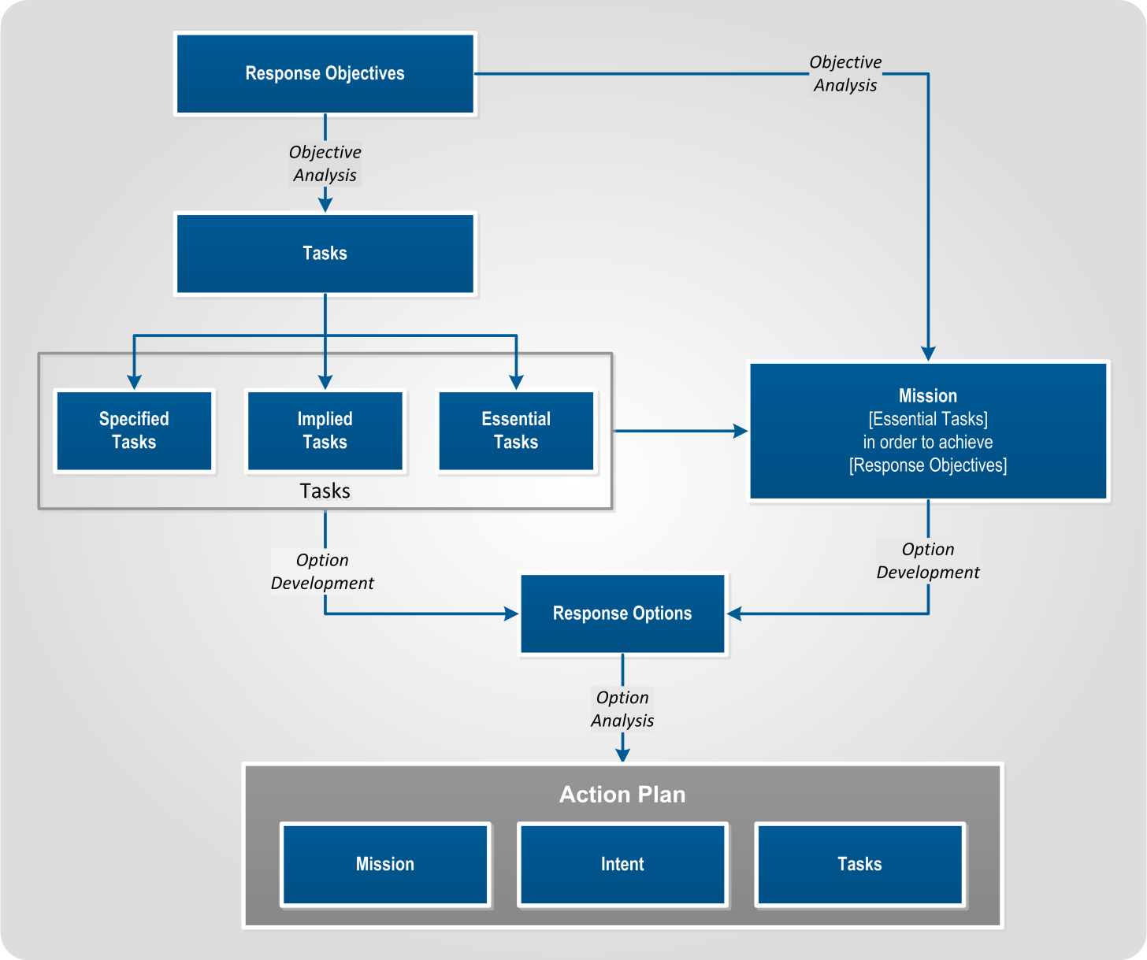
Figure 7 Response objectives and Action Plans
Developing Action Plans to meet response objectives | During the planning process, the Controller and the Planning team determine:  - when (and in which order) response objectives can be achieved  - what tasks are required to achieve them, and  - when (and in which order) these tasks can be completed.  All response objectives may be captured in a single Action Plan. Alternatively, it may take more than one Action Plan to achieve all of the response objectives (as shown in Table 1 on the next page).
Developing Action Plans to meet response objectives (continued) | Table 1 Developing Action Plans to meet objectives  Action Plan Response objectives  Action Plan 1.0 1: Establish welfare support arrangements by 1800 6 April 2: Evacuate all threatened dwellings by 0800 7 April  Action Plan 2.0 3: Reinforce flood defences at Blacktown by 1200 7 April 5: Supply isolated farms by air throughout the response  Action Plan 3.0 4: Reopen and maintain access to all towns and farms in the area of operations by 1600 9 April 5: Supply isolated farms by air throughout the response  Note that multiple Action Plans may be needed to address a single response objective (e.g. objective 5 in Table 1 above).
Advantages and drawbacks | Developing a single Action Plan to cover all response objectives means planning activity is more focused.  However, it will mean that more effort is required up-front to develop a timely, comprehensive plan. Spacing the response objectives across two or more Action Plans may require more effort, but it will be less intense at the start. The later Action Plans will be also be more accurate, as they will be based on firmer information and fewer assumptions.  Ultimately, the Controller must decide how many Action Plans are required to meet the response objectives, and how tasks may be best sequenced.

Key features of an Action Plan
The key features of an Action Plan are the:
- mission statement
- intent, and
- tasks.

Mission statement
A mission statement is a concise description of what the Action Plan is aiming to achieve. The components of a mission statement are:
- who (the agency or coordination centre developing the Action Plan)
- what (essential tasks that must be completed)
- where (the area of operations identified by the Intelligence team during the HEA – see Appendix A Hazard and Environment Analysis (HEA) on page 90)
- when (the time limit set by the Controller), and
- why (to meet response objectives given by the Controller or the requirements of a higher response level Action Plan).
Missions statement (continued) | Note: A mission statement should not simply restate a response objective. It must include clear direction about what the Action Plan covers, and the rationale behind it.
Example | An example mission statement is:  “The Hastings District Council will cordon and evacuate all people from at-risk coastal areas within the Hastings district boundaries by 1200 hours 28 October 2014, in order to prevent a loss of life from the approaching tsunami.”  This mission statement clearly shows:  - who (Hastings District Council)  - what (evacuate all people from at-risk coastal areas)  - where (within the Hastings district boundaries)  - when (by 1200 hours 28 October 2014)  - why (to prevent a loss of life from the approaching tsunami).
Benefit | Having a clear mission statement means that response personnel can continuously work towards a common goal, even if circumstances change, and specific details in Action Plans are no longer valid.

Intent
The Intent is a concise, formal statement that describes how the Controller aims to achieve the mission statement. The Intent gives clear direction to response personnel as to a Controller’s intentions. It is normally described as:
- Method: a sentence or two describing how the response will proceed
- Key Tasks: the tasks that must be completed to achieve the mission (drawn from the list of tasks developed during planning)
- End state (see End state on page 24)
It should not be a synopsis of the operation, but should provide the driving logic behind the plan.

Example | If the mission is “The Hastings District Council will cordon and evacuate all people from at-risk coastal areas within the Hastings district boundaries by 1200 hours 28 October 2014, in order to prevent a loss of life from the approaching tsunami”, the intent would be:  Method: Reduce risk by evacuating at-risk areas and establishing a cordon to prevent re-entry, with welfare arrangements in place to support evacuees.

Example (continued) | Key Tasks:  - continue alerting the at-risk population  - mobilise welfare arrangements to support evacuees  - coordinate and implement the evacuation  - cordon the at-risk area  - mobilise impact assessment teams.  End state: All people from at-risk coastal areas have been evacuated and are receiving appropriate welfare support, the at-risk area is cordoned and CDEM agencies are prepared to conduct an impact assessment.

Tasks
A task is a statement of what has to be done to achieve a response objective. For example, if a response objective is “evacuate at-risk areas”, the tasks to achieve it might include:
- Establish a cordon at this line (specified on a map or in text)
- Organise transport for evacuees without private vehicles
- Conduct a house-to-house door-knock
- Disseminate public messaging advising of the evacuation and cordon, and
- Open a CDC to provide services for evacuees.
Ideally, tasks are Specific, Measureable, Achievable, Relevant and Time-bound (SMART). Tasks created rapidly in the initial response may be refined and improved as part of the planning process.
Tasks are assessed during Objective Analysis, and developed during the Options Development step of the planning process (see Section 3 Planning processes on page 42).

Task types | There are three types of task in response planning;  - Specified tasks: These are the tasks that are clearly specified by the Controller, governance and management, or in a higher-level Action Plan.  - Implied tasks: These are tasks that are not specified, but which the Planning team agrees have to be completed to meet their objectives. For example, if there is an objective to begin recovery operations immediately, an implied task will be to appoint a Recovery team.  - Essential tasks: These are tasks that the Planning team agrees must be performed to achieve the assigned response objectives. The coordination centre will fail to achieve the response objective(s) if these particular tasks are not completed.

Operational period
 | The operational period is the period of time allocated for execution of the Action Plan and the completion of the mission.
Determining the operational period | The Controller sets each Action Plan’s operational period, based on advice from their Planning team and other advisors. Planning or other function staff may recommend an operational period to the Controller, as a result of their analysis.  The operational period is determined by analysing the mission statement, intent, and key tasks, and estimating how long they will take to achieve.  An operational period:  - may be several hours, days, or weeks  - may be revised and extended as a response progresses, and as information is collected and hazard consequences are managed.  Note: An operational period should not be set for the duration of a shift in a coordination centre. This would require the Planning team to create a new Action Plan for each shift, which wastes effort. It may also result in a multitude of similar plans.

Starting state
The starting state is the beginning of an Action Plan’s operational period. It is a short description of the state (location or condition) of:
- the hazard or hazards
- the environment
- response agencies
- resources, and
- the affected population.
The Planning team will often have to assume the starting state, as the plan they are developing may not start until the current Action Plan is completed.
The starting state is established in the ‘Review the situation’ step in Objective Analysis (see Section 3 Planning processes on page 42).

End state
The end state is a short description of what the situation will be when an Action Plan has achieved its objectives at the end of the operational period.
Including an end state in an Action Plan helps response personnel understand what they are aiming to achieve, and what constitutes success. An end state is always expressed in the present tense.

Example | “The town is evacuated, welfare systems are caring for evacuees, the tsunami has finished, damage assessment is underway, and the response is prepared to transition to recovery”.

Operational schedule
Purpose of an operational schedule | Action Plans should include details of the coordination centre’s operational schedule.  The operational schedule helps a coordination centre by establishing a set daily schedule for staff and functions to work to. This provides guidance for meetings, deadlines, and work outputs. It also enables multiple coordination centres to synchronise their activities.  An operational schedule for a coordination centre should include times for:  - Controller and IMT meetings  - media briefings (timed to the news cycle)  - teleconferences  - rosters and shift changes, and  - issuing situation reports.
Setting an operational schedule | An operational schedule is determined by the Control function.  Operational schedules should be synchronised with any other activated coordination centres, particularly those at the CDEM Group or national level).  Note: In EMIS, the ‘operational calendar’ can be used to record the operational schedule.

Phases
The Planning team may use phases to break a complex Action Plan into simpler, discrete periods. Phases are useful when it is not possible to complete all of the essential tasks at once, either due to:
- resource constraints, or
- some tasks requiring others to be completed first.
Phases are numbered sequentially (Phase 1, Phase 2, etc.), and do not overlap.

Initiating phases | A phase begins when a previous one is successfully completed, or may begin on the direction of the Controller.  How phases are initiated should be clearly noted in the Action Plan.
Preliminary and sequel phases | A Controller or Planning team may choose to include preliminary and sequel phases.  A preliminary phase covers actions that occur before the Action Plan’s starting state. Preliminary phases may include information gathering, mobilisation, or logistics preparation.  A sequel phase describes activities that happen after the Action Plan has reached its end state. Sequel phases usually describe the progression to the next Action Plan, or to recovery.
Example | An example of a phased response is given below.  - Preliminary phase: Establish welfare support arrangements.  - Phase 1: Cordon and evacuate the town.  - Phase 2: Monitor the consequences of the flood, support evacuees.  - Phase 3: Conduct impact assessment and prepare recovery plan.  - Sequel phase: Population reoccupies town where possible, welfare arrangements begin to stand down, and transition to recovery begins.

Versions and updates
Versions | During response, Action Plans are given version numbers, starting with 1.0.  Subsequent Action Plans are produced using the planning process. They are given new version numbers (Action Plan 2.0, 3.0) to differentiate them from the first Action Plan.  Subsequent versions are developed in the following situations:  - where Action Plan 1.0 has been completed successfully, but there are still response objectives outstanding, or  - where Action Plan 1.0 is no longer achievable due to a change in the situation, and a new Action Plan is required.  The issue of a new Action Plan will automatically cancel the arrangements of the previous Action Plan.  New Action Plans should not be developed if the current Action Plan’s mission statement, intent, and other arrangements are still valid; in these situations, the current Action Plan may be updated (see below).
Updates | Action Plans are updated when their mission statement, intent, and other arrangements are still relevant, but modifications to specific tasks or coordination measures are required to suit the evolving response.  Updates may be significant enough to require a change to the Action Plan’s version number. For example, Action Plan 1.0 may be updated and released as Action Plan 1.1, 1.2, or 1.3.  Note: It is useful to show updates in a different colour to the original text. The mission statement should not change.

Hierarchical Action Plans
In an emergency where there is only one coordination centre (such as an Incident Control Point), there is likely to only be a single Action Plan.
In larger, more complex responses, there will be multiple coordination centres, many of which will have their own Action Plans. In these responses, Action Plans are part of a hierarchy.
Figure 8 shows the general hierarchy of Action Plans within CDEM, and how they relate to each other.
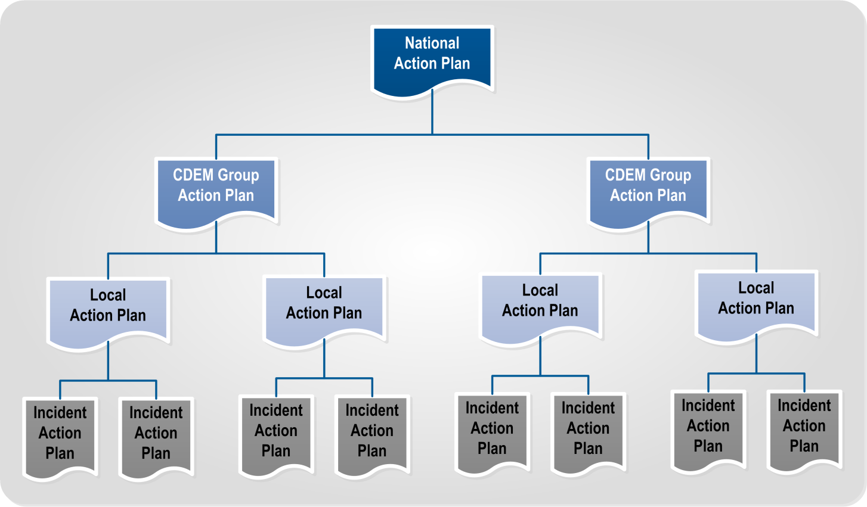
Figure 8 Hierarchy of Action Plans
Alignment between response levels | Higher response level Action Plans provide direction, tasks, resources and coordination arrangements to those prepared at a lower response level.  Lower response level Action Plans must cover the tasks assigned to them, and work within the arrangements stipulated in higher level plans.  However, Controllers at a higher response level do not command response staff at lower response levels. This is because Controllers at a lower response level may be part of a different agency, and therefore accountable to their own governance and management arrangements.  Higher response level Controllers and Planning teams must recognise this, and communicate effectively with those at lower response levels. Any provision in a higher response level Action Plan that affects lower response levels should be discussed and agreed with lower response level Controllers.

Top down and bottom up planning
 | Some responses will be initiated from a higher response level, while many others will be initiated from a lower.
Bottom up | Bottom up planning occurs when incident and local response levels activate first, and develop Action Plans to manage their part of the response.  As higher response level coordination centres activate, Planning teams use lower response level Action Plans to inform their planning process. This ensures that the current activities and intentions of lower response levels are captured.
Top down | Top down planning occurs when a higher response level (national or CDEM Group level), activates first, or takes over the management of a response.  Lower response level Controllers use the higher Action Plan as a key input to their planning process, aligning their mission statement, intent, tasks, and resources accordingly.  In a protracted response, planning is likely to switch from bottom up to top down, as this is a more efficient means of coordinating across multiple agencies and response levels.
More information | Appendix A of the Coordinated Incident Management System (CIMS) manual describes top down and bottom up planning in more detail.  The CIMS manual is available at www.civildefence.govt.nz by searching the document name.

Action Plans that address multiple emergencies
A coordination centre may be required to respond to two separate emergencies at the same time.
In these cases, the Planning team creates an Action Plan that addresses both emergencies. This is to avoid confusion between two Action Plans, and uncertainty about which arrangements have primacy.
A single Action Plan will require the Controller and Planning team to consider both emergencies together, develop response objectives that address both, and prioritise the respective response arrangements.
The planning process is followed, although more staff may be required in the Intelligence team to produce a more comprehensive HEA.

Key planning relationships
Constant communication between response levels, coordination centres, and CIMS functions is extremely important.
Planning is a hub within the coordination centre, as it draws together input from all other functions and agencies.

The Planning-Intelligence relationship
The Planning and Intelligence functions are interdependent. Plans cannot be developed without quality intelligence; similarly, gaps in intelligence are often identified as a result of planning.
In some responses, a single person or team may perform both the Planning and Intelligence functions. Where separate teams are activated, Intelligence must have a strong presence in the Planning team.

Contribution of Intelligence | The Intelligence team contributes to planning by:  - completing the Hazard and Environment Analysis (HEA), to provide context and the worst case/most likely scenarios for how the hazard may progress  - providing hazard input into the Options Analysis step of the planning process, and  - providing the Intelligence Manager or a senior member to take part in the planning process.
HEA | The most crucial Intelligence output is the Hazard and Environment Analysis (HEA). The Intelligence team conducts the HEA in parallel to (or slightly ahead of) the planning process.  The full HEA process is described in Appendix A Hazard and Environment Analysis (HEA) on page 90.
Information Requirements | An Information Requirement is any piece of response information that is not yet known, and that needs to be collected and processed. The Controller, the Planning team, and any other coordination centre function can create an Information Requirement.  Intelligence is responsible for collecting and processing Information Requirements. To enable this, Intelligence develops an Information Collection Plan (see below).
Information Collection Plan | An Information Collection Plan documents all Information Requirements.  The Intelligence team manages the Information Collection Plan, ensuring that:  - each requirement is assigned to the correct agency to answer  - requirements are not lost, and  - answers are collected and passed on to the appropriate people.  See Appendix B Information Requirements on page 100 for more detail.

Planning-Operations Relationship
 | The Planning function works closely with Operations. Both Planning and Operations provide coordination across other functions, support agencies, and lower response levels.
Operations contributes to Planning by:
- providing information about recent activities, intentions, and resource levels of response agencies and lifeline utilities
- providing the Operations Manager or a senior member to take part in the planning process, particularly the Options Analysis step, and
- detailed task planning after the Action Plan is issued.

The coordination boundary | Operations coordinates the response in the short-term, for the duration of the current Action Plan.  Meanwhile, the Planning team develops plans that coordinate the response in the mid to long term, beyond the end point of the current Action Plan. With input from all other functions (including Operations), they may develop another Action Plan, Contingency Plans, or a Long-term Plan.  The coordination boundary is the end point of the current Action Plan. It is the point in time that Operations works up to, and Planning works from (as shown in Figure 9 below). It clarifies which function is responsible for coordinating the response at any given time.  The boundary is not a hard limit, as each function needs input from the other and response activities do not neatly start or end there. Planning may assist Operations in amending the current Action Plan, while Operations must participate in developing the next Action Plan.  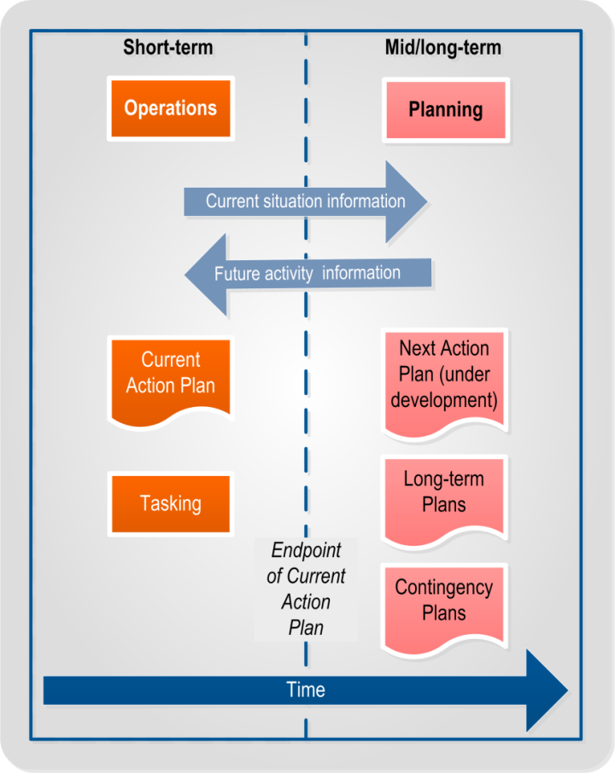  Figure 9 Coordination boundary

Planning relationships in an ECC or EOC
Planning teams within Emergency Coordination Centres (ECCs) or Emergency Operations Centres (EOCs) must work closely with response personnel:
- within and outside the coordination centre, and
- at the response levels above and below.
Planning relationships within an ECC are shown in Table 2 below.
Planning relationships within an EOC are shown in Table 3 on the next page.

Table 2 CDEM Response relationships for Planning in an ECC
EMERGENCY COORDINATION CENTRE
Within the ECC | CDEM Group Controller  Planning staff must understand the objectives and intentions of the Group Controller, so that their efforts help accomplish them.
Other CIMS functions at the ECC
Planning relies upon the other functions to ensure planning is comprehensive and timely. Other functions must understand the constraints and timeframe that Planning works to, to enable them to support the planning effort adequately, and to provide input to plans.

Regional response level | Other activated ECCs  Interactions between Planning teams at the regional response level primarily consist of informing each other of the aim and direction of their planning efforts. Sending intelligence analyses, response option statements and preliminary notices will aid other ECCs, by informing them of what a specific ECC is intending to do, and make their own planning more comprehensive and coordinated.
Regional response agencies and NGOs
ECC Planning will require input from regional response agencies and NGOs. ECC Planning needs to know where the agencies and NGOs are based, their level of activation, their actions, resources and who the appropriate contacts are for Planning. Agency liaison officers will be useful in determining this, and agency representatives are essential for planning.

Local response level | EOCs in the CDEM Group  Effective links with EOC Planning teams enables ECC Planning staff to be aware of events at the local level and the EOC’s intended actions. The ECC will in turn provide preliminary notices, information, advice and Action Plans to the planners at the EOC level, to warn them of upcoming activities and allow them to prepare in advance.
National response level | NCMC Planning  NCMC Planning provides preliminary notices, information, advice and Action Plans to the ECC. ECC and NCMC Planning staff should be in communication with each other so that both are aware of upcoming activities. This will allow ECC staff to prepare in advance for impending operations, and NCMC to be aware of ECC actions and intentions.

Table 3 CDEM Response relationships for Planning in and EOC
EMERGENCY OPERATIONS CENTRE
Within the EOC | Local Controller  Planning staff must understand the objectives and intentions of the Local Controller, so that their efforts help accomplish them.
Other CIMS functions at the EOC
Planning relies upon the other functions to ensure planning is comprehensive and timely. Other functions must understand the constraints and timeframe that Planning works to, to enable them to support the planning effort adequately, and to provide input to plans.

Local response level | Other activated EOCs  Interactions between Planning teams at the local response level primarily consist of informing each other of the aim and direction of their planning efforts. Sending intelligence analyses, response option statements and preliminary notices will aid other EOCs, by informing them of what a specific EOC is intending to do, and make their own planning more comprehensive and coordinated.
Local response agencies and NGOs
EOC Planning will require input from local response agencies and NGOs. EOC Planning needs to know where the agencies and NGOs are based, their level of activation, their actions, resources and who the appropriate contacts are for Planning. Agency liaison officers will be useful in determining this, and agency representatives are essential for planning.

Incident response level | ICPs reporting to the EOC  Effective links with Incident Controllers and their planners enables EOC Planning staff to be aware of events at the incident level and an Incident Controller’s intended actions. The EOC will in turn provide preliminary notices, information, advice and Action Plans, to warn them of upcoming activities and allow them to prepare in advance.
Community | Community Groups  EOC Planning should coordinate official response activities with community groups. This may require allocating resources to the community. The Controller and IMT should also be aware of community needs and determine the response objectives with these in mind. Representatives from community groups may be included as part of the Planning team.
Regional response level | ECC Planning  ECC Planning provides preliminary notices, information, advice and Action Plans to the EOC. EOC Planning staff should be in communication with their ECC counterparts so they are aware of upcoming activities. This will allow EOC staff to prepare in advance for impending operations.

Planning tasks carried out by other CIMS functions
 | All other CIMS functions in a coordination centre have a role to play in response planning.
Control | Control’s responsibilities for planning include:  - clarifying, contextualising and relaying governance and management input to provide initial guidance to the Planning team  - setting response objectives  - being available at key points in the planning process to provide guidance and to ensure planning is proceeding in accordance with the Controller’s intent  - approving the Action Plan  - briefing IMT and lower response level Controllers on the Action Plan  - determining what situations require contingency planning and long-term planning  - Response Manager oversight of the planning process, and  - technical advisors providing expert input.
Logistics | Logistics’ responsibilities for planning include:  - providing logistics information to the planning process, in particular available and expected resources  - advising if a response option is logistically supportable or not  - developing the logistics appendix if required, and  - providing the Logistics Manager or a senior member to take part in the planning process.
PIM | Public Information Management’s responsibilities for planning include:  - providing PIM information to the planning process, in particular key messages, community liaison and media schedules  - developing the PIM appendix if required, and  - providing the PIM Manager or a senior member to take part in the planning process.
Welfare | Welfare’s responsibilities for planning include:  - providing welfare information to the planning process, particularly the needs of the community, and the activities, intentions and resources of welfare agencies  - developing the welfare appendix if required, and  - providing the Welfare Manager or a senior member to take part in the planning process.
Liaison | Liaison responsibilities for planning include:  - providing supporting agency information, particularly the recent activities, intentions and resource levels of their agency, and  - providing a senior member to take part in the planning process.

Factors that influence effective planning
There are a number of factors that will influence the development, timeliness, and quality of response plans. These factors include:
- information and communication
- governance and management
- resourcing, and
- limitations of the methodology.

Information and communication
Effective planning relies on current, accurate information. This not only includes specific data (relevant numbers, times, and locations), but also an understanding of the overall response.
The Planning team must communicate with the other coordination centre functions to ensure they maintain situational awareness. This is a key reason for having other function representatives in the Planning team. They must also share relevant information (via formal and informal communication processes) with:
- other levels of response (personnel in a higher or lower response level coordination centre), and
- other agencies or organisations who are active in the response.

Situational awareness
Situational awareness is an understanding and appreciation of the complexities of an emergency, including consequences for people and the environment, likely developments, and implications for response activities.
In the dynamic conditions of a response, it can be a challenge to gain and maintain situational awareness. However, good situational awareness is essential in enabling response personnel to:
- make accurate, timely decisions
- understand where and when to apply their specialist skills and knowledge, and
- take advantage of opportunities that arise.
How situational awareness is developed | Situational awareness is developed via a variety of means, including (but not limited to):  - personal observations from response personnel  - reconnaissance and impact assessments  - incident reports from other response elements and the public  - meetings and teleconferences with other agency and response element staff  - advice from technical and scientific experts  - maps, diagrams and other displays  - situation reports from other response elements  - media reports, and  - monitoring social media.
Contributing to situational awareness | Different coordination centre functions maintain a situational awareness relevant to their role. For example, an Operations team member and a Logistics team member will not always need to know the same information.  However, all functions must contribute to the situational awareness of the coordination centre as a whole. This can be achieved by:  - face to face discussions between function desk staff  - briefings to teams in the coordination centre  - response maps  - information displays, either projected on screens or on white boards, and  - situation reports.
Gaps in situational awareness | A gap in situational awareness should lead to the creation of an Information Requirement, which is then added to the Information Collection Plan.  See Appendix B Information Requirements on page 100 for more detail.

Common operating picture
To be truly effective, situational awareness must be shared between all response personnel and agencies. The common operating picture is an understanding of the response, based on the best available information and shared amongst all staff, coordination centres, and response agencies.
A common operating picture is not likely to be 100% accurate in terms of information. Building a common operating picture involves filtering and analysing information to create a cohesive picture. Critically, this is shared between agencies and coordination centres, so all response personnel understand the intentions, activities, and needs of each response agency.

Preliminary notices
Preliminary notices | A preliminary notice advises other response levels and agencies that an action is about to happen; it is a ‘heads up’ of a Controller’s intentions. It includes as much information about the action as possible, ensuring that other response levels and agencies can begin their own planning earlier and align their actions with the lead agency as soon as possible.  There can be multiple preliminary notices issued throughout the planning process. They may be issued verbally, at a meeting or teleconference.  Preliminary notices should be issued:  - as soon as possible during or after the Controller’s preliminary scoping (see Section 3 Planning processes on page 42)  - typically no later than after the Objective Analysis step of the planning process (see Section 3 Planning processes on page 42), and  - with all information about the action that is available.  Preliminary notices may (if time and circumstances allow) be issued as a written document. A template for a written preliminary notice is provided in Appendix C Preliminary notice on page 107. Note that this is a guide only – not all fields in the template will be able to be completed every time. A preliminary notice should not be delayed because of insufficient information to fit with the template format.

Facts and assumptions
Response planning is based on information about the environment, resources, hazards, and other aspects of the response.
Facts are statements of proven truth which are backed up with verified data.
Assumptions are pieces of information that are yet to be verified, and are used as substitutes for facts until verification is received.

Using assumptions in response planning | Assumptions are used in response planning when facts are not known; for example, the condition of a bridge on a critical road. The bridge may be assumed to be open or closed (whichever is most useful for planning).  Implications for using assumptions in response planning include:  - assumptions must be verified, and lead to an Information Requirement being added to the Information Collection Plan (see Appendix B Information Requirements on page 100 for more detail.)  - assumptions may become facts as information is collected  - information that remains unverified must be highlighted in briefings to Controllers, and  - if assumptions are proven to be false, any plans based on that information will require revision.

Governance and management
Governance | Governance comprises the elected representatives from local authorities, such as mayors or regional council chairs. They provide the strategic context within which a response is managed and the outcomes that a response should achieve. Elected representatives provide the political accountability for the high-level direction set for the response.
Management | Management comprises chief executives and senior managers. During a response they ensure that the council continues to meet its strategic aims. They also provide operational services that support response (e.g. a local authority provides road, water, and waste management services). Management also provides many of the resources used during a response.
Role of governance and management in response | Under the CDEM Act 2002, a Controller has considerable freedom to determine how a response will proceed. A Controller may, in consultation with other response agencies, set response objectives as they see fit, and determine their own intent.  However, a Controller should consider governance and management context and priorities, as well as the intentions and requirements of other agencies.  Governance and management provide the context within which a Controller responds. They help to situate the response within the wider agency activities, and give the Controller a clearer understanding of the resources available to them.
Before a response | Direction from governance and management will often be determined well in advance of a response, and incorporated into standing arrangements and procedures (e.g. financial delegations, likely response objectives, available resources, activation triggers etc.).  The Controller may discuss desired outcomes and resourcing needs with governance and management during readiness. This allows the Controller to develop objectives and planning guidance quickly during an emergency, without having to immediately consult with governance and management. It also allows the Controller to set expectations for governance and management roles and responsibilities within a response, and how they may contribute.
During a response | The Controller briefs governance and management as early as possible during a response, especially if the emergency has extreme or sensitive consequences.  Governance and management may provide direction to the Controller on response objectives, but the Controller has the final decision.

Direction from higher response levels | Action Plans issued by a higher response level will establish the wider response context within which a regional or local response will operate. They will give tasks to the receiving coordination centre, detail the higher Controller’s intent, give coordinating instructions and describe how resources will be allocated.  Where there are clashes and discrepancies between these higher Action Plans and a council, the Controller must raise these as soon as possible with the higher Controller. It may also require consultation with higher response level management and governance.  On occasion, higher response level political influences take precedence over local arrangements. The political debate takes place in parallel with a response. This may affect the political context in which a regional or local response operates. Controllers should be prepared to adapt to changing situations.

Resourcing
Factors related to resourcing that affect response planning include:
- staff availability, experience, and training
- time
- cost
- logistics considerations, and
- capability shortfalls.

Staff availability, experience, and training
The number of available staff, and their training and experience levels will determine the quality of response plans.
It is crucial that the Planning Manager is a trained and experienced planner, and is able to guide Planning team members through the planning process. They may be assisted by other experienced staff.
Training during the readiness phase, as well as experience from previous responses, will help build capacity. Where possible, subject matter experts and decision makers (e.g. Managers) should represent their functions and agencies, to ensure the input is as robust as possible.
Where staff are less experienced, planning should follow a simpler process with less detail (e.g. the quick planning process described in section 3.3 Quick planning process on page 48).

Time
Time is a crucial factor, even when planning takes place before an emergency occurs. During response, time pressure increases when lives and property may be at risk.
The time available for planning will determine:
- how much input the Controller has into the plan
- how much detail can be included, and
- how many response options may be developed.
Figure 10 shows how the time available will affect the planning process.
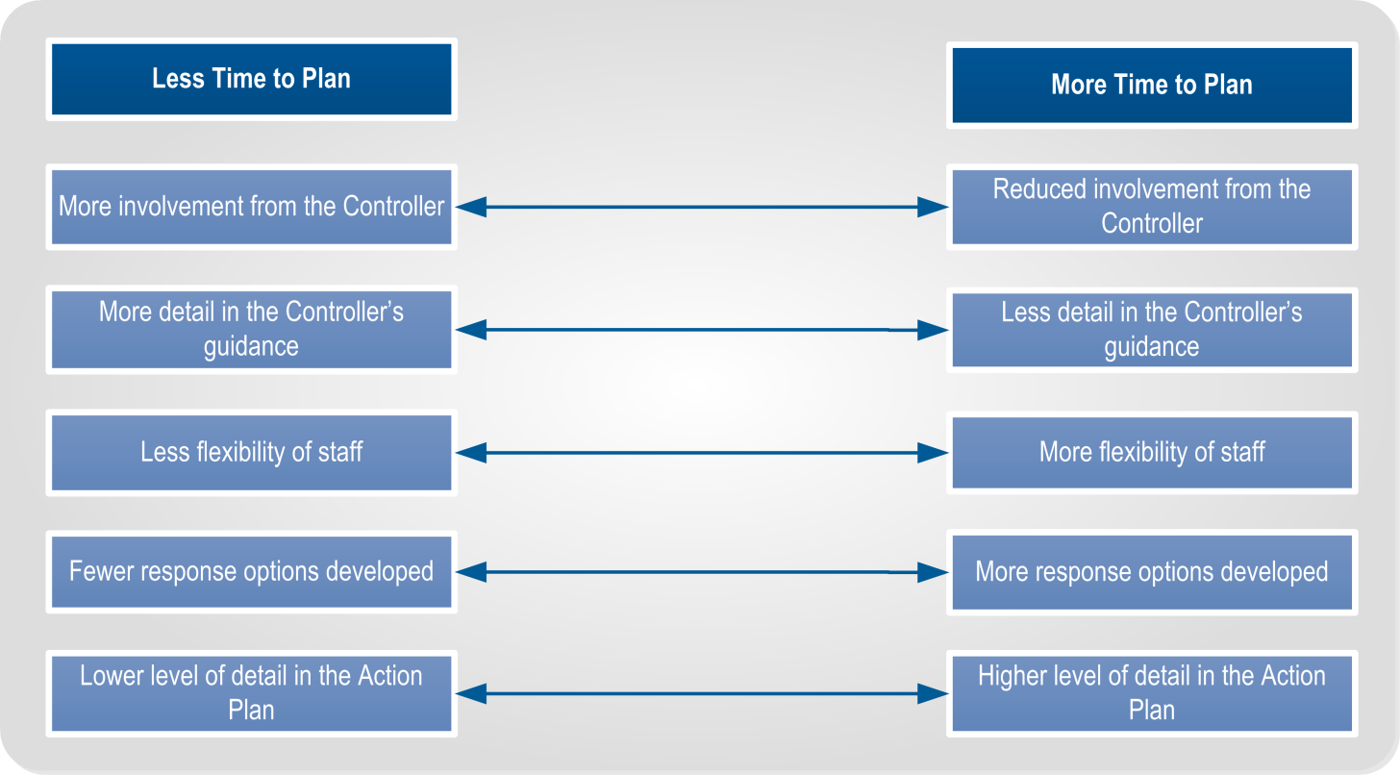
Figure 10 - Time and Planning relationship
‘One third, two thirds’ rule | A further factor limiting the time available to a Planning team is the need to allow timing for lower response levels and other agencies to do their own planning and preparation. If a National Action Plan is due to start in 24 hours, it must be issued well in advance of that time, to allow CDEM Groups, EOCs and incident teams time to plan and prepare.  To allow sufficient time, a Planning team should aim to use only 1/3 of the available time for themselves, leaving the remaining 2/3 to those at lower response levels. In the example above, the National Planning team will need to issue the Action Plan within eight hours, giving 16 hours to those at lower response levels. In turn, the CDEM Groups would need to complete their Action Plan within 5-6 hours, leaving the remainder for local and incident level planners.

Cost
Costing a response is an important part of planning. The Finance sub-function in the Logistics team will be responsible for tracking costs, but all functions contribute by detailing their resource needs and intended activities.
Financial delegations will need to be factored into planning.

Logistics considerations
All response options must be logistically supportable; i.e. all resources required to perform each response option must be:
- available on time, at the right location, in the right quantities, with the right support, and
- able to be maintained at these levels as long as needed.
Any shortfalls will either prevent a response option being considered, or must at least be highlighted as a risk.
Logistics considerations may also play a part in sequencing and prioritising response objectives or options.

Capability shortfalls
A capability shortfall is where necessary personnel, equipment, or supplies are not available to carry out a required response task.
Procurement may provide the capability, but even if this is possible, there may be delays in receiving it. These shortfalls will limit the response options available to the Controller and the Planning team.

Limitations of the methodology
 | Response planning involves a comprehensive methodology and terminology for coordinating responses, but there are limitations to what it can do.
Disconnect between response levels | National and CDEM Group Planning teams need to be aware of activities taking place at lower response levels, so that they can assign achievable tasks and appropriate resources to response agencies.  Likewise, local and incident level Planning teams need to be aware of the higher-level Controller’s intent, so that the plans they develop are aligned.  Ineffective and infrequent communication may result in a disconnect between plans at different response levels and, consequently, between response actions.

Problem type | Planning processes are best suited to solving well-structured problems with clear guidance. Planning processes are less effective in dealing with poorly-structured problems that are difficult to define, or that do not have a clear endstate or solution.  This structure and definition must be provided ‘up front’ by the Controller, often in consultation with governance, management and other agencies. Unclear problem-definition at the start of a planning process is likely to lead to an unclear Action Plan.
Desire to be comprehensive | The goal of the Planning team is to develop plans that are as comprehensive as possible, taking account of the maximum number of variables.  However, total comprehensiveness is not usually possible. Attempting to account for all variables may cause unacceptable delays in the planning process.  The Controller and Planning team must determine the acceptable level of detail given the time, staff, and information available. Contingency planning may help manage risks from unaccounted variables.

Planning processes
The Planning P (Figure 11) is the basis for response planning processes in CIMS and CDEM. It is designed to enhance:
- the Controller’s decision making
- identification and analysis of response objectives
- analysis of information coming into the coordination centre, and
- coordinating separate agencies and personnel into a single, cohesive response.
The Planning P consists of two processes:
- the initial response process (steps shown in grey A-D), and
- the planning process (steps shown in blue 1-7).
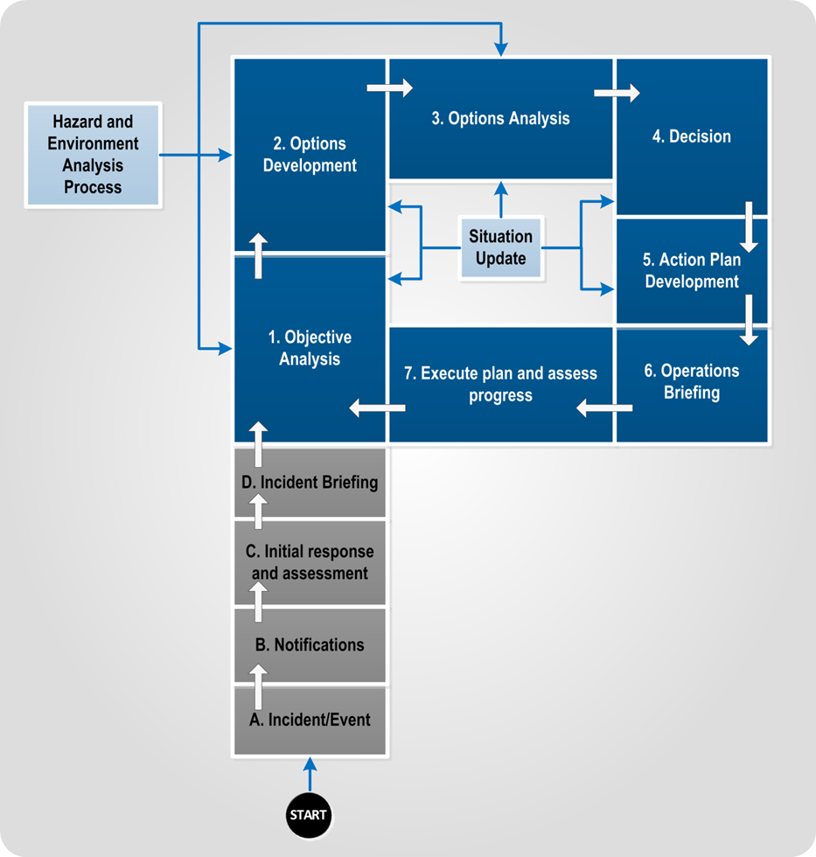
Figure 11 The Planning P
The Planning P is based on a planning methodology developed by the United States Federal Emergency Management Agency (FEMA), and adapted to fit New Zealand practice.

Versions of the planning process | Depending on the response circumstances, the Planning team may use:  - the quick version of the planning process, or  - the detailed version.  Both versions are based on steps 1-7 of the Planning P, but differ in the amount of detail and time required. Both versions may be used during a single response, for different plans.
The quick planning process | The quick planning process emphasises speed over detail. It is best suited for:  - responses with a shorter lead-time or which are reacting to a sudden onset emergency  - lower response levels  - simpler, shorter emergencies, and  - where Controllers and staff are less experienced and/or trained.  See section 3.3 Quick planning process on page 48 for more detail.
The detailed planning process | The detailed planning process requires more time and staff effort, but produces a more comprehensive Action Plan. It is best suited for:  - responses with a longer lead-time, including pre-emergency contingency planning  - the latter stages of a response, if the time pressure starts to ease  - higher response levels  - more complex emergencies, and  - more experienced Controllers and Planning staff.  See section 3.4 Detailed planning process on page 56 for more detail.
Participation in the planning processes | Planning processes are driven by the Controller in the coordination centre, supported by the Planning team. They require the participation of all activated coordination centre functions, as well as support agencies.
Scalability | Planning processes are scalable; they can be completed by a single person in a few minutes, or a team of 20 or more over a month. This will depend on the complexity of the emergency, need, available time and staff.
Breakout | If two or more broad response options are to be considered, the Planning team may split into sub-teams, one to each option. This will require more staff, but will save time. Subject experts (e.g. logistics, Welfare, PIM, support agency reps etc) may need to float between teams to ensure they provide input to all of the options.  The Planning Manager oversees the sub-teams, and ensures they are following the planning process in a timely manner.

Key planning inputs
Key inputs to the planning process (quick or detailed) are:
- Controller’s preliminary scoping
- the Hazard and Environment Analysis (HEA), and
- situation updates.

Controller’s preliminary scoping
The Controller conducts a preliminary analysis of the situation, in order to provide guidance to the coordination centre (particularly the Planning and Intelligence functions).
The key inputs required for preliminary scoping are shown in Table 4 below. The Controller considers these inputs, either alone or with key staff, who may include:
- the Response Manager
- selected function managers (particularly the Intelligence and Planning managers)
- key support agency representatives, and
- technical experts.

Table 4 Key inputs for preliminary scoping
Input | Information provided
Governance and management direction | - The outcomes/endstate that the Controller and coordination centre has to achieve  - The degree of authority the Controller and response element has over council resources  - Council resources that are available to the response  - Any constraints on the response that are imposed by governance and management (such as deadlines, budget limits, geographical limits, directions to work with specific agencies or stakeholders).
Higher response level Action Plan (where issued) | - The higher response level mission and intent  - Tasks for the coordination centre to achieve  - Coordination arrangements, such as key locations, boundaries, timings  - Additional resources allocated to the coordination centre, or which are available for request
Lower response level Action Plans (where issued) | - Actions undertaken by lower response levels  - Intended response actions  - Current resource use
Initial Action Plans | - Current location of response resources, and their intended tasks  - Current Information Collection Plan
Situation reports | Situation to date, and how it has developed
Continued on the next page
Input | Information provided
HEA analysis | - Level of detail achievable within the timeframe  - Initial information requirement recommendations  - Broad hazard scoping, including outline of anticipated hazards  - Significant environmental characteristics  - Possibly steps 1 and 2 of the HEA (see Appendix A Hazard and Environment Analysis (HEA) on page 90).

Controller’s guidance | The Controller (supported by key staff) develops guidance to the Planning function, based on the key inputs. How long this takes and how detailed the guidance is depends on time constraints and quality of the information available.  At a minimum, the Controller’s guidance should include the information listed in Table 5 below.
Table 5 Controller's guidance
Guidance | Description
Higher response level/ Governance intent | The Controller’s understanding of the higher response level’s intentions and the intended outcomes and context of governance and management. If there are any conflicts, the Controller must resolve them, and may note this in their guidance.
Response objectives | The Controller’s selection of what the objectives are for the response, and which ones apply to this Action Plan.
Timelines and responsibilities | - Includes a timeframe (starting and end times) for the Action Plan’s operational period  - A time for the completion of the planning process  - Includes any additional planning responsibilities for function managers and support agency representatives
Hazard appraisal | An outline of the hazards to be considered during planning.
Broad response options | If the Controller has already determined that there are one or more options that the response will follow, they can be noted here. This will ensure these options are considered by the Planning team from the start of the planning process.
Information Requirements | Any Information Requirements that the Controller has determined must be filled during the planning process.

Outputs | The output from this step will be either verbal or (ideally) written guidance from the Controller to the Planning team.  Preliminary notices to notify and inform agencies and response elements can also be created following this step. See section Preliminary notices on page 36 for information
Templates | The following templates in Appendix C are relevant to the Controller’s preliminary scoping:  - Controller Preliminary Scoping Template on page 103  - Preliminary Notice on page 104.

Hazard and Environmental Analysis (HEA)
The Hazard and Environment Analysis Process (shown adjacent to the planning process steps in Figure 11) is a crucial input into the planning process. It takes place in parallel to the planning process.
The HEA involves analysing the operational environment and hazards, and is vital for:
- forecasting hazard developments
- analysing environmental factors
- helping the coordination centre (including the Planning team) to maintain their situational awareness, and
- enabling a proactive response that acts before hazard consequences occur.
The process is carried out by the Intelligence team. See Appendix A Hazard and Environment Analysis (HEA) on page 90.

Situation updates
Situation updates are shown within the planning process steps in Figure 11.
These occur throughout the planning process to ensure that planning is based on the latest information. These updates may be:
- information given by coordination centre function representatives, or representatives from other response agencies
- formal briefings and reviews by the whole team
- incident reports, and
- answers to Information Requirements that were issued earlier (see Appendix B Information Requirements on page 100 for more detail).
After an update, the Controller and Planning team:
- quickly assess the implications of new information, and
- decide whether any existing plans are still valid, and whether they need to be changed.
Situation updates may result in the Planning team updating an existing plan, returning to an earlier step in the planning process, or starting again from the beginning.

The initial response process
The initial response process has four steps
- Incident/emergency
- Notification
- Initial response and assessment, and
- Incident briefing.
These steps are described in Table 6 below.
Table 6: Initial response process
Step | Description
A. Incident/ emergency | The process begins when an emergency occurs, or with recognition that an emergency may be about to occur (for example a widespread human disease outbreak overseas, or a Volcanic Alert Bulletin indicating a potential eruption in the near future).  Emergency services may begin responding at this stage.
B. Notifications | Agencies send warning messages and activation notifications. These may be:  - via a communications centre following an alert from the public  - via a scientific source, or the national warning system.  Agencies assess warning messages and determine an initial response. This may include:  - standing down (if the warning is below activation thresholds)  - activating their response structures,and  - issuing their own warning/advisory messages.
C. Initial response and assessment | Responding agencies:  - mobilise response personnel (including the Controller)  - confirm and activate response structures (including coordination centres)  - gather information  - assess the situation, and  - initiate any immediate response actions.  Response agency personnel may follow standard operating procedures while carrying out initial response actions. Agencies may develop an Initial Action Plan to provide greater coordination during this step.  Note: This step may take minutes or it could take several days, depending on the hazards, scale of the response, and the response level.
D. Incident briefing | The Controller conducts a briefing for staff, stakeholder agencies, and (if required) governance and management (see below). This may be a formal presentation, a teleconference, a meeting, or a written brief.  If an Initial Action Plan has been developed, the Controller presents this at the briefing.  Briefing governance and management  The Controller may brief governance and management on the initial response, including any major issues, likely response objectives, and response options.  Governance and management will discuss the response with the Controller, and may shape the Controller's response objectives.  See section 2.8.2 Governance and management on page 37 for more information on the role of governance and management.

Quick planning process
The quick planning process may be carried out multiple times during an evolving response to produce a series of Action Plans. It is also used to create a Contingency Plan, or a Long Term Plan.
The quick planning process has seven steps:
- Objective Analysis
- Options Development
- Options Analysis
- Decision
- Action Plan Development
- Operations Briefing
- Execute Action Plan and Assess Progress.

Preliminary scoping | Before the planning process begins, the Controller completes a preliminary scoping, which provides initial guidance to the Planning team.  See Controller’s preliminary scoping on page 44 for more detail.
Input from other agencies | Support agencies should be included in the quick planning process.  Their input enables their knowledge, experience, resources, objectives, operational parameters, and legal requirements to be reflected in the Action Plan.

1. Objective Analysis
Objective Analysis is the first and most important step in the planning process. It involves analysing the situation, information gaps, and the Controller’s response objectives, and aligning planning accordingly. This ensures that the Action Plan is aimed at achieving the Controller’s response objectives.
In this step, the Planning team asks four key questions, and notes the answers (see Table 7 on the next page).
A template is provided in Appendix C Quick Planning- Objective Analysis Template on page 114.

Table 7: Objective Analysis
Question | Description
- What is the situation? | Planning team members each give a brief summary of the situation in their functional areas. This ensures that all members have a common understanding of the situation.
 | Key output: shared situational awareness
- What do we need to know? | Information gaps  As the Planning team discusses the situation in step 1, gaps in the information picture are identified. These gaps become Information Requirements (see Appendix B Information Requirements on page 100 for more detail).  Assumptions  As an interim measure, assumptions may be used to allow planning to continue. Assumptions must be recorded as Information Requirements so they can be verified as planning continues, and replaced by facts.
 | Key outputs: A list of assumptions and a list of Information Requirements
- What do we need to achieve? | Response objectives  If the Controller has set the response objective, the Planning team analyses, refines, and suggests modifications to them (see section 2.6.1 Response objectives on page 19). If the Controller has not set any, the Planning team will create some suggested objectives for the Controller’s review.  The Controller determines which response objectives will be addressed in this Action Plan, and which ones will be addressed by subsequent Action Plans.  The list of response objectives should be as small as possible, ideally no more than six.  Note: The Planning team may be required to generate response objectives from scratch, if this has not already been done by the Controller.
 | Key output: Suggested modifications to response objectives
- How do we achieve that? | Task list  Response objectives must be broken into tasks, so they can be assigned.  For each objective, the Planning team determines what tasks have to be completed to deliver the objective. List the tasks for all of the objectives together, as there may be some crossover.  Essential Tasks  The Planning team determines which tasks are essential (i.e. if they’re not completed, one or more response objectives will not be achieved). There should be only one or two essential tasks for an Action Plan.  Mission Statement  The essential tasks form the basis of the Mission Statement, along with the selected response objectives (see section 2.6.2 Mission statement on page 21).  Broad Response Options  The list of tasks can form the basis for broad response options.  Note: Developing a single response option risks overlooking better solutions that may not be immediately obvious.
 | Key outputs: A task list, mission statement, and broad response options

Key outputs | The key outputs of Objective Analysis are:  - a shared situational awareness  - a list of assumptions  - a list of Information Requirements (see Appendix B Information Requirements on page 100)  - a list of response objectives, prioritised and sequenced by the Controller  - an understanding of which response objectives this planning process addresses  - a task list  - a mission statement, and  - broad response options.  The Planning team will need to provide a briefing to the Controller, if the Controller has not been part of the discussion.

2. Options Development
In this step, the Planning team develops options for how the response can achieve its mission. These options must be viable with the resources available, aimed at achieving the mission, and distinct from each other.
Options Development is the part of the planning process where the Planning team uses its experience, knowledge and creativity to develop solutions to the problems posed by the hazard(s). The Planning team should think widely of any potential action that will help improve the situation.
In this step, the Planning team asks three key questions, and notes the answers (see Table 8 on the next page).
A template is provided in Appendix C Quick Planning- Options Development Template on page 117. It includes a briefing format.

Situation review | Before Options Development begins, the members of the Planning team review the situation to make sure they have the most accurate information.

Table 8: Options Development
Question | Description
- Where can we best accomplish each task? | Task location  For each broad response option, the Planning team determines appropriate locations (as required) for where each task can be best accomplished, for example:  - establishing CDCs  - flood defences or other hazard mitigation measures  - emergency movement control (e.g. road blocks or cordons)  - Assembly Areas (working with the Logistics function).  Tasks that don’t involve a physical location (e.g. public messaging) will be addressed in Question 7.  Response options  At this stage, broad response option statements can start to be developed using Appendix C Option Statement Template on page 126.
 | Key outputs: Draft option statements
- What resources are available, and what do we need to accomplish each task? | Resources  The Planning team determines what resources are available for the response, either immediately, or within a useful timeframe. They then determine what resources are needed to accomplish each task.  Resource shortfalls  Any resource shortfalls can be resolved by sequencing the use of a resource (see Question 7), by issuing Resource Requests (via the Logistics function) or by deciding not to carry out a particular task.  The draft option statements can be updated.
 | Key outputs: Assigned resources
- When and where do the actions take place in relation to each other? | Sequence of tasks  Once necessary locations and resources have been identified, response tasks can then be sequenced. This ensures:  - a logical flow of action, and  - resources are used effectively and efficiently.  Some tasks rely on others to be carried out first. An evacuation may require clearing debris from roads on the evacuation route. Reinforcing flood defences will require the transport of resources to the site. Some tasks may have to start later than planned if a key resource is needed for a another, higher-priority task.  Resource shortfalls  At this step, the Planning team determines which of the resource shortfalls identified at Question 6 can be met by sequencing the use of resources, or by deleting the task. Remaining shortfalls will require Resource Requests to be issued.
 | Key outputs: Updated option statements, timeline for tasks, Resource Requests for the Logistics team

Key outputs | The key outputs of the Options Development step are:  - draft option statements  - sequence and timeline for tasks  - resources assigned to tasks, and  - Resource Requests for the Logistics team.  The Planning team will need to provide a briefing to the Controller, if the Controller has not been part of the discussion.

3. Options Analysis
In this step, the Planning and Intelligence teams compare the response options against the hazard scenarios developed by the HEA. This ensures that the response options can counter the hazard consequences. This step also determines which option is the best one to recommend to the Controller.
In this step, the Planning team involves asking one key question (see Table 9), and noting the answer.

Key input | A key input in Options Analysis is the HEA, which is carried out by the Intelligence function (see Appendix A Hazard and Environment Analysis (HEA) on page 90).
Situation review | Before Options Analysis begins, the members of the Planning team review the situation to make sure they have the most accurate information.
Table 9: Options Analysis
Question | Description
- How do the options deal with the hazard(s), and which is the best one? | Other functions  It is useful to involve the other function managers, especially Operations, in this step. This will ensure they are familiar with the response options and the most likely/most dangerous hazard scenarios.  Testing  The Planning team tests the response options against the most likely and most dangerous hazard scenarios. Testing the response options against hazard scenarios will highlight weaknesses in the response options.  This is done by comparing the timelines of each response option with the hazard scenarios developed by the Intelligence team during the HEA. Also compare the risks highlighted by the HEA, and how each option addresses these.  Comparison  This enables the response options to be modified and improved. It also allows them to be compared and ranked.  Ranking  Based on this discussion, the response options are ranked, and a preferred option may be recommended to the Controller.  For a more comprehensive description of Options Analysis, see section 3.4.4 Options Analysis on page 66.
Key output | The key outputs of the Options Analysis step are the completed response options for the Controller’s approval.  The Planning team may recommend their preferred option to the Controller, if they have one.

4. Decision
In this step, the Planning team briefs the Controller on the response options they have developed.
The Controller considers:
- the response options
- the recommendations of the Planning team, and
- the results of the Objective Analysis testing.
The Controller then selects an option as the basis for an Action Plan.
Note: The Controller may direct that further development and analysis of the options is required.

Preliminary notice | A preliminary notice (see Preliminary notices on page 36) should be issued at this stage, even if one was issued earlier. The Controller’s decision to select a response option means there is sufficient information to pass onto other coordination centres, to aid their planning effort and reduce planning time.
Controller’s briefing | The Controller may deliver the preferred option in a briefing to the coordination centre, other agencies, or governance and management.  A template for briefing is provided in Appendix C Decision Briefing on page 129

5. Action Plan Development
 | The purpose of this step is to develop the preferred response option into an Action Plan, for approval by the Controller.
Verbal Action Plan | If time is short, the Planning team may prepare the Action Plan as a brief, to be delivered verbally by the Controller.  A verbal Action Plan should include all the key features of a written Action Plan (see section 2.6 Action Plans on page 19). The Controller should also be provided with maps and other visual aids, where necessary.  See Appendix C Decision Briefing on page 129, which may be used as a template for a verbal Action Plan.
Written Action Plan | Where time allows, the Planning team prepares a written Action Plan. A template is provided in Appendix C Action Plan template on page 131.  Other coordination centre functions (such as PIM, Logistics, and Welfare) may be required to prepare their own specialised appendices to the Action Plan. These allow important specialist information and instructions to be included, without cluttering the main body of the Action Plan.
Controller approval | Once the Action Plan has been drafted to the satisfaction of the Planning Manager, it is presented to the Controller for their review, modification, and final approval.  The Controller may brief governance and management on the Action Plan, if required.

6. Operations Briefing
The purpose of this step is to inform all relevant response personnel of the Action Plan, and explain its key elements.
The Operations Briefing signals the handover of the Action Plan from the Planning team to the Operations team (and other functions) who will begin implementing it.
See Appendix C Decision Briefing on page 129 for a template.

Controller’s role | The Controller:  - verbally briefs lower response level Controllers, function managers, and/or support agency leaders, and  - answers questions and gauges understanding.
Planning role | The Planning team:  - ensures that copies of the Action Plan and any supporting materials are distributed (printed or emailed), and  - supports the Controller in answering questions, if necessary.
Other function managers | Relevant function managers (e.g. Intelligence Manager, Logistics Manager), may deliver part of the briefing, or be available to answer questions relevant to their functional areas.
Operations tasking | The Action Plan describes the tasks and arrangements that the response will follow, but it will often require further, more detailed, task planning to ensure response actions are properly coordinated. This is the responsibility of the Operations function.

7. Execute Plan and Assess Progress
Once the Action Plan has been issued, the Operations function oversees the actions of other functions, lower response levels, and support agencies as they implement the Action Plan.
All coordination centre personnel, including the Planning team, have responsibilities in supporting the execution of the action plan, and assessing progress (see Table 10).
Note: The planning process is circular, and may take place multiple times until all of the Controller’s response objectives are complete.

Table 10: Responsibilities for executing Action Plan and assessing progress
Team or agency | Responsibility
All coordination centre personnel | - Implement their tasks in the Action Plan  - Actively liaise with counterparts in other coordination centres  - Monitor progress of activities against the Action Plan
Control | - Oversee execution of the Action Plan, including deciding on any changes  - Brief governance and management on progress, as required.  - Determine whether to develop a new Action Plan, Contingency Plan or Long-Term Plan
Operations team | - Oversee the actions of other functions, lower response levels, and support agencies as they implement the Action Plan.  - Update the Action Plan to manage unexpected and changing events.  - Conduct detailed task planning to ensure tasks are fully coordinated.
Planning team | - Prepare and issue any updates to current Action Plans.  - Develop Contingency or Long Term Plans as necessary.
Support agencies | - Conduct own planning in alignment with lead agency Action Plan.  - Provide situation reports to the lead agency coordination centre.

End of the planning process | The quick planning process ends when the Action Plan’s mission is achieved.  A new planning process should be initiated if:  - the mission cannot be achieved, or is no longer relevant, or  - there are still response objectives yet to be addressed.

Detailed planning process
The detailed planning process may be carried out multiple times during an evolving response to produce a series of Action Plans. It is also used to create a Contingency Plan, or a Long Term Plan.
The detailed planning process follows the same seven steps as the quick planning process:
- Objective Analysis
- Options Development
- Options Analysis
- Decision
- Action Plan Development
- Operations Briefing
- Execute Action Plan and Assess Progress.

More detail | The steps are more involved than they are for the quick planning process, and necessitate a deeper level of deliberation and consultation. This is illustrated in Figure 12 on the next page.  Figure 12 also identifies the actions of the different coordination centre functions, governance and management, and support agencies.
Initial Response Process | Figure 12 shows the Initial Response Process. This is described in section 3.2 The initial response process on page 47.
Hazard and Environmental Analysis Process | Figure 12 shows the steps of the Hazard and Environmental Analysis (HEA) Process, and how they interact with the detailed planning process.  It illustrates how support agencies may assist with the HEA; this may be through the provision of trained staff or through providing information about the environment and/or hazard(s) to the lead agency.  See Appendix A Hazard and Environment Analysis (HEA) on page 90 for more detail on the HEA process.
Support Agency input to planning | Support agency input into the planning process (shown in Figure 12) is vital. This input enables their knowledge, experience, resources, objectives, operational parameters, and legal requirements to be reflected in the Action Plan.  This input is not all one-way, and support agency staff will be able to feed planning information back to their agency to aid agency planning and preparation.

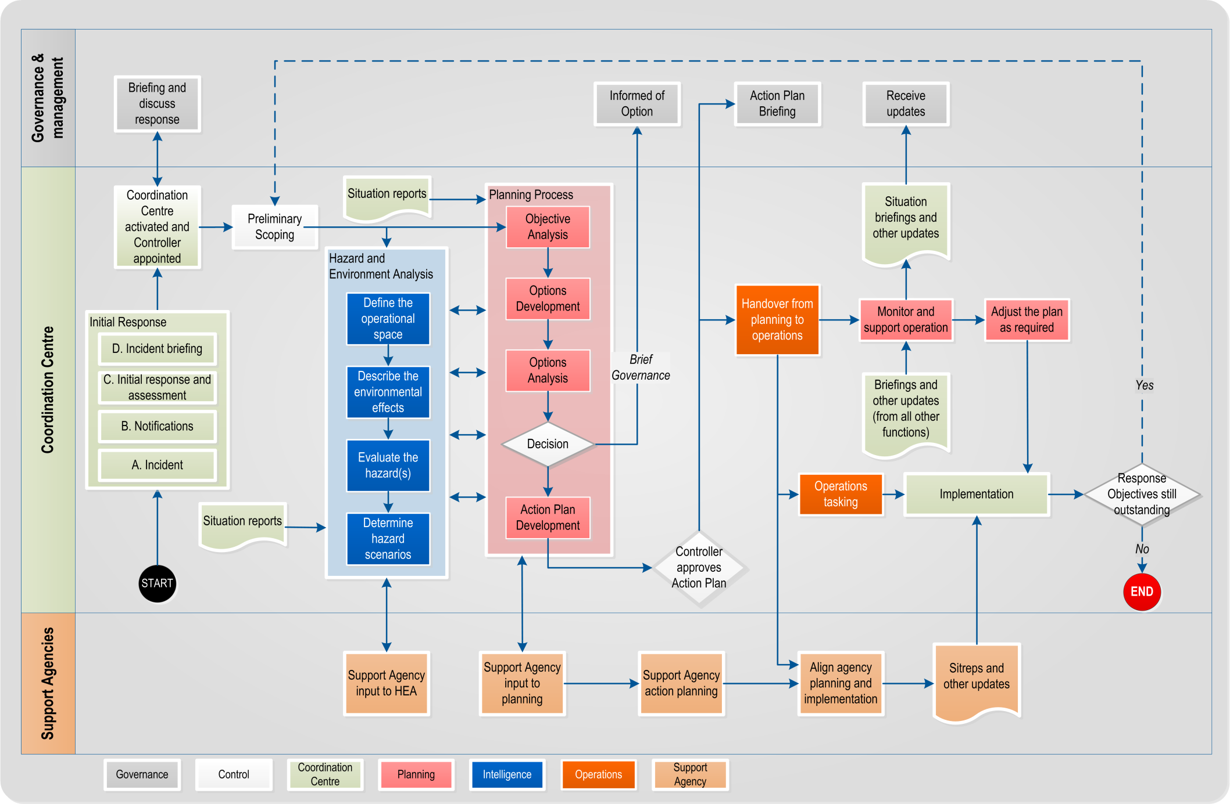
Figure 12 The detailed planning process

Preliminary actions
Preliminary actions are those that take place before the HEA and the planning process. These actions include:
- coordination centre activated and Controller appointed
- briefing and discuss response options
- Controller’s preliminary scoping, and
- situation reports.

Coordination centre activated and Controller appointed | A coordination centre (ECC or EOC) will activate to manage the emergency, in accordance with their activation procedures. As part of the activation, a Controller is appointed to lead the response. This appointment is usually made in advance of the response.
Briefing and discuss response options | The Controller will brief governance and management on the response to date, major issues, likely response objectives, and response options. Governance and management will discuss the response with the Controller; and this may shape the Controller's response objectives.  Governance and management are described in more detail in section 2.8.2 Governance and management on page 37.
Preliminary scoping | In this step, the Controller conducts a preliminary analysis of the situation, in order to provide guidance to the coordination centre (particularly the Planning and Intelligence functions).  See Controller’s preliminary scoping on page 44 for more detail.
Situation reports | These are the ongoing situation updates needed throughout the planning and HEA processes, to ensure that these are as accurate as possible.  See Situation updates on page 46 for more detail.

Objective Analysis
Objective Analysis is the first and most important step in the planning process. It involves analysing the situation, information gaps, and the Controller’s response objectives, and aligning planning accordingly.
In this step, the Planning team:
- reviews the situation
- analyses higher response level intentions
- determines tasks
- determines freedoms and constraints
- identifies critical facts and assumptions
- drafts mission statement and broad response options, and
- briefs the Controller.
 | A template is provided in Appendix C Detailed Planning- Objective Analysis Template on page 119.
Importance of effective Objective Analysis | Effective Objective Analysis ensures that the Action Plan that is developed directly addresses the Controller’s response objectives.  If this step is bypassed, Action Plans may still be comprehensive and coordinate the response. However, they may fail to achieve the Controller’s response objectives. This may make the Action Plan a failure before it is implemented.

1. Review the situation
In this step, the Planning team reviews the situation to ensure that all members have good situational awareness, and a common operating picture, including:
- review of the Controller’s preliminary scoping
- time factors – this includes;
  - the time available for planning, and
  - the time available for achieving the response objectives (if a deadline has been set)
- steps 1 and 2 of the HEA analysis (led by an Intelligence representative), and possibly 3 and 4
- known hazard information (if not covered by HEA analysis already); this includes the type of hazard(s), locations, consequences and development (led by an Intelligence representative)
- response actions to date, including agencies activated, resources deployed or mobilising, and
- any Initial Action Plans, previous Action Plans, or Action Plans issued by other coordination centres.

2. Analyse higher response level intentions
In this step, the Planning team discusses and analyses the Controller’s guidance developed during preliminary scoping. This will ensure that the team has a common understanding of what the response is aiming for, and allows the initial analysis to be verified by a wider group. Major discrepancies in the analysis should be raised during the brief to the Controller at the end of this step (or as soon as possible).
The analysis focuses on four key areas:
- the purpose of or reason for the response
- the response objectives – the Planning team should consider the Controller’s response objectives (particularly those that this plan will address) to determine if there are any gaps, or if some are unnecessary or could be adjusted
- the desired endstate for the response, and
- the role of the coordination centre – is it the lead in a local emergency, or is it supporting a larger response structure? What role is it playing within the agency’s business as usual structure?

3. Determine tasks
In this step, the Planning team determines the tasks that are required to achieve the response objectives given by the Controller and/or a higher response level Action Plan. There are three types of tasks:
- specified tasks
- implied tasks, and
- essential tasks
See section 2.6.2 Tasks on page 23 for more detail.

4. Determine freedoms and constraints
 | In this step, the Planning team defines any limitations that are imposed on the response by governance and management, or a higher response level Controller or Action Plan.
Constraints | A constraint is any restriction that is placed on a response. This may include time limits or deadlines, budgets, locations that must or must not be covered by the response, agencies that must (or must not) be included in the response, or any resource that is put out of scope.  Environmental or hazard factors are not considered constraints, they are simply factors to be considered.

Freedoms | A freedom is any undefined factor relevant to the response. If a time limit is not set for an activity, then time becomes a freedom for that activity. This doesn’t mean unlimited freedom, but it does mean the Controller and Planning team can define that parameter themselves.  Freedoms and constraints help to set the boundaries within which the Action Plan must be developed. The Action Plan cannot exceed any of the constraints placed on it.

5. Identify critical facts and assumptions
In this step, the Planning team determines what they need to know. They distinguish between critical information that they know to be true (facts) and information that requires verification (assumptions).
Using assumptions in the planning process will generate Information Requirements, and an update to the Information Collection Plan (see Appendix B Information Requirements on page 100).

6. Draft mission statement and broad response options
In this step, the Planning team drafts a mission statement (see Mission statement on page 21). This draft can be amended later, if required.
The Planning team may also identify options for how the response might develop; there is no limit on how many might be identified. Planning staff draw on their knowledge and experience to describe how agencies and resources should be deployed to meet the mission statement.
Response options must be:
- suitable (achieve the essential tasks identified in Objective Analysis)
- feasible (within the capabilities of the likely resources)
- acceptable (obtainable versus the level of likely risk)
- distinguishable (different from each other), and
- complete (covers the period from the starting state to the endstate)
At this stage, response options will be expressed as a short descriptive statement (e.g. Option 1: shelter in place, Option 2: mass evacuation after a specific time, Option 3: partial evacuation before a specific time).

7. Brief the Controller
At the conclusion of Objective Analysis, the Planning team must brief the Controller.
This briefing is best done as a presentation, allowing the use of maps, visual aids, and charts. It can also be a meeting or a teleconference, using the briefing format as an agenda.

Outputs
The key outputs of Objective Analysis are:
- a shared situational awareness
- confirmed understanding of the governance and management outcomes and context
- confirmed Controller’s guidance
- draft mission statement and broad response options
- a task list
- an initial list of Information Requirements, and
- confirmed timeline for the response and for planning.

Options Development
In this step, the Planning team develops options for how the response can achieve its mission. These options must be aimed at achieving the mission, viable with the resources available, and distinct from each other.
Options Development is the part of the planning process where the Planning team uses its experience, knowledge and creativity to develop solutions to the problems posed by the hazard(s). The Planning team should think widely of any potential action that will help improve the situation.
The Planning team:
- seeks the latest situation update
- creates option concepts
- develops option concepts
- tests the options for validity using established criteria, and
- briefs the Controller.
The number of options developed will depend on the time and staff available, and the guidance from the Controller; between one and three is the usual number.

Templates | A template for this step is provided in Appendix C Detailed Planning- Options Development Template on page 122. It includes a briefing format.  An Option Statement template is provided in Appendix C, Option Statement Template on page 126.

1. Situation Update
Before the Planning team can develop their response options, they need to ensure that their information is up to date. Function and support agency representatives update the rest of the team as shown in Table 11.
Only new information needs to be discussed. Where there has been no change in the situation, the Planning team should move to the next subject.
Table 11: Situation Update
Subject | Function | Information
Planning timeline | Planning | - Time available for Options Development, and time that the Controller will be briefed
Hazard and environment information | Intelligence | - Steps 1 and 2 of the HEA, and possibly 3 and 4  - Change in consequences, locations  - Any new hazards, actual or potential  - Change in area of operations/interest  - Environmental changes (weather, terrain, demographics etc)
Response situation changes | Operations, Welfare | - Increase or reduction in affected population  - Change in state of affected population  - Change in number of agencies or response elements  - Agency actions (where there are no liaison officers)
Resource changes | Logistics, Liaison officers | - Increase or decrease in resource types and quantities  - Resources en-route to the area of operations
Media changes | PIM | - Change in media situation, including coverage and media positioning on response  - Community liaison and changes in public views  - Current key messages
Agency updates | Liaison officers | - Increase or decrease in agency resources and activity  - Changes in agency intentions

2. Create Option Concepts
In this step, broad option concepts developed during Preliminary Scoping or Objective Analysis are assessed, taking into account information from the HEA and outcomes from the Objective Analysis step.
The Planning team selects between one and three options for further development. How many are selected will depend on timeframes and staff availability.

Selecting the right number of options | Selecting one option for development is a risk; at this early stage, no option has been analysed sufficiently to prove it is the best course of action. Three options give a broad range for comparison, and a greater chance of developing the best course.  In a dynamic and rapid response, experienced Controllers and Planning teams may use their judgement to select 1-2 options to save time.
Differentiating and describing options | Response options are differentiated by emphasising distinctions in where the main effort of the response will go (either by task or by response element), the time and sequencing of essential tasks, and by the management and acceptance of risks and costs.  Options are initially described by a short, active sentence, such as:  - Option 1: Shelter in place, reinforce flood defences  - Option 2: Mass evacuation of the at-risk population on day 2  - Option 3: Partial evacuation on day 1, reinforce flood defences.

3. Develop Option Concepts
In this step, the Planning team take the selected option concepts and develop them into full response options. If there is sufficient staff available, it will save time to break into smaller groups, with each group developing one of the options.
The option should be written in an Option Statement (see Appendix C Option Statement Template on page 126) complete with a sketch. A common format makes it easier to compare options during the Option Analysis stage.

Aim | The aim of this step is to consider each option and determine how it will work. Factors include:  - hazard developments and environmental characteristics from the HEA  - the specified and implied tasks identified in Objective Analysis  - resources available or en-route (including a potential loss of resources if there are other responses with higher priorities)  - the endstate given by the Controller, and  - the coordination arrangements detailed in a current Action Plan, or in a higher Action Plan.
Describing full response options | A full response option must include:  - a statement of intent, which includes a method, key tasks, and endstate  - timeline for how the response will proceed  - the structure and control arrangements needed  - task allocation to response elements and support agencies  - a list of any points when the Controller needs to make a key decision  - a list of the key resources needed, and  - a list of relevant risks and vulnerabilities.  Resource shortfalls may be identified. They can be met by changing the sequence of tasks, issuing Resource Requests, or cancelling tasks.
Allocating tasks to lower response levels | During options development, the Planning team allocates tasks and resources to the next lowest response level. However, they must also consider response activities two levels down.  For example, a Planning team in an ECC must allocate tasks to local EOCs with consideration to activities occurring at the incident level. In a flood response, an ECC Planning team would consider which EOCs are managing evacuations, reinforcing flood defences, and resupplying isolated communities (all incident level activities), before assigning the EOCs with tasks and resources. This ensures that incident level response elements and communities are effectively supported, and that the tasks and resources assigned to the EOC are appropriate to their needs and capacity.

4. Test Options for Validity
Once the options have been fully developed, they need to be tested to ensure they are valid. Table 12 shows the testing criteria.
Table 12: Validity testing criteria
Criteria | Detail
Suitable | - Does the option achieve the mission and the essential tasks identified in Objective Analysis?  - Does it meet the governance/management and/or higher Controller’s intent?  - Are the essential tasks assigned and are they resourced adequately?
Feasible | - Is the option achievable with the resources that will be available?  - Do these resources have the right capabilities and enough capacity?
Acceptable | - What is the risk that the option may not be achieved at the right time and to the right standard, due to time limits, resource shortfalls etc?  - What are the risks, and are they acceptable?
Distinguishable | - Is the option fundamentally different from other options?  - Primary means of differentiating between response options are:  - Assigning priority for the response, either by task or by response element. Task means emphasising one key activity over others occurring at that time. Response element means focusing effort on one team, agency or area over others.  - Time and sequencing of essential tasks, e.g. if the two essential tasks are evacuation and reinforce flood defences, Option 1 might evacuate first, then reinforce, while Option 2 might reinforce first then evacuate. Changing the order will have a marked effect on agency tasks, resource allocation, timings, support requirements etc.  - Acceptance of risks/costs. Two options may have the same sequencing and assignment of main effort, but can be differentiated by different risk and cost profiles. Option 1 might have a longer timeframe, reducing costs but increasing risk, while Option 2 might have a much shorter timeframe, reducing risk but increasing costs.
Continued on the next page

Criteria | Detail
Complete | - Does the option detail arrangements from the time the Action Plan becomes valid (the starting state) through to when it is completed (the endstate)?  - Does it answer the questions, Who, What, When, Where and Why?

5. Brief Controller
At the conclusion of Options Development, the Planning team briefs the Controller. The briefing enables the Controller to determine if the options are satisfactory, or whether they require further development.
The Controller may then confirm and/or modify the options presented, allowing the Planning team to move onto the next step. If the Controller rejects the options, the Planning team returns to the start of the Options Development step.

Outputs
The key outputs for the Options Development step are:
- response options confirmed by the Controller, ready for testing during Options Analysis
- Resource Requests, and
- further Information Requirements and an updated Information Collection Plan.

Options Analysis
In this step, the Planning and Intelligence teams compare the response options against the hazard scenarios developed by the Hazard and Environmental Analysis (HEA). This ensures that the response options can counter the hazard consequences. This step also determines which option is the best one to recommend to the Controller.
The Planning team:
- gathers materials, data, and appointments
- lists assumptions
- determines a method for testing and recording
- tests the option and assesses results, and
- briefs the Controller.

 | A template for Options Analysis is provided in Appendix C Detailed Planning- Options Analysis Template on page 124.
Importance of Options Analysis | Options Analysis represents the point where the HEA process and the planning process come together. Testing the response options against hazard scenarios will highlight weaknesses, and enable options to be modified and improved. It also helps the response options to be compared and ranked.
Saving time | This step can be time consuming, so the Planning Manager, Response Manager, and/or Controller may decide to concentrate on key elements of a response option, to save time.
Collaboration | It is useful to have the other function managers present during the testing, as they will be responsible for implementing the chosen option. In particular, involvement by Operations staff will ensure that they are familiar with the response options and the most likely/most dangerous hazard scenarios.

1. Situation Update
At the start of Options Analysis, the Planning team update their understanding of the situation. This is carried out the same as it was for the Options Development step. See Situation Update on page 63 for more detail.

2. Gather materials, data, and appointments
In this step, the Planning and Intelligence teams gather the appropriate tools, material, and data. These include:
- response option statements
- most likely hazard scenario
- most dangerous hazard scenario
- map of the area of operations and area of interest
- markers or symbols to represent hazard consequences, response elements and the affected population, and
- tools to record findings (electronic or paper-forms).

Appointments | The following appointments will need to be filled:  - Facilitator: sets the pace of the tests, arbitrates between the testers, and oversees testing. This is likely to be the Response Manager or the Planning Manager.  - Response Option Tester: talks through the response option. If options were developed by separate teams, this position will change with each option tested.  - Hazard Scenario Tester: talks through the hazard scenarios.  - Scribe: records findings to make sure these are not lost.

3. List assumptions
If any assumptions are still outstanding for the response options, list these so that they are clear to all staff taking part in the testing. Outstanding assumptions may need to be identified as risks.

4. Determine method of testing
 | Ideally, all response options are tested against both the most likely and the most dangerous hazard scenario; however, time and staff limits may prevent this. The Response Manager or Planning Manager determine which response options will be tested, with the Controller’s guidance.
Developing a schedule | A schedule of testing is developed, with time allocated to each test. This should include time to discuss the findings, and to modify response options, and to address weaknesses or opportunities identified in the testing.  The amount of time available determines how detailed the tests will be.
Criteria | The Facilitator leads a discussion to determine what criteria will be used to assess the results of the testing, and compare options. Suggested criteria that can be used are listed on Table 13 below.
Table 13: Suggested testing criteria
Criteria | Notes
Time | If time is a key factor in the response, it is worth rating the options based on how soon they achieve the mission.
Cost/resources | Cost is almost always a consideration, and rating options on their cost or projected resource use is useful. It is not necessary to put a dollar figure on an option, as long as it is clear whether an option costs more or less than the others.
Achievability | Rate the options against each other on how likely they are to achieve the mission.
Complexity | More complex plans are likely to encounter difficulties, so it may be useful to rate options based on their complexity. Complexity will be based on number of agencies, changes in structure, changes in priority or lead agency and other factors that complicate a response.
Population consequences | How do the options affect the affected population, in comparison to each other?
Political interest | Rate the options against each other on how much political involvement they are likely to attract, including from other regional and local jurisdictions.
Media interest | Compare the options on how likely they are to gain media attention, or to influence media messaging and story angles.
Hazard consequences | Compare the options based on how far they will allow the hazards to develop and affect the area of operations. These criteria are useful where response actions may prevent, mitigate, or even exacerbate hazard consequences.

The Response Manager or Planning Manager will determine how the tests will proceed, and how the information will be recorded.

5. Test the option and assess results
 | In this step, the Planning team visualise the progress of the option being tested, alongside the selected hazard scenario. This is a deliberate, methodical effort to describe response actions in time and space.
Testing process | The response options and the hazard scenario start at the same time, and are shown on a map at their starting state. The Response Option Tester and Hazard Scenario Tester describe the start situation for their options. The Facilitator determines which option leads, and how long the time increments are during testing.  The testing follows a pattern of “Action- Action- Review”. The Facilitator will ask one of the testers to describe what their option looks like at a specific time; this is the “Action”, which changes the situation within the area of operations. The other tester then states the “Action” from their timeline that is concurrent. Following the “Action” statements, the Facilitators and testers review the situation to determine the likely effects of the hazard and the response option on each other.
Further testing and modification | The testing then moves on through another time interval. This could be one hour later, six hours or even days later, whatever is determined to be the most useful. The Scribe notes down the deductions at each step in the testing, in particular the modifications to the response option. This is to make sure that all information is not lost, and can be recalled to update the response options.
Example | Figure 13 shows the testing of a response option against a hazard scenario. Table 14 describes the activity in Figure 13.
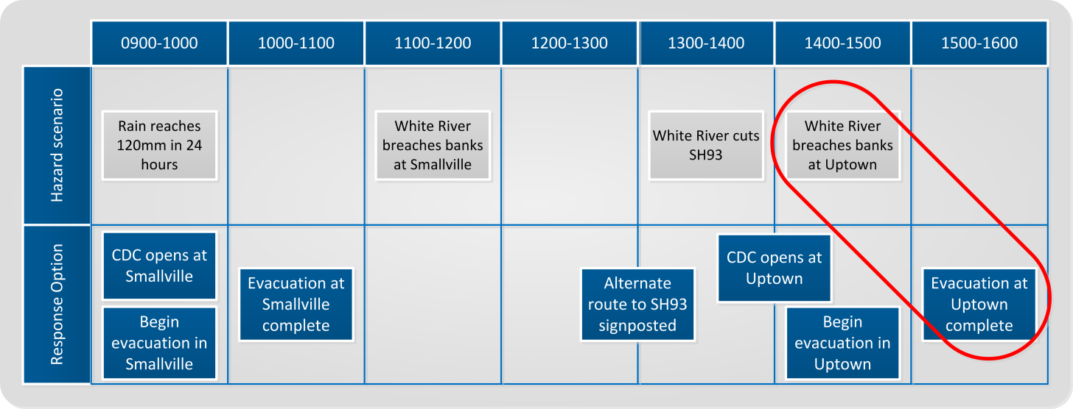
Figure 13 Example response option testing
Example (continued) | Table 14 Example response option testing  No. Action Description  1 Hazard action Rain reaches 120mm by 1000 hours.  Response action Open a CDC in Smallville, and begin an evacuation.  Review There is no consequence either way  2 Hazard action At 1100-1200, the White River breaches its banks at Smallville.  Response action None.  Review There is a low risk to life because the evacuation of Smallville is already complete.  3 Response action At 1300, signposting of an alternate route on SH93.  Hazard action White River cuts SH93.  Review No further action is required, as the consequence at SH93 has been mitigated.  4 Response action At 1400, CDC opens in Uptown, followed shortly after by the start of the evacuation.  Hazard action White River breaches the bank at Uptown, before the evacuation is due to complete.  Review The response option has a flaw, as it exposes the residents of Uptown to substantial risk.
 | Step 4 shows that this option has a flaw; the evacuation of Uptown occurs after the area is likely to be flooded. The response option will either need to be amended, discarded, or (at the very least) have this raised as a vulnerability.
Benefits of the testing process | This process gives the Planning team a valuable means of highlighting any weaknesses in the response options. If the hazard scenario describes a consequence which the response option doesn’t effectively manage then that weakness must be modified within the option. If it can’t be modified, it should be noted as a vulnerability.

Ranking the options | Once testing is complete, the Planning team uses the criteria (Table 13 on page 68) to rank the options. The options can be weighted if necessary, and this can be on any scale (e.g. 1-5, 1-10). An example is shown in Table 15.
Table 15: Example Option Ranking Table
Criteria (1-5) | Weighting | Option 1 | Option 2 | Option 3
Cost/Resources | 2 | 10 | 8 | 6
Risk of failure | 2 | 4 | 6 | 8
Population consequences | 1 | 2 | 4 | 3
Media interest | 1 | 4 | 3 | 3
Hazard consequences | 1 | 1 | 2 | 5
Total | - | 21 | 23 | 25

In the example in Table 15, Option 3 is assessed as the best of the three.
This ranking is subjective, as it will be very difficult to perform it objectively during a response. The Planning team must rely on their judgement, knowledge, and experience to justify their rankings.

Preferred option | The testing and ranking will likely lead to a preferred option. This option should be recommended to the Controller at the briefing.

6. Brief the Controller
At the conclusion of Options Analysis, the Planning team briefs the Controller on their conclusions. This will include which option, if any, is preferred.
This briefing is when the Controller chooses which option to accept. The Controller may also modify the options presented, or direct that further testing is carried out.

Output
The key output for the Options Analysis step is a list of updated and ranked response options for the Controller.

Decision
In this step, the Planning team briefs the Controller on the response options they have developed.
The Controller considers:
- the response options
- the recommendations of the Planning team, and
- the results of the Objective Analysis testing.
The Controller then selects the best option as the basis for an Action Plan.
Note: The Controller may direct that further development and analysis of the options is required.

Preliminary notice | A preliminary notice (see Preliminary notices on page 36) should be issued at this stage, even if one was issued earlier. The Controller’s decision to select a response option means there is sufficient information to pass onto other coordination centres, to aid their planning effort and reduce planning time.
Controller’s briefing | The Controller may deliver the preferred option in a briefing to the coordination centre, other agencies, or governance and management.  A template for briefing is provided in Appendix C Decision Briefing on page 129.

Action Plan Development
 | The purpose of this step is to develop the preferred response option into an Action Plan, for approval by the Controller.
Verbal Action Plan | If time is short, the Planning team may prepare the Action Plan as a brief, to be delivered verbally by the Controller.  A verbal Action Plan should include all the key features of a written Action Plan (see section 2.6 Action Plans on page 19). The Controller should also be provided with maps and other visual aids, where necessary.  See Appendix C Decision Briefing on page 129, which may be used as a template for a verbal Action Plan.
Written Action Plan | Where time allows, the Planning team prepares a written Action Plan. A template is provided in Appendix C Action Plan template on page 131.  Other coordination centre functions (such as PIM, Logistics, and Welfare) may be required to prepare their own specialised appendices to the Action Plan. These allow important specialist information and instructions to be included, without cluttering the main body of the Action Plan.
Controller approval | Once the Action Plan has been drafted to the satisfaction of the Planning Manager, it is presented to the Controller for their review, modification, and final approval.  The Controller may brief governance and management on the Action Plan, if required.
Support agency action planning | While the Action Plan is being developed, support agencies will be conducting their own planning processes.  They may develop their Action Plans before the lead agency issues its plan. This will save time, but there is a risk that the Action Plans will not be aligned. This risk is reduced by the inclusion of support agency representatives in the lead agency Planning team, and the provision of preliminary notices, planning information, and direction to support agencies.

Operations Briefing
The purpose of this step is to inform all relevant response personnel of the Action Plan, and explain its key elements.
The Operations Briefing signals the handover of the Action Plan from the Planning team to the Operations team (and other functions) who will begin implementing it.
See Appendix C Decision Briefing on page 129 for a template.

Controller’s role |  | The Controller:  - verbally briefs lower response level Controllers, function managers, and/or support agency leaders, and  - answers questions and gauges understanding.
Planning role |  | The Planning team:  - ensures that copies of the Action Plan and any supporting materials are distributed (printed or emailed), and  - supports the Controller in answering questions, if necessary.
Other function managers |  | Relevant function managers (e.g. Intelligence Manager, Logistics Manager), may deliver part of the briefing, or be available to answer questions relevant to their functional areas.
Operations tasking |  | The Action Plan describes the tasks and arrangements that the response will follow, but it will often require further, more detailed, task planning to ensure response actions are properly coordinated. This is the responsibility of the Operations function.

Execute Plan and Assess Progress
Once the Action Plan has been issued, the Operations function oversees the actions of other functions, lower response levels, and support agencies as they implement the Action Plan.
All coordination centre personnel, including the Planning team, have responsibilities in supporting the execution of the action plan, and assessing progress (see Table 16).
Note: The planning process is circular, and may take place multiple times until all of the Controller’s response objectives are complete.

Table 16: Responsibilities for executing Action Plan and assessing progress
Team or agency | Responsibility
All coordination centre personnel | - Implement their tasks in the Action Plan  - Actively liaise with counterparts in other coordination centres  - Monitor progress of activities against the Action Plan
Control | - Oversee execution of the Action Plan, including deciding any changes  - Brief governance and management on progress, as required.  - Determine whether to develop a new Action Plan, Contingency Plan or Long-Term Plan
Operations team | - Oversee the actions of other functions, lower response levels, and support agencies as they implement the Action Plan.  - Update the Action Plan to manage unexpected and changing events.  - Conduct detailed task planning to ensure tasks are fully coordinated.
Planning team | - Prepare and issue any updates to current Action Plans.  - Develop Contingency or Long Term Plans as necessary.
Support agencies | - Conduct own planning in alignment with lead agency Action Plan.  - Provide situation reports to the lead agency coordination centre.

Briefings and other updates | As the situation develops, lower response levels will provide briefings and other updates to the coordination centre. These will help the coordination centre to monitor progress of the plan, and assess if the Action Plan is able to achieve its mission.  The coordination centre should not be a passive recipient of information, but should actively seek it. The Controller and key staff should visit response elements and support agencies, while all staff should call their counterparts in other coordination centres as required.  Situation briefings and other updates are developed by the coordination centre and passed up to governance and management, to ensure they are kept informed of the developing situation.

Support agencies
Align agency planning and implementation | Once the Action Plan has been approved and disseminated, support agencies should ensure that their own plans align with the mission, intent, tasks, and coordinating arrangements. Once aligned, support agencies will then implement their plans.  If a support agency has not started detailed planning, receipt of the Action Plan will enable them to start.
Sitreps and other updates | Support agencies will provide situation reports and other updates to inform the coordination centre of their activities.  These will be included in the collated situation reports passed onto governance and management, and used to monitor implementation of the plan.

End of the detailed planning process
The planning process ends when the Action Plan’s mission is completed.
A new planning process should be initiated if:
- the plan’s objectives cannot be achieved, or
- there are still response objectives outstanding.
If a new Action Plan is required, the best point to initiate the planning process is at the Controller’s preliminary scoping (see page 44) to allow the Controller time to develop their guidance for the new Action Plan.

Readiness
This section describes the Planning tasks that need to be carried out before an emergency, including:
- preparing contingency plans
- gathering current information
- planning for and setting up a team and workspaces
- developing processes and supporting documentation, including forms and templates, and
- organising training and development.

Readiness for Planning | The main planning task during readiness is to prepare so that the Planning team is able to produce Action Plans, Contingency Plans and Long-term Plans during response.  Appendix E Planning readiness checklist on page 133 can be used to ensure that readiness activities are carried out effectively. The Planning Manager and team may amend this checklist to reflect the specific tasks required by themselves and their team.

Gathering information
Contact database | The Planning Manager needs to set up a new database or gain access to an existing database of contact details for everyone they are likely to work with before, during, or following an emergency, including:  - CDEM personnel (local, regional, and national), including co-workers, and partners in local authorities  - planning related personnel in emergency services and government agencies (e.g. Fire Service, Police, Ambulance, hospitals, health and disability services, New Zealand Defence Force, and Ministry of Education)  - any other agencies (including lifeline utilities) or large volunteer organisations with a potential planning role in CDEM (New Zealand Red Cross, Salvation Army etc.), and  - any local businesses that may contribute to a response and would need to be included in planning.  The contact database must be updated regularly, available both electronically and in hard copy, and be able to be accessed by the Planning team during and following an emergency.

Local CDEM information | The Planning team needs to know the local, regional, and national CDEM structure and CDEM personnel relevant to their roles during a response to an emergency.  This includes understanding how Planning fits into the CDEM structure, including:  - the overall CIMS structure  - who the Planning Manager reports to during and following an emergency (usually different from BAU), and  - what tasks the Planning team are responsible for under the CDEM Group Plan.  Planning personnel also need access to the following information so they can consider their implications for Planning during a response:  - any existing response plans (such as Initial Action Plans or Contingency Plans)  - Operations team procedures, contacts, and arrangements for working with other agencies  - analysis of local geography and hazards from a Planning perspective, and  - any local lifelines interdependencies.

Planning and setting up
This section describes the resources that need to be planned for or set up before an emergency.

Output assessment
An output assessment involves assessing:
- what planning outputs (Action Plans, Contingency Plans, and Long-Term Plans) will be required in different levels of response, or for different hazards
- when they will be expected (in relation to the onset of an emergency), and
- whether any response plans could be prepared during readiness.
An output assessment should be conducted by the Planning Manager and team, in conjunction with the Controller and other functions. Output assessments will help determine the structure of the Planning team within coordination centres.

Risk assessment
When preparing for Planning tasks that will be carried out during a response, it is important to determine any risks, and mitigate them where possible. Some examples of potential resourcing risks are:
- having one person for the Planning Manager role, who may be absent, injured in the emergency, or otherwise unable to carry out the role
- needing to access one particular building to gain resources for the Planning team, and the building has become inaccessible
- depending on cellphone networks, which may become overloaded or damaged, and
- not having access to required information systems.

Challenges | Challenges often faced in response planning include:  - needing to organise the Planning team quickly  - having to rely on other functions and agencies to provide experienced and trained members to the Planning team  - gaining the Controller’s input at key points during the planning process  - incomplete situational awareness  - using personnel with limited training and experience, and  - urgency, as there will be a need to develop a robust Action Plan quickly, especially in the early stages of a response.

The Planning team
To set up the Planning team:
- develop the team structure
- allocate available staff to team positions, and identify shortfalls, and
- determine outline rosters so staff know who will respond during an activation.
The Planning Manager during readiness may be a different person to the Planning Manager during response and recovery, though this is not ideal.

Develop team structure | The majority of the members on a Planning team will be ‘borrowed’ from other functions and agencies for the duration of a planning activity. The Planning function in a coordination centre can therefore be quite small. The Planning function will include:  - a Planning Manager (as a minimum), and  - a number of Planning Officers (activated as needed by the Planning Manager depending on the demands of the response).
Required skills | The skills required for the Planning team are listed in Table 17. The main requirement for all Planning team members is that they be familiar with the planning process. Ideally they will have worked in other emergency responses, and be familiar with the rhythm and characteristics of a response.
Table 17 Skills required by Planning staff
Planning appointment | Required experience and qualifications | Required knowledge
Manager | - Emergency responses (in Planning)  - Integrated Training Framework (ITF) planning course | - The planning process  - Task management  - Action Plan development  - Mapping
Planning Officer | - Emergency responses (in any function)  - Integrated Training Framework (ITF) | - The planning process  - Action Plan development  - Mapping
Team member (other function or agency) | - Emergency responses  - CIMS 2 trained  - Integrated Training Framework (ITF) | - Their own function’s or agency’s capabilities, capacity and intentions  - The planning process  - The HEA process (Intelligence function only)

Rosters | In readiness, the Planning Manager works with Logistics function staff to:  - prepare draft rosters for Planning personnel  - ensure that the needs of the Planning team are incorporated into rostering arrangements and procedures.  In response, the Planning Manager determines when Planning personnel are rostered. Logistics uses this information to prepare the overall coordination centre roster.  It is important to make sure that the pool of Planning team members is sufficient to allow for two or three shifts a day, especially for the first 2-4 days of a response, when there is a greater need to quickly create an Action Plan.  The nature of response planning means that there will be periods of high, low, or no planning activity. The Planning team can be reduced during quiet periods, or even stood down (if no Contingency or Long-Term Planning is required). Planning personnel can join other functions; for example Operations (they will have a good understanding of the Action Plan, and how to implement it). When a new response plan is required, the Planning team can be re-activated.
Personal preparedness | All members of the Planning team need to be prepared for an emergency at home as well as at work, including having emergency provisions and an emergency plan. Having this in place before an emergency will help the Planning team to carry out their roles effectively during an emergency.  Information on how to be prepared at home for an emergency is available at the Get Ready Get Thru website, at www.getthru.govt.nz.

Planning workspaces
When deciding where the Planning team will set up during an emergency, consider:
- proximity to CIMS functions that work closely with Planning such as Operations, Intelligence, Logistics, and the Controller
- resource availability, such as phones, power supplies, computers, and IT support
- breakout rooms or other areas where detailed planning can occur without disturbing the rest of the coordination centre
- security and access (keys, swipe cards, and ID cards for any cordons), especially for out-of-business hours, non-local authority personnel, and when the main key holder is not present, and
- alternative venues in case the main venue is affected by the emergency, or access is blocked.

Planning requirements at a coordination centre | Planning staff at a coordination centre will require the following:  - work stations for all personnel (desks, chairs, and landline phones with reliable connections)  - sufficient computers to allow staff to write Action Plans  - access to EMIS  - access to both paper and digital mapping  - access to printers, copiers, scanners, and faxes  - breakout room with a large table  - projectors, screens, whiteboards and/or corkboards for displaying information, especially maps of the area of operations  - access to records from previous responses, particularly Action Plans, Hazard and Environment Analyses and impact assessments  - access to databases  - dedicated email accounts and phone lines, and  - access to coordination centre reference manuals, plans, procedures, and documentation.

Other Planning resources
This section refers to any resources that the Planning team may need, other than people and workspaces (covered in the two previous subsections).
The Planning Manager is responsible for determining the equipment and supplies the Planning team is likely to need in an emergency and ensuring that these are available and in good working order.

Personnel identifiers | Planning personnel will need identifiers, such as vests or name tags, in the CIMS Planning colour of pink, with ‘Planning’ clearly written on them.
Phones | Consider attaching phone numbers to roles, rather than to individuals. This ensures that:  - the number is current for the duration of the emergency  - contact information can be circulated as soon as an emergency occurs (no need to confirm who is doing what first)  - contact information does not change every shift, and  - off-duty personnel are not contacted in error.
Planning response resource boxes | Consider storing Planning response resources in labelled boxes, so they are:  - easily identifiable  - accessed as one item  - lockable, and  - easy to relocate if necessary.  If Planning response resource boxes are used, there should be boxes with identical content stored in at least two different locations as a contingency. Planning response resources need to be stored:  - in spaces unlikely to be affected during an emergency, and  - where they are accessible to any person on the roster for the initial Planning team.
Hard copies of information | Keep current hard copies of any information that may be needed during and following an emergency (for example, the contact database), and store them in at least two places that are likely to be accessible during an emergency.  Hard copies must always be available, in case electronic copies are not available during power or telecommunications outages. The Planning Manager may decide to keep an up-to-date hard copy of the contact list with them at all times.
Electronic copies of information | Store electronic versions of the Planning CDEM information on USB flash drives, and/or smartphones, so that the information is always available wherever the Planning personnel are and is easily transportable.  Processes to update these versions regularly need to be developed and followed. Note that hard copies need to be available as well, in case of power or telecommunications outages.

Developing processes and supporting documentation
Ideally most Planning staff will be experienced and trained CDEM personnel. CDEM Groups at all levels must ensure regular and adequate training is undertaken in all CDEM functions by all staff (paid and volunteer) who operate in coordination centres. When developing Planning procedures:
- describe the tasks, and the responsibilities of the different roles in detail, using Plain English so that it is easier for personnel (often under stress) to understand and follow, and
- use tables, diagrams, and lists where possible.

Preparation | Before writing the procedures for the Planning team, confirm the structure of the coordination centre, the roles and responsibilities of each of the functions, and the relationship of the Planning team to each of these.  Once the broader coordination centre structure and responsibilities have been determined, carry out a basic analysis of the area of responsibility, the types of emergencies and consequences, demographics, and local businesses. For CDEM Groups, this is usually part of the Group Plan, so it may simply require becoming familiar with the hazard analysis in that document.  The aim is to gain an understanding of:  - what type of emergencies are possible (such as flood, tsunami, volcano)  - the potential scale of response (such as the range of response agencies, numbers of personnel, types of equipment needed), and  - the resources available from the agency, supporting agencies, business and the community.  This should be conducted jointly with Intelligence.

Response planning procedures
The Planning Manager may be required, by their workplace or the CDEM Group, to prepare response planning procedures for use in response. These procedures document all the arrangements for the Planning function in the CDEM context. They will include all of the outcomes of working through this section, as well as activation and ongoing response processes for the Planning function.
See Appendix D Developing response planning procedures on page 132 for a summary on the recommended content.

Process templates | The Planning Manager is responsible for leading the development of processes for use by the Planning team during response. This may involve customising or otherwise preparing the templates provided in Appendix C Templates on page 102, including:  - Controller’s preliminary scoping and preliminary notices  - Quick or detailed planning process templates  - Briefing template  - Action Plan template.  The Planning Manager should work with other members of the Planning team, Controllers, and the Intelligence function to develop these templates and their associated processes.

Role descriptions
The Planning Manager should also ensure that role descriptions are prepared during readiness. These need to include:
- role title
- where the role fits in the response structure
- any required competencies
- the role’s responsibilities
- any financial delegations
- reporting line (including who may report to them), and
- any available procedures for their tasks (in full, or where to access them).
The task procedures need to be:
- in Plain English
- clear and concise, and
- broken into sequential steps where practicable.

Archiving
Central and local government must archive records under the Public Records Act 2005.
Planning Manager responsibilities include ensuring that all Planning records are archived following the record management processes in their CDEM Group and/or council office. This includes planning notes, analyses and comparisons. Take photos of whiteboards at key stages and store the images.
The Planning team may need to develop processes for storing information (hard and/or soft copies) that is handled by the Planning team during and following an emergency. This will ensure that the information can be easily retrieved for archiving when there are resources and time available to do so.
Archiving (continued) | Any emergency that requires an Action Plan is likely to have a high degree of public interest. All planning documents must be retained and archived, so that decisions made during the response can be examined and justified at a later date.  Information held on an CDEM EMIS event site will be retained in CDEM EMIS when the event site is terminated. Information held outside CDEM EMIS will need to be archived as normal.  Advice on archiving, including which records need to be kept, and the requirements of how they are archived, is available from Archives New Zealand, by searching ‘Advice on archiving’ on their website www.archives.govt.nz.

Training and development
During readiness, the Planning Manager is responsible for ensuring that a development needs analysis is carried out for staff and volunteers who carry out Planning tasks during readiness, or who are intended to carry out Planning tasks during response.
Planning personnel need to have training to ensure they know their roles, their assigned responsibilities, and how they are to fulfil these during a response. This is based on the Planning procedures. Training may include:
- lectures and workshops
- shadowing and mentoring
- attending exercises (see paragraph below), and
- team table-top exercises.

Training material | Training material needs to be:  - based on the Planning procedures  - available at all times, and  - role specific so new personnel aren’t overwhelmed with unnecessary information.
Training development topics | Training and development may cover Planning during response in general, or cover specific topics such as:  - setting up interagency Planning teams and communications  - conducting the planning process  - conducting the Hazard and Environment Analysis (HEA) process  - setting up ECCs/EOCs, and  - assisting with the development of contingency plans.

Attending exercises | Personnel who may be involved in Planning tasks may have opportunities to participate in exercises run locally, regionally, or nationally.  As well as preparing people for their roles, exercises also provide an opportunity to test procedures, and establish working relationships.  Information on local and national exercises is available from the EM Officer or GEMO Manager. Information about national level training and development in Planning is also available from MCDEM, which can be contacted through the website www.civildefence.govt.nz.
Responses in other territorial authorities | Staff may deploy to other coordination centres during a response to increase capacity and capability for the affected coordination centre. This will allow the deployed staff to gain valuable experience managing a response. It also allows staff to develop relationships with their peers in different agencies, which may be useful in subsequent responses.
Shadowing and mentoring | Shadowing someone while they carry out Planning tasks provides opportunities to learn skills from someone with expertise. It also provides an opportunity to carry out peer review. It may be particularly useful during a response.  Mentoring is an effective way to provide guidance to personnel who are new to the Planning role. It can be done remotely if there is no-one in the same agency with the required skills. This depends on the availability of mentors.
Regional workshops | Some GEMOs or agencies run workshops for Planning personnel. They may invite Planning personnel from other organisations that they will work with during an emergency.  The workshops may be a general sharing of processes, information and ideas, or cover specific topics.
Other planning training | Where possible, members of the Planning team should attend courses run by other organisations on planning, or specific aspects of planning, as another way to increase planning skills.

Response
This section describes the additional Planning tasks that need to be carried out during a response. The majority of the tasks carried out by the Planning team during a response will be the creation of response plans, as described in Section 3.

Considerations during response
Activation of the Planning team during the Initial Response Process will take the following considerations into account:
- documented activation plans and checklists
- availability of personnel, and
- file naming conventions.

Activation plans and checklists | The Planning team should follow any procedures developed during readiness, and may use a checklist (see the suggested checklist in Appendix F Planning response procedure on page 135) to keep a record of which steps are done.
Availability of personnel | Personnel need to be given sufficient time when they begin in a role to familiarise themselves with the content of the Planning team procedures.  Availability of qualified personnel may be an issue. In this case, coordination centres may issue a Resource Request to the NCMC or ECC, asking for additional staff. These can be sourced from around New Zealand and across government agencies to expand capacity.
File naming conventions | The following naming convention for filenames is designed so that when files are stored electronically in a folder they sort into a logical sequence that is easy to search through, especially during an emergency when many documents are shared between agencies and different response levels.  The naming convention for filenames is:  - organisation initials, and the place the report is coming from  - type of report; sequential reference number, including zeros as place holders, and  - date in the format yyyy-mm-dd, including zeros as place holders.  Some examples are:  - Wainui DC EOC SitRep 04 2013-04-31  - NZFS ECC AP 01 2012-09-31  - NCMC SitRep 17 2014-02-29  The footers of all files need to include the filename (by inserting the filename field), and pagination (for example ‘page x of xx’).

Starting the planning process
Starting | Response planning may start at one of three different points relative to the onset of the emergency. These are described in Table 18 below.
Table 18 Starting points
Well before (hazard is forecast)
Risk assessment undertaken during reduction and readiness has indicated that a hazard is likely, or has significant consequences.
Plan types
An Initial Action Plan that can be activated when the hazard is imminent or is in progress.
Example: Wellington Earthquake National Initial Response Plan (WENIRP), available at www.civildefence.govt.nz by searching for the document name.

Level of detail
The Planning team has time to follow more detailed processes for Objective Analysis, Options Development, and Options Analysis.
Planning will rely on assumptions as it is based on a scenario, not an actual emergency.
A key appendix will be the Information Collection Plan. This enables the coordination centre to immediately start collecting pre-targeted information to develop situational awareness.

Immediately before (hazard is imminent)
The hazard has not happened, but is imminent.
Example: an Action Plan developed for a volcanic eruption where an eruption is likely within the next week.

Plan types
An Action Plan that mobilises agencies and holds them ready for when the hazard eventuates.

Level of detail
Planning can be more deliberate and methodical, but not to the same degree as when the hazard is only forecast.
Planning will be based on some assumptions, but a lot of information will be verifiable.
An Information Collection Plan, particularly for the hazard(s) consequences will be a key product.

After (emergency has occurred/is occurring)
An emergency has occurred. Emergency services may already be responding. Any Initial Action Plans developed during readiness are activated.

Plan types
An Initial Action Plan or an Action Plan.

Level of detail
Initial response: Planning will be rapid, informal, and unlikely to be very detailed.
Later stages of response: Planning may be able to become more detailed.
Assumptions will initially be needed, but it will be possible to verify much of this in a timely manner, provided the Information Collection Plan is comprehensive and implemented well.

Winding down
As the coordination centre achieves its response objectives, it will begin to transition to recovery. As this happens, the Planning team will return to business as usual.

Debriefing the Planning team
The Planning Manager is responsible for debriefing the Planning team as they are stood down, including reviewing:
- how they did against their objectives and assigned tasks
- whether rosters and team management worked effectively
- what was learned, and
- any effects on personnel, including psychosocial issues.
The Planning Manager will also contribute to the wider debrief within the Incident Management Team.
The MCDEM publication Organisational debriefing is available on the MCDEM website www.civildefence.govt.nz by searching for the document name.
These debrief points are used to update procedures, to ensure that lessons are embedded into response arrangements and not forgotten. Only when procedures and training are updated to reflect response experience are lessons actually learned.

Reviewing procedures and documentation
Following a response, the Planning Manager is responsible for ensuring a review of procedures and documentation is carried out, any areas for improvement are identified, and the procedures and documentation amended. It is important that the review includes feedback from all personnel who carried out Planning tasks during the response, and ideally needs to include feedback from external parties who used the plans created.
It is essential that experience gained in a response is preserved, by amending and updating procedures and training.

Archiving
As described in section 4.3.3 Archiving on page 83, archive all Action Plans, briefings and planning notes. These may be required for post-response investigations, but may also be useful in subsequent emergencies of a similar nature.

Appendices
Appendix A Hazard and Environment Analysis (HEA) 90
Controller’s preliminary scoping 90
1. Define the operational space 90
2. Describe the environmental effects 93
3. Evaluate the hazard(s) 94
4. Determine hazard scenarios 95
5. HEA support to the planning process 98
Appendix B Information Requirements 100
Appendix C Templates 102
1. Controller Preliminary Scoping Template 103
2. Preliminary Notice 104
3. HEA Template: Define the Operational Space 106
4. HEA Template: Describe the Environmental Effects 108
5. HEA Template: Evaluate the Hazard(s) 109
6. HEA Template: Determine Hazard Scenarios 110
7. Hazard Scenario Sketch Template 112
8. Quick Planning- Objective Analysis Template 114
9. Quick Planning- Options Development Template 117
10. Detailed Planning- Objective Analysis Template 119
11. Detailed Planning- Options Development Template 122
12. Detailed Planning- Options Analysis Template 124
11. Option Statement Template 126
12. Decision Briefing 129
13. Action Plan template 131
Appendix D Developing response planning procedures 132
1. Content 132
Appendix E Planning readiness checklist 133
Appendix F Planning response procedure 135
1. Planning response activation 135
2. Setting up Planning team and workspace 135
3. On-going Planning tasks 136
4. Winding down 137
Appendix G Task log 138
Appendix H Task sheet 140
Appendix I Glossary 141

Hazard and Environment Analysis (HEA)
The Hazard and Environment Analysis (HEA) is an analytical process designed to forecast how hazard(s) might develop in the affected area. The HEA is future-focused, and a key input into the planning process; ideally it will run slightly ahead of the planning process, as the products of the HEA must inform planning as well as help to maintain the situational awareness of the Controller and coordination centre staff.
The HEA is carried out by the Intelligence function, but is driven by the Controller and is used by all other functions.
Its two main products are scenarios for how the hazard(s) may develop; one based on the highest probability (most likely) and one based on the worst consequence (most dangerous). These two hazard scenarios give the Planning team a solid basis to plan against. While hazards are likely to develop in different ways to the HEA scenarios, an Action Plan designed with these options in mind will be adaptable to match the changing situation.
Ideally, the first three steps of the HEA will be completed to a draft state before a response starts. Depending on the type of hazard and the area affected, previous responses may have already developed an HEA that can be adjusted to match the current response.

Controller’s preliminary scoping
The Controller’s preliminary scoping is not technically part of the HEA, but it does inform it. It is provided by the Controller, and will inform the Intelligence team about:
- the Controller’s understanding of the context and expected governance and management outcomes; this will guide Intelligence staff in their assessment of what are the most hazardous consequences
- planning timelines; this will tell Intelligence staff how much time they have to complete the HEA, and therefore how much detail to go into, and
- what hazards need to be considered during the HEA (e.g. during an earthquake response, there may be a need to consider flooding, due to changes in the topography and damage to flood defences).
See Controller’s preliminary scoping on page 44 for more detail.

Define the operational space
In this step, the Intelligence team defines the space that the response will operate in, as well as the space that will affect it. They also evaluate current information sources and any information gaps, and begin the process of collecting information.
A template for this step is provided in Appendix C HEA Template: Define the Operational Space on page 106.

Define the area of operations
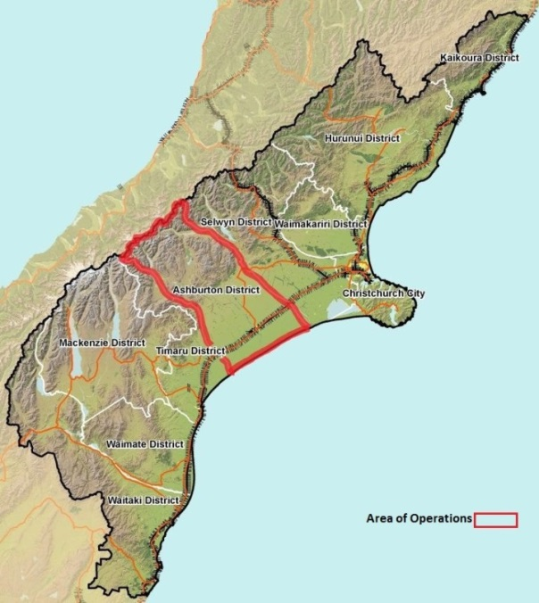
The area of operations is the area in which the response is taking place. It needs to be sufficiently large that it encompasses all direct response activities, though not necessarily all supporting activities.
It is best shown graphically, though it can also be described if there are already pre-determined boundaries, or easy map coordinates. It might be the whole of New Zealand (for the NCMC), a single local authority, a suburb or even a single property, depending on the size and nature of the emergency.
The example shown in Figure 14 is for a response by the Ashburton District Council, where they have defined their area of operations as their council boundaries.
Figure 14 Area of operations
At this stage, the Intelligence team can only recommend the area of operations. It will be confirmed by the Controller at a later briefing (usually in the Objective Analysis step of the planning process).

Define the area of interest
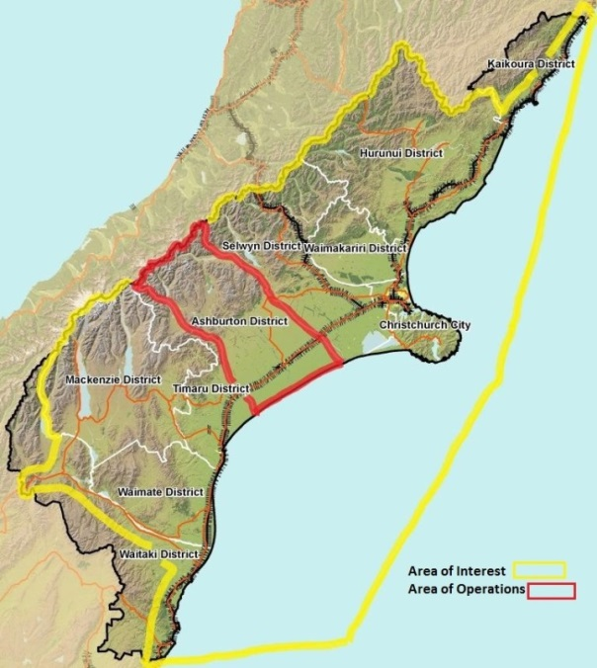
The area of interest is the wider area beyond the area of operations, but within which hazards, response activities, resources, supply sources, infrastructure, or transport may affect the area of operations.
Like the area of operations, it is best shown graphically, though it can be described in words, using pre-existing boundaries.
The example shown in Figure 15 carries on from the example above. In this case, the Ashburton District Council EOC has determined that they are interested in events, resources and infrastructure in all of the Hurunui, Waimakariri, Selwyn, Timaru and Mackenzie districts and Christchurch city, and in parts of the Waitaki and Kaikoura districts (linked here with transport infrastructure).
Figure 15 Area of interest
In this case, their area of interest also stretches out to the sea, which may be linked to the hazard and/or transport routes.
Defining the area of interest will help drive information collection, by defining where and who the Controller and Intelligence want to gain information from, and by defining what it is happening in or available from this area.
The Controller will confirm the area of interest at a later briefing (usually in the Objective Analysis step of the planning process).
Identify significant characteristics of the environment
The Intelligence team identifies characteristics of the environment within the area of operations and area of interest that require a deeper analysis of the likely effects on the response and the hazard. This includes terrain, weather, demographics, infrastructure, and the local economy. The Intelligence team then determines the level of detail required for the assessment of each characteristic.
The characteristics will be analysed in more detail in step 2 Describe the environmental effects on page 93.

Identify the amount of information required and feasible
The staff and time available will determine how detailed the HEA can be.
The Controller’s preliminary guidance determines how much time is available to complete the HEA. The activation mode of the coordination centre and other tasks will determine how many staff are available.
During this step, a timeline for the HEA is created, so that the Intelligence team has a series of deadlines to work to.

Evaluate existing databases
The Intelligence team will have access to databases and information sets prior to the response. These may include geographic information systems (GIS), hazard and/or risk assessments, historical records, census data, and lifeline utilities information. Information may be stored online, in physical records, or in digital drives. It may be provided by coordination centre staff or Liaison Officers from other agencies.
In this step, the Intelligence team determines if they have enough appropriate information to proceed with the HEA. If they do not, the gaps that are identified become Information Requirements, and are added to the Information Collection Plan.

Collect information
The Intelligence team collects the information needed to proceed with the HEA. This can involve summarising complex information, calling in Liaison Officers and technical experts, processing Information Requirements using the Information Collection Plan, and ensuring easy access to digital databases.
The HEA often takes place in parallel to the processing and closure of Information Requirements. The HEA may be based on assumptions, especially during the early stages of response. As Information Requirements are closed, the HEA will need to be updated and revised accordingly.

Outputs
At the end of this step of the HEA, the Intelligence team will have determined:
- the areas that it will analyse, and the characteristics that need to be analysed within those areas
- the time and staff available, and therefore how detailed the analysis will be
- what information is available to conduct this analysis, and any information gaps that exist, and
- how to access the information they need to proceed.

Describe the environmental effects
In this step, the Intelligence team evaluates the environment of the area of operations and area of interest. It then describes what effects this will have on the response and the hazard(s). The process of collecting information continues throughout this step, as outstanding Information Requirements are met and new ones created.
The area of operations should be considered in as much detail as possible, while the area of interest will be analysed as necessary, focusing on different areas or locations depending on the factors of interest. A template for this step is contained at Appendix C HEA Template: Describe the Environmental Effects on page 108.

Analyse the environment of the areas of operations/interest
The Intelligence team conducts the following analyses:
- Terrain analysis: The effects that terrain will have on the response and the hazard. The terrain analysis will be guided by the hazard type. Analysis might include access routes into and across the affected area, transport chokepoints, watersheds and flood plains, slip-prone slopes, active faults, low beaches, and hours of daylight.
- Weather analysis: The effects of weather on response resources (particularly aircraft), and the ability to undertake certain actions. Weather may increase or reduce the effects of the primary hazard. In non-weather emergencies, the effects of weather on terrain and infrastructure may mean that weather becomes a secondary hazard.
- Demographic analysis: Where the population in the affected area lives, their ability to support themselves, and how vulnerable they are to the hazard(s).
- Infrastructure analysis: The location and capacity of lifeline utilities and infrastructure, and how vulnerable it might be to the hazard(s). Transport infrastructure will inform potential evacuation routes.
- Other analyses as required: May include economic, political, and natural environment analyses.

Describe the effects on the response and hazard(s)
The Intelligence team describes the effects of the environment on both the response and the hazard.
This allows the development of broad scenarios for how the hazard might develop. Hazard scenarios may be described generally, and refined during later stages of the HEA and planning process.
Examples of broad hazard scenarios include:
- “Flood scenario 1: Rainfall concentrates on the northern hills, flooding the Black River catchment”
- “Flood Scenario 2: Rainfall concentrates on the eastern hills, flooding the Black River and Blue River catchments”
- “Tsunami scenario 1: Small Bay is likely to have wave heights up to 4 metres, but the eastern beaches will only be up to 1 metre”
- “Tsunami scenario 2: Long Bay is likely to have wave heights up to 4 metres, Small Bay will be less than 1 metre”

Outputs
At the end of this step of the HEA, the Intelligence team has:
- an understanding of the effects of terrain, weather, demographics, infrastructure and other factors on the response and hazard
- broad scenarios for how the hazard might develop, and
- additional Information Requirements and an updated Information Collection Plan.

Evaluate the hazard(s)
In this step, the Intelligence team uses all available information to develop an understanding of how the hazard (or hazards) usually develop. Key sources of information are:
- hazard assessments
- historical records, and
- scientific research and advice.
By evaluating hazard characteristics in generic terms, Intelligence staff gain insight into the potential threats presented by the hazard, and the conditions those threats require to develop.
This step may be completed during readiness, requiring only a quick revision by the Intelligence team during response. A template for this step is contained at Appendix C HEA Template: Evaluate the Hazard(s) on page 109.

Understand the hazard(s)
The Intelligence team reviews how the hazard(s) develop in generic terms. Examples are shown in Table 19.
Table 19 Generic characteristics of hazards
Hazard | Generic characteristics
Flood | A flood occurs where the volume of rainfall exceeds the capacity of the watershed to drain.  For a flood to develop there has to be high and/or intense continuing rainfall in a watershed.  Exacerbating factors include the saturation of the ground, current river levels, tides, and blockages in the drainage system.
Hazard | Generic characteristics
Earthquake | An earthquake is followed by aftershocks.  Aftershocks can come at any time, and may be some distance from the epicentre.  Structures are already damaged, and may suffer further damage leading to partial or complete collapse. Infrastructure is also damaged, and there may be further power/waters/telecommunications outages and blocking of transport routes.  The affected population will want to contact family and friends, and there may be increased demand for welfare services.  Following a major aftershock, the situation may change, and the response will require a fresh impact assessment to provide a clear picture of the change in situation.

Outputs
At the end of this step of the HEA, the Intelligence function will have:
- an understanding of the generic nature of the hazard(s),
- an understanding of what the hazard(s) need to develop and propagate, and
- additional Information Requirements.

Determine hazard scenarios
In this step, the Intelligence team creates fully developed hazard scenarios using:
- the broad hazard scenarios identified in Step 2, and
- all information gathered in steps 1, 2, and 3.
The main aim of this step is to determine the most dangerous scenario (worst case) and the most likely scenario (highest probability), so that this information can be used in the Options Analysis step of the planning process.
The Intelligence team develops hazard scenarios by predicting:
- how the general characteristics of the hazard (from Step 3) will interact with the specific characteristics of the area of operations and area of interest (from Step 2), and
- what consequences this interaction will have.

The Planning team uses the hazard scenarios to:
- focus action planning (planned activities must address the most dangerous and the most likely scenarios)
- take account of as many hazard-related variables as possible (allowing for flexible response plans that can be amended easily as the hazard develops), and
- carry out contingency planning.
A template for this step is contained at Appendix C HEA Template: Determine Hazard Scenarios on page 110.

Identify hazard scenarios
The Intelligence team uses the analysis of the environment and hazard(s) developed in steps 1-3 to identify the possible ways that the hazard(s) could develop within the area of operations. This is an intuitive process, and will be informed by experience, expertise, and past responses. The broad options identified in Step 2 “(Describe environment effects) are a useful starting place. Situation updates may identify more.
Each option should be:
- feasible and realistic, given the nature of the hazard and local environment (e.g. following a magnitude 8.0 earthquake, it is unlikely for aftershocks to be greater than magnitude 7.0), and
- distinct from each other. This can be based on times (fast spread versus slow spread), the sequence by which the hazard develops (e.g. north to south versus east to west), or the mix of hazards (e.g. aftershocks only, versus aftershocks and severe weather).
There is no upper limit on how many hazard scenarios should be identified, as long as they are feasible and distinct. All hazard scenarios must be presented to the Controller and Planning team.

Develop hazard scenarios
The Intelligence team calculates the rate of spread, consequences, and locations where the hazard will develop. Each option needs to have:
- a title to differentiate it from the other options
- a concise description of the hazard scenario
- graphic diagram or sketch showing where the hazard will occur, and the consequences
- timeline of how and when the hazard will develop, and
- consequences for the population, infrastructure, economy, and environment.
Each hazard scenario is developed to the level of detail that time and staffing allows. However, each scenario needs to be sufficiently well developed that it can be used to test the response options during the ‘Options Analysis’ stage of the planning process.
See the example hazard scenario in Appendix C Hazard Scenario Sketch (example) on page 113.

Evaluate and prioritise hazard scenarios
The Intelligence team evaluates each scenario on the basis of:
- how likely it is, and
- how much danger it poses to the response objectives assigned to the coordination centre by the Controller.
Note: Preservation of life is usually a key response objective – therefore danger posed to communities and response personnel is always taken into account when evaluating and prioritising hazard scenarios.

Identify Information Requirements
Each hazard scenario can be expected to develop in different ways. They will therefore have unique indicators. For example:
- hazard scenario 1 predicts flooding in the north of the area of operations – a unique indicator would be a rise in river levels in the northern area
- hazard scenario 2 predicts flooding in the east of the area of operations – unique indicator would be a rise in river levels in the eastern area
Unique indicators should be noted as Information Requirements. As information on unique indicators is collected, this will show which scenario most accurately describes the developing hazard.
This information must be passed on to the Planning team, so that they can update or create new response plans accordingly.

Determine most likely and most dangerous
Having evaluated and developed the hazard scenarios, the Intelligence team determines the most likely and the most dangerous scenarios. These will be used in the planning process.

Outputs
At the end of this step of the HEA, the Intelligence function will have:
- a developed set of hazard scenarios
- a hazard scenario identified as the most likely/highest probability
- a hazard scenario identified as the most dangerous/worst case, and
- additional Information Requirements, including some that will help indicate how the hazard is developing (unique indicators).

HEA support to the planning process
The HEA delivers a number of key outputs that feed into the Controller’s preliminary scoping, and three key steps of the planning process. Therefore, the HEA needs to run ahead of the planning process, as some of those key outputs are required by the planning process at an early stage.
HEA inputs into the planning process are shown in Figure 16.
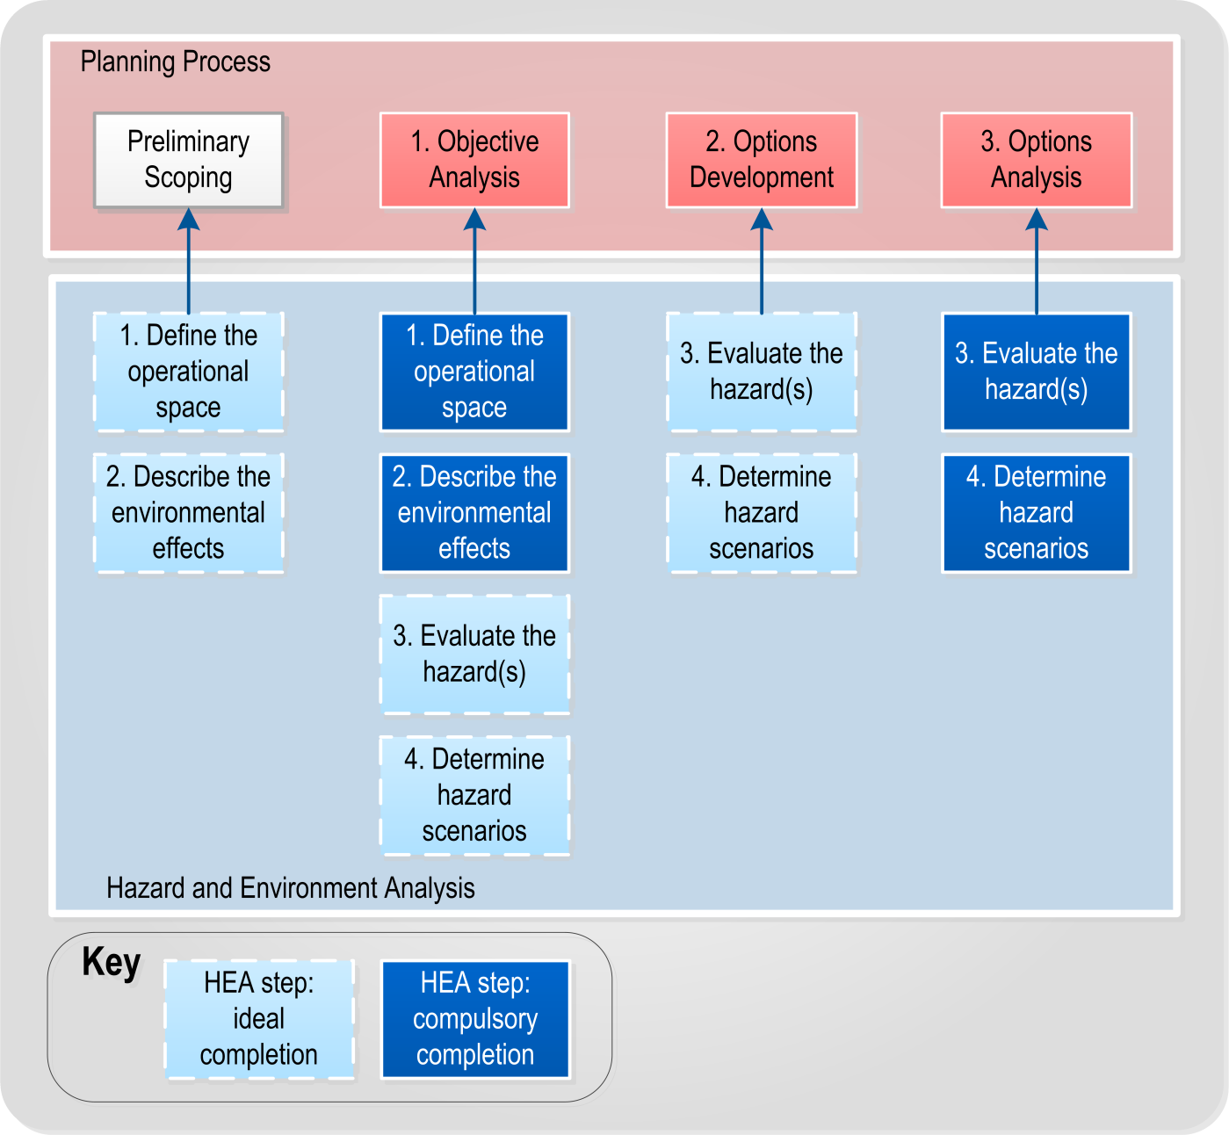
Figure 16 HEA support to the planning process

A breakdown of these inputs is included in Table 20 on the next page.

Table 20 HEA input to the planning process
Planning process | HEA input | Notes
Preliminary scoping | - Level of detail achievable within the timeframe  - Initial information requirement recommendations  - Broad hazard scoping, including outline of anticipated hazards  - Significant environmental characteristics | - This information is drawn from the first step of the HEA ‘Define the operational space’.  - This may be difficult, as the preliminary scoping step usually precedes the HEA. However, the Intelligence Manager may still provide input based on their initial analysis and previous experience.
Objective Analysis | HEA step one  - Review of the situation, including hazard development  - Recommended area of operations and area of interest  - Significant characteristics of the area of operations and the area of interest.  - Time available and level of detail achievable  - Information gaps and Information Requirements  HEA step two  - Understanding of the effects of terrain, weather, demographics etc on hazard and response  - Broad options for how the hazard may develop  As much information from HEA steps three and four as possible. | - Objective Analysis usually commences with the results of HEA steps one and two, but will possibly include step three and ideally step four.  - At a minimum, the Intelligence staff should provide the input from steps one and two, which provides an analysis of the operational area.
Options Development | - All input from HEA steps one and two  - Changes to the hazard and environment since the Objective Analysis brief  - If possible, an analysis of the generic nature of the hazard(s) and how they develop  - If possible, refined hazard scenarios | The planning and intelligence teams must work closely during this step, to ensure that information is passed freely. This enables all staff to fully understand the realities of the response and to reflect this in planning, which can change as information is updated.
Options Analysis | All steps of the HEA should be complete  Refined hazard scenarios (needed for testing response options) | Completed hazard scenarios are required for the Options Analysis step of the planning process.

Information Requirements
An Information Requirement is an item of information about the response that needs to be collected and processed in order to meet the information needs of the Controller and coordination centre. The identification, collection and processing of Information Requirements is a key element of situational awareness.
The Intelligence team collects Information Requirements into an Information Collection Plan.
All functions can create an Information Requirement. An Information Requirement includes the following
- the information that is needed, stated as specifically as possible e.g. “Rainfall forecast for the Hawkes Bay region for 18 May” or “When is the evacuation of Bigville complete?”
- the requesting function or coordination centre, and
- a time the information is required.
Table 21 below shows example Information Requirements.
Table 21 Example Information Requirements
Information | Requester | Date/time required
First wave arrival time in Kaikoura | Kaikoura DC | 20/06 1800
Activation status of local EOCs | Group Controller | 20/06 1930
Is State Highway 1 Kaikoura-Blenheim open | Logistics | 21/06 0600
Is State Highway 1 Kaikoura-Cheviot open | Logistics | 21/06 0600

Controller Information Requirements
These are Information Requirements that have been specifically given or approved by the Controller. They are a higher priority, as they are needed to fill gaps in the Controller’s knowledge and understanding of the response.

Information Collection Plan
An Information Collection Plan is a document that gathers all of the Information Requirements a coordination centre has into a set format and allocates these to agencies for answer. It provides for a structured, targeted, and methodical approach to information gathering. It is an important tool for response planning, as planning generates a large number of Information Requirements.
The Information Collection Plan is managed by the Intelligence function, but they are not responsible for answering the requirements. They will add Information Requirements, and then assign them to other functions and agencies for completion. Table 22 on the next page shows an example Information Collection Plan.

Table 22 Example Information Collection Plan
No. | Information | Requester | Date/time required | Assigned to | Status
098 | Evacuation status of Timaru | Operations | 20/06 1200 | Timaru DC | Closed
099 | First wave arrival time in Kaikoura | Kaikoura DC | 20/06 1800 | NCMC | Overdue
100 | Activation status of local EOCs | Group Controller | 20/06 1930 | Operations | Closed
101 | Is State Highway 1 Kaikoura-Blenheim open | Logistics | 21/06 0600 | NZTA | Open
102 | Is State Highway 1 Kaikoura-Cheviot open | Logistics | 21/06 0600 | NZTA | Open
103 | When can Waimakariri DC receive evacuees from other local authorities? | Welfare,  Logistics | 21/06 0800 | Waimakariri DC | Open

The columns of Table 22 are;
- No.: All Information Requirements within the plan should be numbered, so they can be easily referred to
- Information: The information requirement question
- Requester: The function or agency who requires this information and/or who created the Information Requirement. Several agencies or functions may be listed here
- Date/time required: When the information is needed by
- Assigned to: The agency or agencies tasked with providing the information
- Status: Whether the information requirement is open (i.e. the information has not been received), closed (the information has been received) or overdue (i.e. the information has not been received and the deadline is past

A coordination centre may also add a prioritisation column if required, to show which information requirements are of particular importance.

Templates
1. | Controller Preliminary Scoping Template | 103
2. | Preliminary Notice | 104
3. | HEA Template: Define the Operational Space | 106
4. | HEA Template: Describe the Environmental Effects | 108
5. | HEA Template: Evaluate the Hazard(s) | 109
6. | HEA Template: Determine Hazard Scenarios | 110
7. | Hazard Scenario Sketch Template | 112
8. | Detailed Planning- Objective Analysis Template | 119
9. | Detailed Planning- Options Development Template | 122
10. | Detailed Planning- Options Analysis Template | 124
11. | Option Statement Template | 126
12. | Decision Briefing | 129
13 | Action Plan template | 131

Controller Preliminary Scoping Template
Reference number |  | Date | [201X-month(xx)-day(xx)]
Issuing Coordination Centre | [name here] | Emergency
Prepared by | [name and role] | Approved by | Controller [name]

High Level Intent
Higher response level Controller’s intent:
[Controller’s understanding of how higher response level Controllers want the response to proceed. N/A if this is not applicable]

Governance outcomes:
[Controller’s understanding of what governance want the situation to be when the response is completed]

Response objectives
[Controller’s selection of the response objectives. These may only be draft at this stage. Also describe which response objectives will apply to a particular Action Plan]

Timelines and responsibilities
Time for the Action Plan to be written and distributed:

Action Plan start time:

Action Plan end time:

Planning responsibilities (additional to SOPs):

Hazard appraisal
Primary hazard:

Additional hazards to plan for:

Broad response options
[If the Controller has determined any response options for consideration, note them here]

Information Requirements
List any Information Requirements that the Controller or key staff determine must be filled.

- [Information Requirement 1]
- [Information Requirement 2]
etc

Preliminary Notice
Reference number |  | Date | [201X-month(xx)-day(xx)]
Issuing Coordination Centre | [name here] Coordination Centre | Emergency
Prepared by | [name and role] | Approved by | Controller [name]

Current situation
Hazard:
[Keep this to a single sentence, it is not a SitRep. “Flooding and gale force winds across the north and west of the district” would be sufficient].

Response:
[Keep this to the major activations and response activities to date, no more than a short paragraph]

Mission statement
[Enter the mission statement, or if not known “To be determined”]

Broad response options
[May include specific planning or preparatory tasks for support agencies and response elements]
Response Option 1:

Response Option 2:

Response Option 3:

Coordinating instructions
Timing: [When the Action Plan is likely to begin, any subsequent timings such as a possible transition to the recovery phase.]

Anticipated length of the operational period:

Key locations: [Assembly Areas, main transport nodes, main CDEM facilities.]

Information collection
[May include specific Information Requirements from Preliminary Scoping, HEA and/or the planning process]
[May include information collection priorities; subjects of interest, rather than discrete items]

Logistics
Critical resources: [List any identified critical resources]

Procurement: [List any procurement restrictions (e.g. procure out of boundaries), if any resources will be centrally procured]

Control
Lead agency:

Outline response structure: [Agencies and response levels (higher or lower) that have activated]

Other information
[Any additional information]

Notes
- If something is not known, then state “To be determined”.
- If something has not changed from a pre-response arrangements, previous preliminary notice or Action Plan, state “No change”.

HEA Template: Define the Operational Space
This template has been developed to assist with the ‘Define the operational space’ step of the HEA process. It should be used to record the Intelligence team’s analysis and conclusions, and as an agenda for an Intelligence meeting.
The template consists of a series of steps. The aim is to discuss each step, recording the conclusions reached from the discussion. The final step is for the Intelligence team to report their deductions back to the Controller and Planning team.
Inputs
The main inputs into ‘Define the operational space’ are:
- Higher response level Action Plan (if created)
- Controller’s Preliminary Scoping and guidance
- Situation information
- Initial Action Plan (if created)

Step 1: Define the area of operations
[Determine the area that the response will occur in.]

Step 2: Define the area of interest
[Determine the area where events may influence the response, and which will therefore be of interest.]

Step 3: Identify significant characteristics of the environment
[Identify characteristics of the environment that require a deeper analysis of their likely effects on the response and the hazard.]
- Terrain:

- Weather:

- Demographics:

- Infrastructure :

- Local economy:

- Other:

Step 4: Identify the amount of information required and feasible
Time available for completion of the HEA:

Staff available for completion of the HEA:

Create a timeplan for the HEA:
- Complete ‘Step 1: Define the operational space’ by:
- Complete ‘Step 2: Describe the environmental effects’ by:
- Complete ‘Step 3: Evaluate hazards’ by:
- Complete ‘Step 4: Determine hazard scenarios’ by:

Step 5: Evaluate existing databases
List available databases and other information sources:

Determine information gaps (compare available databases with ‘Identify significant characteristics of the environment’):

Step 6: Collect material
[Collect the information needed to proceed with the HEA. This can involve summarising complex information, calling in liaison officers and experts, receiving answers to Information Requirements and ensuring easy access to digital databases.]

Outputs
At the end of this step of the HEA, the Intelligence team will have:
- determined the area that it will analyse (the area of operations and the area of interest)
- the characteristics that need to be analysed within those areas
- the time and staff available, and therefore how detailed the analysis will be
- what information is available to conduct this analysis, what is readily available, any information gaps that exist and the Information Requirements that are needed to fill those gaps, and
- have ready access to the information they need to proceed with the HEA.

HEA Template: Describe the Environmental Effects
This template has been developed to assist with the ‘Describe the environmental effects’ step of the HEA process. It should be used to record the Intelligence team’s analysis and conclusions, and as an agenda for an Intelligence meeting.
The template consists of a series of steps. The aim is to discuss each step, recording the conclusions reached from the discussion. The final step is for the Intelligence team to report their deductions back to the Controller and Planning team.
Inputs
The main inputs into ‘Describe the environmental effects’ are:
- Deductions and information from HEA ‘step 1: Define the operational environment’
- Controller’s Preliminary Scoping and guidance
- Situation information
Step 1: Analyse the environment of the areas of operations/interest
- Terrain analysis: Analyse the effects that terrain will have on the area of operations/interest, the response and the hazard.

- Weather analysis: Analyse the effects that weather will have on the area of operations/interest, the response and the hazard.

- Demographic analysis: Analyse where the population in the area lives, their ability to support themselves and how vulnerable they are to the hazard(s).

- Infrastructure analysis: Analyse the location and capacity of lifelines infrastructure, and how vulnerable it might be to the hazard(s).

- Other analyses as required. This can include economic, political and natural environment analyses.

Step 2: Describe the effects on the response and hazard(s)
Develop broad scenarios based on the environments ability to shape the response and the hazard. Hazard scenarios can be described in broad terms, and refined in later stages of the HEA and planning process.

Scenario 1:

Scenario 2:

Scenario 3:

Outputs
At the end of this step of the HEA, the Intelligence team will have:
- an understanding of the effects of terrain, weather, demographics, infrastructure and other factors on the response and hazard,
- broad scenarios for how the hazard might develop, and
- additional Information Requirements.

HEA Template: Evaluate the Hazard(s)
This template has been developed to assist with the ‘Evaluate the hazard(s)’ step of the HEA process. It should be used to record the Intelligence team’s analysis and conclusions, and as an agenda for an Intelligence meeting.
The template consists of a series of questions. The aim is to discuss each step, recording the conclusions reached from the discussion. The final step is for the Intelligence team to report their deductions back to the Controller and Planning team.
Inputs
The main inputs into ‘Evaluate the hazard(s)’ are:
- Deductions and information from HEA steps 1 and 2
- Situation information

Understand the hazards
Describe how the hazard(s) develop in generic terms, without applying them to the operational environment.

What are the causes of this hazard?

What does the hazard require to develop?

What generic consequences could it have on the population, lifelines, economy, environment of the area of operations?

What is the usual timeframe and sequence for this form of hazard?

Outputs
At the end of this step of the HEA, the Intelligence team will have:
- an understanding of the generic nature of the hazard(s)
- an understanding of what the hazard(s) need to develop and increase, and
- additional Information Requirements.

HEA Template: Determine Hazard Scenarios
This template has been developed to assist with the ‘Determine hazard scenarios’ step of the HEA process. It should be used to record the Intelligence team’s analysis and conclusions, and as an agenda for an Intelligence meeting.
The template consists of a series of steps. The aim is to discuss each step, recording the conclusions reached from the discussion. The final step is for the Intelligence team to report their deductions back to the Controller and Planning team.
Inputs
The main inputs into ‘Determine hazard scenarios’ are:
- Controller’s guidance
- Deductions and information from HEA steps 1, 2 and 3
- Situation information
Step 1: identify hazard scenarios
Identify the possible ways that the hazard(s) could develop within the area of operations .

Scenario 1

Scenario 2

Scenario 3

Step 2: Develop hazard scenarios
For each scenario, determine:
- A title to differentiate it from other hazard scenarios
- A concise description of the hazard scenario
- Graphic/sketch showing where the hazard will occur and consequence
- Timeline of how and when the hazard will develop
- Consequences for the population, infrastructure, economy and environment

Using the Hazard scenario templates, sketch and document the scenario.
Step 3: Evaluate and prioritise hazard scenarios
Evaluate each scenario on the basis of how likely it is and how much danger it poses to the Controller’s mission and response objectives.
No. | Scenario | Probability | Danger
1
2
3

Step 4: Identify Information Requirements
- Determine one or more unique indicators that will show if the hazard is developing in line with a scenario.

- Develop Information Requirements based on these indicators, to help inform how the hazard is developing.

Step 5: Determine the most likely and most dangerous scenarios
Most likely/highest probability hazard scenario:

Most dangerous/worst case hazard scenario:

Outputs
At the end of this step of the HEA, the Intelligence team will have:
- A developed set of hazard scenarios
- A hazard scenario identified as the most likely/highest probability
- A hazard scenario identified as the most dangerous/worst case, and
- Additional Information Requirements, including some that will help indicate how the hazard is developing.

7. Hazard Scenario Sketch Template
Title:
Scenario sketch

Scenario description:  Timeline: | Consequences:
Degree of danger (to response objectives) | Probability of scenario occurring

Hazard Scenario Sketch (example)
Title: Scenario 1: Heavy rain to north, moderate rain to the west and east
Scenario sketch
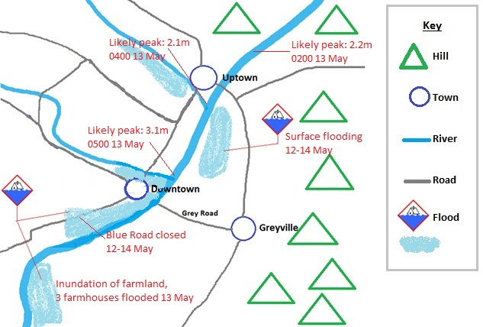
Scenario description:  Heavy rain in the northern hills leading to the river and the Uptown creek bursting their banks on 12 May, with peaks on the morning of 13 May.  Timeline:  11 May: 100mm rain in northern hills, ground already sodden from earlier rain.  12 May: Further 120mm rain in northern hills. Surface flooding starts, Blue Road closes  13 May: Rain eases. Expected river peaks , some properties flooded near river  14 May: Surface flooding begins to ease  15 May: Likely end to flooding. | Consequences:  - Threat to Downtown, particularly on morning 13 May when waters may exceed flood defences  - Inundation of farmland, expect three farmhouses to flood 13 May  - Blue Road closed 12-14 May  - Surface flooding near Uptown and Downtown
Degree of danger (to response objectives)  Moderate danger compared to scenarios 2 and 3 | Probability of scenario occurring  Most likely scenario

Quick Planning- Objective Analysis Template
This template has been developed to assist with the Objective Analysis step of the quick planning process. It should be used to record the Planning team’s analysis and conclusions, and as an agenda for a planning meeting.
The template consists of a series of questions. The aim is to discuss each question, recording the conclusions reached from the discussion. The final step is for the Planning Team to brief the Controller on its deductions.
Inputs
The main inputs into Objective Analysis are:
- Higher response level Action Plan (if created)
- Controller’s Preliminary Scoping and guidance
- Hazard and Environment Analysis (HEA) data
- Situation information
- Initial Action Plan (if created)

Question 1: What is the situation?
Each member of the Planning team provides a brief update on their respective area of the response;

Speaker | Subject
Controller | - Higher intent (other Controllers, governance, management)  - Response objectives (if decided)  - The timeframe for planning and the operational period the Action Plan will cover  - Role of the coordination centre as part of the response
Intelligence rep | - Hazard situation  - Characteristics of the area of operations  - Any HEA analysis
Operations rep | - Response review, including other agency activations  - Initial response actions  - Previous Action Plans or Initial Action Plans
Welfare rep | - Current welfare dependency (who needs help, where)  - Current welfare arrangements and resources
PIM rep | - Media situation, audiences, coverage and angles, including social media
Logistics rep | - Critical resources available  - Resource shortfalls
Support agency reps | - Activation status  - Current response actions and planned activities
Technical experts | - Any relevant information

Key output: Shared situational awareness

Question 2: What do we need to know?
Determine what gaps there are in the Planning team’s understanding of the situation, based on the discussions in the previous step. Note down these gaps as Information Requirements.
Information Requirement 1:

Information Requirement 2:

Information Requirement 3:

Information Requirement 4:

Information Requirement 5:

Assumption 1:

Assumption 2:

Assumption 3:

Assumption 4:

Assumption 5:

Create as many Information Requirements as needed to define all of the information gaps. Intelligence will use these to create the Information Collection Plan

Key outputs: A list of Information Requirements and a list of Assumptions

Question 3: What do we need to achieve?
The Controller and staff can now determine what they must achieve during the response. This is the list of response objectives. The response objectives that this Action Plan addresses should be highlighted.

Response Objective 1:

Response Objective 2:

Response Objective 3:

Response Objective 4:

Response Objective 5:

Response Objective 6:

If the Controller has set a list of response objectives, the Planning team analyses these and may suggest modifications.
Key output: A list of response objectives

Question 4: How do we achieve that?
- Response objectives need to be broken down into tasks, so that they can be assigned. For each objective, determine what tasks have to be completed to deliver the objective, into a joint list with all other objectives.

- Determine which tasks are essential. These are the ones that have to be done otherwise the response objectives will fail. Ideally there will only be one or two.

- The essential tasks form the basis of the mission statement (see Mission statement on page 21)

- Using the task list, discuss various ways in which the tasks could be completed (the order for completion, the timing, resource allocation, prioritisation etc.). The different ways to achieve them become broad response options.

Key outputs: A task list, mission statement and broad response options

Final Action: Brief the Controller
This step is only necessary if the Controller has not been part of the discussion. Prepare an Objective Analysis briefing for the Controller, in order to confirm the deductions made. The briefing should proceed as follows:

Subject | Speaker
HEA deductions, such as area of operations/interest, hazard evaluation (if available), hazard consequences (if available) | Intelligence rep
Response review | Operations, Welfare reps
Media situation, audiences, coverage and angles, including social media | PIM rep
Outline higher Controller’s intent, governance context and outcomes, and role of the coordination centre | Planning rep
Recommended response objectives, if these are different from those given by the Controller | Planning rep
List essential tasks | Planning rep
List available and likely resources | Logistics rep
Likely Information Requests, in order of priority | Planning rep
Give draft mission statement | Response Manager or Planning rep
Outline broad response options | Response Manager or Planning rep

At the end of this brief the Controller will confirm and/or amend the Objective Analysis, and give their guidance for further planning.

Quick Planning- Options Development Template
This template has been developed to assist with the Options Development step of the quick planning process. It should be used to record the Planning team’s analysis and conclusions, and as an agenda for each planning meeting.
The template consists of a series of questions. The aim is to discuss each question, recording the conclusions reached from the discussion. The final step is for the Planning Team to brief the Controller on its deductions.

Inputs
The main inputs into Options Development are:
- Controller’s guidance from Objective Analysis
- Objective Analysis conclusions
- List of Information Requirements
- Hazard and Environment Analysis (HEA) data
- Situation information.

Initial Action: Situation review
The Planning team representatives update each other on any changes in their function or agency areas:
- Planning timeline (Planning rep)
- Hazard and environment information (Intelligence rep):
- Response situation changes (Operations/Welfare reps):
- Resource changes (Logistics rep and Liaison Officers):
- Media changes (PIM rep)
- Agency updates (Liaison Officers)

Question 5: Where can we best accomplish each task?
- For each broad response option, go over the list of tasks and determine where each task can be best accomplished

- For those that don’t require a physical location, put them to one side for now.

At this stage, the broad response options developed in Objective Analysis can start to be drafted using the option statements found in Appendix C Option Statement Template on page 126.

Key outputs: Draft option statements

Question 6: What resources are available, and what do we need to accomplish each task?
- Determine what resources are available for the response, either immediately, or within a useful timeframe.

- Determine what resources are needed to accomplish each task.

Any resource shortfalls can be resolved by sequencing the use of a resource (in the next step), by issuing Resource Requests or by deciding not to carry out a particular task.
The draft option statements developed in Question 5 can be updated.

Key outputs: Assigned resources

Question 7: When and where do the actions take place in relation to each other?
- Determine where and when tasks and response actions take place, in a logical sequence.

- Determine which of the resource shortfalls identified at Question 6 can be met by sequencing the use of resources, or by deleting the task. The other shortfalls will require Resource Requests to be issued.

- Update response option statements. The Logistics rep should determine how each of the response options will be supported. The PIM rep will develop key messages for each one.

Key outputs: Updated response option statements, timeline, Resource Requests

Final Step: Brief Controller
This step is only necessary if the Controller has not been part of the discussion. Prepare an Options Development briefing for the Controller, in order to confirm the deductions made. The briefing should proceed as follows:

Subject | Speaker
Purpose of briefing, time analysis | Response Manager or Planning rep
Changes to hazard and environmental information, most dangerous and most likely hazard scenarios (if developed) | Intelligence rep
Brief on each option statement, giving a verbal and graphic description of how operations will proceed | Planning rep
Logistics supporting concept | Logistics rep
PIM concept and key messages | PIM rep

At the end of this brief, the Controller may modify and/or confirm these options, allowing the Planning team to move onto the next step. If the Controller rejects these options, the Planning team returns to the start of this procedure.

Detailed Planning- Objective Analysis Template
This template has been developed to assist with the Objective Analysis step of the detailed planning process. It should be used to record the Planning team’s analysis and conclusions, and as an agenda for a planning meeting.
The template consists of a series of steps. The aim is to discuss each step, recording the conclusions reached from the discussion. The final step is for the Planning Team to brief the Controller on its deductions.
Inputs
The main inputs into Objective Analysis are:
- Controller’s Preliminary Scoping and guidance
- Higher response level Action Plan (if created)
- HEA data
- Situation information
- Initial Action Plan (if created)
Step 1: Review the situation
- Determine the time available, for planning/dissemination, and for the implementation of the Action Plan.
Time the Action Plan document must be completed for issue
Time for Action Plan to achieve its mission
Review the Controller’s preliminary scoping

- Review the HEA analysis
Particularly steps 1 and 2, which will give the area of operations, the area of interest, key characteristics and initial information requests.

- Review the known hazard information (if not covered by the HEA).
Outline what consequences the hazard(s) has had so far.

- Review the response actions to date
Which agencies have activated, what resources are responding in the area of operations (lead and support agencies), what resources are mobilising or enroute, their locations and current capability, what initial actions are underway, provisions of any previous Action Plans.

Step 2: Analyse higher response level intentions
- Determine the purpose of the response
What is the purpose, or reason, for this response?

- Determine response objectives
What are the objectives for the response? Have they been given, or do they need to be deduced by the Planning team? If given, are they complete or suitable for the situation?

- Determine the endstate
What is the endstate for the response (i.e. what would a successful response look like)? Has this been given by the Controller, or does it need to be deduced by the Planning team?

- What is our role in the response?
What is the coordination centre’s role in this? What part does it play in the wider response? Is it a lead agency, or in support?

Step 3: Determine tasks.
- Determine specified tasks
What are the specified tasks that have been given by the Controller or governance/management for the coordination centre to complete?

- Determine implied tasks
What are the implied tasks that haven’t been directed, but which must be completed?

- Identify essential tasks
Of all the tasks identified, which ones are essential to meeting the Controller’s objectives and intent?

Step 4: Determine freedoms and constraints
- Determine constraints
What constraints are there that will limit coordination centre’s response options?

- Determine freedoms
What operational freedoms does the coordination centre have with regard to this response?

Freedoms and constraints are imposed by higher Controllers and governance/management. They help to set the boundaries for how the Action Plan can be developed. Typical freedoms and constraints include deadlines, budgets, resources, geographical boundaries and directions to coordinate with specific agencies.

Step 5: Identify critical facts and assumptions.
- What critical information is needed in order to plan? List this down; if it is already known, it is considered to be a fact.
- Anything not known may be covered with an assumption, which is a substitute for fact. Assumptions must be written down so that they can be confirmed, and will become Information Requirements.
Step 6: Draft mission statement and broad response options.
- Draft the mission statement
Link the essential tasks with the response objectives.

- Draft broad response options
Based on the Controller’s preliminary scoping, understanding of essential tasks, resources and hazard consequences to date, develop 1-3 broad courses of action. At this stage they don’t require any detail beyond a short, descriptive statement.

Step 7: Brief Controller
Prepare an Objective Analysis briefing for the Controller, in order to confirm the deductions made. The briefing should proceed as follows:

Subject | Speaker
Purpose of briefing, time analysis | Response Manager or Planning rep
HEA deductions, such as area of operations/interest, hazard evaluation (if available), hazard consequences (if available) | Intelligence rep
Response review | Operations, Welfare reps
Media situation, audiences, coverage and angles, including social media | PIM rep
Outline higher Controller’s intent, governance context and outcomes, and role of the coordination centre | Planning rep
Recommended response objectives, if these are different from those given by the Controller | Planning rep
List essential tasks | Planning rep
List Freedoms and Constraints | Planning rep
Likely Information Requests, in order of priority | Planning rep
List available and likely resources | Logistics rep
Give draft mission statement | Response Manager or Planning rep
Outline broad response options | Response Manager or Planning rep

At the end of this brief the Controller will confirm and/or amend the Objective Analysis, and give his/her guidance for the response.

Detailed Planning- Options Development Template
This template has been developed to assist with the Options Development step of the detailed planning process. It should be used to record the Planning team’s analysis and conclusions, and as an agenda for each planning meeting.
The template consists of a series of questions for each step. The aim is to discuss the questions, recording the conclusions reached from the discussion. The final step is for the Planning team to brief the Controller on its deductions.
Inputs
The main inputs into Options Development are:
- Controller’s guidance from Objective Analysis
- Objective Analysis conclusions
- List of Information Requirements
- HEA data
- Situation information.
Step 1: Situation Update
The Planning team representatives update each other on any changes in their function or agency areas:
- Planning timeline (Planning rep)
- Hazard and environment information (Intelligence rep):
- Response situation changes (Operations/Welfare reps):
- Resource changes (Logistics rep and Liaison Officers):
- Media changes (PIM rep)
- Agency updates (Liaison Officers)

Step 2: Create option concepts
Using the broad options approved by the Controller at the Objective Analysis step, select 1-3 as the basis for further planning. The number of options developed will depend on the Controller’s guidance and the time available.

Step 3: Develop option concepts
For each Option, determine:
  - A short statement of intent describing the method, key tasks and endstate
  - Describe the timeline for how the response will proceed
  - Describe the control arrangements and structures required
  - Allocate tasks to response elements and support agencies
  - List any decision points
  - List the key resources
  - List the risks and vulnerabilities of the concept

Using the Option Statement templates, sketch and document the Option.

Step 4: Test options
Test each option to ensure it is:
- Suitable: Does it meet the objectives given by the Controller?
- Feasible: Can the option be achieved in the time and space, and with the resources available?
- Acceptable: What is the degree of risk associated with the option? What is the probability that it will succeed in meeting the Controller’s objectives?
- Sustainable: Can the option be supported by the logistics arrangements in place?
- Distinguishable: Is the option easily distinguishable from the other options? Or are all the options just variations on a theme?
- Complete: Does it plan from the starting state through to the endstate?

Step 5: Brief Controller
Prepare an Options Development briefing for the Controller, in order to confirm the deductions made. The briefing should proceed as follows:

Subject | Speaker
Purpose of briefing, time analysis | Response Manager or Planning rep
Changes to hazard and environmental information, most dangerous and most likely hazard scenarios | Intelligence rep
Brief on each option, giving a verbal and graphic description of how operations will proceed. The brief should follow this format:  - Concept  - Key tasks  - Control arrangements and structure  - Decision points  - Resource allocation  - Key locations  - Timeline | Option development team member (if separate teams have developed each option),  or,  Planning rep
Logistics supporting concept | Logistics rep
PIM concept and key messages | PIM rep

At the end of this brief, the Controller may modify and/or confirm these options, allowing the Planning team to move onto the next step. If the Controller rejects these options, the Planning team returns to the start of this procedure.

Detailed Planning- Options Analysis Template
This template has been developed to assist with the Options Analysis step of the detailed planning process. It should be used to record the Planning team’s analysis and conclusions, and as an agenda for a planning meeting.
This template consists of a series of steps. The aim is to discuss each step, recording the conclusions reached from the discussion. The final step is for the Planning team to brief the Controller on its deductions.
Inputs
The main inputs into Options Analysis are;
- Controller’s selected response options
- HEA most likely and most dangerous hazard scenarios
- HEA data
- Situation information.

Step 1: Situation Update
The Planning team representatives update each other on any changes in their function or agency areas;
- Planning timeline (Planning rep)
- Hazard and environment information (Intelligence rep)
- Response situation changes (Operations/Welfare reps)
- Resource changes (Logistics rep and Liaison Officers)
- Media changes (PIM rep)
- Agency updates (Liaison Officers)

Step 2: Gather materials, data and appointments
- Gather material and data
Material and data needed for testing includes:
- Response option statements
- Hazard most likely scenario
- Hazard most dangerous scenario
- Map of the area of operations and area of interest
- Markers or symbols to represent hazard consequences, response elements and the affected population
- Notepaper or device to record findings
- Appointments
The following appointments will be needed:
- Facilitator
- Response Option tester (1 for each option)
- Hazard scenario tester
- Scribe

Step 3: List assumptions
If any assumptions are still outstanding for the response options, list these so that they are clear to all staff taking part in the testing.

Step 4: Determine method of testing
- Testing timetable
Determine which response options will be tested against which hazard scenarios, and to what level of detail.

- Testing criteria
Establish the criteria that the response options will be evaluated against.

Step 5 Test the option and assess results
- Testing
Run each test, matching a response option to a hazard scenario, using the ‘Action-Action-Review’ format.

- Modify response options
Note the weaknesses of the response options, and modify them to address the weaknesses.

- Rating and ranking
After testing is complete, rate each response option against the criteria selected, and then compare all of the response options. If possible, select a most preferred option.

Criteria | Option 1 | Option 2 | Option 3
Total Scores

Step 6: Brief Controller
Brief the Controller on each option, its advantages and risks. Recommend the response option(s) that the team considers most suitable. The briefing should proceed as follows:

Subject | Speaker
Purpose of briefing, time analysis | Response Manager or Planning rep
Conduct: the method of testing selected and degree it was carried out | Response Manager or Planning rep
Outcome of testing: Results, modifications | Facilitator
Ranking table and criteria used | Facilitator
Preferred Option, including risks and vulnerabilities | Response Manager or Planning rep

At the conclusion of this brief, the Controller will direct one option to be used as the basis for detailed planning. There may be a requirement to develop this as a brief to governance and management, to gain their approval.

Option Statement Template
Option Sketch

Method:  Key Tasks:  Endstate: | Groups:  Timeline:  Key Resources:  Key Decisions:  Risks / Vulnerabilities:
Advantages (From Option Analysis) | Disadvantages (From Option Analysis)

Option Statement (example 1)
Option Sketch
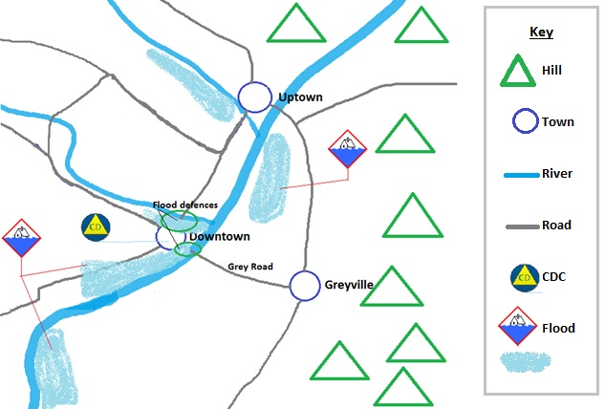
Method:  Flood defences reinforced in Downtown, with no mandatory evacuation. Flood diversion at Grey Road to remain closed. CDCs established in Downtown to support self-evacuees  Key Tasks:  - Establish flood defence group at Downtown  - Coordinate volunteers to help with flood defences  - Establish CDCs at Downtown  - Conduct impact assessment  - Establish recovery group  Endstate:  Flood defences reinforced and holding. Evacuees receiving support in Downtown. Impact assessment underway, and response preparing to transition to recovery. | Groups:  Flood defence, Downtown CDCs, road management, impact assessment, recovery  Timeline:  CDCs established by 1000 12 May  Flood defences reinforced by 2100, 12 May. Flood peak expected 0500 13 May.  Key Resources:  Diggers, generators, sandbags and filler, floodlights  Key Decisions:  - Evacuate Downtown if flood defences fail  - Reoccupation of evacuated houses  Risks / Vulnerabilities:  - Risk to Downtown residents if flood defences fail  - Greater risk of large-scale flooding upstream of the Grey Road diversion
Advantages (From Option Analysis)  - Least disruptive to Downtown residents  - Most timely response option  - Less risk to families south of Grey Road  - Not reliant on diversion decision | Disadvantages (From Option Analysis)  - More risk to Downtown residents  - More costly response option

Option Statement (example 2)
Option Sketch
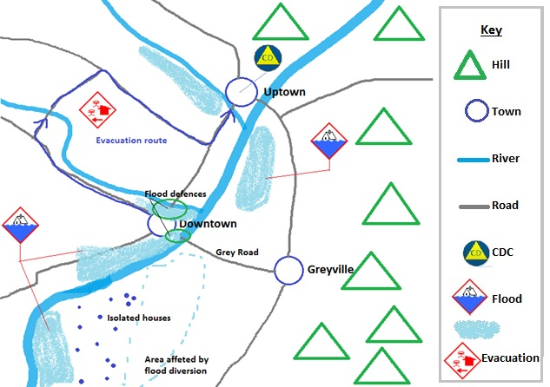
Concept:  Partial evacuation of Downtown, with CDCs established in Uptown to support evacuees. Flood defences reinforced, with possible diversion at Grey Road.  Key Tasks:  - Evacuate vulnerable areas in Downtown  - Establish CDCs at Uptown  - Establish flood defence group at Downtown  - Be prepared to open diversion at Grey Road  - Conduct impact assessment  - Establish recovery group  Endstate:  Vulnerable population evacuated from Downtown and receiving support in Uptown. Flood defences reinforced and holding. Impact assessment underway, and response preparing to transition to recovery. | Groups:  Flood defence, Uptown CDCs, road management, evacuation transport, impact assessment, resupply, recovery  Timeline:  Evacuation complete by 1200, 12 May.  Flood defences reinforced by 2300, 12 May. Flood peak expected 0500 13 May.  Key Resources:  Diggers, generators, sandbags, bedding, floodlights  Key Decisions:  - Open Grey Road Diversion  - Reoccupation of evacuated houses  Risks / Vulnerabilities:  - Earlier rain may push peak flood time prior to 2300.  - Grey Road diversion will isolate 14 houses.  - Decision to divert the flood may be taken too late
Advantages (From Option Analysis)  - Least risk to Downtown residents  - Least costly response option. | Disadvantages (From Option Analysis)  - Risk to isolated families  - More disruptive to Downtown residents  - Diversion decision may be too late to influence the flood.

Decision Briefing

The decision briefing is designed to be given by the Controller and the Planning team together, to enable subject experts to brief listeners on their areas of knowledge. The briefing format template below can be adapted and used as the agenda for a meeting or teleconference.

Subject | Speaker
Ground  - area of operations  - area of interest  - topography  - watersheds and hydrology (if relevant to the hazard)  - demographics  - lifelines  - weather | Intelligence rep
Situation- Hazard(s)  - hazard type(s)  - hazard locations, intensity  - hazard consequences to date  - most likely hazard scenario  - most dangerous hazard scenario  - key Information Requirements | Intelligence rep
Situation- Response  - agencies and response elements activated  - response structure  - response actions to date | Operations rep
Mission  [Read out the confirmed mission statement] | Controller
Execution- Intent  - method  - key tasks  - endstate | Controller
Execution- Coordinating Instructions  - key timings, including phases  - key locations  - boundaries | Planning rep
Execution- PIM  - media stance and interest  - key messages  - community liaison | PIM rep
Execution- Welfare  - welfare dependency  - concept for welfare provision and support | Welfare rep

Subject | Speaker
Administration/Logistics  - concept of logistics support  - critical resources  - finance | Logistics Rep
Control and Communications  - control arrangements  - communications plan | Operations rep
Questions  - questions to the Controller  - questions from the Controller (to test understanding)  Note: Controller can pass questions onto Planning team members for a more detailed answer. | Controller

Action Plan template
Action plan details
Name of field | Comments
Coordination centre | Coordination centre issuing the Action Plan (include agency)
Type of report | Action Plan
Action Plan number | Include a hash (#) (updates are indicated by adding .1, .2 etc.)
Emergency | Type of emergency and location, and time
Date and time issued
Operational period covered | Date/time Action Plan covers (start and finish)
Main body
Name of field | Comments
Summary of incident | A summary of the hazard consequences, environment and response actions to date, including the most dangerous and most likely hazard scenarios. This is based on the HEA and SitReps.
Mission | Mission statement
Intent | Give the intent, best stated as a method, key tasks and endstate.
Designated tasks | Specific tasks and timings for each agency under the plan
Limiting factors | Matters that may or will limit options, timeframes, outcomes
Coordination measures | Times, locations, boundaries, and other measures designed to coordinate the response
Resource needs | Who will provide what and when they will do it – including: supply, personnel, equipment, transport
Information flow | Who needs to know and who has information we need. May include information collection plan (or this may be an appendix)
Public information plan | Outline of intended public information processes and outputs. This may be an appendix.
Communications plan | Frequencies, purpose, coverage, role cellphone numbers, communications schedule, etc.
Organisation | List/organisation chart of key roles, contact details, and rosters of people assigned to the roles
Appendices | Specialist functions, lists, tables, maps, etc. Suggested appendices include response map, operational schedule, PIM, logistics and welfare.
Approval and distribution
Name of field | Comments
Action Plan prepared by | Name (and rank if applicable), response role, signature, and contact details
Action Plan approved by | Name (and rank if applicable), response role, signature, and contact details of response element’s Controller
Distribution | Include CIMS functions, all partner agencies representatives at the CC, and any other activated sub-functions

Developing response planning procedures
Response planning procedures describe what planning activities are intended to be carried out during a response, and how to prepare for them. This appendix summarises what needs to be included.
When the response planning procedures are prepared, they must be approved by the CDEM Group Manager (if planning is taking place at a Group level) or the EM Officer (if planning is taking place at a local level).

Content
Coordination Centre structure | Describe the overall Planning team structure, including:  - the coordination centre structure  - Planning’s role within the coordination centre structure, and  - Planning team structure, including function and support agency representatives who will be attached to the Planning team during a response.
Individual procedures
Include the processes and documentation prepared under Section 4 Readiness on page 76. This can be as descriptions with references, or as complete documents as appendices (see Appendix E Planning readiness checklist on page 133 for a full list). This should include the items listed in Table D-1 and Table D-2.

Table D-1 Procedures to include
Topic | Content to include
Role descriptions | Role descriptions of all positions in Planning, including support agency representatives
Planning process | Based on the planning process in this guideline. See Section 3 Planning processes on page 42.
Hazard and Environment Analysis (HEA) | - This should be placed in the Intelligence CDEM Plan, as it is an intelligence process.  - Whichever document it is included in, it should be based on the process in Appendix A Hazard and Environment Analysis (HEA) on page 90.
Activation procedure | See Appendix F Planning response procedure on page 135.
Table D-2 Appendices to include
Appendices | Content to include
Templates | - See Appendix C Templates on page 102.
Databases | - See section 4.1 Gathering information on page 76.

Planning readiness checklist
This (optional) checklist is for use by CDEM personnel responsible for preparing for Planning activities before an emergency occurs.
References are to sections in the Response Planning Director’s Guideline.
Gathering information | (see 4.1 Gathering information on page 76)
Contact database tasks:
database has been set up
database is accessible to all potential members of a Planning team during an emergency
database is updated every 3 months, any hard copies reissued, and users informed
appropriate email groups have been set up
Database includes:
next response level Planning Manager |  | emergency services
nearby CDEM Groups or local authorities |  | lifeline utilities
local CDEM roles that work with Planning |  | hospital and health services
other local CDEM related organisations |  | Commercial providers
Supporting CDEM information held and understood by Planning personnel includes:
local, regional, and national CDEM structures |  | links to National CDEM Plan and Guide
the CDEM Group Plan |  | readiness roles of local CDEM volunteers
readiness roles of local and CDEM Group staff |  | response roles of local CDEM volunteers
response roles of local and CDEM Group staff |  | recovery roles of local CDEM volunteers
recovery roles of local and CDEM Group staff

Planning and or/setting up | (see 4.2 Planning and setting up on page 77)
Tasks completed: (Locations and people identified in this section are available [insert location here])
initial Planning team (and a back-up team) is identified |  | hard copies & USBs of required documents set up
Planning pool is identified for any required rosters |  | Planning workspace default location is identified
Planning personnel details are updated every 3 months |  | Planning workspace back-up locations are identified
Planning personnel have emergency plans for home |  | required resources are sourced
means of communication set up |  | Planning response resource boxes are set up

Developing processes and documentation
(see 4.3 Developing processes and supporting documentation on page 82)
Documentation and processes developed:
Planning Readiness checklist |  | descriptions of duties for Planning team members
Planning Response checklist |  | required resources list
Planning Response procedure  (including activation) |  | Planning role descriptions
monitoring and evaluation process
Training and development | (see 4.4 Training and development on page 84)
Training tasks carried out:
skill gaps are identified |  | Planning personnel participating in exercises
potential programmes by CDEM and external organisations are identified |  | Planning training and development programmes for individual personnel developed
workshops for CDEM Group Planning organised |  | mentoring/shadowing exchanges organised

Planning response procedure
This (optional) template is:
- for use by the Planning Manager and their teams during an emergency
- completed as part of readiness
- intended to be amended to reflect actual processes used by the Planning team
- intended to have grey text replaced with the required information, and brown text deleted.

Planning response activation
Activation trigger | The Planning Manager:  - Is informed of the emergency by:  - [insert method – phone call from GEMO/EMO duty manager/paged by GEMO/EMO activation system], or  - natural indications, such as feeling an earthquake.
Planning briefing | The Planning Manager:  - (if applicable) Replies to the activation to confirm availability.  - Contacts the Controller or Response Manager on [insert phone number and alternative, or where it is found] to determine the current situation and response, and  The Controller or Response Manager:  - Briefs the Planning Manager on the emergency.  - If the Planning Manager does not respond within [insert time], the Duty Officer/activation system contacts the back-up person on the roster [insert phone number and alternative, or where it is found].

2. Setting up Planning team and workspace
Note: this may occur before the initial message is sent, during slow onset emergencies such as flooding.
Setting up Planning team | The Planning Manager, or a person delegated by them:  - Determines the Planning team members required for the initial response.  - Contacts the team members.  - Gives them the Planning workspace address which will be one of (in order of preference):  - (EOC)  - alternate address  - other suitable (ad hoc) address as directed by the Planning Manager  - Tells them the access requirements of [who holds keys/swipe cards and where are they located].  - Asks them their expected time of arrival, and records it.  - Sets up a short-term roster.

On arrival | Whichever Planning team member arrives first at the Planning workspace:  - Accesses the:  - workspace, using the [key/swipe card held where]  - Planning response resources (may be a ‘Planning response box’) described (where) using the [key/swipe card held where].  - Informs the Planning Manager that they have arrived on site and briefly updates them on the current situation there (is the building safe, are other EOC members present?).  - Sets up the physical resources (desks, computers, whiteboards), if necessary.  - Other staff assist with this as they arrive.
- Sets up an attendance log using the [what] template [held where].
- Sets up:
- daily Planning tasks checklist using the [what] template [held where].
- task log using the [what] template [held where].
Communication with GEMOs and EMOs | The Planning Manager (or person on site delegated by them):  - Assigns the tasks of setting up communication links, and making contact, if appropriate, with:  - NCMC (if appropriate) [insert email addresses, phone numbers, or list that contains them all]  - any activated EOCs/ECCs [insert email addresses, phone numbers, or list that contains them all]  - CDCs [insert email addresses, phone numbers, or list that contains them all]  - ICPs (if Planning team in an EOC).
Communication within the [Coordination Centre] | The Planning Manager (or person on site delegated by them):  - Assigns the tasks of setting up communication with the [Coordination Centre] CDEM roles that need to liaise with Planning, including: (insert contact details such as role specific cellphone numbers/ specific role emails etc. for each role)  - Operations  - Logistics, and  - Intelligence.

On-going Planning tasks
Tasks listed in Planning response checklist | The Planning Manager:  - advises the Controller and IMT on planning issues  - determines the need for further planning with the Controller  - leads the planning process, and  - monitors staff welfare.

Winding down
Debriefings | The Planning Manager:  - Ensures all unused resources are stored for BAU use, returned, or disposed of  - Ensures used resources are replaced  - Ensures all Planning personnel are debriefed before they return to their BAU duties  - Participates in CDEM debriefings, and  - That debrief information is analysed and approved changes made to plans and procedures.
Archiving records | The Planning Manager:  - Ensures all Planning records are archived according to the requirements of the Public Records Act 2005 by following the [what] procedure [held where].

Task log
If more space is required for an entry, complete a task sheet.
Task no. | Task sheet y/n | Time created | Task requirements | Assigned to | Actions taken | Time completed | Signed off by
1
2
3
4
5
6
7
8
9
10
11
12
13
14
15
16
17
18
19
20
21
22
23
24
25
26
27
28
29
30
31
32
33
34
35
36
37
38
39
40

Task sheet
This is used to record tasks that require more information than there is space for in the task log.
Task requested by
Task number (from task log) |  | Time/date logged in |  | Needed by (time)
Time full task completed |  | Signed by (name) |  | Signature

Requirements | Assigned to
Actions taken | Time/date completed | By whom

Glossary
Term | Abbreviation | Definition
4Rs |  | Reduction, readiness, response, and recovery. (see individual entries).
Action Plan | AP | A document that describes how the response will be managed and how response agencies will integrate their activities to achieve the response objectives. It is owned by the Controller, and developed by Planning with participation of all the functions and agencies activated.
Affected area |  | The area directly affected by an emergency.
Agencies |  | Government agencies (including public service departments, non-public service departments, Crown entities, and Offices of Parliament), non-governmental organisations, local government bodies, emergency services, and lifeline utilities.
Area of interest |  | The area where the coordination centre isn’t coordinating the response, but is interested in events that occur there as they may affect the area of operations. Factors of interest can include hazards, response actions, resources, supply sources, infrastructure and transport.
Area of operations |  | The area in which the response is taking place. It needs to be sufficiently large that it encompasses all direct response activities, though not necessarily all supporting activities.
assumption |  | A supposition on the current or future situation which is used as a substitute for fact, to enable planning to continue. Assumptions must be documented as Information Requirements, and verified.
business as usual | BAU | Refers to structures, practices, and procedures that apply when there is no emergency response; i.e. during normal conditions.
CDEM Group Plan |  | The CDEM Group Plan sets the strategic direction for the CDEM Group. It describes and prioritises the hazards and risks particular to the CDEM Group’s area, and provides objectives and a framework for activities across the 4Rs. Required under the CDEM Act 2002, and regularly reviewed.
CDEM organisation |  | Any part of a CDEM Group or local authority that has responsibilities in CDEM.
Contingency Plan |  | A document that describes how the response will manage a ‘what if’ situation that may but has not yet occurred. It is developed using the planning process and Action Plan format.
Coordinated Incident Management System | CIMS | The primary reference for incident management in New Zealand. The purpose of CIMS is to achieve effective coordinated incident management across responding agencies for all emergencies regardless of hazard, size and complexity.
coordination boundary |  | A point in time which Operations coordinates the response up to and Planning coordinates the response from. This boundary clarifies which function is responsible for coordination at any given time in the response.
coordination centre | CC | The location from which a Controller and Incident Management Team (IMT) manages a response. They include Incident Control Points (ICPs), Emergency Operations Centres (EOCs), Emergency Coordination Centres (ECCs), and National Coordination Centres (NCCs).
common operating picture | COP | An understanding of a situation based on the best available information, shared among all response agencies.
constraint |  | A restriction that is placed onto a response by governance/management or a higher response level Controller. This may include time limits/deadlines, budgets, areas that must be covered by the response or that can’t be used, agencies that must be included in the response, or any matter that is put out of scope.
Controller |  | The person in charge of an emergency, or an aspect of it. The level of their control is given by the name – National Controller (usually based at the NCMC), Group Controller (usually based at an ECC), and Local Controller (usually based at an EOC).  The functions and powers of the National Controller are described in Sections 10 and 11 of the CDEM Act 2002.  The appointment and functions of Group and Local Controllers are described in Sections 26 to 28 of the CDEM Act 2002.
Director of CDEM |  | The head of MCDEM who reports to the Minister of Civil Defence. The Director has the role of National Controller during an emergency led by CDEM, unless they choose to delegate this role.  The functions and powers of the Director are described in Sections 8 and 9 of the CDEM Act 2002.
emergency |  | In this document, emergency has the same meaning as in the CDEM Act 2002.
Emergency Management Office | EMO | The office(s) where CDEM functions are carried out at a local level before an emergency occurs.
Emergency Management Officer | EM Officer | The person who manages the Emergency Management Office (EMO) at a local level.
endstate |  | A short description of what the situation will be when an Action Plan has achieved its objectives. Expressed in the past tense, e.g. “The town is evacuated, welfare systems are caring for evacuees, the tsunami has finished, damage assessment is underway and the response is prepared to transition to recovery”.
essential task |  | A task that must be completed in order to achieve a response objective assigned by the Controller.
Group Emergency Management Office | GEMO | The regional office where CDEM functions are carried out on behalf of the CDEM Group before an emergency occurs.
Group Emergency Management Office (GEMO) Manager | GEMO Manager | The person who manages the Group Emergency Management Office (GEMO).
Hazard and Environment Analysis | HEA | An analytical process designed to forecast how the hazard(s) might develop in the affected area. It is future-focused and a key input to the planning process.
incident |  | An occurrence that needs a response from one or more agencies. It may or may not be an emergency.
Information Collection Plan |  | A document that gathers a coordination centre’s Information Requirements into a set format and allocates these to agencies for answer. It provides for a structured, targeted, and methodical approach to information gathering. It is managed by the Intelligence function.
Information Requirement | IR | An item of information about the response that needs to be collected and processed in order to meet the Information Requirements of the Controller and coordination centre.
implied task |  | A task that a response agency must perform or prepare to perform to accomplish a response objective, but which is not stated in any directive or Action Plan.
Initial Action Plan |  | A document that describes how the initial response will be coordinated, while the response structure is mobilising and information is being gathered. They may be prepared during readiness.
intent |  | A formal statement that gives clear direction on a Controller’s intentions regarding a response. It is normally expressed as a method, key tasks and an end state.
Lead agency |  | The agency that manages the response to or recovery from a particular emergency. Some agencies are required by law to lead particular types of emergencies; other types of emergencies will have the lead agency determined by expertise.
local authority |  | A territorial authority, regional council, or unitary authority.
Long-Term Plan |  | A document that describes how the response will manage response objectives that cannot be met in the short term (the current Action Plan) or the medium term (the subsequent Action Plan). They are developed using the planning process and Action Plan format. A Long-Term Plan may be for hours, days or weeks in advance, depending on the response.
Ministry of Civil Defence & Emergency Management | MCDEM | The central government agency responsible for providing leadership, strategic guidance, national coordination, and the facilitation and promotion of various key activities across the 4Rs. It is the lead agency at a national level responsible for coordinating the management of the emergencies listed in Appendix 1 of the National CDEM Plan 2015.
National Crisis Management Centre | NCMC | A secure, all-of-government coordination centre used by agencies to monitor, support, or manage a response at the national level.
objective |  | Goals which a response element works towards. They are a statement of what is to be achieved, and are best described as Specific, Measureable, Achievable, Relevant and Time-bound (SMART).
Operational period |  | The period of time scheduled for execution of the Action Plan.
option |  | In the planning process, a possible pathway that will accomplish or contribute to the accomplishment of a mission, and from which a detailed plan is developed. Also called a Course of Action (COA).
Phase |  | Phases are used to break a complex plan into simpler, discrete parts. Phases are also used when it is not possible to complete all of the essential tasks at once, either due to resource constraints or because one must be completed before another.
preliminary notice |  | A warning notice advising that an activity is about to happen, to allow planning and preparation to commence.
preliminary phase |  | A preliminary phase covers actions that occur before the Action Plan takes effect; these are often information gathering, mobilisation or logistics arrangements
Readiness |  | Developing operational systems and capabilities before an emergency happens, including self-help and response programmes for the general public, and specific programmes for emergency services, lifeline utilities, and other agencies.
Recovery |  | The coordinated efforts and processes used to bring about the immediate, medium-term, and long-term holistic regeneration and enhancement of a community following an emergency.
regional council |  | A region-based council, primarily responsible for natural resource management, including in the coastal marine area.
Response |  | Actions taken immediately before, during, or directly after an emergency to save lives and property, and to help communities recover.
response element |  | A team or group that makes up part of the response. It might be a single small team or all of the personnel and equipment assigned to a Controller. Each element should cover all of the CIMS functions, even if all are carried out by a single individual.
Reduction |  | Identifying and analysing long-term risks to human life and property from natural or non-natural hazards, taking steps to eliminate these risks if practicable, and, if not, reducing the magnitude of their impact and the likelihood of their occurring.
sequel phase |  | A phase describing activities that occur after the Action Plan has reached its endstate. It is normally a progression to the next Action Plan or to recovery
situational awareness |  | An understanding and appreciation of the complexities of an emergency including an understanding of the environment, the situation, likely developments, and implications
specified task |  | A task that has been specifically stated and directed to a coordination centre, either by a Controller, governance/management, or by a higher response level Controller through an Action Plan.
starting state |  | The state at which response agencies, resources, the environment (including the population) and the hazard is in, when the Action Plan is due to begin.
Support agency |  | Any agency that assists the lead agency by providing services, resources, information, or otherwise contributing to the response or recovery.
territorial authority | TA | A city or district council or unitary authority that provides public services and regulates land use, buildings, public nuisances, and environmental health.
unitary authority |  | A territorial authority with regional council functions and powers.

In some agencies, an operational schedule is known as the ‘battle rhythm’.
In the New Zealand Defence Force (NZDF), a preliminary notice is called a warning order.

