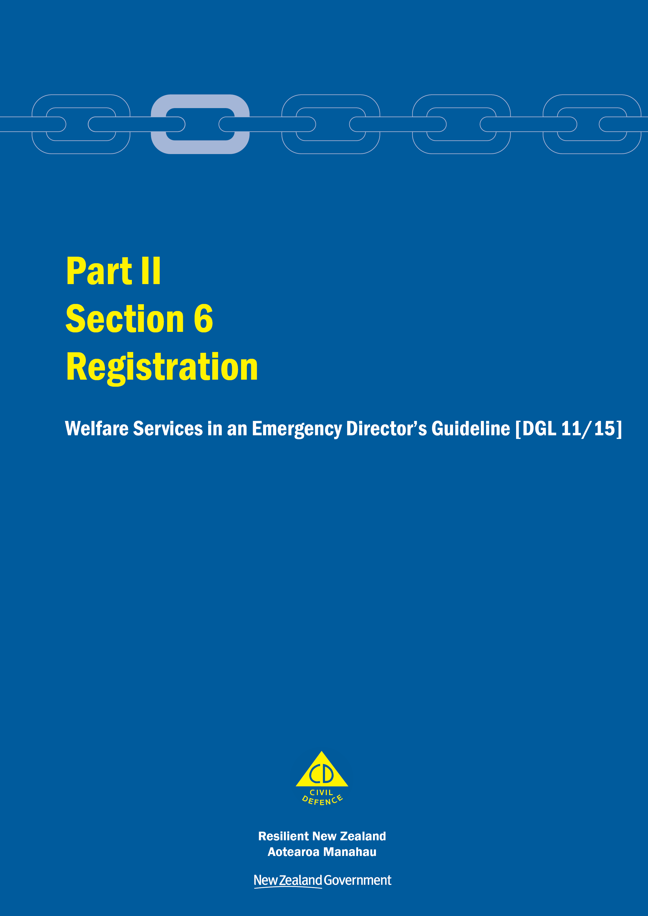
Welfare Services in an Emergency
Director’s Guideline for CDEM Groups and agencies with responsibilities for welfare services in an emergency [DGL 11/15]

October 2015
ISBN 978-0-478-43513-9
Published by the Ministry of Civil Defence & Emergency Management

Authority
This guideline has been issued by the Director of the Ministry of Civil Defence & Emergency Management pursuant to s9(3) of the Civil Defence Emergency Management (CDEM) Act 2002. It provides assistance to CDEM Groups and agencies with responsibilities for welfare services in an emergency to understand and work towards the welfare roles, structures, and responsibilities described in the National Civil Defence Emergency Management Plan 2015.

This document is not copyright and may be reproduced with acknowledgement. It is available, along with further information about the Ministry, on the MCDEM website www.civildefence.govt.nz.

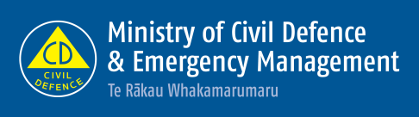

Ministry of Civil Defence & Emergency Management
PO Box 5010
Wellington 6145
New Zealand
Tel: +64 4 817 8555
Fax: +64 4 817 8554
Email: emergency.management@dpmc.govt.nz
Website: www.civildefence.govt.nz

Contents
Section 6 Registration 3
6.1 Introduction 3
6.2 Principles 4
6.3 Welfare registration process 5
6.3.1 Before registration begins – meet and greet 5
6.3.2 The official registration process 6
6.3.3 CDEM EMIS Welfare Registration System 7
Appendix A Information applicable to all welfare services 9

Registration
This section should be read in conjunction with the other parts and sections in the Welfare Services in an Emergency Director’s Guideline [DGL 11/15].

Introduction
Registration involves collecting information from people in order to identify who has been directly affected by an emergency, and may require emergency welfare services.
Registration information informs the needs assessment sub-function, and is used to support the Inquiry sub-function.
Registration is primarily a response sub-function. However, people affected by an emergency may not require welfare services until some later time after the emergency occurs (possibly during recovery).
Registration is a voluntary activity that assists with coordinated assessment of needs and provision of welfare services in an emergency. People affected by an emergency and that are registered can be easily identified by CDEM Groups/local authorities.

Agency responsible | MCDEM and CDEM Groups (including local authorities) are the agencies responsible for coordinating the registration sub-function:  - at the national level, MCDEM is the agency responsible for the provision of the CDEM welfare registration system for registering people who are affected by an emergency and who may require emergency welfare services, and  - at the CDEM Group level, CDEM Groups are responsible for registering people who have been affected by an emergency and who may require emergency welfare services.
Support | Support may be provided by any other government agency or non-government organisation that can provide relevant advice, information, or trained staff.
Registrar and registrant | A registrar completes the welfare registration process with the information provided by an individual (registrant), or their parent, legal guardian, or usual caregiver.

Principles
The following principles guide the registration process:
- Only register people who are affected by an emergency and who have a need for welfare services (this includes people who identify as being affected by an emergency, or simply wish to be registered).
- Ensure registrars are empathetic towards registrants, and that the experience is people-focused (not process-focused) and positive; consider the barrier that a (computer) screen may create between people.
- People affected by an emergency should be encouraged by all agencies to register, to ensure:
  - an integrated approach to welfare service provision, and
  - that people’s needs are met through the most appropriate channel.
- The registration process must be efficient.
- Use the CDEM Emergency Management Information System (CDEM EMIS) Welfare Registration System (the national standard), and complete all compulsory fields as a minimum.
- Train personnel and volunteers in the use of the CDEM EMIS Welfare Registration System and in information privacy requirements.
- Put all trained registrars through the Police vetting process.
- Avoid using spontaneous volunteers as registrars if possible.
- Clarify privacy and information sharing intentions with all registrants and obtain agreement to be registered (if no agreement is given, a person cannot be registered).
- Sight and record identification, preferably photographic if this is available.
- Gather as much useful information about individuals as possible, with a view to only asking individuals for this information once.
- Welfare registration information should be shared across relevant agencies to enable effective response and recovery.

Welfare registration process
The registration process is carried out:
- in a face to face setting in a Civil Defence Centre (CDC) – including during recovery
- in a community setting (by mobile teams), or
- remotely, such as via self-service online or by telephone.

Before registration begins – meet and greet
Meet and greet in a CDC setting | People arriving at CDCs are greeted by members of the Welfare team (reception personnel) who make initial decisions (i.e. triage, a preliminary form of needs assessment) about whether a person needs to be registered.  At this point, immediate needs are identified and addressed, and any other initial assistance provided.  Some people may only be seeking general information and therefore do not need to be registered. Meet and greet/reception personnel will be able to assist them to access the information they require, diverting them away from a busy registration area or unnecessary queue.  Some people may require some assistance prior to being registered, some food or a hot drink, a bathroom stop, or merely someone to talk to.  If people are queueing (at a desk, to be registered for example) or congregating in waiting areas, having some roaming, trained personnel to walk the queues/waiting areas can be very helpful to identify any issues or difficulties that a person may be experiencing or that may arise.
Immediate needs | Immediate needs may include the treatment of an injury or a need for other medical assistance, the requirement for an interpreter, provision of warm/dry clothing, or a need to make an urgent phone call.  People may also be distressed or anxious and require privacy.
Meet and greet in a community setting | Welfare teams conducting mobile or door to door visits decide which people they see have a need for welfare services, and are therefore to be registered. Only these peoples’ details are recorded.

The official registration process
The official registration process begins when the decision to register an affected person is made; the person presents themselves at the registration desk/area, or to a registrar, or contact is made with a registrar in a community setting (or via self-service in a remote setting).
Information about the registration process, including a statement of agreement to be registered, can be provided in advance via a hand-out or by way of on-screen displays or posters.
In a CDC setting | In the CDC setting, a variety of methods may be used to register affected people including:  - registration desks may be established in the CDC with multiple registrars equipped with:  - laptops, with internet connection for the CDEM EMIS Welfare Registration System  - the paper based equivalent of the system (printed Welfare Registration Forms from the CDEM EMIS Welfare Registration System)  - laptops, using a specific spreadsheet that will upload registration data directly into the CDEM EMIS Welfare Registration System, in the correct format, and  - roaming registrars in the CDC equipped with printed Welfare Registration Forms.
In a community setting | Outreach teams (mobile teams door to door, or the setup of a mobile facility) may be used in the community setting to register affected people. Community members may be provided with printed Welfare Registration Forms, or mobile devices.
Remote registration | Remote options to register affected people may also be a possibility, including:  - self-service telephone capability via a generic or 0800 number (e.g. a Council or other call centre)  - self-service (online), or  - outbound calling.  See Part II Section 7 Needs assessment of the Welfare Services in an Emergency Director’s Guideline [DGL 11/15] for more information on these options (available at www.civildefence.govt.nz).

CDEM EMIS Welfare Registration System
The CDEM EMIS Welfare Registration System is the national standard registration system which stores registrations and inquiries in a single, online database. The database allows all CDEM EMIS users to enter and access welfare information for their own organisation or on behalf of any other organisation in New Zealand, regardless of location. Access to/administration of the system is managed by CDEM at each level (local authority, CDEM Group, MCDEM).
For more information on the system and permissions, refer to the CDEM EMIS User Guide – Welfare Registration outlined under the Resources heading of this section.
Welfare inquiry | The welfare inquiry component of the CDEM EMIS Welfare Registration System interrogates the welfare registration data stored in the system. This feature can be used when a person makes an inquiry about another person they wish to make contact with.
Permission levels | There are multiple permission levels in the CDEM EMIS Welfare Registration System. Strict procedure is applied to ensure the privacy and security of personal information about all registrants and people being sought after.
 | Refer to the CDEM EMIS User Guide – Welfare Registration outlined under the Resources heading of this section, for detailed information on permissions and procedures.

Planning considerations
Online versus paper based system | A paper based replica of the system should be available for use during an emergency, including situations where there is either:  - no power  - no internet connection, or  - no IT capability (e.g. laptops or PCs).  Forms can be printed and stored (during readiness) as part of CDC welfare kits/equipment.  Hard copy records will need to be entered into the online system at the earliest opportunity. This may involve the physical transfer of hard copy records to the coordination centre or other facility for data entry into the CDEM EMIS Welfare Registration System at a later time.  Information security must be addressed to protect personal information and to meet privacy obligations (see section A.5 Privacy, information sharing, and vetting on page 11 for more information).  Plan for these situations when considering and exercising the welfare registration sub-function.
Retention and disposal of data | Each local authority will have its own policy for records/information storage. Storage of registration data will come under a CDEM Group/local authority’s retention and disposal plan or policy.

Resources
Printable Welfare Registration Forms | A number of printer-friendly forms for use when registering people are available in CDEM EMIS, each with a different purpose.  Forms include:  - a Group Registration Form to register people residing/working at the same address. This feature carries address information across to individual registrations, eliminating the need to enter the same data multiple times  - a two-page Welfare Registration Short Form which captures pertinent registration information in a shortened format and is intended for hard copy use  - a Welfare Inquiry Form to record information from a person making an inquiry about a person/people being sought after  - a Welfare Needs Assessment Form to record detailed information about an individual’s requirement for welfare services. Each of the requirements/services is featured on a new page allowing printing as required, and  - a Civil Defence Centre Report Form to record information about the functioning of a CDC (affected people, personnel, welfare services etc.) to relay to the coordination centre.
CDC Registration Card | A CDC registration card can be given to a registrant as physical evidence that the person is registered by a local authority. The card includes the name, date registered, CDC details and contact information for further assistance (e.g. local authority details, as the CDC may close).  A CDC registration card is not required by any agency in order to provide welfare services, but may be a useful record for a registrant.  Templates for CDC registration cards are available in CDEM EMIS (see link below).
For further detailed information on the use of the CDEM EMIS Welfare Registration System refer to the suite of CDEM EMIS User Guides which are available in CDEM EMIS at https://cdem.emis.govt.nz (under National Documents, EMIS User Guides).
Note: A login is required to access these guides.
In particular, see:
- CDEM EMIS User Guide – Getting Started
- CDEM EMIS User Guide – Welfare Registration.

Information applicable to all welfare services
This section provides overarching information applicable to all welfare services.

Welfare services agency representation
Some government agencies responsible for the coordination of the welfare services sub-functions do not have a presence in all communities.
Where agencies are not represented at the regional or local level, those agencies need to identify how they will fulfil their responsibilities. This may include:
- identifying alternative agencies or organisations to coordinate or support the delivery of the welfare services sub-function, or
- deploying personnel into the region or local area.
Agencies should work with the CDEM Group/local authority to identify alternative agencies/organisations present in the local community. These organisations may be non-government, community-based, or voluntary.
See the National CDEM Plan 2015, the Guide to the National CDEM Plan 2015, and the sections in Part II Welfare services of this guideline for details of the agencies responsible for, and who support the welfare services sub-functions.

Human rights
New Zealand’s human rights commitments | The provision of welfare services to people affected by an emergency, either via a CDC or in a community setting, must contribute to ensuring that New Zealand meets its national and international human rights commitments.  See the Human Rights Commission website www.hrc.co.nz under the ‘Your rights’ tab for more information.
Age, people with disabilities, and people from CALD communities | Consideration must be given to providing access to welfare services to people of any age, people with disabilities, and people from culturally and linguistically diverse (CALD) communities. For example, people with disabilities require welfare services to be delivered in a disability-inclusive way, and will work with CDEM to achieve this. CALD community members often have specific requirements around social interaction, food, prayer, or gender which must be considered when planning for the delivery of welfare services.
More information | For more information and a list of relevant statutory documents, refer to the MCDEM publications:  - Including people with disabilities: Information for the CDEM Sector [IS 13/13]  - Including culturally and linguistically diverse (CALD) communities: Information for the CDEM Sector [IS12/13].  Along with the resources listed above, see Part I of the Welfare Services in an Emergency Director’s Guideline [DGL 1/15] (Appendix H Accessibility).  These are available at www.civildefence.govt.nz (search for the document name).

Working with communities
An inclusive approach | An emergency can be a stressful and emotional experience, which may impact or compound any existing difficulties or issues that people are facing. At the local and regional levels, consideration must be given to vulnerable and hard to reach communities, acknowledging that they may have:  - specific challenges to address  - skills and strengths that may contribute to welfare services delivery.
Considerations | Consider when planning:  - age  - gender  - children and young people  - people living alone  - elderly  - health and disability issues  - mental health and general health issues  - drug or alcohol dependency  - cultural requirements  - ethnicity and language  - socio-economic status  - people with companion animals  - isolation, and  - people with unreliable or no internet access or mobile phone coverage.
Utilising community networks | Opportunities should be taken wherever possible to build links with existing community networks. These networks should be utilised to reach people requiring support in an emergency, with resulting arrangements formalised in local plans.
Culturally and linguistically diverse (CALD) communities | CALD communities have many strengths, including skills, experience, and language capabilities.  CALD community networks are often well developed, with strong connections both within their own community and between communities. Partnering with CALD community leaders can enable appropriate and effective engagement and communication with community members.
People with disabilities | Working with people with disabilities and their wider networks of family/whānau, friends, and supporters provides an opportunity to gain an understanding of both the requirements and strengths of these members of the community.  People with disabilities and disabled people’s organisations provide expertise on the impact of disability. Disability service providers have technical and professional expertise, and may also have resources that can be drawn upon in an emergency.

Minimum standards in the Sphere Handbook
CDEM Groups/local authorities should take The Sphere Handbook: Humanitarian Charter and Minimum Standards in Humanitarian Response into account when planning for, setting up, and delivering welfare services.
The Sphere Handbook is one of the most internationally recognised sets of common principles and universal minimum standards in life-saving areas of humanitarian response.
The Minimum Standards include recommendations in water supply, sanitation, hygiene promotion, food security and nutrition, shelter, settlement, and non-food Items.
The Sphere Handbook is available at www.spherehandbook.org.

Key considerations | Some of the key requirements (taken from the Sphere Handbook) to be considered when planning for people affected by an emergency are shown in Table 1.  Table 1 Key considerations for planning for people affected by an emergency  Rights Key requirements  Protection from Poor health, disease and wellbeing  Environment, weather, heat or cold  Violence, crime or abuse  Dangerous structures  Nutrition Clean drinking water  Food, baby food and pet food  Cooking facilities, utensils and fuel  Water and Sanitation, Hygiene (W.A.S.H) Clean water for washing  Waste water, solid waste  Hygiene, nappies, soap and disinfectant

Privacy, information sharing, and vetting
Information about welfare registrants, including personal information, will be shared with agencies contributing to the coordination and delivery of welfare services.
A privacy statement features as the first step in the registration process, and this must be understood and agreed to by all potential registrants. The privacy statement can be displayed by way of posters, hand-outs or on-screen if people are waiting to be registered (e.g. in a CDC).
Welfare registrars need to be trained in and must understand and abide by the provisions of the Privacy Act 1993. This Act controls how agencies collect, use, disclose and give access to personal information. Note that people have the right to request any information gathered about them under this Act.
See section 6 in Part 2 of the Privacy Act 1993 which features 12 Information privacy principles.
The Privacy Act 1993 is available at the New Zealand Legislation website: www.legislation.govt.nz or for more information refer to the Privacy Commissioner’s website: www.privacy.org.nz.

Civil Defence National Emergencies (Information Sharing) Code 2013 | The Civil Defence National Emergencies (Information Sharing) Code 2013 (the Information Sharing Code) is a regulation issued by the Privacy Commissioner, and applies to a state of national emergency only.  The Information Sharing Code provides agencies with the authority to collect, use, and disclose personal information relating to an individual, in relation to an emergency.  The Information Sharing Code applies as follows:  - To assist with the effective management of the response to a national emergency, this code applies in relation to any emergency in respect of which a state of national emergency is in force.  - To assist with the recovery from a national emergency, this code continues to apply in relation to such an emergency for a further 20 working days after the date on which a state of national emergency expires or is terminated.  Specific criteria apply to the Information Sharing Code. For full details, refer to the Civil Defence National Emergencies (Information Sharing) Code 2013 on the Privacy Commissioner’s website: www.privacy.org.nz.  As stated above, the Information Sharing Code applies only to a state of national emergency. The Privacy Act 1993 applies at all times including during and following any emergency.
Police Vetting Service | The New Zealand Police Vetting Service offers an online process for approved organisations to check the criminal records of potential or existing personnel, including volunteers.  Vetting requests cannot be made by individuals, and organisations must register in order to ask for Police vetting. To become an approved organisation, agencies must show that their personnel provide services or care for children, older people, people with special needs or other vulnerable members of society.  Vetting can only be carried out with the signed consent of the person being vetted. Organisations are expected to ensure the person being vetted is aware of the vetting process.  The standard turnaround time for completing a Police vetting process is 20 working days.  Police recommend that vetting of existing personnel including volunteers, is carried out on a regular basis, i.e. every two to three years.  An organisation must have information security procedures in place to protect the confidential information and any Police material they hold as a result of the vetting process.  More information about Police vetting is available at www.police.govt.nz.
Safety checking for the children’s workforce | The Vulnerable Children Act 2014 introduces new requirements for organisations funded by the government that employ people to work with children. Safety checking requirements are being phased in over several years.  Any agency working with children and young people must meet the approval obligations outlined in the Vulnerable Children Act 2014.  The Vulnerable Children Act 2014 is available at the New Zealand Legislation website: www.legislation.govt.nz or for more information refer to the Children’s Action Plan website: www.childrensactionplan.govt.nz.
Screening CDEM-trained volunteers | For information about screening processes for CDEM-trained volunteers, refer to the Volunteer Coordination in CDEM Director’s Guideline for CDEM Groups [DGL 15/13] available at www.civildefence.govt.nz (search for ‘volunteer coordination DGL’).

