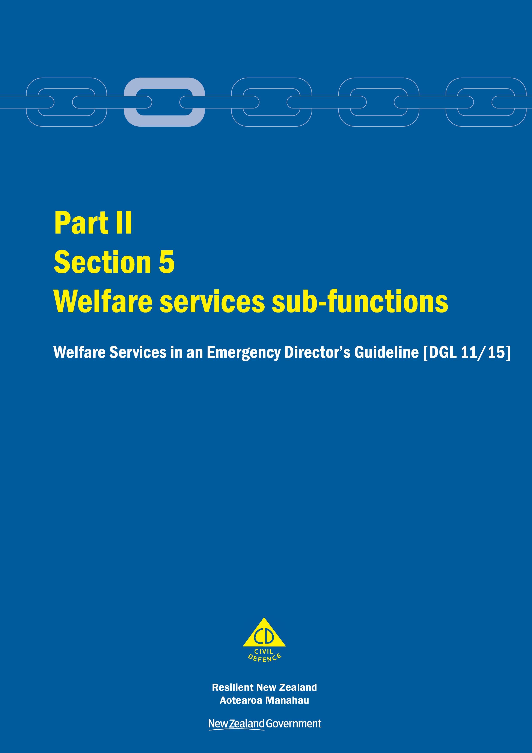
Welfare Services in an Emergency
Director’s Guideline for CDEM Groups and agencies with responsibilities for welfare services in an emergency [DGL 11/15]

October 2015
ISBN 978-0-478-43513-9
Published by the Ministry of Civil Defence & Emergency Management

Authority
This guideline has been issued by the Director of the Ministry of Civil Defence & Emergency Management pursuant to s9(3) of the Civil Defence Emergency Management (CDEM) Act 2002. It provides assistance to CDEM Groups and agencies with responsibilities for welfare services in an emergency to understand and work towards the welfare roles, structures, and responsibilities described in the National Civil Defence Emergency Management Plan 2015.

This document is not copyright and may be reproduced with acknowledgement. It is available, along with further information about the Ministry, on the MCDEM website www.civildefence.govt.nz.

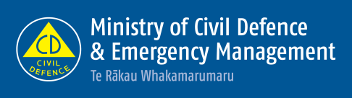

Ministry of Civil Defence & Emergency Management
PO Box 5010
Wellington 6145
New Zealand
Tel: +64 4 817 8555
Fax: +64 4 817 8554
Email: emergency.management@dpmc.govt.nz
Website: www.civildefence.govt.nz

Contents
Section 5 Welfare services sub-functions 1
5.1 Overview 1
5.2 Information applicable to all welfare services 2
5.2.1 Welfare services agency representation 2
5.2.2 Human rights 3
5.2.3 Working with communities 3
5.2.4 Minimum standards in the Sphere Handbook 5
5.2.5 Privacy, information sharing, and vetting 6

Welfare services sub-functions
This section provides an introduction to the nine welfare services sub-functions described in the National CDEM Plan 2015.
It includes important information applicable to all welfare services. Sections 6-14 of this guideline should be read in conjunction with this section.

Overview
Introduction | Welfare services include the following sub-functions:  - registration  - needs assessment  - inquiry  - care and protection services for children and young people  - psychosocial support  - household goods and services  - shelter and accommodation  - financial assistance, and  - animal welfare.
Relationship between welfare sub-functions | Registration and needs assessment provide the fundamental information and understanding about people affected by an emergency and their associated needs. The registration and needs assessment welfare services sub-functions are therefore crucial to effectively meeting the needs of those affected. The remaining sub-functions are service delivery functions based on the needs identified.  The needs of people affected by an emergency change throughout response and recovery. Ongoing coordination of service delivery, and monitoring and reporting of both needs and service delivery are required throughout.  Figure 1 on the next page shows the relationship between the welfare services sub-functions.
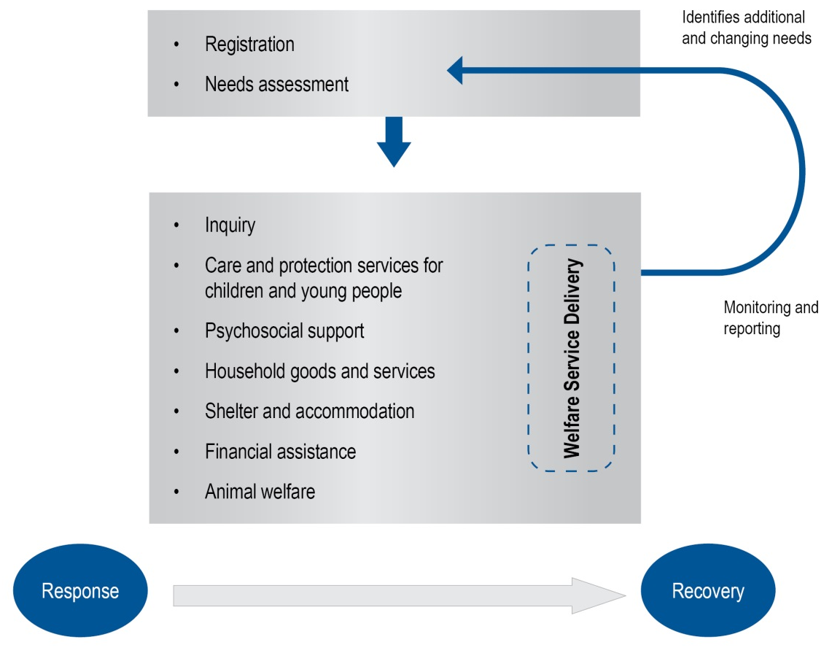
Figure 1 Relationship between the welfare services sub-functions

Information applicable to all welfare services
This section provides overarching information applicable to all welfare services.

Welfare services agency representation
Some government agencies responsible for the coordination of the welfare services sub-functions do not have a presence in all communities.
Where agencies are not represented at the regional or local level, those agencies need to identify how they will fulfil their responsibilities. This may include:
- identifying alternative agencies or organisations to coordinate or support the delivery of the welfare services sub-function, or
- deploying personnel into the region or local area.
Agencies should work with the CDEM Group/local authority to identify alternative agencies/organisations present in the local community. These organisations may be non-government, community-based, or voluntary.
See the National CDEM Plan 2015, the Guide to the National CDEM Plan 2015, and the sections in Part II Welfare services of this guideline for details of the agencies responsible for, and who support the welfare services sub-functions.

Human rights
New Zealand’s human rights commitments | The provision of welfare services to people affected by an emergency, either via a Civil Defence Centre (CDC) or in a community setting, must contribute to ensuring that New Zealand meets its national and international human rights commitments.  See the Human Rights Commission website www.hrc.co.nz under the ‘Your rights’ tab for more information.
Age, people with disabilities, and people from CALD communities | Consideration must be given to providing access to welfare services to people of any age, people with disabilities, and people from culturally and linguistically diverse (CALD) communities. For example, people with disabilities require welfare services to be delivered in a disability-inclusive way, and will work with CDEM to achieve this. CALD community members often have specific requirements around social interaction, food, prayer, or gender which must be considered when planning for the delivery of welfare services.
More information | For more information and a list of relevant statutory documents, refer to the MCDEM publications:  - Including people with disabilities: Information for the CDEM Sector [IS 13/13]  - Including culturally and linguistically diverse (CALD) communities: Information for the CDEM Sector [IS12/13].  Along with the resources listed above, see Part I of the Welfare Services in an Emergency Director’s Guideline [DGL 1/15] (Appendix H Accessibility).  These are available at www.civildefence.govt.nz (search for the document name).

Working with communities
An inclusive approach | An emergency can be a stressful and emotional experience, which may impact or compound any existing difficulties or issues that people are facing. At the local and regional levels, consideration must be given to vulnerable and hard to reach communities, acknowledging that they may have:  - specific challenges to address  - skills and strengths that may contribute to welfare services delivery.
Considerations | Consider when planning:  - age  - gender  - children and young people  - people living alone  - elderly  - health and disability issues  - mental health and general health issues  - drug or alcohol dependency  - cultural requirements  - ethnicity and language  - socio-economic status  - people with companion animals  - isolation, and  - people with unreliable or no internet access or mobile phone coverage.
Utilising community networks | Opportunities should be taken wherever possible to build links with existing community networks. These networks should be utilised to reach people requiring support in an emergency, with resulting arrangements formalised in local plans.
Culturally and linguistically diverse (CALD) communities | CALD communities have many strengths, including skills, experience, and language capabilities.  CALD community networks are often well developed, with strong connections both within their own community and between communities. Partnering with CALD community leaders can enable appropriate and effective engagement and communication with community members.
People with disabilities | Working with people with disabilities and their wider networks of family/whānau, friends, and supporters provides an opportunity to gain an understanding of both the requirements and strengths of these members of the community.  People with disabilities and disabled people’s organisations provide expertise on the impact of disability. Disability service providers have technical and professional expertise, and may also have resources that can be drawn upon in an emergency.

Minimum standards in the Sphere Handbook
CDEM Groups/local authorities should take The Sphere Handbook: Humanitarian Charter and Minimum Standards in Humanitarian Response into account when planning for, setting up, and delivering welfare services.
The Sphere Handbook is one of the most internationally recognised sets of common principles and universal minimum standards in life-saving areas of humanitarian response.
The Minimum Standards include recommendations in water supply, sanitation, hygiene promotion, food security and nutrition, shelter, settlement, and non-food Items.
The Sphere Handbook is available at www.spherehandbook.org.

Key considerations | Some of the key requirements (taken from the Sphere Handbook) to be considered when planning for people affected by an emergency are shown in Table 1.  Table 1 Key considerations for planning for people affected by an emergency  Rights Key requirements  Protection from Poor health, disease and wellbeing  Environment, weather, heat or cold  Violence, crime or abuse  Dangerous structures  Nutrition Clean drinking water  Food, baby food and pet food  Cooking facilities, utensils and fuel  Water and Sanitation, Hygiene (W.A.S.H) Clean water for washing  Waste water, solid waste  Hygiene, nappies, soap and disinfectant

Privacy, information sharing, and vetting
Information about welfare registrants, including personal information, will be shared with agencies contributing to the coordination and delivery of welfare services.
A privacy statement features as the first step in the registration process, and this must be understood and agreed to by all potential registrants. The privacy statement can be displayed by way of posters, hand-outs or on-screen if people are waiting to be registered (e.g. in a CDC).
Welfare registrars need to be trained in and must understand and abide by the provisions of the Privacy Act 1993. This Act controls how agencies collect, use, disclose and give access to personal information. Note that people have the right to request any information gathered about them under this Act.
See section 6 in Part 2 of the Privacy Act 1993 which features 12 Information privacy principles.
The Privacy Act 1993 is available at the New Zealand Legislation website: www.legislation.govt.nz or for more information refer to the Privacy Commissioner’s website: www.privacy.org.nz .

Civil Defence National Emergencies (Information Sharing) Code 2013 | The Civil Defence National Emergencies (Information Sharing) Code 2013 (the Information Sharing Code) is a regulation issued by the Privacy Commissioner, and applies to a state of national emergency only.  The Information Sharing Code provides agencies with the authority to collect, use, and disclose personal information relating to an individual, in relation to an emergency.  The Information Sharing Code applies as follows:  - To assist with the effective management of the response to a national emergency, this code applies in relation to any emergency in respect of which a state of national emergency is in force.  - To assist with the recovery from a national emergency, this code continues to apply in relation to such an emergency for a further 20 working days after the date on which a state of national emergency expires or is terminated.  Specific criteria apply to the Information Sharing Code. For full details, refer to the Civil Defence National Emergencies (Information Sharing) Code 2013 on the Privacy Commissioner’s website: www.privacy.org.nz.  As stated above, the Information Sharing Code applies only to a state of national emergency. The Privacy Act 1993 applies at all times including during and following any emergency.
Police Vetting Service | The New Zealand Police Vetting Service offers an online process for approved organisations to check the criminal records of potential or existing personnel, including volunteers.  Vetting requests cannot be made by individuals, and organisations must register in order to ask for Police vetting. To become an approved organisation, agencies must show that their personnel provide services or care for children, older people, people with special needs or other vulnerable members of society.  Vetting can only be carried out with the signed consent of the person being vetted. Organisations are expected to ensure the person being vetted is aware of the vetting process.  The standard turnaround time for completing a Police vetting process is 20 working days.  Police recommend that vetting of existing personnel including volunteers, is carried out on a regular basis, i.e. every two to three years.  An organisation must have information security procedures in place to protect the confidential information and any Police material they hold as a result of the vetting process.  More information about Police vetting is available at www.police.govt.nz.
Safety checking for the children’s workforce | The Vulnerable Children Act 2014 introduces new requirements for organisations funded by the government that employ people to work with children. Safety checking requirements are being phased in over several years.  Any agency working with children and young people must meet the approval obligations outlined in the Vulnerable Children Act 2014.  The Vulnerable Children Act 2014 is available at the New Zealand Legislation website: www.legislation.govt.nz or for more information refer to the Children’s Action Plan website: www.childrensactionplan.govt.nz.
Screening CDEM-trained volunteers | For information about screening processes for CDEM-trained volunteers, refer to the Volunteer Coordination in CDEM Director’s Guideline for CDEM Groups [DGL 15/13] available at www.civildefence.govt.nz (search for ‘volunteer coordination DGL’).

