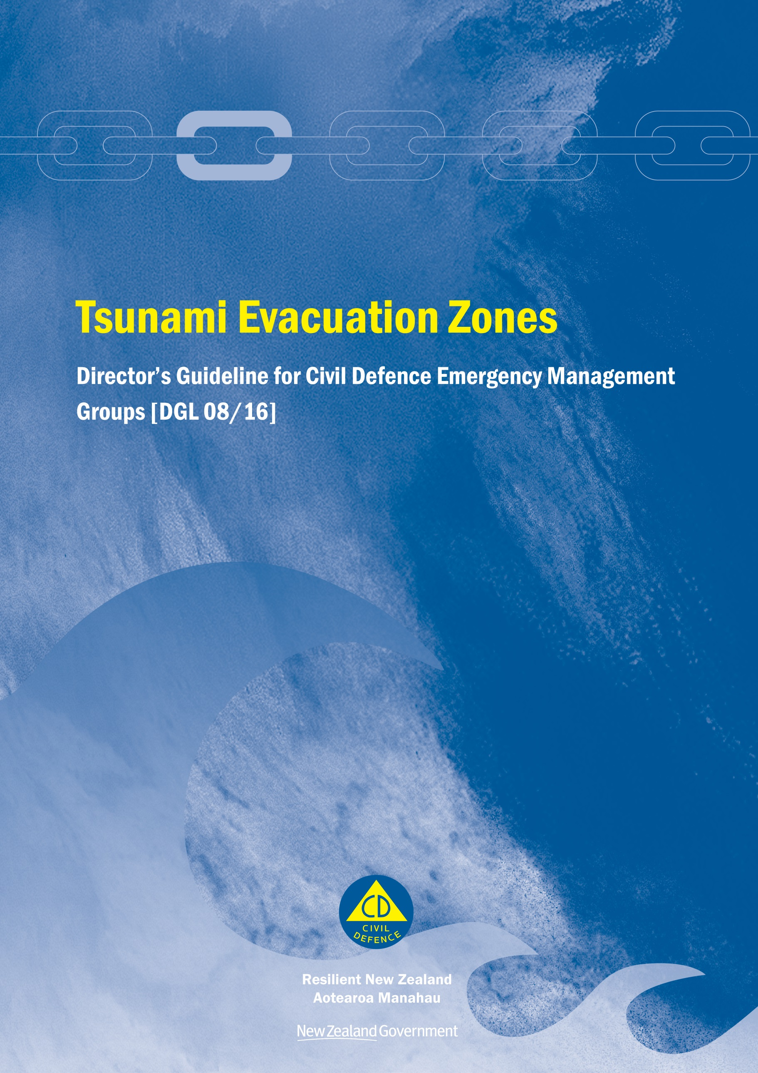
Tsunami Evacuation Zones
Director’s Guideline for Civil Defence Emergency Management Groups [DGL 08/16]

February 2016
ISBN 978-0-478-43515-3
Published by the Ministry of Civil Defence & Emergency Management

Authority
This guideline has been issued by the Director of the Ministry of Civil Defence & Emergency Management pursuant to s9(3) of the Civil Defence Emergency Management (CDEM) Act 2002. It provides assistance to CDEM Groups in their tsunami evacuation planning.

This document is not copyright and may be reproduced with acknowledgement. It is available, along with further information about the Ministry, on the MCDEM website www.civildefence.govt.nz.

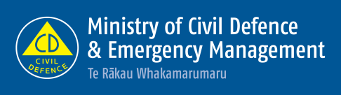
Ministry of Civil Defence & Emergency Management
PO Box 5010
Wellington 6145
New Zealand
Tel: +64 4 817 8555
Fax: +64 4 817 8554

Email: emergency.management@dpmc.govt.nz
Website: www.civildefence.govt.nz

Foreword
The Indian Ocean tsunami of December 26th, 2004 greatly raised awareness of the potential threat tsunami pose to New Zealand. Reports commissioned by the Ministry of Civil Defence & Emergency Management (MCDEM) in 2005 calculated the risk to New Zealand from tsunami as similar to the risk from large earthquakes. Consequently, the science and civil defence emergency management (CDEM) sectors in New Zealand have directed greater effort to improving the understanding of New Zealand’s tsunami hazards and risks, and enhancing tsunami emergency response arrangements. The goal is increased individual and community resilience to tsunami hazards.
The initial Tsunami Evacuation Zones guideline [DGL 08/08] was produced in 2008 following establishment of the National Tsunami Working Group (TWG) in 2007. A series of workshops and regional seminars held in 2008 provided information and advice to assist with development of the guidelines.
Since 2008, ten regions across New Zealand have used the initial guideline to develop evacuation zones and maps. During this time, considerable implementation experience has been gained, and a number of implementation issues have been identified. In addition, significant new work has been completed to update and improve scientific understanding of tsunami hazards and improve tsunami warning systems and procedures.
The 2011 Great East Japan Earthquake and Tsunami in Japan further reinforced the importance of tsunami risk management planning, and a review of tsunami hazard in New Zealand was completed in 2013. In 2014, a workshop was held in Gisborne to identify issues and challenges with regards to evacuation and land use planning, and to develop solutions and recommendations for achieving national consistency. The 2013 review of tsunami risk in New Zealand and the outcomes of the Gisborne workshop have contributed to the development of this guideline.
The objective of this guideline is to support an evidence-based approach to the development of tsunami evacuation zones and maps, which is consistent across New Zealand communities. In this way we can be sure that New Zealanders, no matter where they live or work, can be better prepared.
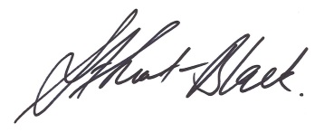
Sarah Stuart-Black
Director of Civil Defence Emergency Management

Contents
Section 1 Introduction 1
1.1 About this guideline 1
1.2 Key terms 3
Section 2 Background 7
2.1 Purpose of evacuation in tsunami risk management 8
Section 3 Tsunami basics 9
3.1 Tsunami generation 9
Section 4 Tsunami evacuation zones 11
4.1 Optimum and recommended number of tsunami evacuation zones 11
4.2 Establishing and defining evacuation zone boundaries 13
4.2.1 Developmental levels for modelling 13
4.2.2 Source data and defining zone boundaries 16
4.2.3 Maritime 18
4.2.4 Probabilistic data 18
4.3 Minimum mapping standard and improving zone boundaries over time 18
4.3.1 Land use planning 19
4.4 Accommodating existing hazard or evacuation zone information 19
4.5 Wave amplitude and sea level 20
4.6 Vertical evacuation 20
Section 5 Triggering evacuations 22
Section 6 Tsunami evacuation maps and education 24
6.1 Public maps 24
6.2 Warning and evacuation information on maps 25
6.2.1 Recommended text for warning and evacuation information 25
6.3 Signage for tsunami information 26
6.4 Community participation in evacuation planning 27
6.5 Education and exercises 28
6.6 Advice for ports, shipping and people in boats 33
6.6.1 Local tsunami 34
6.6.2 Distal tsunami 35
6.6.3 After the tsunami 35
6.6.4 Broadcast during a tsunami 36
Section 7 References 37

Introduction
This section provides an introduction to this guideline and includes definitions for some of the key terms and abbreviations used.

About this guideline
Purpose | The purpose of this guideline is to provide for a nationally consistent approach to developing tsunami evacuation zones, maps, and public information for CDEM Groups and local authorities.
Implementation and relationship to other plans and guidelines | The intention of this guideline is not to be prescriptive regarding the level of risk used as a basis for establishing hazard and/or evacuation zones. Rather it sets a standard approach for developing and displaying evacuation zone information.  This guideline recognises the requirement to balance the complexity and current uncertainty of the tsunami risk environment with the need to provide the community with easily understood emergency information.  This guideline does not provide detailed guidance on mass evacuation planning processes for tsunami. Guidance for mass evacuation planning is provided in the Director’s Guideline on Mass Evacuation Planning: DGL 07/08 (MCDEM 2008). Community response planning process examples are given in the relevant section below.  This guideline is part of a suite of plans and guidance for tsunami warning and response, as shown in Figure 1 on the next page. It represents tsunami-specific guidance for planning at the regional level, and helps to support tsunami warning and response via the National Warning System and the National Tsunami Advisory and Warning Plan: SP01/09 (MCDEM 2014).  This guideline relates specifically to the risks to human life and safety from tsunami hazards, and is consistent with all plans and guidelines shown in Figure 1. The triggering of evacuation during a warning (natural or official) follows the flow diagrams given in the ‘Triggering Evacuation’ section. Risks to property and infrastructure from tsunami hazards are addressed within land use and asset management planning processes.

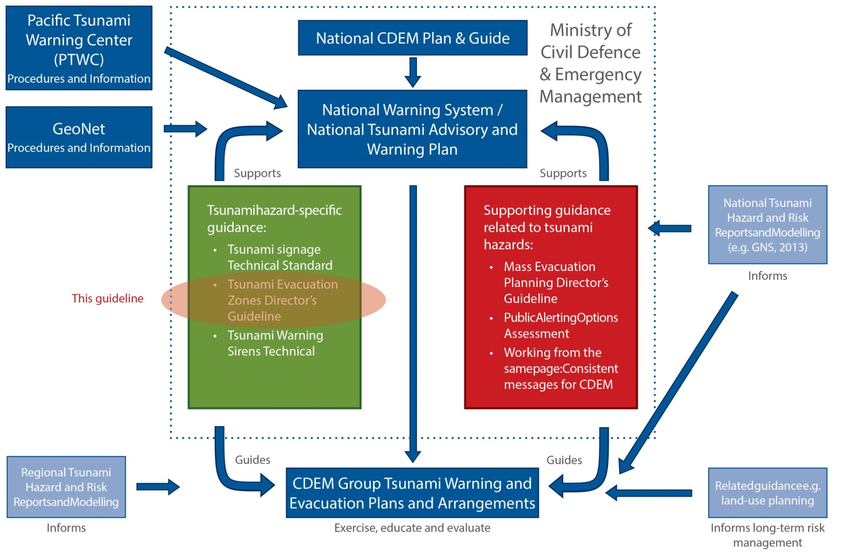
Figure 1 Relationship of this guideline to tsunami warning and evacuation planning in NZ

Key terms
 | This section provides clarification for some of the key terms used in this guideline.
CDEM | In this document, Civil Defence Emergency Management (CDEM) has the same meaning as in the CDEM Act 2002:  - Interpretation…  civil defence emergency management—  - means the application of knowledge, measures, and practices that—  - are necessary or desirable for the safety of the public or property; and  - are designed to guard against, prevent, reduce, or overcome any hazard or harm or loss that may be associated with any emergency; and  - includes, without limitation, the planning, organisation, co-ordination, and implementation of those measures, knowledge, and practices.
 | A full description of CDEM (including a full glossary of terms and abbreviations) is provided in the Guide to the National CDEM Plan, available at www.civildefence.govt.nz by searching the document name.
Emergency | In this document, emergency has the same meaning as in the CDEM Act 2002:  - Interpretation…  emergency means a situation that—  - is the result of any happening, whether natural or otherwise, including, without limitation, any explosion, earthquake, eruption, tsunami, land movement, flood, storm, tornado, cyclone, serious fire, leakage or spillage of any dangerous gas or substance, technological failure, infestation, plague, epidemic, failure of or disruption to an emergency service or a lifeline utility, or actual or imminent attack or warlike act; and  - causes or may cause loss of life or injury or illness or distress or in any way endangers the safety of the public or property in New Zealand or any part of New Zealand; and  - cannot be dealt with by emergency services, or otherwise requires a significant and co-ordinated response under this Act.

The 4Rs | The 4Rs of emergency management are reduction, readiness, response, and recovery.  Reduction means identifying and analysing long-term risks to human life and property from natural or non-natural hazards, taking steps to eliminate these risks if practicable, and, if not, reducing the magnitude of their impact and the likelihood of their occurring.  Readiness means developing operational systems and capabilities before an emergency happens, including self-help and response programmes for the general public, and specific programmes for emergency services, lifeline utilities, and other agencies.  Response means actions taken immediately before, during, or directly after an emergency to save lives and property, and to help communities recover.  Recovery means the coordinated efforts and processes used to bring about the immediate, medium-term, and long-term holistic regeneration of a community following an emergency.
MCDEM | Ministry of Civil Defence & Emergency Management (MCDEM) is the central government agency responsible for providing leadership, strategic guidance, national coordination, and the facilitation and promotion of various key activities across the 4Rs. It is the lead agency at a national level responsible for coordinating the management of the emergencies listed in the National CDEM Plan.  MCDEM may act as a support agency by coordinating the CDEM response to any given emergency managed by another lead agency. MCDEM is responsible for maintaining the National Crisis Management Centre (NCMC), and the National Warning System.
CDEM Group | In this guideline, CDEM Group refers to the collective of local authorities, emergency services, and other agencies that work together to implement CDEM in their area. CDEM Group may also refer to the committee of elected officials that are accountable for CDEM in their area.  CDEM Groups are required under the CDEM Act 2002; every local authority is required to be a member of a CDEM Group.  There are 16 CDEM Groups in New Zealand. Each is responsible for CDEM in its area, including:  - identifying and managing hazards and risks  - providing the organisational structure and resources necessary (including suitably trained personnel) for the effective delivery of CDEM  - undertaking CDEM readiness activities, including raising public awareness about CDEM and preparing a CDEM Group Plan  - coordinating or undertaking CDEM response and recovery activities, and  - providing support and assistance to other CDEM Groups, if required.
Agencies | Agencies are government agencies (including public service departments, non-public service departments, Crown entities, and Offices of Parliament), non-governmental organisations, local government bodies, emergency services, and lifeline utilities.

Tsunami terms
Figure 2 below shows the key terminology related to tsunami.
Figure 2 Tsunami-related terminology used in this guideline

Terms used in local government
Territorial authority | A territorial authority (TA) is a city or district council or unitary authority that provides public services and regulates land use, buildings, public nuisances, and environmental health.
Regional council | A regional council is a region-based council, primarily responsible for natural resource management, including in the coastal marine area. It regulates land use for specific purposes (for example, soil conservation, water quality, and the management of natural hazards). It also regulates for and undertakes pest control and harbour navigation and safety, and provides (in some cases) public transport services.
Unitary authority | A unitary authority is a territorial authority with regional council functions and powers.
Local authority | A local authority is any of the above.

Key CDEM documents
CDEM Act 2002 | The Civil Defence Emergency Management Act 2002 (CDEM Act 2002) provides the legislative framework for CDEM in New Zealand across the 4Rs. It describes the functions and responsibilities of the Director of CDEM, as well as those of government departments, local authorities, emergency services, and lifeline utilities.  The CDEM Act 2002 sets the requirement for CDEM Groups, and defines their statutory functions, duties, and responsibilities. It also provides for local authority delegated representatives, mayors, or the Minister of Civil Defence to declare a state of local emergency (the Minister may also declare a state of national emergency), and defines the powers that CDEM Groups and Controllers may exercise during a state of emergency.  The CDEM Act 2002 requires there to be a National CDEM Strategy and a National CDEM Plan, and enables the Director of CDEM to issue Director’s Guidelines.
Director’s Guidelines | Director’s Guidelines are documents developed by MCDEM, to provide guidance to CDEM Groups and other agencies regarding CDEM. They are issued by the Director of CDEM under the CDEM Act 2002 [s.8(2)(d) & 9(3)].

Background
Tsunami hazards are a threat to life and property for all people that live, work and play near the New Zealand coast. The devastating events in the Indian Ocean in 2004 and Japan in 2011 alerted and reinforced for the New Zealand public the potentially catastrophic impacts of large tsunami waves inundating populated coastal areas.
In 2005, the Ministry of Civil Defence & Emergency Management (MCDEM) commissioned a national tsunami risk and preparedness review. The resulting risk and preparedness reports became the basis of the National Tsunami Risk Management Programme initiated in 2007, which identified four key areas for advancement:
- Knowledge of tsunami hazard risks
- Warning system development
- Planning for response
- Awareness of tsunami risks and what to do.
In March 2007, a National Tsunami Working Group (TWG) was established with representatives from the CDEM sector and GNS Science to help guide the National Tsunami Risk Management Programme. From 2007-2009, the TWG oversaw development of the:
- Tsunami Signage Technical Standard [TS 01/08]
- Tsunami Evacuation Zones Director’s Guideline [DGL 08/08]
- National Tsunami Advisory and Warning Plan [SP 01/09] (revised October 2014).
The March 2011 Great East Japan tsunami reinforced the importance of tsunami risk management, and brought about some key changes in scientific knowledge, including:
- understanding of maximum possible earthquake magnitudes along tectonic plate boundaries
- the impacts of non-uniform tectonic plate movements on tsunami inundation during large earthquakes, and
- the effectiveness of tsunami warning and evacuation practices.
In 2013, a review of the tsunami hazard in New Zealand was completed, including the development of a substantially revised probabilistic hazard model. In 2014, The Director of CDEM issued a Tsunami Warning Sirens Technical Standard [TS03/14] (MCDEM 2014a) to guide the usage of sirens for tsunami warnings.
In October 2014, a workshop was held in Gisborne to identify issues and challenges with using tsunami science to inform evacuation planning and land use planning, and to develop solutions and recommendations for achieving national consistency of usage. Since 2008, the CDEM sector has developed considerable experience with implementation of the former Tsunami Evacuation Zones [DGL 08/08] national guidance, and the issues and challenges with its usage.

Purpose of evacuation in tsunami risk management
The evacuation of a particular area may be necessary when a tsunami threatens the safety of people within the anticipated inundation area. Evacuation becomes necessary when the benefits of leaving the area significantly outweigh the risk of ‘sheltering-in-place’. Evacuation planning is the process of identifying areas potentially at risk from tsunami, and the actions required to ensure the safety of people while evacuating from those areas.
Evacuation planning is therefore a fundamental component of CDEM for tsunami hazards, and this guideline provides a nationally consistent approach to developing tsunami evacuation zones, maps, and public information.
The benefits of a nationally consistent approach to tsunami evacuation planning include enabling:
- A common understanding across New Zealand communities of tsunami evacuation zones, maps, evacuation signage, and tsunami response actions.
- Improved alignment of tsunami evacuation planning with processes for official tsunami warnings.

Tsunami basics
A tsunami is a natural phenomenon consisting of a series of waves generated when a large volume of water in the sea, or in a lake, is rapidly displaced. Tsunami are known for their capacity to inundate coastlines, causing property damage, injuries, and loss of life. The principal sources of tsunami are:
- large submarine or coastal earthquakes, in which significant uplift or subsidence of the seafloor, lakebed or coast occurs (this is the main source of tsunami and the basis of the evacuation zones defined within this guideline)
- underwater landslides, which may be triggered by an earthquake, or volcanic activity
- large landslides from coastal or lakeside cliffs
- volcanic eruptions, such as underwater explosions or caldera collapse, pyroclastic flows and atmospheric pressure waves, and
- meteor (bolide) splash-down, or an atmospheric air-burst over the ocean.

Tsunami generation
For tsunami waves, the whole water column from the sea or lake floor to its surface is affected, and tsunami waves can have periods of up to tens of minutes. This is in contrast to ordinary coastal (wind) waves which only disturb the surface of the water, and usually have periods of seconds to tens of seconds (Figure 3).
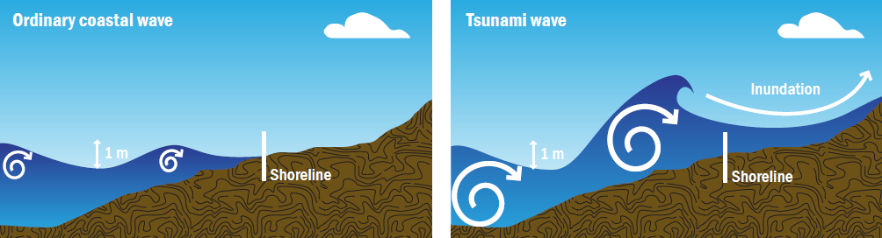
Figure 3 The difference between an ordinary coastal (wind) wave (left) and a tsunami wave (right)

Run-up height | When a tsunami wave runs onto land, the run-up height above sea level it reaches can be up to double the at-shore amplitude, because the long wave length of a tsunami wave pushes water up hill (Figure 4). The largest run-ups typically occur where there are narrow valleys on a steep slope, leading to funnelling of the tsunami wave into a small area.
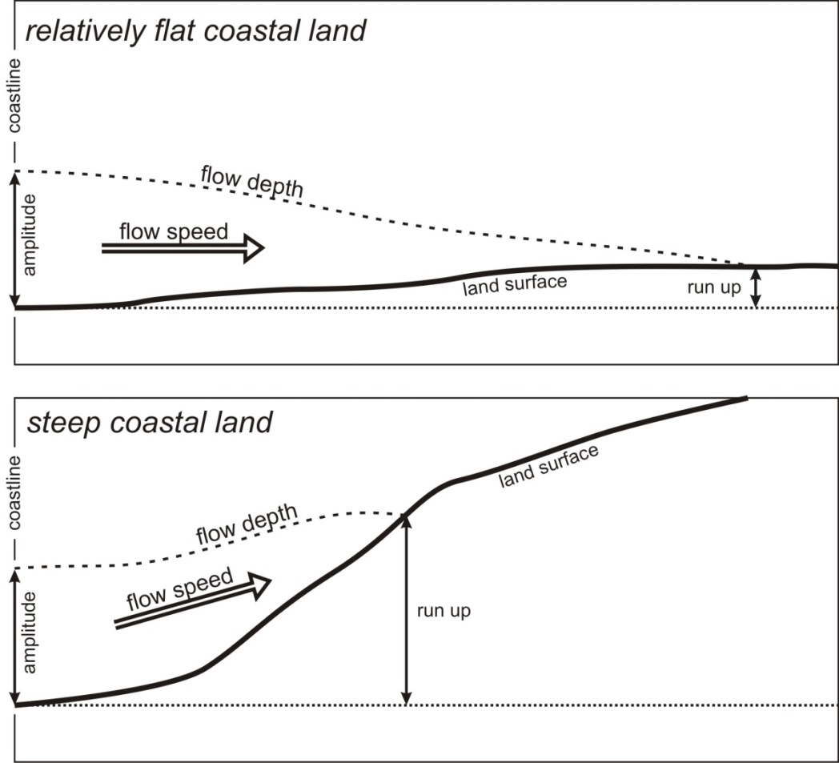
Figure 4 The difference in run-up height and inundation distance on relatively flat coast land versus steep coastal land, for a tsunami of the same wave amplitude at the coast

Tsunami evacuation zones
This section provides a description of key considerations for tsunami evacuation planning.
These include the number of evacuation zones used for evacuation planning, establishing, defining and mapping the zones and the ways in which tsunami risk information is communicated to the public.
Maps of evacuation zones and routes are critical for communicating tsunami risk and emergency response information to the public, and for providing a common platform for evacuation planning. To ensure the effectiveness of both evacuation planning and its implementation during emergency response, a balance is required in this information between oversimplification and excessive detail.

Optimum and recommended number of tsunami evacuation zones
This Guideline adopts a three zone (Red, Orange and Yellow) approach for tsunami evacuation planning. The characteristics of each of the three zones are given below. All zones should be defined on top of high tide.
Use of a single tsunami evacuation zone could have offered some advantages for simplicity in evacuation planning, and for public awareness and understanding. However, because a single zone would have to accommodate for a full range of tsunami risk scenarios, it can result in frequent ‘over-evacuation’ of a larger area than is necessary for more likely, smaller scale events. As well as having extra people to manage during the evacuation, it creates more inconvenience for the public. As such, repeated ‘over-evacuation’ could result in decreasing levels of community trust in, and compliance with, emergency response arrangements. Nevertheless there will be situations when combining two zones into one are justified (see Recommended use of Zones at the end of this sub-section).
At the other extreme, using more than three evacuation zones could more accurately reflect a full range of tsunami risk scenarios. However, such differentiation requires far greater resources to map, and levels of coordination in planning and managing responses for each threat or event. This greater complexity also creates more scope for public misunderstanding about what they need to know and do in each instance.

Red Zone description | The Red Zone is intended as a marine and beach exclusion zone (including harbours, rivers and estuaries) that can be designated off limits in the event of any expected tsunami. This represents the highest risk zone and is the first place people should evacuate from in all types of tsunami warnings (i.e. natural or official). People could expect ‘activation’ of this zone several times during their life. Definition of the Red Zone depends on the quality of elevation data available (see ‘Defining the Red Zone’ below). People should be advised to stay out of the Red Zone and be vigilant and take care in low lying coastal areas.
Orange Zone description | The Orange Zone is intended to be the area evacuated in most if not all distant and regional-source official warnings (i.e. warnings that extend beyond the Red Zone, for tsunami from sources more than one hour of travel time away from the mapped location). The intent is to provide for a middle-zone to avoid over-evacuation in most official warnings; however larger regional/distant-source events may occur in which case the Yellow Zone will apply.  Local differentiation of this zone can be achieved using terms that are familiar to the community such as street names and key landmarks.  The Orange Zone can be defined using modelling Levels 2, 3 or 4 (see ‘Defining Evacuation Zone Boundaries’ below). When using three zones this zone should be rounded up to the nearest threat level boundary. This will avoid ambiguity when deciding between whether an evacuation of either the Orange or Yellow zones is needed in response to a National Tsunami Warning message.  The Orange Zone will be obsolete in areas where the Yellow Zone includes the maximum credible regional and distant-source tsunami.
Yellow Zone description | The Yellow Zone should cover all maximum credible tsunami events including the highest impact events (see ‘Defining Evacuation Zone Boundaries’ below). No rounding of the Yellow Zone up to a threat level boundary is needed. The intention is that the Yellow Zone provides for local-source maximum credible events, based on locally determined risk. People should evacuate this zone in natural or informal warnings from a local source event, and when instructed via formal warnings.  The Yellow Zone can be defined using modelling Levels 2, 3 or 4 (see ‘Defining Evacuation Zone Boundaries’ below).
Recommended use of zones | For each part of a CDEM Group’s coastline the use of either two or all three of the Red, Orange and Yellow evacuation zones is recommended for nationally consistent tsunami evacuation planning.  If only two zones are used (e.g. when steep coastal land means the Orange or Yellow zone becomes too narrow to effectively map and apply; or for simplicity within a lightly populated area), either the Red Zone should be extended inland to incorporate the Orange Zone, or the Orange Zone should be extended inland to incorporate the Yellow Zone.
The Yellow Zone should never be extended seawards to replace the Orange Zone, because a higher risk zone should not be incorporated into a lower risk zone.
This recommended approach also recognises that those parts of the coastline with sufficiently high coastal cliffs need only require a single Red Zone for practical purposes.
The recommended standard for displaying zones on evacuation maps and other colour publications is to use the relevant colours of Red, Orange, and Yellow. The use of words for these colours is also recommended to ensure clarity on greyscale reproductions.

Establishing and defining evacuation zone boundaries
 | While the risk criteria for each zone are described above in general terms, this guideline does not prescribe the methodology by which the tsunami risk is assessed at a regional or local level. The elevations used to establish tsunami evacuation zone boundaries are developed at a local level, based on location-specific hazard analysis and risk assessment.
This section provides: | Detail on the criteria for defining evacuation zones, and how existing local hazard information may be incorporated or aligned to fit the recommendations in this guideline  Illustration and explanation of the four levels of technical development for establishing evacuation zone boundaries. The recommended minimum standard is development Level 2.

Developmental levels for modelling
Evacuation zone boundaries can be determined using a variety of techniques. Zones ideally need to represent an envelope around all possible areas subject to inundation from all known tsunami sources, taking into account all of the ways each of those sources may generate a tsunami wave. The high degree of uncertainty in tsunami source models, and the very time consuming and resource intensive nature of modelling make this comprehensive approach to tsunami risk assessment unlikely in the short term.
The recommended approach to developing tsunami evacuation zones is to map now, and progressively refine the accuracy of boundaries as the science improves over time.
Four developmental levels (1-4) are recognised for establishing tsunami evacuation zone boundaries. These apply to the Orange and Yellow Zones and can be used for the Red Zone if sufficient elevation data is available (see ‘Defining the Red Zone below’).
Level 1 | Level 1 is based on a simple ‘bathtub’ model where inundation is determined based on maximum wave amplitudes (Figure 5), projected inland from the coast to some cut-off elevation. This approach provides the crudest and simplest method of mapping evacuation zones.  This method is not recommended for use in New Zealand because it does not allow for any drop off in tsunami inundation inland.  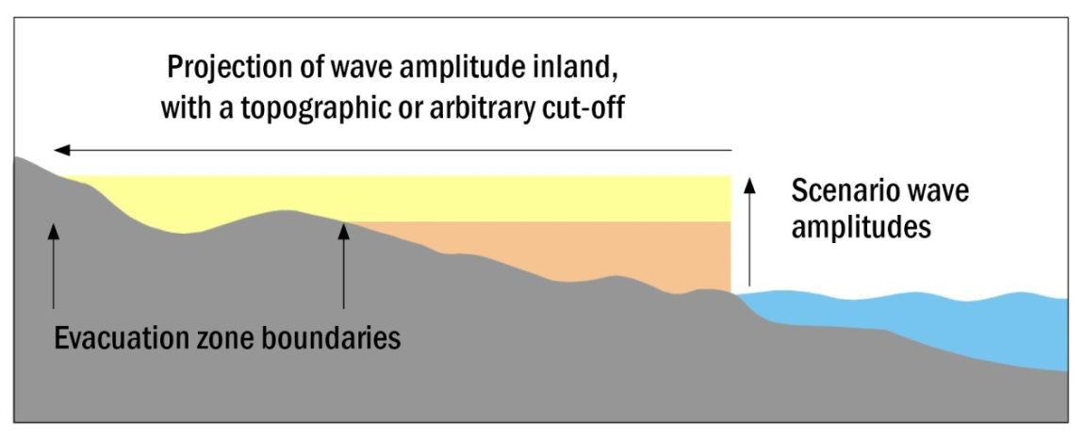  Figure 5 Cross section showing how evacuation zone boundaries can be mapped using a projection of wave amplitudes inland, based on a simple ‘bathtub’ model
Level 2 | Level 2 uses a measure of rule-based attenuation of the potential run-up height that depends on the distance inland from the coast (Figure 6 on the next page). It is an empirical approach. GNS Science has developed a GIS-based approach to applying this method, using a Python/ArcGIS tool that computes the indicative evacuation zone based on maximum potential tsunami run-up.  This approach derives a more realistic output than a simple ‘bathtub’ model, but still provides a rough estimation which does not account for physical variations in wave behaviour. In the form applied in New Zealand it is however generally conservative (i.e. erring towards overestimation of inundation extent). This conservatism helps the zones to cover a broad range of potential scenarios. Local knowledge must also be applied to support the process.  Level 2 is the recommended approach if LiDAR-grade (i.e. better than 1m vertical accuracy) elevation data, and a similar grade of bathymetry data (e.g. from a port-specific navigational chart), are not available; in part because of the conservative nature of the approach, and in part because hydrodynamic models (used in Levels 3 and 4) are more error sensitive when run over low accuracy data.  Level 2 is generally regarded as an ‘interim’ approach because of its conservatism, particularly when used in areas of high population density. See Leonard et al (2009) and Fraser & Power (2013) for specifics of the Level 2 approach as applied in New Zealand. Fraser and Power also includes a validation exercise based on data from the 2011 Great East Japan tsunami.
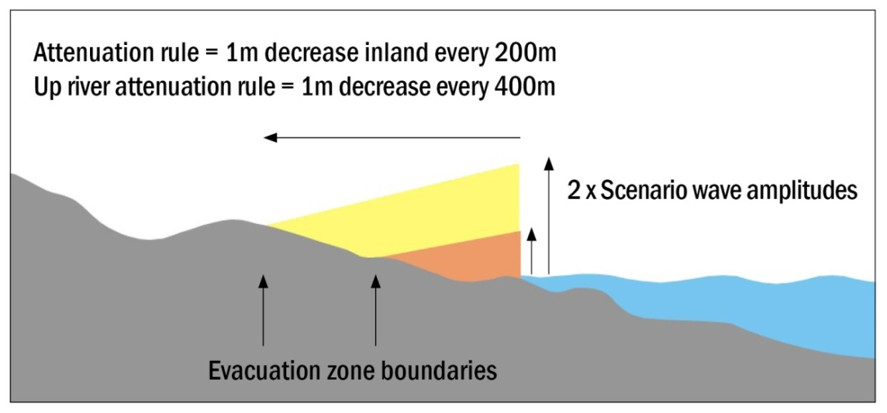
Figure 6 Cross-section at the coast showing how evacuation zone boundaries are determined
 | Evacuation zone boundaries are determined using an attenuation rule (development Level 2), in which elevation decreases from a maximum potential run-up height at the coast, taken to be twice the shoreline wave amplitude⁴ above high tide, and is attenuated inland according to a specified slope angle
Level 3 | Level 3 uses a physics-based computer simulation of the process by which water inundates across land, which theoretically allows for complexities that a simpler ‘rule’ cannot, such as changes in the direction of water flow under the influence of the shape of the land and variations in surface roughness from different land uses. Such modelling is expensive, and the quality of outputs is dependent on the science behind the model and the quality of the elevation or bathymetry data used. The wave hitting the coast may be either:  - Based on an incoming wave of particular amplitude (this is the less-preferred Level 3 approach), or  - Based on multiple scenarios ‘de-aggregated’ from an appropriate probabilistic model and modelled from source (this is the preferred Level 3 approach).
Level 4 | Level 4 is the most comprehensive approach, based on drawing an envelope around all inundations from many well-tested hydrodynamic computer models run from source through to inundation. The number of models must be enough to cover the full range of scenarios that can be expected from all sources. Development to this level of sophistication requires a comprehensive scientific understanding of all possible tsunami sources (distant, regional and local), wave propagation and inundation behaviours, across a range of magnitudes.

Source data and defining zone boundaries
Yellow Zone | Should be defined in such a way that it encompasses the area expected to be inundated by the 2500 year tsunami at the 84% confidence level. This timeframe includes large subduction interface earthquakes, including events comparable to the earthquake that caused the 2011 Great East Japan tsunami, in those areas where they are considered possible. It is not an absolute ‘worst case’, as this is not well defined. It is a compromise between the very low probability of even larger events and the issues and risks involved in a mass-evacuation in the aftermath of strong earthquake shaking.  The 84% confidence level can be expressed in words as ‘erring on the side of caution’ with respect to unknown or uncertain factors. It is similar to using the upper bound of an error bar. Note that this represents a recommended minimum: it is recommended that the following are also considered and may result in a decision to extend the zone:  - The possibility of larger local-source tsunami that occur at longer return periods than 2500 years  - The extent of inundation found in nearby paleo-tsunami deposits of high validity.  If considering extending the zone for either of these reasons it is important to strike a balance between the increases in safety that may come from covering very rare events and the issues and risks inherent in conducting mass-evacuations in the aftermath of strong earthquake shaking.  The Yellow Zone can be extended inland to avoid crossing through buildings or properties, and allow clarity of the boundary location on the ground. This is especially important to consider for institutions and facilities that are likely to have large numbers of, or highly vulnerable people, such as schools and rest-homes. It should never be reduced in area, and its outer extent moved closer to the coast line, in order to achieve this purpose.
Orange Zone | Intended to be used for official warnings of distant or regional source tsunami. It should be linked to a particular threat level, and encompass the range of tsunami that can result in a warning being issued at that threat-level. It is generally anticipated that the choice of threat level should at least encompass the largest tsunami with travel time >1 hour that is to be expected on a 500 year time frame; though this is not a rigid requirement on the basis that the Yellow Zone will also be evacuated if a warning of a tsunami belonging to a higher threat level is made.  It is very important that CDEM authorities know which threat level their area is designed for, so that they can also evacuate the Yellow Zone in the (should be very rare) event of a larger regional or distant tsunami. For this purpose it is best to minimise the number of variations in which threat level the Orange Zone is defined for.

 | As for the Yellow Zone, the Orange Zone can be extended inland to avoid crossing through buildings or properties, and allow clarity of the boundary location on the ground. Again this is especially important to consider for sites that have large numbers of, or highly vulnerable, people associated with them. The zone should never be reduced in area, and its outer extent moved closer to the coast line, in order to achieve this purpose.
Red Zone | Intended as a marine and beach exclusion zone (including harbours, rivers and estuaries) that can be designated off limits in the event of any expected tsunami that is above the minimum warning threshold (currently 20cm amplitude) up to 1m amplitude, above which the Orange, and if appropriate the Yellow Zones, will also be evacuated. People should be advised to stay out of the Red Zone and be vigilant and take care in low lying coastal areas.  Defining the Red Zone depends upon the elevation data available, which is normally either high resolution such as LiDAR data, or low resolution such as the LINZ topographic data. Calculation of the Red Zone from hydrodynamic models is very difficult because of the great variety of potential sources of tsunami in the 0.2-1m range, which may behave in a variety of ways on reaching land.  In high resolution areas (e.g. LiDAR) as a default: ideally use the 2m above high tide contour (MHWS) level, extended to make sure it covers the beach and rocky foreshore in any instances that the 2m elevation doesn't. Discuss any situations where the resulting zone appears unduly large with the TWG before implementation.  In low resolution areas (e.g. LINZ topographic data): the beach and foreshore is generally expected to be approximately 2m above the high tide contour level. The beach and rocky foreshore area should simply be designated as the Red Zone, with assistance from local experts (including CDEM authorities) on where the zone might extend further inland to cover wider areas that are considered to lie less than 2m above high tide level. In addition:  - The 1:50,000 scale beach, rocks, sand, mud, lagoon, swamp, mangroves, and/or estuary polygons can be used to define the Red Zone  - Tidal parts of rivers and estuaries should also be the Red Zone, along with the above same polygon classes where they border rivers and estuaries  - Local knowledge may be used to buffer areas alongside rivers where these are estimated to be less than 2m above high tide level  - In the absence of local information a buffer of the tidal part of rivers can be used that extends 100m perpendicular to the river at the coast, tapers to 50m wide at 400m inland, and to no buffer at 800m inland.  In all cases the Red Zone should be visible along the entire coast at the map's scale, so it should be enlarged to create a decent visual Red line along any coast where it is otherwise visually too thin to be clear.

Maritime
Recommended template advice for ports, shipping and people in boats is provided in section 6.6 Advice for ports, shipping and people in boats on page 33.

Probabilistic data
It is recommended that probabilistic data such as the 2500 year 84% confidence shoreline wave amplitudes, recommended for the Level 2 approach, should be taken from the New Zealand Probabilistic Tsunami Hazard Model (NZPTHM). The current version of the NZPTHM is described in Power (2013), and outputs are available from the GNS Science website: http://www.gns.cri.nz/, under ‘Our-Science/Natural-Hazards/Tsunami’.
The NZPTHM will update over time.
It is also recommended that scenarios for the Level 3b approach are taken from the de-aggregation data provided by the NZPTHM. The NZPTHM uses the concept of an ‘effective magnitude’ to incorporate the effects of random variations (for instance in the distribution of fault movement) between earthquakes and other sources of uncertainty. Variations in the extent of inundation caused by variations among the properties of earthquakes of one magnitude can in this way be encompassed by modelling a uniform-slip earthquake of a larger magnitude. In this way the use of scenarios from the NZPTHM avoids the necessity to run a very large number of scenarios to cover off the full spectrum of possible events. One consequence of this is that it may sometimes be necessary to run models with an ‘effective magnitude’ that is larger than the largest ‘actual magnitude’ a fault is believed to be capable of.
Level 3 and 4 methods for calculating the Orange Zone are in development. The essential requirement is to model a set of scenarios that will encompass the inundation that could be caused by all tsunami that fit within the specified threat level.

Minimum mapping standard and improving zone boundaries over time
As the understanding of tsunami hazard and risk improves, local authorities and CDEM Groups should be looking to advance the level of technical sophistication used in developing tsunami hazard and evacuation zones. Unless higher stage assessments are undertaken, a conservative approach is recommended in defining the placement of evacuation zone boundaries. The recommended minimum development standard for defining tsunami evacuation zone boundaries is the application of a model consistent with developmental Level 2 (rule-based approximation).

An initial step to use for small coastal communities, when faced with limited resources for hazard mapping, would be to agree that the entire settlement is within a Yellow Zone until a Level 2 or higher stage assessment can be undertaken.
Even though tsunami evacuation zone boundaries may change in the future, the components, colours, and style of the maps will not need to change. This is important for sustaining community awareness and inter-generational tsunami readiness.

Land use planning
The New Zealand Coastal Policy Statement (DoC 2010) sets out national policy under the Resource Management Act 1991 (RMA) for managing areas potentially affected by coastal hazards (see Policies 24-27). This policy includes the potential effects of tsunami, and how to avoid or mitigate them. Other than evacuation planning, measures could include requirements for subdivision, development and land-use.
If proposing to use Level 2 modelling for establishing measures beyond that of evacuation planning, it is important to acknowledge that there are large uncertainties involved and that this level is typically conservative. As such, the location of a site in relation to Level 2 evacuation zoning could be used to highlight it’s potential for tsunami risk. This may trigger a need for further high resolution assessments for that site in context to a development or land-use proposal.
Level 2 modelling is generally appropriate for inclusion in a Land Information Memorandum (LIM) in terms of making the owners, occupiers and other interested parties aware that the property is within a tsunami evacuation zone.
Levels 3 and 4 tsunami risk modelling will better inform risk-based RMA planning measures to avoid or mitigate tsunami risk. They could also be used in pre-event recovery planning, such as establishing options for set-back, retreat or re-design.

Accommodating existing hazard or evacuation zone information
The specific method used to define hazard zone boundaries and the level of risk being managed is up to local authorities to decide for themselves, in close consultation with their communities.
Many local authorities or CDEM Groups have gone to some considerable effort to define and map tsunami (and storm surge) hazard areas, based on recognised research and modelling. The guidance provided in this document is expected to accommodate any existing tsunami hazard maps and to support the communication of evacuation information in a consistent manner nationally.
The recommendations presented here aim to be, wherever possible, compatible with the content and methodology of any existing hazard zones.
In some cases, existing zones will be aiming to cover the maximum credible event tsunami, in which case these would be drawn under the guidelines as the Yellow Zone. In other cases, existing zones will be aiming to only cover distant-source tsunami. If only one or the other currently exists, it is recommended that the complementary zone is included and a Red Zone (the marine and beach exclusion zone) added.

Change over time | Factors unique to an area that may impact on planning arrangements must also be carefully identified and taken into account. Consideration should be given to how the natural, built, social, and economic components of a community might be expected to change over the medium to long term. Examples include the potential for sea level rise and increased storm activity through climate change, or increases in the number of elderly people living within a coastal area.

Wave amplitude and sea level
The term ‘wave amplitude’ is used here rather than ‘wave height’, as in some disciplines ‘wave height’ is measured from ‘peak to trough’ instead of ‘zero to peak’. In this guideline, ‘wave amplitude’ is the rise in water level relative to the background level (‘zero to peak’).
The wave amplitude used to define evacuation zones must be the wave amplitude at shore, offshore.
Run-up could be twice as high as the wave amplitude on steep, low-friction slopes near the coast, and we cannot be sure what tide state the largest amplitudes will arrive on
Thus, evacuation zones should be based on an elevation at the coast, which is twice the predicted offshore wave amplitude, above Mean High Water Spring (MHWS).

Vertical evacuation
Vertical evacuation options defined as evacuation to upper floors or the roof of mid to high rise buildings or purpose-built structures (e.g. platforms, towers or protected raised land, within the evacuation zone), should be considered where the distance to high ground is large enough to preclude effective evacuation before tsunami wave arrival. Options must be considered on a local basis, and supported by more detailed evacuation travel-time modelling. Where implemented, vertical evacuation structures should be indicated on tsunami evacuation maps and supported with signage on the structure and the designated evacuation routes to the structure.
A large number of multi-storey, reinforced-concrete, vertical evacuation buildings provided safe refuge to thousands of people during and immediately after the 2011 Great East Japan tsunami (Fraser et al., 2012). However, vertical evacuation structures should be a secondary option to seeking refuge outside of the evacuation zone (i.e. high ground or inland areas). The designation of a safe storey height should be based on the maximum tsunami depth plus a factor of safety. There still remains a risk of isolation in floodwater and debris for hours (and days) after an event, and there is also the added risk of fire to vertical evacuation buildings due to floating debris.
A building used for evacuation purposes must be built to withstand a local subduction zone earthquake and retain sufficient capacity to act as a safe refuge during a tsunami. Therefore, any proposed building should be designed according to, or assessed against, guidelines for tsunami-resistant construction.
There are currently two non-mandatory tsunami design guidelines available internationally. The most recently updated guidelines available are the United States Federal Emergency Management Agency (FEMA) P646 Guidelines for Design of Structures for Vertical Evacuation from Tsunamis, updated in 2012 with observations from Japan (FEMA, 2012) – originally published in 2008 (FEMA 2008, 2009). Structural damage data from the 2011 Great East Japan tsunami are being used by the American Society of Civil Engineers (ASCE) Tsunami Loads and Effects Subcommittee to generate new tsunami loading guidelines for structures, which would be included in the ASCE 7 codes in 2016 and implemented in the International Building Code (IBC) in 2018 or 2021. The guidelines will present both a simple method and a site-specific method to calculate tsunami flow depth and velocity at a site. Structural measures to reduce loads will be presented, as will be prescriptive foundation designs to resist scour.
A review of the Japanese Government Guideline for Tsunami Evacuation Buildings (Cabinet Office Government of Japan, 2005) is also underway, based on data from the 2011 tsunami.
These guidelines consider multiple effects of tsunami wave forces on structures. Formulae and example calculations are provided to demonstrate the use of the guidelines in relation to tsunami flow depth and flow velocity. The guidelines provide attributes of tsunami-resistant structures and structural components, including:
- strong systems with reserve capacity to resist extreme forces
- open systems to allow water to flow through the ground floor to resist forces without failure
- redundancy to allow partial failure without progressive collapse
- circular columns designed to reduce and withstand lateral wave loads
- plan the orientation of shear walls to minimise load, and
- floor systems designed to reduce buoyant forces.

Triggering evacuations
 | This section provides information for triggering evacuations based on tsunami warnings.
Warning types | Evacuations are triggered by two main types of warning:  - Natural – in which case all zones are evacuated (see ‘Education and Exercises’ in the following section)  - Official – in which case local warnings will state the zone(s) to be evacuated.  Official evacuations of the general public are authorised by local authorities. They base their decision to evacuate communities on a National Tsunami Warning or Potential Threat National Advisory issued by the Ministry of Civil Defence & Emergency Management (MCDEM) in conjunction with their own local threat assessment, plans and standard operating procedures (SOPs).  The process and responsibilities for tsunami warnings are described in the National Tsunami Advisory and Warning Plan [SP01/09] (MCDEM, 20014).  The National Tsunami Warning and Advisory Plan provides for the following New Zealand threat levels.
Threat levels | 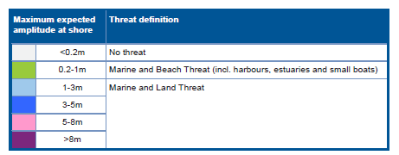  It is critical that the size of the Orange Zone matches a threat level (double the threat level above high tide at coast) exactly. The Red Zone should be set to match the <1m threat level (2m zone height above high tide at coast) when drawn based on LiDAR. This allows for certainty for CDEM Group members deciding which zone(s) need to be evacuated based on the threat level in the warning.
Flow diagrams | Figure 7 and Figure 8 on the next page give flow diagrams of Kermadec regional-source warnings which would trigger evacuation. This is probably the closest case that any official warning can be reliably expected in the foreseeable future. The official warning case here (within 1 hr) would apply to (for example) Auckland in this Kermadec regional-source case, and depends on effective public alerting.  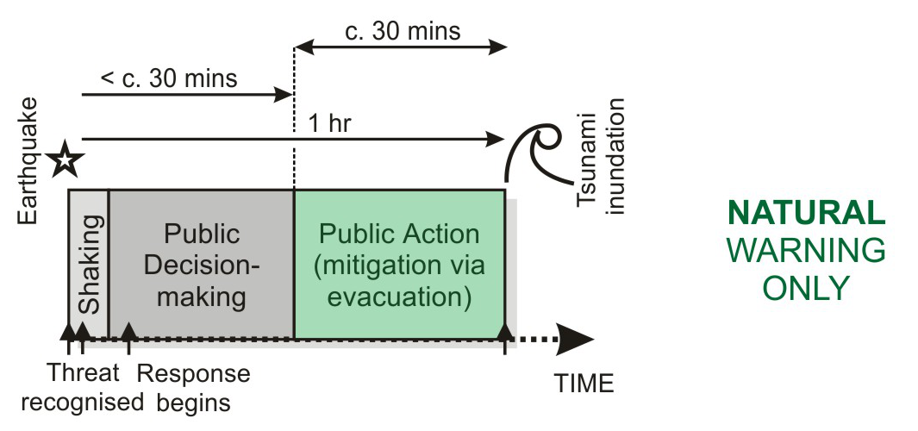  Figure 7 Natural warning only. In the case of natural warning the shaking must trigger evacuation of all zones without delay (e.g. the East Coast around Hawkes Bay) – the education must be recalled accurately without a need to seek further information.
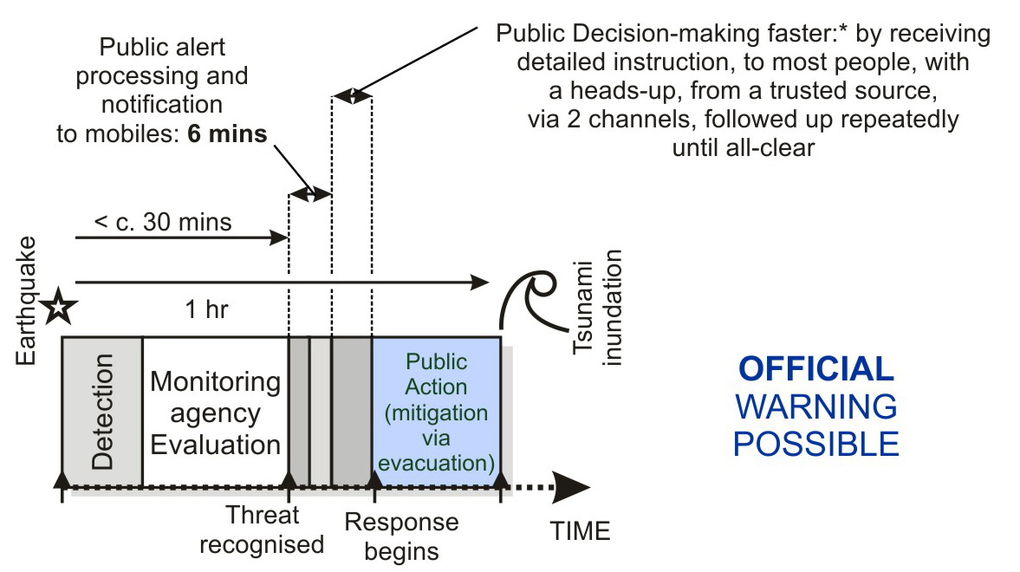
Figure 8 Official warning possible. In the case of official warning the PTWC detection triggers MCDEM and CDEM Group public alerting processes and notifications (implementation of the national plans), and GNS Science GeoNet monitoring agency evaluation, including any engagement of the tsunami experts panel. The public action is to evacuate the zone(s) stated in the warning

Public alerting of areas to evacuate | Warning agencies need to be able to clarify for the public those areas requiring to be evacuated in an official warning. Also to note is that there may be insufficient time or internet server capacity for everyone to check evacuation zones on official websites. Mobile device apps are expected to assist agencies in this role.

Tsunami evacuation maps and education
This section provides information on engaging with communities and providing information on tsunami warnings and evacuation procedures.

Public maps
In addition to the number and appearance of evacuation zones on maps, the basic legend, instruction messages and supporting information on maps should be nationally consistent.
To ensure common understanding across New Zealand communities, maps should use the same or closely similar colours, the same names for evacuation zones, and common symbols. Any and all zones that the public are expected to evacuate from should be shown on the public maps.
Two examples are provided in Figure 9 on page 31 and Figure 10 on page 32, showing possible appearances of maps using the three colour-coded tsunami evacuation zones. For additional clarity and to assist distinction of zones in photocopied or greyscale reproductions, the evacuation zones should also be labelled.
An ArcMap® template for producing standard maps is available from the GNS Science Regional Geology Department GIS team.

Map scale | Maps should be produced to a scale appropriate to the area shown. Note that scale can give a false impression of accuracy if not carefully managed. For zones developed using 20m contour data, and maps using 1:50,000 topographic data, it may be necessary to refine the zone boundaries with detailed local information if enlarging beyond 1:25,000.  For high density urban areas it is recommended that higher resolution elevation data are used (e.g. LiDAR), and additional information sources are included on maps to improve recognition and readability; for example, elements from council cadastral maps showing named streets, or aerial photo imagery that clearly identifies well known geographical features.  Features that are added should be appropriate for the map scale and population density. For example, in urban areas detailed street maps might be required with careful consideration given to expanding zone boundary locations, as needed to accommodate street layout and the location of key facilities such as schools or hospitals.

Legend text | It is recommended that, as a minimum, all of the following should be included on maps and shown in the legend:  - Red Zone  - Orange Zone  - Yellow Zone  - Tsunami Safe Area or locations  - key buildings/urban areas  - roads  - rivers, and  - evacuation routes.  Local customisation of maps is encouraged to ensure information relevant to a community is included, for example, the location of special areas of interest such as marae, or local knowledge such as the safety of a particular pathway or route.

Warning and evacuation information on maps
Principles behind evacuation messages | In ‘natural’ or ‘informal’ warnings, people are expected to evacuate all zones. In ‘official’ warnings from local CDEM Groups, people are expected to evacuate the zone(s) stated in the warning message. Evacuation should be on foot (or bicycle) wherever possible.  Community engagement and public education are essential for improving the understanding of what to look for and what to do during a tsunami. Ideally, communities should plan their own evacuation routes (with assistance from local CDEM Groups), and exercise plans on a regular basis.

Recommended text for warning and evacuation information
The most important message that the eye is drawn to first on every map is: “In a long OR strong earthquake evacuate all zones.”
All other messages are a secondary priority and must not distract from this. The following text is recommended for inclusion on maps as fourth-order priority messages under the following headings.

Natural warnings | In the case of either:  - A large earthquake (one it is hard to stand up in), unusual noises from the ocean, or  - Changes in the ocean (e.g. the ocean rushing in or out), or  - Feeling a weak earthquake that lasts for a minute or more:  Evacuate ALL zones. A wave may arrive within minutes or take more than an hour to arrive. Wait for the official “all clear” or advice from local CDEM Groups.
Official warnings | Official warnings are received from local CDEM Groups. These warnings may come to you via New Zealand TV/radio broadcasts or the emergency services (i.e. police, fire or ambulance). You may receive warnings from one or several sources.  Evacuate from the zone(s) stated in the warning message. Wait for the official “all clear” or advice from local CDEM Groups.
Informal warnings | Warnings from friends, other members of the public or international media may be correct. If you feel the threat is imminent, quickly get to high ground. Consider evacuating from all zones. Verify the warning only once evacuated, or if you can do so, quickly via radio, television, internet, or through your local CDEM Group.
Tsunami evacuation | Evacuate via the routes drawn on this map.  Follow signed routes where present.  Walk quickly if possible, drive only if essential. If driving, keep going once you are well outside all evacuation zones to allow room for others behind you.  The first waves may not be the largest.  There may be multiple waves separated by up to an hour, or more. Large waves may come after a series of smaller waves. The largest waves from distant sources may take many hours to arrive.  Stay OUT of evacuation zones until given the official all clear from your local CDEM Group.  Stay away from the Red Zone and be vigilant and take care in low lying coastal areas. Stay out for at least 24 hours after any tsunami warning – even small waves can create dangerous currents.  Local customisation – Information on specific local response arrangements should be explained, for example, that public alerts may be through siren, telephone, loud hailer or other arrangements.

Signage for tsunami information
Signage is an integral part of tsunami risk management. Signage depicting evacuation zones and routes raises public awareness of tsunami risk, and provides information to increase the efficiency and effectiveness of an evacuation. Well placed evacuation signage is the critical link between the emergency response plan and an actual event.
The next page summarises guidance on types and placement of tsunami signage contained within the National Tsunami Signage Technical Standard (MCDEM 2008a).

- ‘Evacuation Zone’ signs are designed to be placed within the evacuation zones, especially at the coast – to clearly indicate that this place is within the evacuation zone.
- ‘Information Boards’ are intended to house evacuation maps and supporting information. It is critical that Message Priorities (see above) are clearly laid out and prioritised in terms of visual impact and recognition on information boards and maps.
- ‘Evacuation Route’ signs are designed to delineate the route from within the zone to beyond the boundary of the evacuation zone. These signs would be placed on evacuation zone maps after the evacuation routes have been drawn and exercised. For routes where driving may be used for evacuation, these signs must continue for some distance into the safe area to avoid people stopping early and blocking cars behind within the evacuation zone.
- ‘Safe Location’ signs must be within safe areas, and are recommended primarily for walking or cycling evacuation routes because of the potential for drivers to stop at them and block those behind. If used for routes where driving is possible, signs must be a substantial distance within safe areas.
- ‘Previous event’ signs, if used, should be for maximum events only, and would be expected by their nature to lie within but near the boundary of the Yellow Zone.
Maps depicting tsunami evacuation zones, escape routes and tsunami safe areas need to be available as required by the community. It is recommended that maps are available for display in homes, holiday homes, tourist facilities, workplaces and public buildings in areas subject to tsunami risk.
High-use coastal areas should prominently display evacuation maps as part of tsunami information boards. Maps should be prepared and delivered in conjunction with planned tsunami signage placement, which depict evacuation zones and routes on the ground.

Community participation in evacuation planning
Part of the vision for a ‘Resilient New Zealand’ is that individuals and communities understand and manage their own hazard risks. It is recommended that arrangements to support this are best developed at the local level. Community groups have local knowledge, established relationships and resources for assisting their own communities.
Generally it is best when communities are engaged early and often, with opportunities provided for leading plan development. This process may build upon existing community networks and group structures where already established.
Careful consideration needs to be given to the range of unique stakeholders that may exist, such as transient beach users, holiday home owners, permanent residents, businesses, and recreational boaters.
The development of tsunami evacuation plans and maps might be undertaken as a specific emergency planning initiative, or could be approached as one component of a wider programme of community response planning or community development work.
For example, in several regions the development process for community-led multi-hazard response plans was used to develop tsunami evacuation maps and plans. This included personalisation of maps by adding local features of reference, drafting and testing of evacuation routes, education of the wider community, and planning for regular exercises and revisions. The development process also included specific integration with local public alerting arrangements.
Specific considerations should be made for:
- Travel methods (emphasising walking, running and cycling), and avoiding people coming back in to zones (e.g. to check on family or children)
- Planning for vulnerable populations (e.g. elderly and children), which reduces the desire for others to come back in to the evacuation zone
- Welfare at evacuation sites, especially in buildings.
Further planning guidance is available in the:
- Mass Evacuation Planning: Director’s Guideline for CDEM Groups [DGL07/08], MCDEM (2008)
- Community Engagement in the CDEM context Best Practice Guideline [BPG 4/10], MCDEM (2010)
- Welfare Services in an Emergency: Director's Guideline for CDEM Groups and agencies with responsibilities in an emergency [DGL 11/15], MCDEM (2015).

Education and exercises
The dissemination, community engagement and exercising around tsunami maps should be explicitly linked to national and regional tsunami education programmes within the CDEM Group’s work programme. Planning should include an explicit expectation that tsunami readiness and response arrangements will be regularly (ideally annually) exercised within each community (at the least, for example, by schools). Public education for tsunami evacuation should take into consideration the following topics:
- Tsunami basics; different types of warnings for different tsunami, why the public should take immediate action for natural warnings, how official warnings will be delivered
- Local evacuation zones, routes (including most suitable transport), and safe locations
- Evacuation signs; danger zones, route markers, safe location, or other (e.g. blue lines).
A variety of methods for sharing such information will provide the greatest coverage. Methods could involve:
- Meetings with education providers, businesses and other community organisations
- Public meetings and workshops
- Printed materials (billboards, pamphlets, newspaper materials)
- Website and social media materials including videos blogs
- Local radio broadcasts
- Displays at community events
- “Ask a scientist” sessions
- Community drills and exercises to test evacuation routes e.g. Hawke’s Bay “Get ready get thru the vines”(see Leonard et all 2011).
Community education initiatives for tsunami can often be incorporated with other community safety or community development activities.
Evacuation drills involve coordinated mass testing of evacuation routes and safe locations. Evacuation drills provide the opportunity for conducting evaluations of routes (through feedback such as surveys). Questionnaires on accessibility, timing, location of route markers etc. can be provided to groups and individuals to determine whether any adjustments to the routes or public education materials are required. Evacuation drills can provide community cohesion benefits alongside the public education benefits, through more able participants assisting or planning to assist the less able.
For walking evacuation routes, a cross section of participants with varying levels of mobility is preferred to determine whether assistance will be required for less mobile people such as the elderly or re-school children. The suitability of routes for daytime and night-time should also be tested, and if necessary advice on carrying a light source may need to be added to public education materials. Vehicle (bicycle and car) recommended routes should likewise be tested to determine whether any impediments such as congestion or road blockage could impede evacuation. Any impediments to access such as lockable gates on the route should also be identified and planned for accordingly. The suitability of the safe location for sheltering evacuees should be discussed with at-risk communities and advice provided on appropriate supplies to be carried (e.g. water, warm clothing) should evacuation be required.

Message priorities | The most important message (Priority 1) that should be large and the clear focal point for people looking at the map (and in education) is the natural warning and evacuation action (See Figure 9 on the next page and especially Figure 10 on page 32, both are examples emphasising this text). In a natural warning, people must act immediately to recall the most important message (from above) without seeking further information. The message is:  - “In a long OR strong earthquake evacuate all zones.”  The second priority message explains exactly how long or strong:  - Longer than a minute OR hard to stand up, but doesn’t have to be both.  The third priority is explaining what to do in an official warning, because this education can be delivered with the warning message itself:  - In an official warning you will be told which zone(s) to evacuate.  All other tsunami behaviour and education information (‘Warning and evacuation information on maps’ section below) is a fourth order priority.

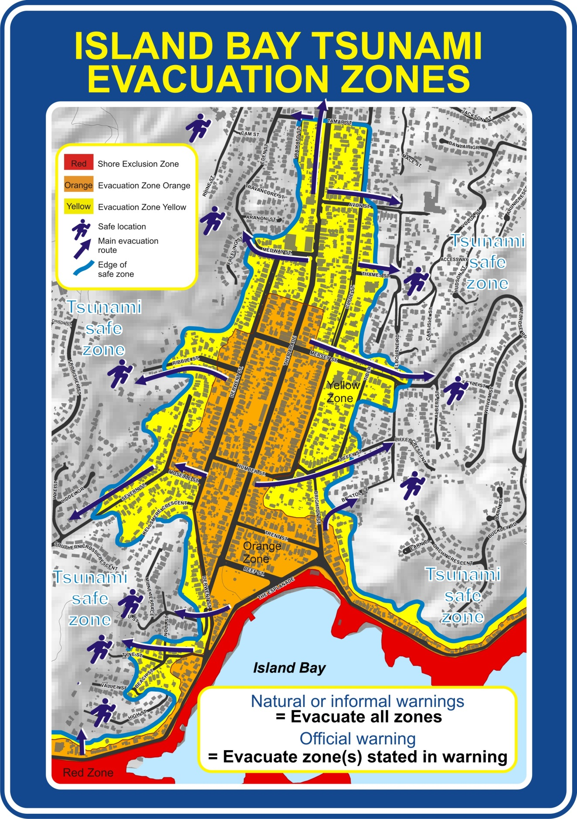
Figure 9 Example map from Wellington using grey scale shaded relief digital elevation model as a base. This map is provided with a separate sheet attached giving details from ‘Warning and Evacuation Information on Maps’ section.

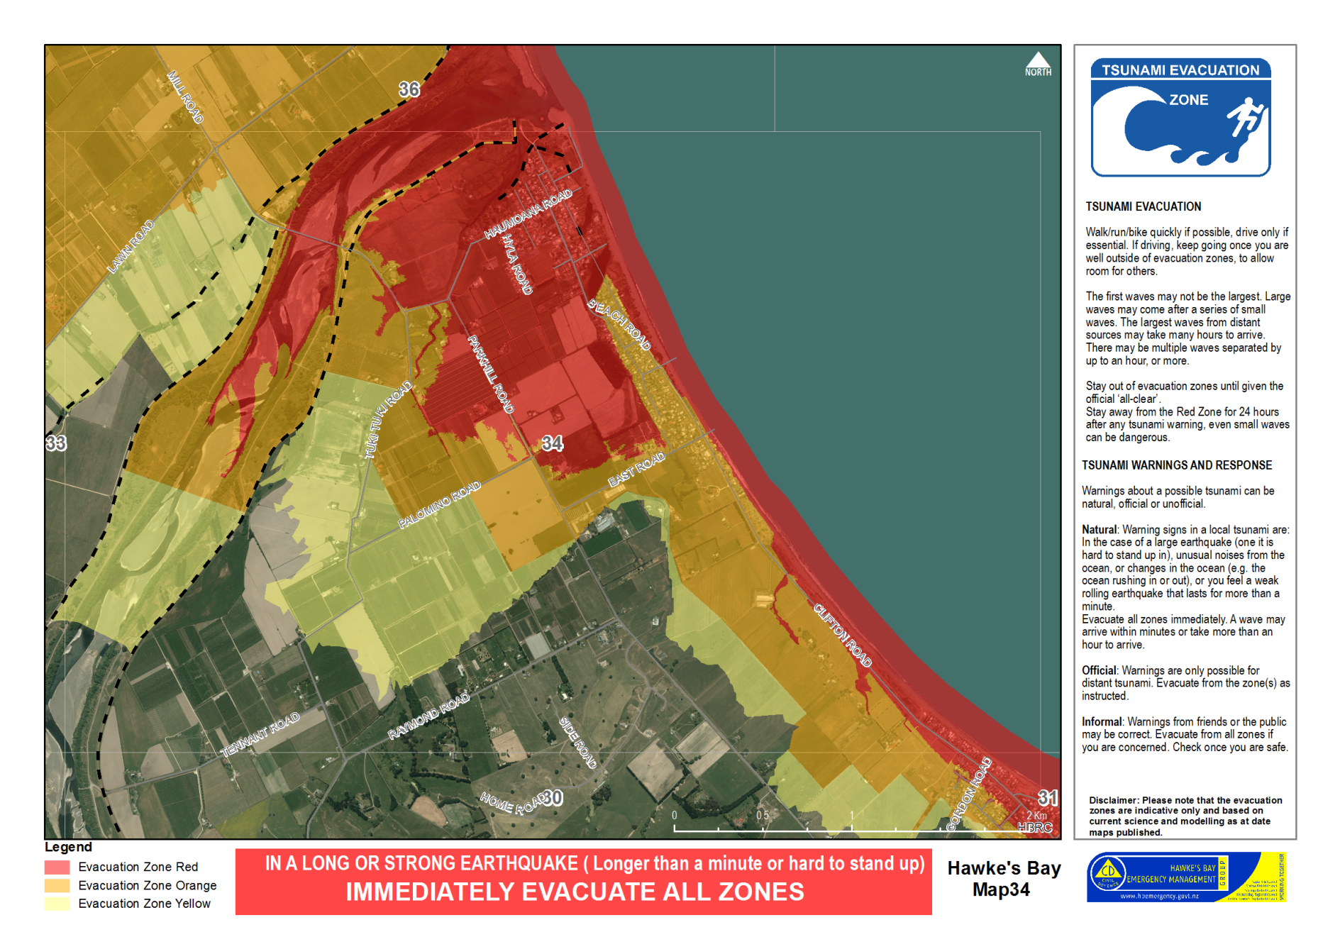
Figure 10 Evacuation map example from Hawkes Bay using an air photo base and including warning and evacuation information on the map face. Note the Orange Zone boundary has been moved inland to meet cultural and landscape features, whereas the Yellow Zone boundary has not.

Advice for ports, shipping and people in boats
The following advice titled “Tsunami Evacuation Minimum Safe Distance for Boats” was developed for Hawke’s Bay (see Figure 11 on the next page), and can be adapted to other marine areas.
Tsunami risk profiles for a local marine area, in terms of likely travel times of the most plausible tsunami waves from relevant sources towards recognised boating areas, can be discussed with scientists knowledgeable about the area concerned.
The CDEM Group and the local Harbourmaster will need to consider the time required for people to reach safety once beached or docked. Given the range of possible sources and circumstances, it may not be possible to provide advice that will be optimal in every situation. A realistic goal is to provide practical advice for the best chance of safety in the most likely scenarios.
The local Harbourmaster may want to pre-plan what actions to take and advice to provide to boat operators for each most likely scenario. In an event, the CDEM Group should communicate with the local Harbourmaster to provide relevant information on the threat.
The local Harbourmaster may need to make judgement calls based on their expertise and local knowledge. It should be recognised that no other official is likely to have more knowledge on the possible effects of unusual or large waves and tidal surges within local harbours, estuaries and bays, and where boats are likely to be on the day.

Minimum evacuation depth | Depth (m): 50m.  Do not stop at the 50m line but continue to head to deeper water which is safer from tsunami currents and waves.  Disclaimer: Please note that the minimum safe distance for boats is indicative only and based on current science and modelling as at date maps published.  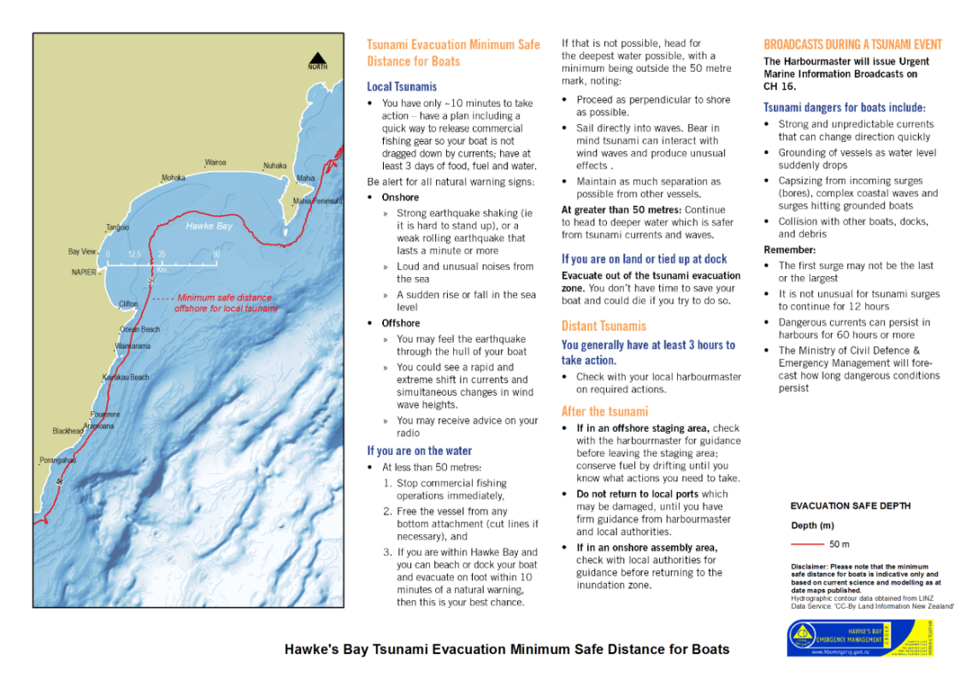  Figure 11 Draft tsunami evacuation advice for boats for Hawkes Bay

Local tsunami
 | You have only ~10 [modify as required] minutes to take action – have a plan including a quick way to release commercial fishing gear so your boat is not dragged down by currents; have at least 3 days of food, fuel and water.
Natural warnings – Be alert | Onshore:  - Strong earthquake shaking (i.e. it is hard to stand up) or a weak rolling earthquake that lasts a minute or more  - Loud and unusual noises from the sea  - A sudden rise or fall in the sea level.  Offshore:  - You may feel the earthquake through the hull of your boat  - You could see a rapid and extreme shift in currents and simultaneous changes in wind-wave heights  - You may receive advice on your radio.

If you are on the water | At less than 50 metres depth:  - Stop commercial fishing operations immediately  - Free the vessel from any bottom attachment (cut lines if necessary)  - If you are within [state the applicable marine area] and you can beach or dock your boat and evacuate on foot within 10 [modify time as appropriate for the location] minutes of a natural warning, then this is your best chance.  If the above is not possible, head for the deepest water possible, with a minimum being outside the 50 metre mark, noting:  - Proceed as perpendicular to shore as possible  - Sail directly into waves; bear in mind tsunami can interact with wind waves, and headlands and islands, and produce unusual effects  - Maintain as much separation as possible from other vessels.  At greater than 50 metres depth:  - Continue to head to deeper water which is safer from tsunami currents and waves  - If you are on land or tied up at dock  - Evacuate out of the tsunami evacuation zone – you don’t have time to save your boat and could die if you try to do so.

Distal tsunami
You generally have at least 3 [modify as required] hours to take action.
Check with your local Harbourmaster on required actions.

After the tsunami
- If in an offshore staging area, check with the local Harbourmaster for guidance before leaving the staging area; conserve fuel by drifting until you know what actions you need to take
- Do not return to local ports which may be damaged, until you have firm guidance from the local Harbourmaster and Local Authorities
- If in an onshore assembly area, check with Local Authorities for guidance before returning to the inundation zone.

Broadcast during a tsunami
The local Harbourmaster will [and in accordance with any pre-plan arrangements] issue Urgent Marine Information Broadcasts on CH 16 [as required].
Tsunami dangers for boats include:
- Strong and unpredictable currents that can change direction quickly
- Grounding of vessels as water level suddenly drops
- Capsizing from incoming surges (bores), complex coastal waves and surges hitting grounded boats
- Collision with other boats, docks, and debris.
Remember:
- The first surge may not be the last or the largest
- It is not unusual for tsunami surges to continue for 12 hours
- Dangerous currents can persist in harbours for 60 hours or more
- The Ministry of Civil Defence & Emergency Management will issue official warnings and information updates via local emergency management agencies and the media, including how long dangerous conditions may persist.

References
Berryman, K., (compiler), 2005. Review of Tsunami Hazard and Risk in New Zealand. GNS Science client report CR2005-104, Lower Hutt.
Cabinet Office Government of Japan. (2005). Guideline for Tsunami Evacuation Buildings. Tokyo. http://www.bousai.go.jp/jishin/tsunami/hinan/hinanbiru.html
DoC, 2010. New Zealand Coastal Policy Statement. Prepared by the New Zealand Department of Conservation. Wellington. 28p.
FEMA, 2008. Guidelines for Design of Structures for Vertical Evacuation from Tsunamis. Redwood City, California. FEMA P646. Prepared by the Applied Technology Council for the Federal Emergency Management Agency. http://www.fema.gov/media-library-data/20130726-1641-20490-9063/femap646.pdf
FEMA (2009). Vertical Evacuation from Tsunamis: A Guide for Community Officials. Redwood City, California. FEMA P646A. Prepared by the Applied Technology Council for the Federal Emergency Management Agency. http://www.fema.gov/media-library-data/20130726-1719-25045-1822/fema_p646a.pdf
FEMA, 2012. Guidelines for Design of Structures for Vertical Evacuation from Tsunamis - 2nd Edition. Redwood City, California. FEMA P646. Prepared by the Applied Technology Council for the Federal Emergency Management Agency. http://www.atcouncil.org/files/FEMA P-646 Final.pdf
Fraser, S. A., Leonard, G. S., Murakami, H., and Matsuo, I., 2012. Tsunami Vertical Evacuation Buildings --- Lessons for International Preparedness Following the 2011 Great East Japan Tsunami. Journal of Disaster Research, 7(7), 446–457.
Fraser, S. A. and Power, W. L., 2013. Validation of a GIS-based attenuation rule for indicative tsunami evacuation zone mapping. GNS Science Report 2013/02. Lower Hutt. 21 p.
Leonard, G., (compiler), 2008. Draft guidelines for consistent New Zealand tsunami evacuation mapping. GNS Science Report SR2008/30, Lower Hutt. 18p.
Leonard, G.S.; Power, W.; Lukovic, B.; Smith, W.; Johnston, D.; and Downes, G., 2008. Tsunami evacuation zones for Wellington and Horizons regions defined by a GIS-calculated attenuation rule, GNS Science Report 2008/30. 22p.
Leonard, G.S. and Wright, K.C. 2010. Evaluation of Get Ready Get Thru The Vines, GNS Science Report 2011/01. 22p.

The following publications are available on the Ministry of Civil Defence & Emergency Management website www.civildefence.govt.nz (search for each document by name).
MCDEM, 2008. Mass Evacuation Planning Director’s Guideline for Civil Defence Emergency Management Groups [DGL 07/08], Prepared by Ministry of Civil Defence & Emergency Management, Wellington. 86p.
MCDEM, 2008a. National Tsunami Signage, Technical Standard for the CDEM Sector [TS01/08]. Prepared by Ministry of Civil Defence & Emergency Management, Wellington. 19p.
MCDEM, 2010. Community Engagement in the CDEM context Best Practice Guideline for Civil Defence Emergency Management Sector [BPG 4/10]. Prepared by Ministry of Civil Defence & Emergency Management, Wellington. 38p.
MCDEM, 2014. National Tsunami Advisory and Warning Plan. Prepared by Ministry of Civil Defence & Emergency Management, Wellington. 71p.
MCDEM, 2014a. Tsunami Warning Sirens Technical Standard [TS03/14]. Prepared by Ministry of Civil Defence & Emergency Management, Wellington. 14p.
MCDEM, 2015. Welfare Services in an Emergency: Director's Guideline for CDEM Groups and agencies with responsibilities in an emergency [DGL 11/15]. Prepared by Ministry of Civil Defence & Emergency Management, Wellington. 260p.
Power, W. L., (compiler)., 2013. Review of Tsunami Hazard in New Zealand (2013 Update), GNS Science Consultancy Report 2013/131. 222 p.
Saunders, W.S.A.; Prasetya, G. and Leonard, G.S., 2011. New Zealand’s Next Top Model: Integrating tsunami inundation modelling into land use planning, GNS Science Miscellaneous Series 34, 42p.
Webb T., (compiler), 2005. Review of New Zealand's preparedness for tsunami hazard, comparison to risk and recommendations for treatment. GNS Science Client Report 2005/162, 104p. plus appendices.

GNS Science reports: ‘Tsunami Hazard and Risk in New Zealand’ (compiled by Berryman, 2005); ‘New Zealand’s Preparedness for Tsunami Hazard’ (compiled by Webb, 2005).
GNS Science report ‘Review of Tsunami Hazard in New Zealand’ (2013 Update) (compiled by William Power).
Please note that values of Mean High Water Springs are often quoted relative to nautical chart datum or the lowest astronomical tide, and these will need to be adjusted to be relative to Mean Sea Level. Using topographic data defined relative to Mean Sea Level is recommended when defining evacuation zones.

