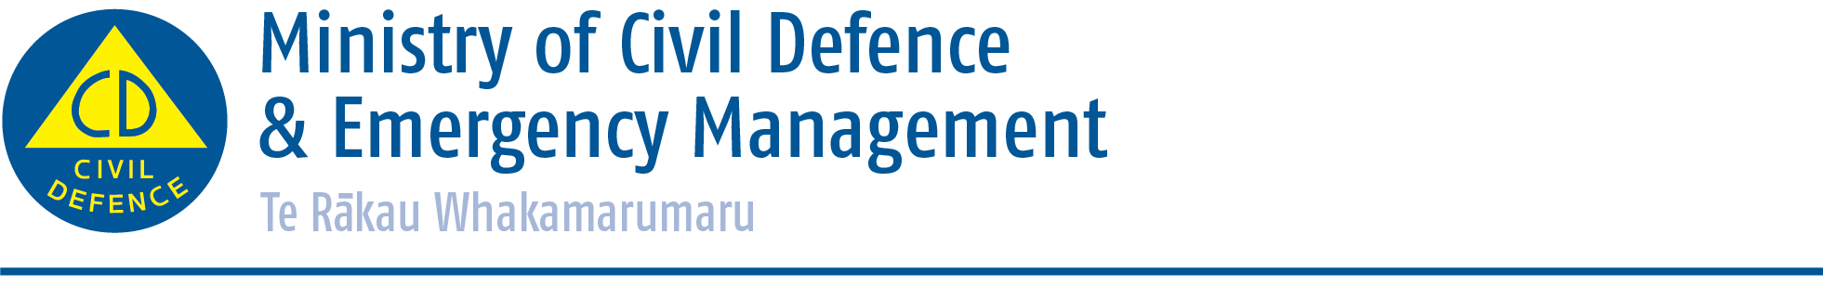

Media release

Monday 25 May 2015
Get Ready to ‘Get Thru’ winter
With winter approaching the Ministry of Civil Defence & Emergency Management is using social media to help make sure New Zealanders are prepared.
A series of tweets and facebook posts will be shared at the end of May to highlight the importance of learning about disasters, having a household emergency plan, having emergency survival items and preparing a getaway kit.
Director CDEM Sarah Stuart-Black said floods were New Zealand’s number one hazard in terms of frequency, losses and number of states of local emergency declared.
“Snow can also have a significant impact. It only takes a few centimetres on a road to make driving dangerous. In large quantities, snow can immobilise regions by disrupting communications, transport and supply lines, hampering the operation of emergency services, and increasing the risks to the most vulnerable members of the community.”
She says communities can help themselves to reduce the impact of winter flooding, storms and snow events by determining their risk now and getting their household ready.
The tips, which will be posted on www.facebook.com/nzgetthru and www.twitter.com/nzgetthru, are:
- Develop or update your household emergency plan and learn more about storms, floods and landslides before the worst weather strikes.

- Extreme winter weather, including floods, storms and landslides can isolate households and knock out heat, power and communication services. Assemble and maintain Emergency Survival Items for your home, work and vehicle, so you can be self-sufficient for at least three days.

- Make sure your home is properly insulated and consider buying emergency heating equipment to reduce your reliance on power sources during an emergency. Have a backup plan if your health depends on your power supply.
- Floods, storms, landslides and other winter hazards may mean you have to evacuate your home. Assemble and maintain a getaway kit in case you have to leave in a hurry. Include long pants, a long-sleeved shirt, a warm jacket, and sturdy shoes. The most common injury following emergencies is cut feet.

- If severe weather is threatening your region, keep listening to radio or television stations and follow the instructions of local civil defence emergency management officials. Authorities do not ask people to leave unless they conclude that lives may be in danger, if they tell you to evacuate immediately, evacuate immediately, take your getaway kit and go.

ENDS

Media contact
Ministry of Civil Defence & Emergency Management
Public Information Duty Officer
24/7 media phone: 04 494 6951
E-mail: pim@ncmc.govt.nz

- Follow the Ministry on Twitter or subscribe to our RSS feed
-  If a disaster happened now, would you be ready? www.getthru.govt.nz

